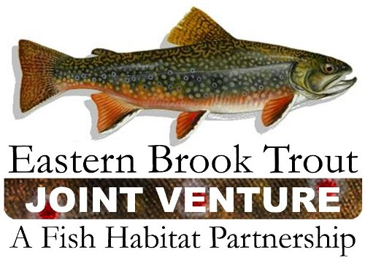

EBTJV Grants & Development Committee

AGENDA

October 27, 2010

- Review of past and current funding

- Current & potential projects needing funding

- Discussion of current and potential funding sources

- Develop outline of a funding plan

