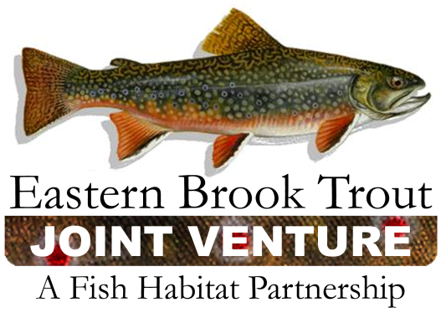

EBTJV Steering Committee
Conference Call Summary
December 20, 2011
10:00 am - Noon

Participants:
Doug Stang, Jason Detar, Rachel Muir, Steve Moore, Dianne Timmins, Mike Shingleton, Alan Heft, Callie McMunigal, Tai-ming Chang, Bob Carline, Doug Besler, Elizabeth Macklin, Nat Gillespie, Jim Habera, and Jeff Durniak

- Review of Action items from October Conference Call
- Doug S. will send a copy of the letter to Tom Sadler so that he can follow up with Orvis on the status of the potential project funding.
Done. Orvis moved ahead without our list this time. There will be opportunities to work with them in the future. They will try to give us more notice next year.

- Doug Stang, Doug Besler, Tom Sadler, and Callie McMunigal will work on completing the self evaluation of the EBTJV by mid-November if possible. We will then use that evaluation to see how we need to tweak our process or criteria for next year.
In progress. Doug has drafted the evaluation and the others are working on reviewing it. The report should be submitted by the end of the week. We need assistance from the science and data committee to answer the science and data question. Rachel & Jason provided the following during the call for question #9:
Efforts with Chesapeake Bay Program
Hudy’s model that evaluates climate change effects to cold water species. This information has not been formally presented to the National SD Committee, but will be done and available in 2012.
Working to develop standardized sampling methods.
Updated catchment scale assessment.
Working with NALCC and AppLCC and FHPs.
Summarize and transfer data to the national committee.
Rachel will check on national assessment to see if we provided information for that effort.

- Merry Gallagher will send draft culvert replacement specs to the SC for review.
Pending

- Doug will call Jaime Geiger and talk to him about the West Brook project and potential funding from NFPP or other sources. Merry Gallagher will draft a letter for Doug from EBTJV to Jaime Geiger / Jan Rowan (NFPP Coordinator) asking for support for the West Brook Project.
Pending

- Doug Stang will send the SC approved project list for FY12 to the Service (Jaime Geiger, Linda Kelsey, and Callie McMunigal).
Done.

- Callie will forward email with ALCC Workshop registration to Doug Besler and Mike Shingleton.
Done. Both participated at the workshop along with Jake Rash, Mark Hudy and Rachael Muir.

- Callie will forward the email from Ryan Roberts that outlines the option with DJ Case for website development, training and hosting to the Steering Committee.
Done. Keith McGilvray participated on the conference call hosted by the Board with DJ Case. Cost is $5,000 start up and $2,500 annually. This would be a good option if all FHPS used it consistently.

Action Item: Doug will talk to Ryan Roberts about the website.

- Callie will call Jaime Geiger and ask for guidance as to how EBTJV can best handle this - outside of the project ranking process.
Pending

- Petition from EPA to Join EBTJV and EBTJV Steering Committee
EBTJV received a request from Tai-ming Chang to consider adding EPA to the EBTJV Steering Committee and partnership. A motion to nominate EPA for membership was made by Dianne Timmins. Doug Bessler seconded the motion. The motion was approved by voice vote. Tai- Ming Chang will be the EPA representative to the EBTJV Steering Committee.

- Update on Appalachian LCC Science Needs Workshop
The following are the top five priority science need categories as determined by the participants at the workshop and approved by the ISC the following week:
- Ecological Flows
- Resource Extraction and Demands from Energy
- GIS / IT Capacity
- Species Habitat Distribution Trends
- Vulnerability Assessments (Climate and Non-Climate Stressors)

The LCC is now prioritizing specific science needs within each of those broad categories. They have created teams to review needs for each priority category. Only the top three needs will be forwarded to the ISC for ranking and funding. The total amount of funding available from FY11 for projects is around $600,000.

Rachel and Tai are serving on the committee to refine and select projects under Ecological Flows. Rachel will send out the top priorities under Ecological Flows and ask for comments from EBTJV. The NE Climate Center can also provide funding for science needs particularly related to climate.

Action Item –Tai will work with Jason, Rachel and Doug to ensure that our science needs are submitted to the LCC for consideration by the deadline.

- Multi State Conservation Grant Proposal
We submitted a joint grant proposal with ACFHP and SARP for two years of funding. We made it through the first level of evaluation and are still in consideration for a single year of funding. Doug will have a conference call with the other two partnerships to decide what can be done with a single year of grant funding. Our initial goals for the two year grant included having funding for a part time coordinator, the annual all partners meeting, workgroup meetings, and a joint meeting with SARP and ACFHP to improve coordination. After brief discussion on priorities for reduced levels of funding, Doug said that he will ensure that we have funds for our annual meetings at a minimum and funds for a coordinator if possible.

- Spring 2012 All Partners Meeting
We will be meeting in conjunction with the East Coast Trout Management and Culture V meeting in Frostburg, MD on June 13 and 14, 2012. Alan Heft is organizing the facilities for both meetings. Hotel and college residence hall accommodations will be posted for folks by the end of January on the East Coast Trout Management and Culture V Website. Alan recommends that we have an EBTJV presentation at the East Coast meeting to update participants on the effort and progress to date.

Action Item - Dianne will give a presentation on behalf of the EBTJV

- EBTJV 2012 Progress Review
We should follow through on evaluating our progress towards our regional habitat objectives since they are all linked to specific accomplishments by 2012. The regional workgroups should coordinate this update and potentially present these results at the East Coast meeting.

- NFWF BBN Grant
The NFWF Bring Back the Natives Grant program is accepting new proposals. Priority areas for brook trout include the Chesapeake Bay and the Upper Ohio watersheds. The SC decided not to submit an application that combined several project applications on behalf of the EBTJV.

Action Item - Callie will forward the funding notice out to partners so that they know about the opportunity and can apply on their own if they are interested.

- 2012 EBTJV Steering Committee Conference Call Schedule
March 20
June 5
September 18
December 18

Conference calls begin 10:00 am and generally last 1 – 1.5 hours.

