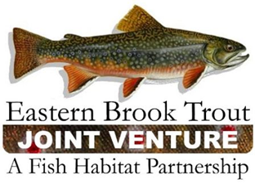
Steering Committee Conference Call
16 June 2015
10:00 a.m. - Noon

Call-In Number: 866-793-8933
Participant Code: 86086865#
Master Link to Agenda Documents: http://bit.ly/1Qtgs3g

AGENDA

- Steering Committee Roll Call & Establishment of Quorum (Doug Besler)

- Approval of March 2015 Steering Committee Meeting Summary (Doug Besler)
Document link: http://bit.ly/1eRhyu5

- EBTJV 2015 Meeting (Steve Perry)
Document link: http://bit.ly/1JtgCaq

- 2015 NFHP 10 Waters to Watch (Steve Perry)
Document link: http://bit.ly/1H4yXdx

- FY15 FWS-NFHAP Funding Allocation (Callie McMunigal/Steve Perry)
Document link: http://bit.ly/1EYf6a3

- Project Tracking Database (Steve Perry/Callie McMunigal/Dianne Timmins)

- Update on the EBTJV’s Performance Evaluation by the NFH Board (Steve Perry)

- Brook Trout Video (Nat Gillespie/Doug Besler)
Document Link: http://bit.ly/1KeLOLe

- Monitoring Brook Trout in the Chesapeake Bay Watershed (Mark Hudy/Steve Perry)

- NFHP Marketing and Branding Initiative

- June 2015 NFH Board Meeting (Steve Perry)

- EBTJV Committee Updates (Committee Chairs)

