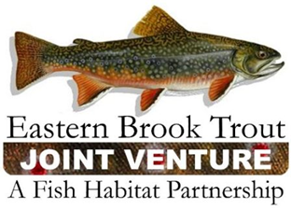
Steering Committee Teleconference
December 17, 2019
1:00 – 3:00 p.m.

Call-In Number: 866-793-8933
Participant Code: 86086865

AGENDA

- Steering Committee Roll Call & Establishment of Quorum (Nat Gillespie)

- Approval of September 17, 2019 Steering Committee Meeting Summary (Nat Gillespie)

- Approval of the Priority Ranking for FY20 Brook Trout Conservation Projects (Steve Perry)

- Preparation of the FY20 FWS-NFHAP Work Plan and Accomplishment Report (Steve Perry)

- Development of the FY20 EBTJV Coordination and Operations Project Proposal (Steve Perry)

- EBTJV Science and Data Committee Progress Report (Jake Rash/Steve Faulkner/Jason Detar)

- Development of an updatable database
- Addition of new data fields to the database
- Hosting of the database and web viewer
- Use of genetics to answer certain management questions
- Preparing for the next range wide assessment

- Other Business
- EBTJV Meeting in 2020?
- Trout Power (NY)
- EBTJV Website Refreshed

