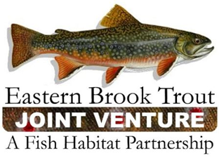
EBTJV Steering Committee Meeting Summary
June 16, 2020

Participants: Nat Gillespie, Dianne Timmins, Merry Gallagher, Steve Reeser, Jason Detar, Lee Simard, Mike Beauchene, Dave Kazyak, Matt Kulp, Glenn Erikson, Jake Rash, Bill Pastuszek, and Steve Perry.

This teleconference was called to order by Chair Nat Gillespie at ~1:00 p.m. on June 16th. The first order of business was for the Chair to establish a quorum (≥10 SC members), which was achieved as twelve Steering Committee members participated in the meeting.

The following notes summarize the business conducted during the conference call held on June 16, 2020:

- The December 17, 2019 Steering Committee Meeting Summary was approved.

- The 2020 EBTJV Website Maintenance Contract was approved.

- The Eastern Native Brook Trout Poster Funding Request was approved.

- The March 17, 2020 Steering Committee Meeting Summary was approved.

- The Steering Committee discussed the NFWF Process for recruiting and selecting a new EBTJV Coordinator. To stay on top of this process the Steering Committee established an ad hoc Coordinator Transition Committee. The Committee’s membership consists of Nat Gillespie, Dianne Timmins, Mike Beauchene, Jason Detar, and Callie McMunigal.

- The EBTJV received level 3 FY20 FWS-NFHAP Funding for Brook Trout Conservation Projects. This is the highest level of funding ($273,000) available to the Fish Habitat Partnerships.

- Other business discussed included an eDNA workshop being hosted by the Chesapeake Bay Program; a genetic workshop that is being planned for the late fall/early winter time frame; how Covid 19 is impacting field work; and a review of Brook Trout Management Plan updates being completed by various state agencies.

The EBTJV Steering Committee meeting adjourned at 2:10 p.m.

