FINAL REPORT
South Carolina State Wildlife Grant F21AF03715
South Carolina Department of Natural Resources
October 1, 2021 – December 31, 2023

Project Title: Eastern Brook Trout Restoration in Pig Pen Branch and Lick Log Creek, Oconee County, South Carolina

Objective:
The objective of this project was to restore a reproducing Eastern Brook Trout Salvelinus fontinalis population in Pig Pen Branch and Lick Log Creek. Eastern Brook Trout are listed as a species of Moderate Priority in the South Carolina’s State Wildlife Action Plan (South Carolina Department of Natural Resources 2015), but has been elevated to High Priority in the 2024 revision, which is in progress. The project also sought to produce secondary benefits toward developing status information and guide future management of other State Wildlife Action Plan (SWAP) species within the immediate project area and downstream, such as the Chauga Crayfish Cambarus chauganensis.
The objectives were to 1) assist Naturaland Trust and The United States Forest Service (USFS) with land acquisition and dam removal on Burrell’s Pond Property; 2) Conduct pre- and post-Antimycin treatment surveys of all aquatic invertebrates, salamanders, and crayfish in Pig Pen Branch and Lick Log Creek; 3) Conduct pre-treatment evaluation and preparation of Pig Pen Branch and Lick Log Creek; 4) Conduct Antimycin treatment to remove non-native fishes and re-introduce Eastern Brook Trout in Pig Pen Branch and Lick Log Creek; 5) Conduct in-stream habitat survey and habitat improvement planning post- Antimycin treatment.

Accomplishments:
Objective 1
A temporary siphon was installed by SCDNR and Naturaland Trust to lower the Burrell’s Pond water level. After the pond water level was lowered, the existing plastic riser standpipe was notched to keep the streambed in Burrell’s Pond dewatered. Winter Rye, Brown Top Millet, Winter Wheat, and granular fertilizer were broadcasted along the pond banks and pond bed to establish temporary ground cover to minimize erosion. The USFWS and USFS removed Burrell’s Pond dam in March of 2022, depositing all fill material into an on-site borrow pit (Figure 1). Logs and stumps removed from the preexisting dam were strategically placed along the stream banks to reduce erosion downstream (Figure 2).

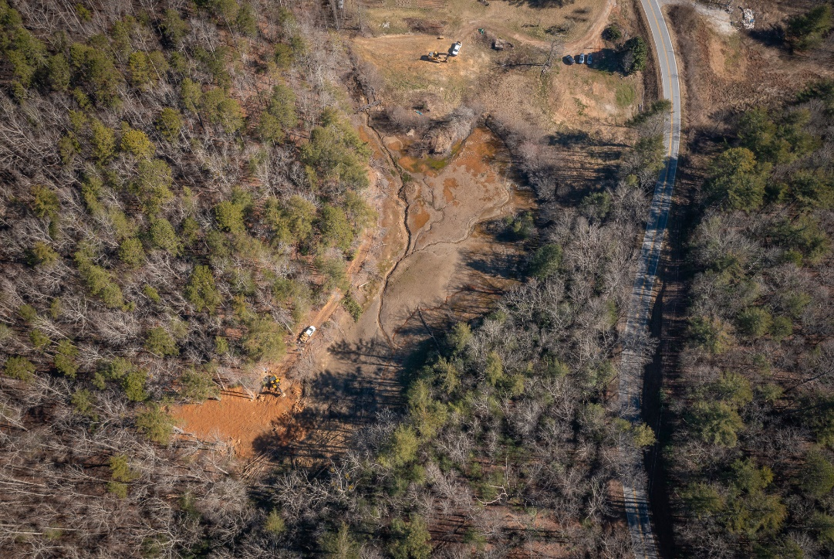

Figure 1. Aerial photo captured by Mac Stone (Naturaland Trust) of Burrell’s Pond dam removal.

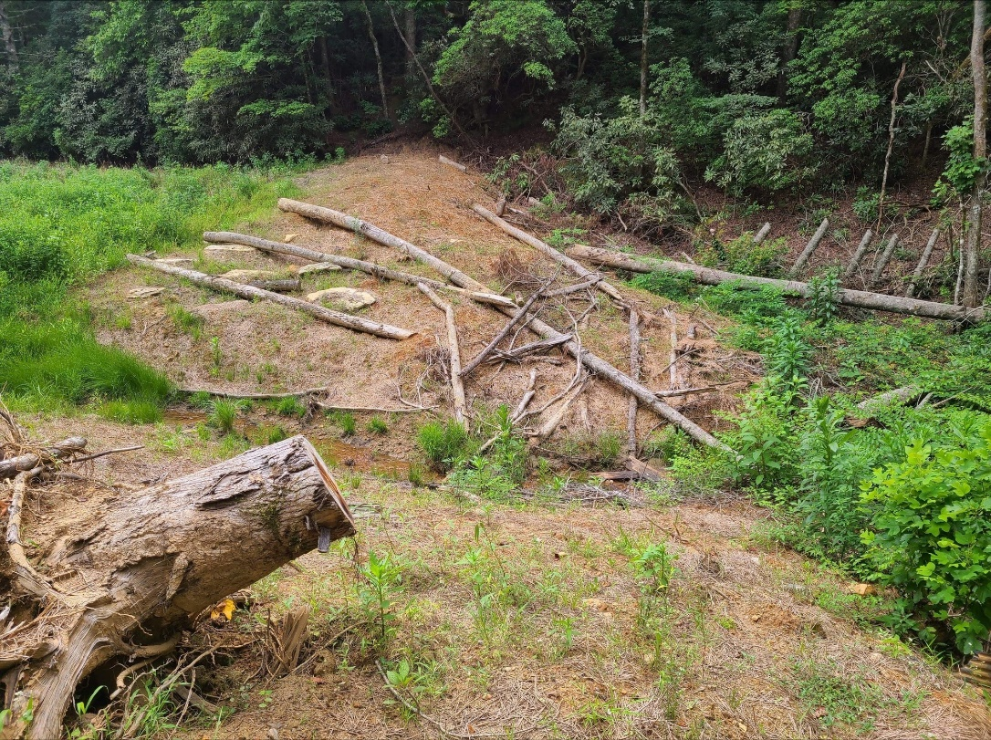

Figure 2. Photo captured by Hailey Goyette (SCDNR) of post Burrell’s Pond dam removal and erosion control methods.

Objective 2
Dr. Jeremy Pike, with Clemson University, conducted surveys of the aquatic invertebrates, crayfish, and salamander community in Pig Pen Branch and Lick Log Creek. Six sites were established with two control sites above the Antimycin treatment area where no fish are present, three sites within the Antimycin treatment area, and one below the detox site within the Chattooga River:
CHR1 - N34° 55.811' W83° 07.966'
PPB1 - N34° 55.726' W83° 07.630'
PPB2 - N34° 56.021' W83° 06.452
PPB3 - N34° 56.673' W83° 06.200'
PPBt4 - N34° 55.954' W83° 06.431'
PPBt5 - N34° 55.313' W83° 06.411'

CHR1 - “Detoxification” station located on the Chattooga River immediately downstream of confluence with Pig Pen Branch.
PPB1 - “Treatment” station located on Pig Pen Branch immediately upstream of the footbridge above Upper Pigpen Falls. This station is located below the confluence with Lick Log Creek.
PPB2 - “Treatment” station located on Pig Pen Branch immediately upstream of confluence with major unnamed tributary.
PPB3 - “Control” station located in the headwaters of Pig Pen Branch. This station is immediately downstream of a large in-stream bedrock feature.
PPBt4 – “Treatment” station located on a major unnamed tributary immediately upstream of Pig Pen Branch.
PPBt5 – “Control” station located in the southern headwaters of the major unnamed tributary of Pig Pen Branch.

Pre-treatment aquatic community collections, habitat assessments and in situ water quality measurements were conducted at each station on September 5, 2023. Since this time, collected sample detritus has been sorted of aquatic organisms and separated to the order level. Post-treatment aquatic community collections, habitat assessments and in situ water quality measurements were conducted at each station on October 5, 2023. The collection/assessment at “control” station PPBt5 was conducted immediately downstream of the Antimycin treatment site PPBt A12 due to extreme low water levels in channel. Since this time, collected sample detritus has been sorted of aquatic organisms and separated to the order level. A follow-up survey will be conducted for a one-year post-Antimycin treatment, and a final report will be submitted in Fall-Winter 2024.
Dr. Jeremy Pike with Clemson University conducted this sampling of aquatic invertebrates, salamanders, and crayfish pre- and post-Antimycin treatment.

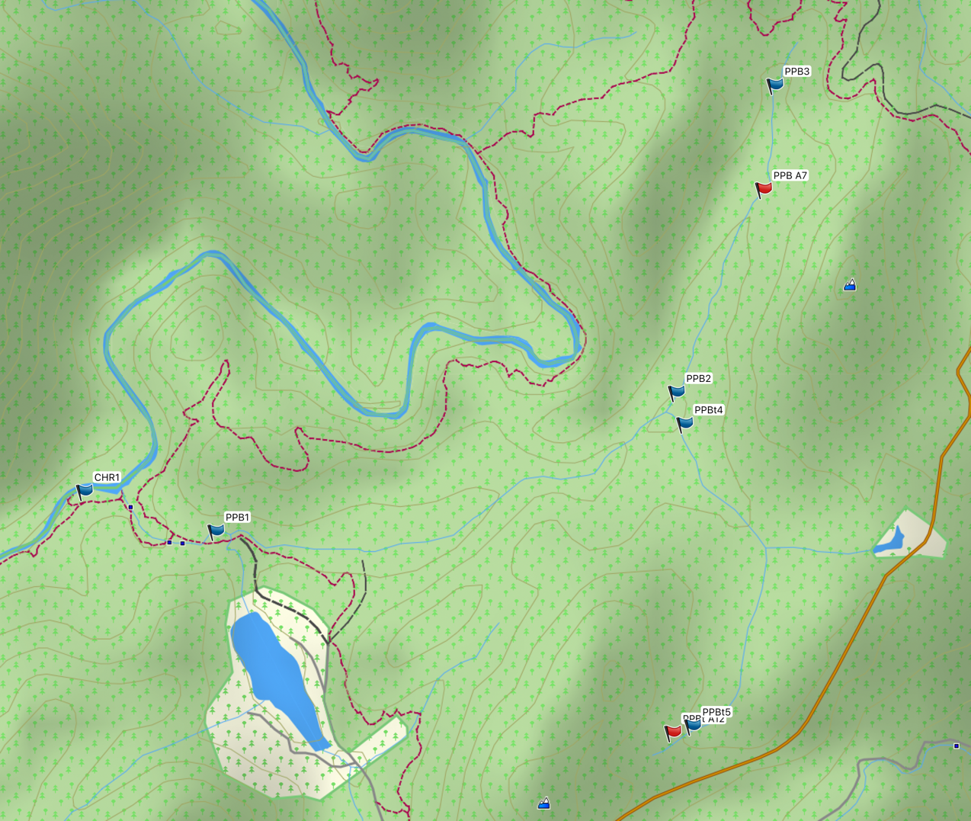

Figure 3. Aquatic invertebrate, crayfish and salamander monitoring stations located on Pig Pen Branch near Mountain Rest, South Carolina. Blue flags demark monitoring stations. Red flags demark the uppermost Antimycin treatment locations for the project.

Objective 3
SCDNR flagged and cleared approximately 6 km (3.73 miles) of trail and old logging roads for creek access in fall 2021- spring 2022. SCDNR removed thick in-stream vegetation over approximately 5.8 km (3.6 miles) of stream on Lick Log Creek and Pig Pen Branch in spring 2022. Once Lick Log Creek and Pig Pen Branch were accessible, SCDNR performed longitudinal fish sampling using backpack electrofishers throughout the 5.8 km of creek. Two backpack electrofishers were used to identify distribution of Creek Chub Semotilus atromaculatus and Eastern Brook Trout. Figure 4 shows the distribution observed from these efforts.
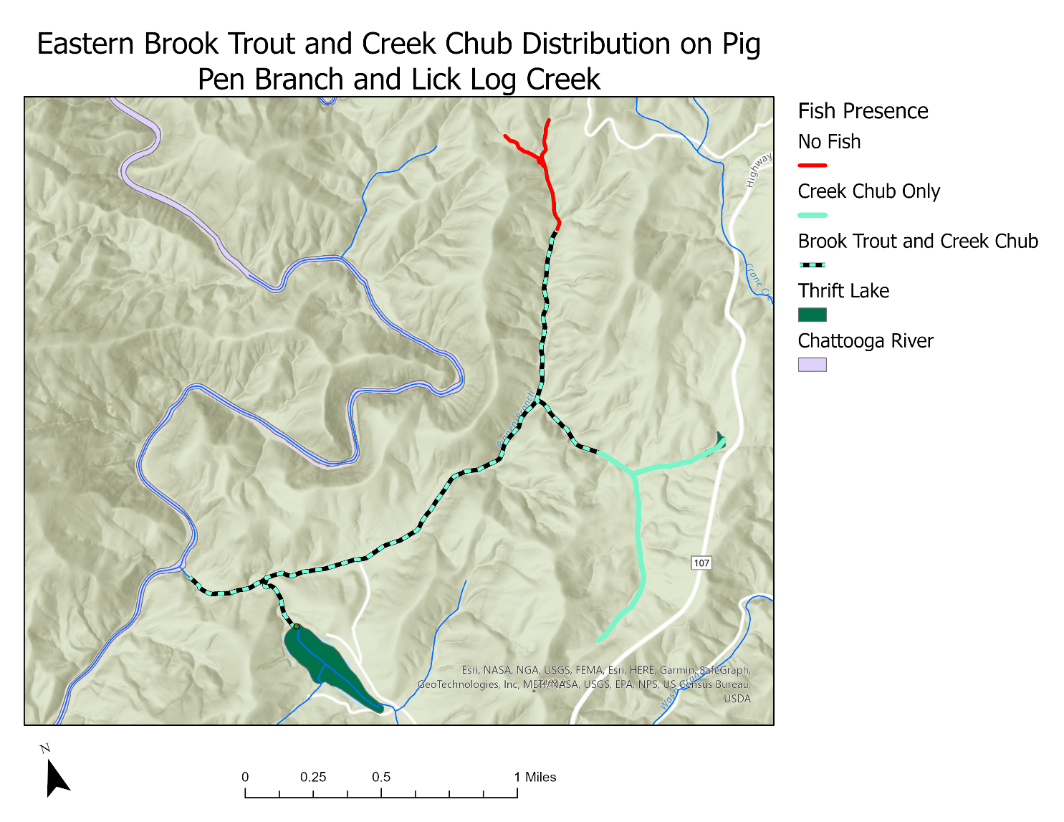

Figure 4. Distribution of Eastern Brook Trout and Creek Chub in Pig Pen Branch and Lick Log Creek.

Data from 2003 through 2021, pre-restoration project backpack electrofish sampling of Pig Pen Branch, shows a declining Eastern Brook Trout population at two historical sampling sites, upper and lower Pig Pen Branch (Figure 5 & 6) (SDCNR unpublished data). Density calculations for all years between 2003 and 2021 show greater amounts of Creek Chub per hectare when compared to Brook Trout per hectare (Figure 7 & 8).

Figure 5. Pig Pen upper site absolute catch for Brook Trout, Creek Chub, Brown Trout, and Bluegill for years 2003-2021.

Figure 6. Pig Pen lower site absolute catch for Brook Trout, Creek Chub, Brown Trout, and Bluegill for years 2003-2021.

Figure 7. Pig Pen Branch upper site fish density (fish/ha) for Brook Trout, Creek Chub, Brown Trout, and Bluegill for years 2003-2014.

Figure 8. Pig Pen Branch lower site fish density (fish/ha) for Brook Trout, Creek Chub, Brown Trout, and Bluegill for years 2003-2021.

Antimycin stations were set up based on the minimum 75-foot elevation gradient requirements and non-native fish, primarily Creek Chub, distribution. Past Antimycin treatment projects in the southern Appalachian Mountains indicated the effectiveness of Antimycin degraded substantially with 75-foot elevation change (drop). Stream gradients were initially calculated using LIDAR provided by the USFS to identify 13 treatment stations to achieve no more than 75 feet of elevation drop between stations (Figure 9). After longitudinal fish distributions were completed (Figure 4), we determined that non-native fish did extend all the way to the headwaters and only 12 stations were needed (Figure 10 & 11).

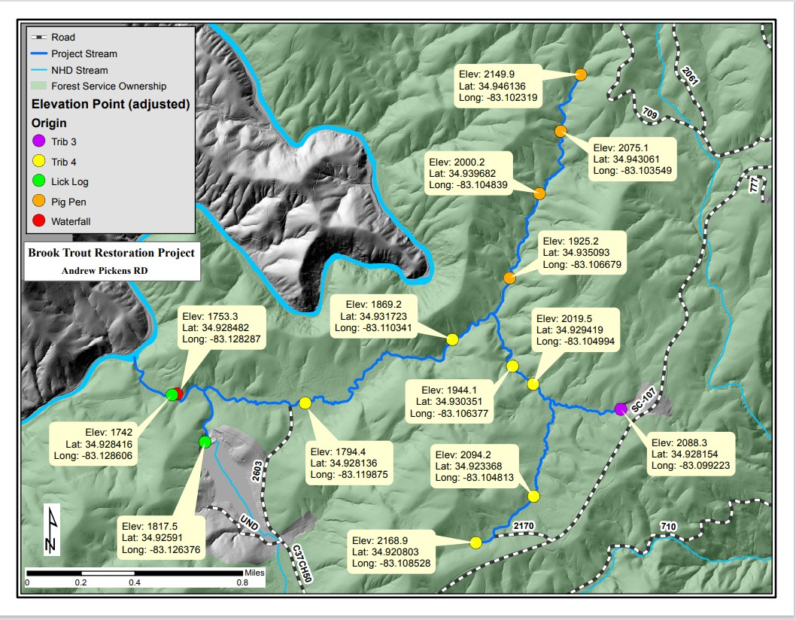
2
13
12
11
10
9
8
7
6
5
4
1
3

Figure 9. Thirteen projected Antimycin treatment sites based on Lidar elevation and flow measurements.

Staff delineated and marked every 100 m interval within the treatment area for reference and to designate placement of live cages during Antimycin treatment (Figure 10 & 11). These 100 m stations were also used for dye retention studies before Antimycin treatments.

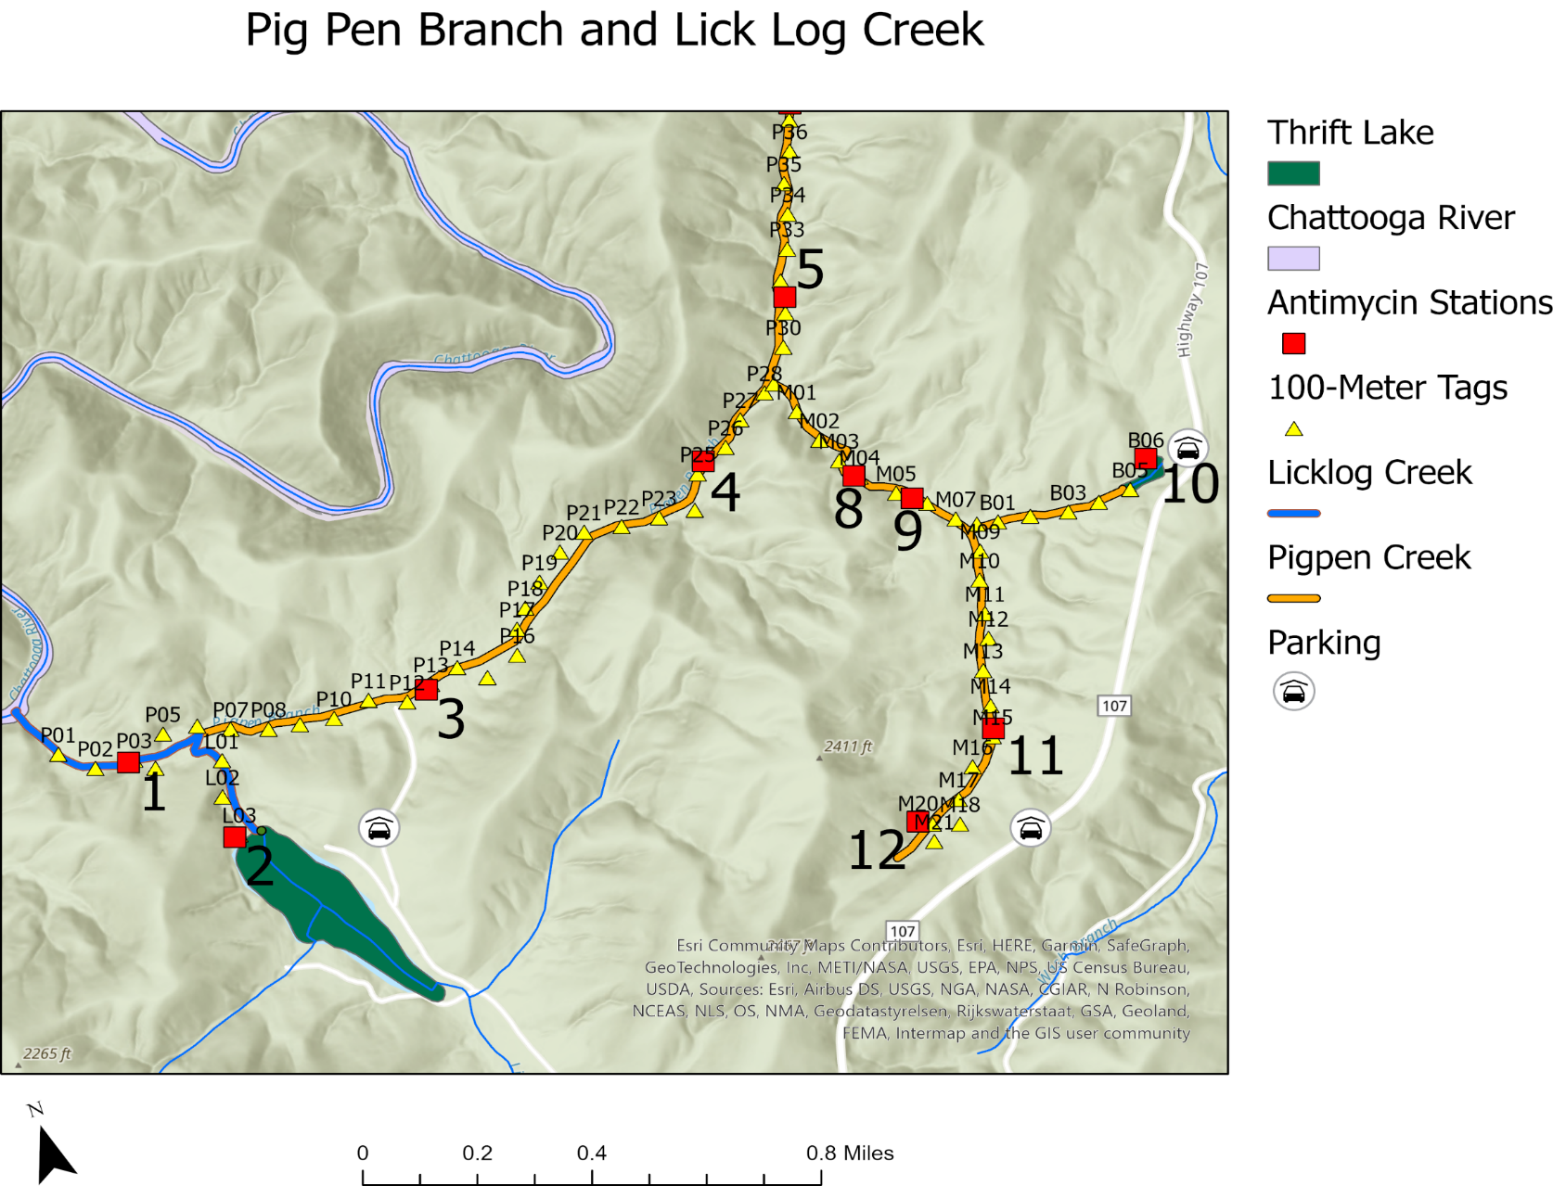

Figure 10. Antimycin treatment sites: 1, 2, 3, 4, 5, 8, 9, 10, 11, and 12 were based on Lidar elevation and Creek Chub distribution.

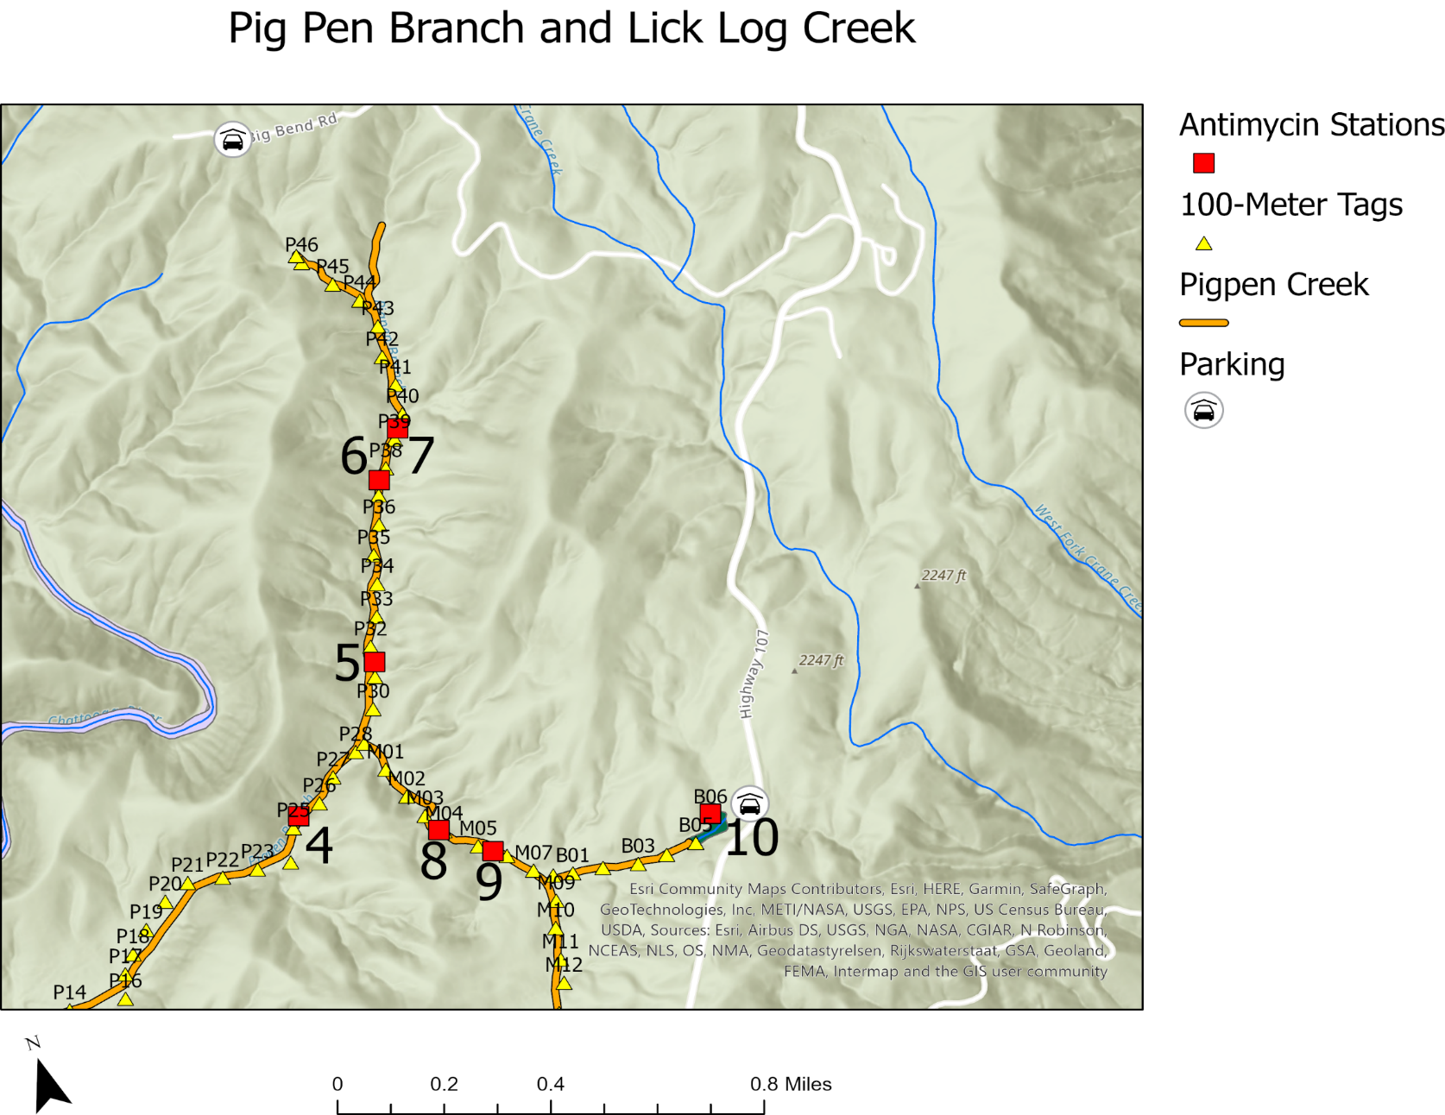

Figure 11. Antimycin treatment sites: 4, 5, 6, 7, 8, 9, and 10 were based on Lidar elevation and Creek Chub distribution.

Twenty-one (21) Eastern Brook Trout were collected from Pig Pen Branch in a 1.3 km (0.8 miles) segment to be tested for the causative agents of whirling disease Myxobolus cerebralis and gill lice Salmincola edwardsii. The Auburn University Coop Disease Lab received these Eastern Brook Trout on May 9, 2022. Results showed that all fish collected tested negative for both whirling disease and gill lice. This result relieved biosecurity threats and meant the remnant population of Pig Pen Brook Trout could be safely removed and held at Walhalla State Fish Hatchery while non-native fish were removed. SCDNR proceeded to electrofish the entire reach of Pig Pen Branch and Lick Log Creek through the summer of 2022, and was able to collect approximately 75 Eastern Brook Trout for transport to Walhalla State Fish Hatchery. Hatchery staff assembled two separate holding tanks, one for young-of-year fish and one for adult fish. In fall 2022, hatchery staff were able to spawn 11 unique Eastern Brook Trout male/female pairings, collecting 1,530 eggs. In winter of 2023, hatchery staff were able to spawn five unique Eastern Brook Trout male/female pairings, collecting 1,348 eggs.
Brook Trout captured from Pig Pen Branch and held at the Walhalla State Fish Hatchery were fin-clipped for genetic analyses on May 24, 2023. Adipose fins from 32 broodstock Brook Trout for the 2022 production year class and 30 of the two-year-old collected Brook Trout were sent to Dr. Tanya Darden, SCDNR, at the Marine Resources Research Institute for further genetic testing. The primary question was if the remnant Pig Pen Brook Trout population was genetically diverse enough to use as brood to reestablish the population.
Samples were run on Beckman CEQ at 13 loci (SfoC24, SfoB52, SfoC79, SfoD91, SfoC113, SfoC88, SfoD75, SfoD100, SfoC38, SfoC28, SfoC86, SfoC115, SfoC129). Samples were amplified with M13 tails in single primer reactions. Loci SfoC24, SfoC79, and SfoC38 were dropped from analysis due to lack of amplification, being monoallelic, or inconclusive results. The other 10 loci were successfully amplified and scored in all 62 individuals, and these genotypes were used for genetic diversity analyses.
Genotypes were analyzed with GenAlEx and Genepop to determine Hardy-Weinberg Equilibrium (HWE), heterozygosity, inbreeding coefficient (F_{IS}), and allelic richness. Values calculated through GenAlEx and Genepop were comparable, so the following results are mostly based on GenAlEx values. Additionally, genetic diversity was compared between broodstock Brook Trout and the two-year-old collected individuals.
Pregler et al. 2018 also measured genetic diversity of Pig Pen collected Brook Trout. SCDNR compared their diversity metrics to Pregler’s results to assess if the fish currently held at the Walhalla State Fish Hatchery are representative of the previous state of diversity in the population. Additional analyses were performed to compare the genetic diversity of individuals genotyped by Pregler et al. (n=63) to individuals from SCDNR’s analysis (n=62) at the nine common loci used in both studies (SfoB52, SfoD91, SfoC113, SfoC88, SfoD75, SfoD100, SfoC86, SfoC115, SfoC129).
Genetic diversity measurements are needed to help determine if these fish were suitable to be used as the sole source of broodstock and provide guidance on genetically responsible numbers of offspring to release back into Pig Pen Branch to reestablish their natural population. With all samples and loci combined, the population was found to be in HW equilibrium following Bonferroni correction (p = 0.007); however, when analyzed separately, a single locus was found to be out of equilibrium (C88; Table 3). Overall observed and expected heterozygosity calculations were moderate, 0.542 and 0.517 respectively (Table 1). The inbreeding coefficient was close to zero (F_{IS}=-0.050), an indication that inbreeding is not occurring at a concerning level despite a small population size (Table 1). The allelic richness ranged from 2–5 and averaged 3.6 alleles per locus (Table 2).

Table 1. Heterozygosity (observed [H_{O}] and expected [H_{E}]), inbreeding coefficient (F_{IS}), and Hardy-Weinberg Equilibrium (HWE) of each locus and an overall average for the combined Brook Trout groups currently at the Walhalla State Hatchery. Overall HWE is calculated via Fisher’s method. Loci significantly out of Hardy-Weinberg Equilibrium are bolded, critical value following Bonferoni correction is p=0.005 (GenAlEx; HWE- Genepop).

Locus | H_{O} | H_{E} | F_{IS} | HWE
D75 | 0.484 | 0.483 | -0.001 | 1.0000
C113 | 0.677 | 0.630 | -0.075 | 0.0299
D91 | 0.774 | 0.779 | 0.007 | 0.3910
C28 | 0.565 | 0.570 | 0.010 | 0.4519
C86 | 0.597 | 0.484 | -0.232 | 0.1207
C129 | 0.581 | 0.541 | -0.074 | 0.6093
B52 | 0.484 | 0.481 | -0.005 | 1.0000
C88 | 0.613 | 0.599 | -0.023 | 0.0002
D100 | 0.468 | 0.424 | -0.102 | 0.3541
C115 | 0.177 | 0.176 | -0.007 | 0.1480
Average | 0.542 | 0.517 | -0.050 | 0.0072

Table 2. Allelic richness (in parentheses) and allele frequencies for each of the 10 loci used to genotype Brook Trout; based on the combined Brook Trout groups currently at the Walhalla State Hatchery (GenAlEx).

D75 (3.0) |  | C129 (4.0)
196 | 0.065 | 242 | 0.613
216 | 0.274 | 248 | 0.089
232 | 0.661 | 251 | 0.024
C113 (4.0) |  | 254 | 0.274
149 | 0.016 | B52 (2.0)
152 | 0.339 | 237 | 0.403
158 | 0.476 | 245 | 0.597
173 | 0.169 | C88 (5.0)
D91 (5.0) |  | 204 | 0.145
235 | 0.153 | 207 | 0.161
243 | 0.105 | 210 | 0.024
255 | 0.250 | 216 | 0.081
283 | 0.210 | 219 | 0.589
287 | 0.282 | D100 (3.0)
C28 (5.0) |  | 227 | 0.105
194 | 0.073 | 239 | 0.734
198 | 0.105 | 287 | 0.161
202 | 0.194 | C115 (3.0)
206 | 0.016 | 244 | 0.903
208 | 0.613 | 256 | 0.008
C86 (2.0) |  | 328 | 0.089
121 | 0.411
133 | 0.589

When comparing broodstock individuals and two-year-old individuals, the genetic diversity does vary between the groups. The allelic richness and inbreeding coefficient are comparable between the two groups (A=3.6 and 3.2 respectively; F_{IS}= -0.090 and -0.091 respectively; Table 3). Observed heterozygosity varied slightly at H_{O}=0.600 for the broodstock and 0.480 the younger group.
SCNDR genetic diversity values were compared to the Pig Pen values generated in Pregler et al. 2018; the diversities were found to be comparable. Additional analyses were run for genotypes from both studies utilizing only the nine common loci. The results of all the analyses were similar (Table 4).

Table 3. Mean allelic richness (A), heterozygosity (observed [H_{O}] and expected [H_{E}]), and inbreeding coefficient (F_{IS}) across all ten loci as well as Hardy-Weinberg Equilibrium (HWE) for the Pig Pen broodstock Brook Trout (n=32) and the 2-year-old Pig Pen Brook Trout (n=30) (GenAlEx).

 | A | H_{O} | H_{E} | F_{IS}
Broodstock | 3.6 | 0.600 | 0.552 | -0.090
2-year-old | 3.2 | 0.480 | 0.444 | -0.091

Table 4. Comparison of genetic diversity metrics between Pig Pen Brook Trout studied in Pregler et al. 2018 to the individuals analyzed in this study. N: number of samples; H_{E}: expected heterozygosity; H_{O}: observed heterozygosity; A: allelic richness; F_{IS}: inbreeding coefficient; HWE: Hardy-Weinberg Equilibrium.

 | N | H_{E} | H_{O} | A | F_{IS} | HWE
Pregler | 63 | 0.500 | 0.519 | 4.000 | -0.047
SCDNR 2023 | 62 | 0.517 | 0.542 | 3.600 | -0.050
9 Common Loci (Pregler) | 63 | 0.498 | 0.520 | 4.222 | -0.042 | 0.0036
9 Common Loci (SCDNR 2023) | 62 | 0.511 | 0.539 | 3.444 | -0.057 | 0.0046

The genetic diversity of 62 Pig Pen Brook Trout were analyzed to determine suitability of these fish as the sole source of broodstock for the upcoming reintroduction efforts. Thirty-two (32) of these fish are currently used as broodstock, while the other 30 individuals were included to test their potential to be added to the broodstock pool in the future. Genetic diversity of the current individuals at Walhalla State Fish Hatchery are similar to what was captured in Pig Pen Branch during population sampling over the last decade. Inbreeding coefficients approached 0.1 in both groups when analyzed separately, which is a level at which we would begin to watch for future concerns. However, when combined, the inbreeding estimate is reduced to 0.05 – an indicator that cross generational spawning would be a beneficial hatchery strategy to maintain the diversity of the Pig Pen reintroduction and minimize negative genetic impacts due to a small population size. Therefore, there is no genetic evidence in the analyses that would indicate any concerns with spawning these fish together for the reintroduction efforts and would advise against bringing in additional genetic sources. From the genetic analyses it is suggested to encourage all possible efforts of pairwise recombination to maximize genetic diversity of offspring – in the case of Brook Trout, this may be changing spawning pairs across years.
Stream flow measurements were taken using a flow meter and staff in September and October 2022 at Lidar produced Antimycin stations (12) provided by USFS. This data was entered into an excel spreadsheet and used to calculate daily discharge measurements and Antimycin needed at each station (Table 5). For the initial 12 stations a mean and maximum discharge were calculated based off flows recorded from September and October 2022. Antimycin amounts were then calculated based on mean and maximum flow rates at each station (Table 6).

Table 5. Discharge measurements (ft³/s) for September and October 2022, mean flow rates, and maximum flow rates for all thirteen stations.

Stations | Discharge Measurements (ft³/s)
Stations | 9/15/22 | 9/20/22 | 9/26/22 | 10/5/22 | 10/6/22 | 10/14/22 | 10/19/22 | 10/20/22 | 10/24/22 | 10/25/22 | Mean | Maximum
1 | 5.56 | 6.09 | 7.32 | . | 7.11 | 3.65 | 5.92 | . | 5.31 | . | 5.85 | 7.32
2 | 5.74 | 4.71 | 3.14 | . | 3.39 | 3.18 | 3.15 | . | 2 | . | 3.62 | 5.74
3 | 3.12 | 2.15 | 2.45 | . | 2.32 | 2.31 | 1.67 | . | 1.67 | . | 2.24 | 3.12
4 | 3.66 | 1.41 | 2.05 | 1.7 | . | 1.18 | . | 1.1 | . | 1.31 | 1.77 | 3.66
5 | 0.73 | 1.11 | 1.22 | 0.72 | . | 0.63 | . | 0.6 | . | 0.56 | 0.8 | 1.22
6 | 0.3 | 0.84 | 0.4 | 0.59 | . | 0.39 | . | 0.42 | . | 0.3 | 0.46 | 0.84
7 | 0.34 | 0.48 | 0.18 | 0.51 | . | 0.18 | . | 0.2 | . | 0.2 | 0.3 | 0.51
8 | 0.03 | 0.09 | 0.05 | 0.04 | . | 0.07 | . | 0.03 | . | 0.03 | 0.05 | 0.09
9 | 1.4 | 0.99 | 0.94 | 1.2 | . | 0.79 | . | 1.11 | . | 0.69 | 1.02 | 1.4
10 | 1.12 | 2.15 | 0.92 | 0.66 | . | 0.83 | . | 0.65 | . | 0.53 | 0.98 | 2.15
11 | 0.11 | 0.08 | 0.11 | 0.1 | . | 0.08 | . | 0.08 | . | 0.09 | 0.09 | 0.11
12 | 0.08 | 0.08 | 0.11 | 0.19 | . | 0.09 | 0.08 | . | 0.07 | . | 0.1 | 0.19
13 | 0.01 | 0.01 | 0.03 | 0 | . | 0 | 0 | . | 0 | . | 0.01 | 0.03
Total | 22.2 | 20.19 | 18.92 | 5.71 | 12.82 | 13.38 | 10.82 | 4.19 | 9.05 | 3.71 | 17.28 | 26.38

Table 6. Calculated mean and maximum Antimycin need for each station, 1-13, based off average and maximum discharge values.

Stations | Antimycin Measurements (mls)
Stations | Mean | Maximum
1 | 381 | 476
2 | 236 | 374
3 | 146 | 203
4 | 115 | 238
5 | 52 | 79
6 | 30 | 55
7 | 20 | 33
8 | 3 | 6
9 | 66 | 91
10 | 64 | 140
11 | 6 | 7
12 | 7 | 9
13 | 1 | 2
Total | 1127 | 1713

Stream flow measurements were taken using a flow meter and staff on August 16th and 17th of 2023 at the new 12 Antimycin treatment stations produced by SCDNR based off Creek Chub distribution. This data was entered into an excel spreadsheet and used to calculate daily discharge measurements at each station (Table 7). For all 12 stations a mean discharge was calculated based off flows recorded on August 16th and 17th of 2023. Antimycin amounts were then calculated based on mean flow rates at each station (Table 8). A mean of 1.5 units was calculated based on the flow rates for August 16th and 17th, 2023. This was a low discharge due to drought conditions occurring during this time.

Table 7. Discharge measurements (ft³/s) for August 16 & 17, 2023, for all twelve Antimycin stations.

Stations | Discharge Measurements (ft³/s)
Stations | 8/16/2023 | 8/17/2023
1 | 7.62
2 | 0.56 | .
3 | 1.54 | .
4 | . | 0.39
5 | . | 0.11
6 | . | 0.08
7 | . | 0.15
8 | . | 0.19
9 | . | 0.11
10 | . | 0.02
11 | 0.01 | .
12 | 0.00 | .
Total | 9.73 | 1.060073

Table 8. Calculated mean amount of Antimycin (mls) needed for each station, 1-12 and total Antimycin units for project.

Stations | Antimycin Measurements (mls)
Stations | Mean
1 | 496
2 | 37
3 | 100
4 | 26
5 | 7
6 | 5
7 | 10
8 | 12
9 | 7
10 | 2
11 | 1
12 | 0
Total | 703
Units | 1.5

Temperature loggers were set on Pig Pen Branch and Lick Log Creek to record minimum and maximum temperature (°C) per day and an average temperature for every 30-minute interval. Eight temperature monitoring stations were established (Figure 12). Temperature loggers 1-7 were placed on Pig Pen Branch on 5/23/2022. Temperature logger 8 was set on Lick Log Creek on 6/1/2023. All temperature loggers were retrieved 5/22/2023. Graphs were made to log minimum, maximum, and average water temperature in Celsius for temperature loggers 1-8 (Figure 13). All Pig Pen Branch loggers generally had maximum and mean temperatures which did not exceed 20 ºC, which indicates great temperature regime from Brook Trout. The Lick Log Creek logger 8 clearly demonstrated a point-source thermal temperature impact caused by the low-head impoundment Thirft’s Lake. Even the minimum summer temperature at this site exceeded 20 ºC all summer. Mean temperature hovered close to 25 ºC in Lick Log Creek above the confluence with Pig Pen Branch (Logger 8). Logger 8 reached a maximum temperature of 27.6 on July 7, 2022, almost 3 degrees above maximum survivable temperature for Eastern Brook Trout, indicating that this area will not likely provide tolerable temperatures year-round. It appears that Lick Log Creek will likely not support a restored Brook Trout population until this thermal pollution issue is addressed. Temperatures at Sites 1 and 2 just downstream of the Lick Log and Pig Pen confluence were very marginal with summer means hovering around 20-22 ºC. Minimum temperatures at both sites did exceed 20 ºC, which could limit Brook Trout survival in this lower reach.
Logger 5 and 6 both had complications on November 13, 2022, showing large variations in minimum and maximum temperatures. This could be a result of loggers being out of water and or loggers being covered in silt below the water column. High temperatures at site 8 are influenced by a surface water discharge from Thrift’s Lake. This lake has a deep-water siphon pipe installed, which could be used in the future to mitigate this thermal pollution and reduce summer temperatures to restore brook trout habitat. We are confident the temperature regime in Pig Pen Branch, the majority of the stream, is suitable for reclamation of a year-round native Brook Trout population. However, we recognize that temperatures in Lick Log Creek downstream of Thrift’s Lake may prevent habitation by Brook Trout.

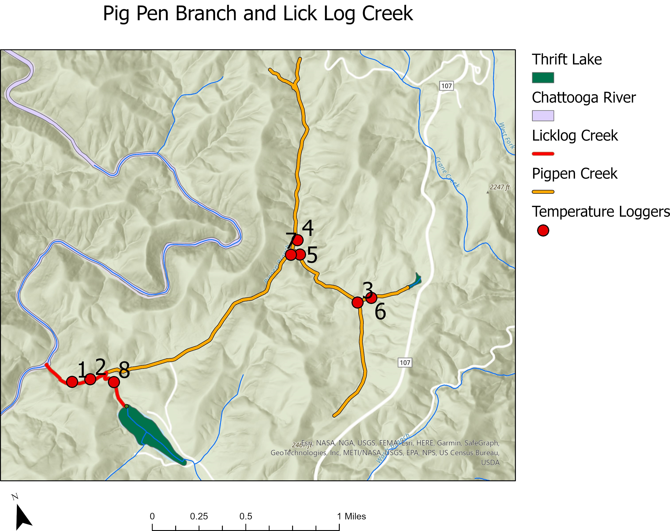

Figure 12. Locations of temperature loggers 1-8, indicated by red dots, on Pig Pen Branch and Lick Log Creek.

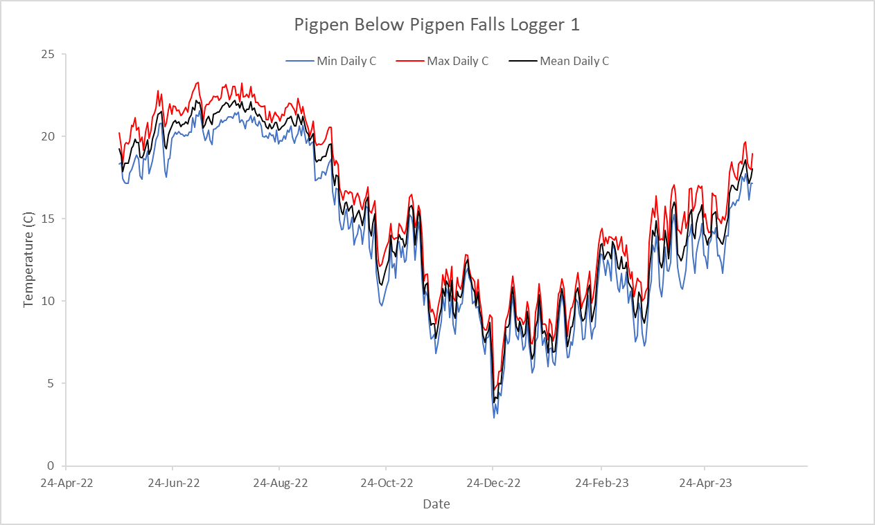
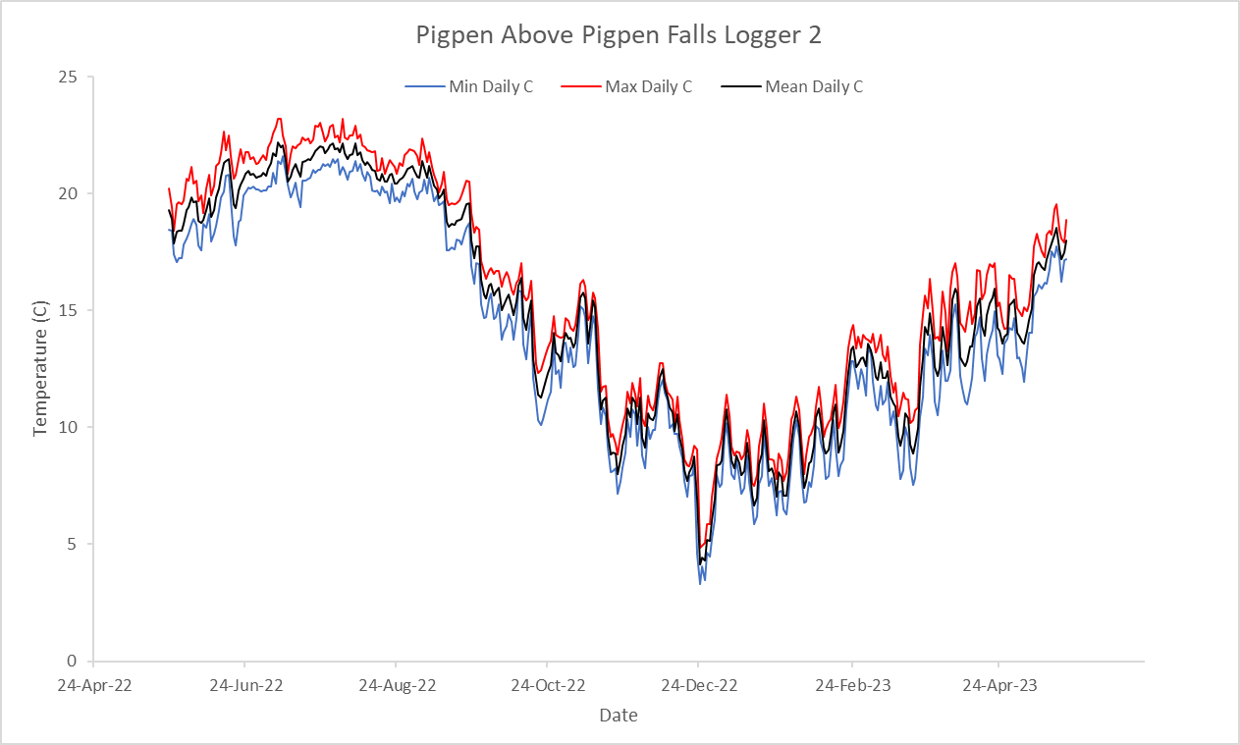
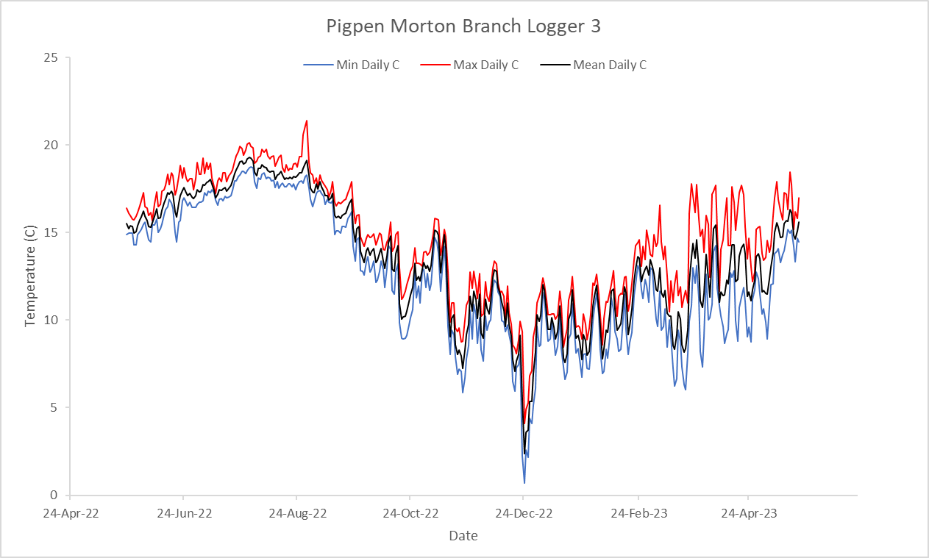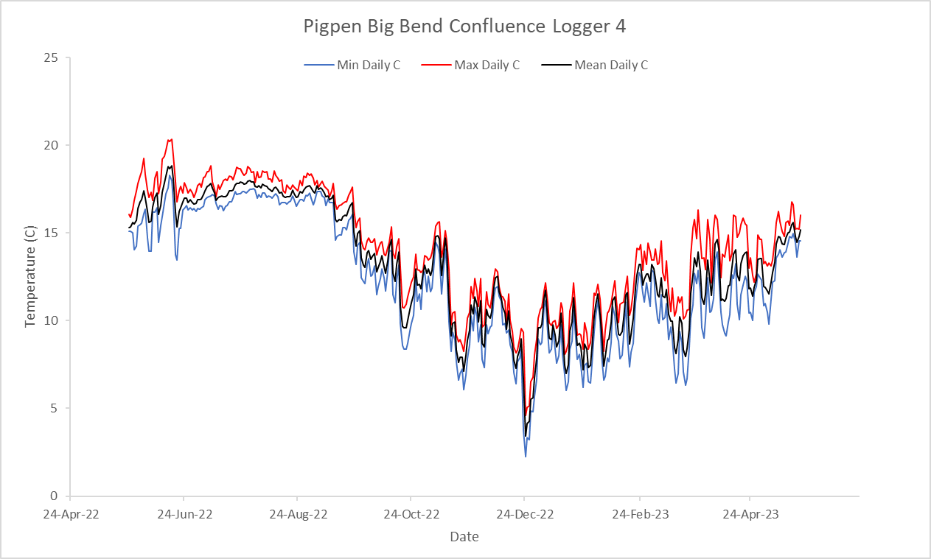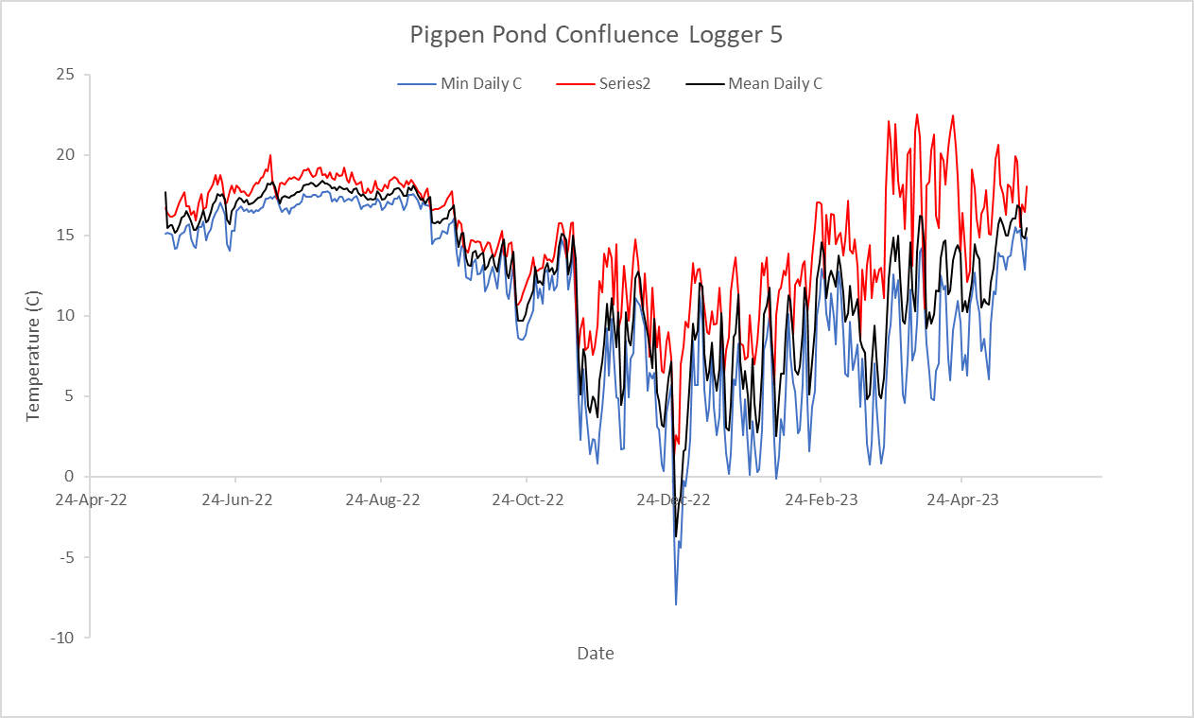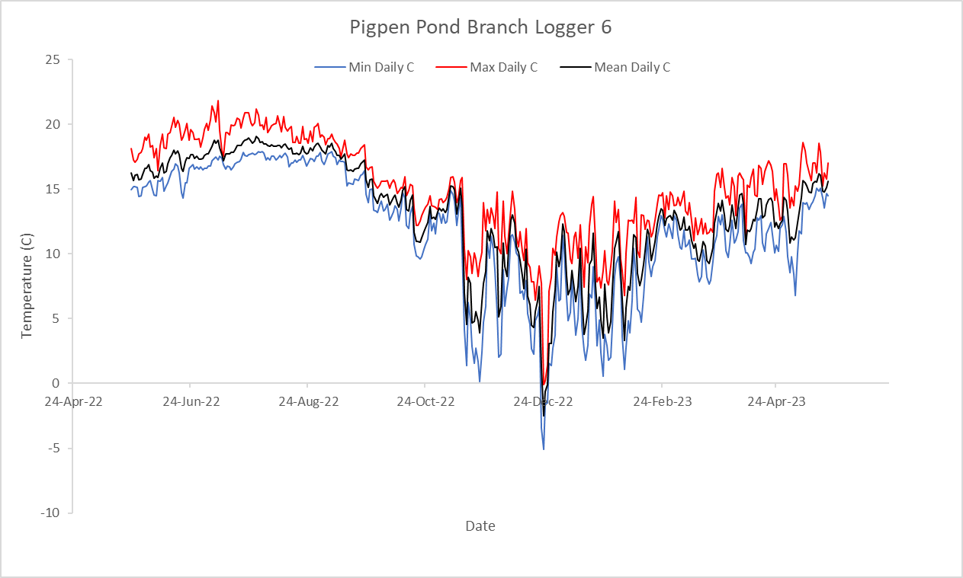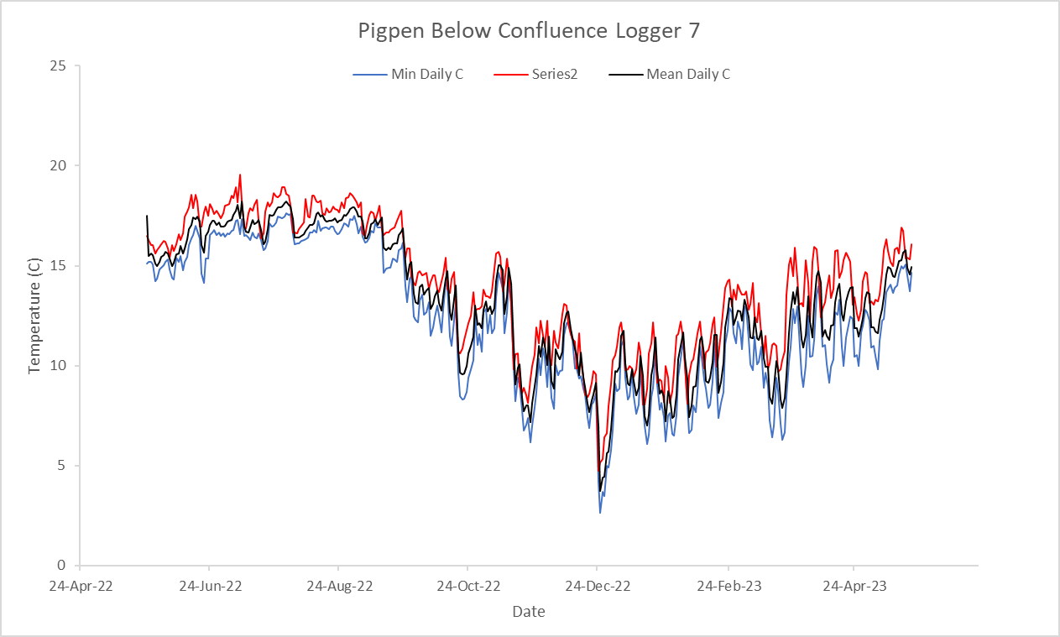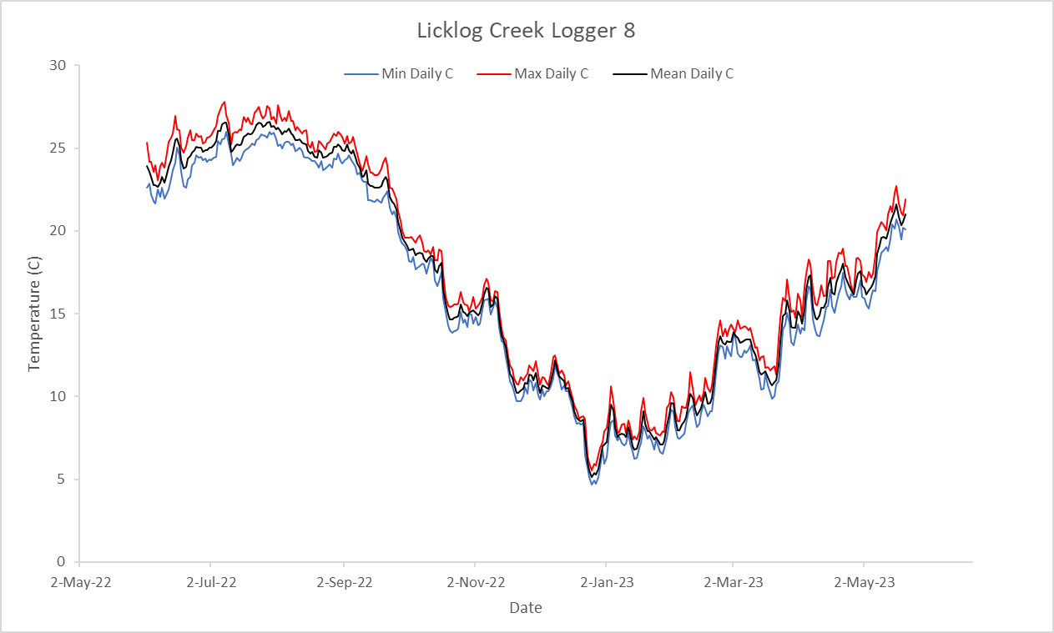
- Logger likely out of water
- Logger likely out of water

Figure 13. Minimum, maximum, and mean daily temperatures in Celsius for eight temperature loggers on Pig Pen Branch and Lick Log Creek.

Bioassays were performed using ten Antimycin units, purchased by TU from NPS, on Creek Chubs to determine Antimycin efficacy. Three 150-gallon tanks sourced with Indian Camp Creek water from the Walhalla State Fish Hatchery ran through a chiller to maintain 15-18 Celsius, a comparable water temperature to that of Pig Pen Branch. Tanks were used to hold Creek Chubs for a 48-hour period for testing. Ten Creek Chubs of varying age classes were collected from Pig Pen Branch and Lick Log Creek and placed into the tanks and held approximately 24 hours prior to treatment. Once fish had become acclimated to the tank, an Antimycin-A stock solution of 45.4 ml (8 ppm) was introduced into the tanks via pipet. Fish mortality and behavior were observed and recorded at 4, 8, or 24 hours. Any fish dead after 4-, 8-, or 24-hour intervals were removed from the tank and total mortalities were recorded. If fish were still alive after the initial 24 hours, an additional stock solution of 8 ppb was added at the 24-hour mark. From the bioassays performed with NPS Antimycin unit’s, results showed high variation of effectiveness in killing Creek Chubs. Some units killed 9 out of 10 Creek Chubs within three to four treatments while other units killed 1 out of 10 Creek Chubs over three to four treatments. Due to high variability between NPS units, an additional 15 Antimycin units were procured through USGS before treatment and tested for effectiveness on Creek Chubs. Results also showed variation between Antimycin units from USGS. Only higher efficacy units were used in the field treatments.
A dye retention study was performed on September 7, 2023, to measure the travel time between stations. One SCDNR staff member put in 100 ml of dye at station 12 and recorded the time in their notes. Another SCDNR employee was positioned at station 9 and recorded the time dye arrived at station 9. The dye took approximately 3:45 minutes to go 1,300 m. The discharge data was used to assist with calculating daily treatment segments and total manpower needed during treatment.

Objective 4
Site Preparation
Stream discharges were gathered daily throughout the treatment period at the treatment stations to calculate the amount of Antimycin needed to maintain 8 ppb for 8 hours during treatment at each station (Table 9 & 10). Additionally, dye retention studies were done pretreatment to determine travel time between established 100 m stations. This data was used to estimate the length of time required for the chemical to travel from one treatment station to the next and to coordinate logistics for the application of chemical at each station.

Table 9. Discharge measurements (ft³/s) for September 10th -15th, 2023 for stations B01, M09, M01, P30, P29, P27, P07, P04, P03, P01, L01, and L02.

Stations | Discharge Measurements (ft³/s)
Stations | 9/10/2023 | 9/11/2023 | 9/12/2023 | 9/13/2023 | 9/14/2023 | 9/15/2023
B01 | 0.38 | 0.22 | 0.22 | 0.24 | . | .
M09 | 0.55 | 0.33 | 0.33 | 0.25 | . | .
M01 | 0.73 | 1.31 | 1.01 | 0.8 | . | .
P30 | . | . | 0.54 | 0.46 | . | .
P29 | 0.5 | 0.68 | . | . | . | .
P27 | . | 1.87 | 2.1 | 1.65 | . | .
P07 | . | . | 2.66 | 2.14 | 2.73 | 2.44
P04 | . | . | 3.24 | 3.83 | . | 5.66
P03 | . | . | . | . | 8.76 | .
P01 | . | . | . | 3.54 | . | .
L01 | . | . | . | 2.13 | 4.57 | 3.12
L02 | . | . | 1.38 | . | . | .
Total | 2.16 | 4.41 | 11.48 | 15.04 | 16.06 | 11.22

Table 10. Discharge measurements (ft³/s) for October 10th -12th, 2023 for stations P08, P06, L01, and P03.

Stations | Discharge Measurements (ft³/s)
Stations | 10/9/2023 | 10/12/2023
P06 | 1.42 | 1.77
P04 | 3.5 | 4.11
L01 | 1.23 | 1.38
Total | 6.15 | 7.26

On September 10th, 2023, at 9:00 am, NPS, USFS, and SCDNR held a pretreatment briefing to discuss treatment locations, job duties, radio training, safety protocols while using Antimycin-A and Potassium Permanganate, and general safety while in the field. One electrofishing pass over the entire reach of Pig Pen Branch and Lick Log Creek was made to collect Creek Chubs, sentry fish, for live cages prior to the initiation of Antimycin. A live cage was set above each treatment site and at confluences with approximately 5-10 Creek Chubs per live cage prior to treatment on September 11th, 2023. A total of 23 live cages were deployed with sentry fish. Additional live cages were set during treatment when new stations were added or moved.
Live cages were evaluated hourly throughout the day (1, 2…,8 hours) and at first light the following morning (~24 hours later) to determine the effectiveness of the previous day’s treatment and if there was a need for additional treatment at each site. Data sheets were provided at every treatment station and daily live cage observations were recorded with the associated date, number of dead fish removed, and other additional comments. Notes on mortality and condition of live fish were kept by observers to guide planning of Antimycin treatments.
Round one of Antimycin treatment began on September 11th, 2023, and concluded on September 16th, 2023. Although 8 ppb concentration over 8 hours (64 exposures) had proven effective to achieve 100% mortality of Brook Trout and Rainbow Trout Oncorhynchus mykiss in all previous projects, that did not hold true for Creek Chubs in Pig Pen Branch (Moore, et al., 2008). Toxicity of Antimycin to Creek Chubs in previous studies (Gilderhus, et al. 1969; Moore, et al. 2008) indicated 100% mortality between 75-80 exposures. Bioassays performed pretreatment revealed it took three to four successive treatments each at 8 ppb for 8 hours to achieve 100% mortality of Creek Chubs. Therefore, on September 11th, 2023, Antimycin was applied at 8 ppb for 8 hours based on mean flow measurements recorded pretreatment and following the protocols outlined by Moore et al. (2005) (Figure 14). Round two of Antimycin treatment began on October 10th, 2023, and concluded on October 12th, 2023. A range of (192-256) exposures (ppb-hours) maximum was needed to attain 100% mortality of Creek Chubs in Pig Pen Branch and Lick Log Creek.

Figure 14. Pig Pen Branch and Lick Log Creek site map including mean discharge measurements (ft³/s) from September and October 2022.

Over the nine days of treatment, a total of 19.4 units of Antimycin were used to treat Pig Pen Branch and Lick Log Creek. This was a12.8-unit difference from our projected 6.6 units treating at 8 ppb twice, based on flow measurements recorded pretreatment in September and October 2022 (Table 11). However, the Pig Pen Branch and Lick Log Creek project was affected by frequent thunderstorms particularly on September 12th and 13th and October 12th causing rising water levels that diluted the Antimycin treatment.

Table 11. Pretreatment Pig Pen Branch and Lick Log Creek calculations based off flow measurements taken in September and October of 2022. Tables include cubic feet per second (cfs) (ft³/s), total milliliters (ml) of Antimycin needed per station each day, total ml of Antimycin needed for each station and for two backpack sprayers for two consecutive treatments, and total units of Antimycin needed for entire project over two days.

 |  | Day-1 |  |  | Day-2 |  |  | TOTAL
Station | Tag | cfs | ml | #_Units | cfs | ml | #_Units | ml | #_Units
7 | P39 | 0.5 | 33 |  | 0.5 | 33 |  | 66
6 | P37 | 0.5 | 33 |  | 0.5 | 33 |  | 66
5 | P31 | 1.0 | 65 |  | 1.0 | 65 |  | 130
10 | B05 | 0.5 | 33 |  | 0.5 | 33 |  | 66
12 | M21 | 0.5 | 33 |  | 0.5 | 33 |  | 66
11 | M16 | 1.0 | 65 |  | 1.0 | 65 |  | 130
9 | M07 | 1.5 | 97 |  | 1.5 | 97 |  | 194
8 | M05 | 1.5 | 97 |  | 1.5 | 97 |  | 194
4 | P25 | 2.5 | 162 |  | 2.5 | 162 |  | 324
3 | P13 | 2.5 | 162 |  | 2.5 | 162 |  | 324
1 | P03 | 6.0 | 390 |  | 6.0 | 390 |  | 780
2 | L03 | 4.0 | 260 |  | 4.0 | 260 |  | 520
 |  |  | 1430 | 3.0 |  | 1430 | 3.0 | 2860.0 | 6.0
 | Sprayer |  | 143 | 0.3 |  | 143 | 0.3 | 286.0 | 0.6
TOTAL |  |  | 1573 | 3.3 |  | 1573 | 3.3 | 3146.0 | 6.6
 |  |  |  |  |  | Treaters + Sprayer (10%) |  |  | TOTAL
DAY-1 Treatment: Set stations 7, 6, 5, 10 ,12, 11, 9, 8 |  |  |  |  |  | = 456ml + 46ml |  |  | = 502ml
DAY-2 Treatment: Repeat DAY-1 |  |  |  |  |  | = 456ml + 46ml |  |  | = 502ml
DAY-3 Treatment: Set stations: 4, 3, 1, 2 |  |  |  |  |  | = 974ml + 98ml |  |  | = 1,072ml
DAY-4 Treatment: Repeat DAY-1 |  |  |  |  |  | = 974ml + 98ml |  |  | = 1,072ml
 |  |  |  |  | TOTAL |  |  |  | 3,148ml
 |  |  |  |  |  |  |  |  | (6.6 units)

Antimycin Treatment: Round One
Round one of Antimycin treatment began at the upstream end of the project area on September 11, 2023, and proceeded downstream treating 2,600-4,400 m stream segments per day until September 16th, 2023 (Table 12).
An Antimycin detox site was established at P01, 175 m upstream on Lick Log Creek to prevent any impacts to non-target fish or insects downstream on the Chattooga River. The detox site was set as close to the barrier (Lick Log falls) as possible given the difficult terrain in that area. Antimycin was detoxified using 4ppm of potassium permanganate (KMnO₄) using the techniques outlined by Moore et al. 2005. Antimycin detoxification was delayed until treatment stations were within 1,200 m (1.2 km) of the detox station. The detox station was started on 9-14-23 (day 4) and ran at 4 ppm for 8 hours to ensure all facets of the station were working properly and that no surplus Antimycin was traveling below the detoxification site (Table 12).

Table 12. Summary of daily Pig Pen Branch and Lick Log Creek Antimycin and Potassium Permanganate application rates and general stream characteristics.

Date | Number of Stations | Total Antimycin (ml) (Treaters) | Total Antimycin (ml) (Sprayer) | Total Antimycin (ml) | Water Temp (ºC) | Maximum Discharge (ft³/sec) | Stream Length Treated (m) | Conc. KMnO₄ (ppm)/ Hours | Total KMnO₄ Applied (g)
9/11/23 | 8 | 488 | 100 | 588 | 16 | 1.0 | 3,000 | 0 | 0
9/12/23 | 8 | 554 | 120 | 674 | 16 | 1.5 | 3,000 | 0 | 0
9/13/23 | 10 | 815 | 150 | 965 | 16 | 2.5 | 2,600 | 0 | 0
9/14/23 | 9 | 1,563 | 260 | 1,823 | 16 | 5.0 | 4,400 | 4 / 8 | 2,040
9/15/23 | 10 | 2,017 | 370 | 2,387 | 16 | 9.0 | 3,800 | 4 / 8 | 3,672
9/16/23 | 6 | 1,269 | 254 | 1,523 | 16 | 6.0 | 2,700 | 4 / 8 | 2,450

Daily total travel distance was closely monitored throughout the project to determine the effective travel distance of Antimycin. Daily notes taken by project leaders regarding treatment and success of treatments follow:
9/11/23 (Monday) – A total of 8 stations treating 3,000 m of stream was conducted this day. Stations 5, 6 and 7 were set on the Big Bend arm of Pig Pen Branch, stations 8, 9, 11, and 12 were set on the Morton Branch arm, and station 10 was set on the Burrell’s Pond arm of Pig Pen Branch. Stations 6, 7, and 8 treated approximately 900 m. Stations 8, 9, 11, and 12 treated approximately 1,500 m. Station 10 treated approximately 600 m. Station 7 had no fish to observe in live cages because they were stationed in a fish absent area above a barrier. Station 7 started at 0830, station 12 started at 0806, and station 10 started at 0851, and ran at 8 ppb for 8 hours. Two sprayers used 50 ml each and operated from station 7 down to the confluence of Pig Pen Branch where Morton Branch and Big Bend Branch split, and from station 12 to station 10 and down to the confluence of Pig Pen Branch.
Station 6 witnessed one dead YOY 6 hours after treatment and one dead adult 7 hours after treatment. Station 5, and 12 saw reduced fright response in Creek Chub. Stations 11, 10, 9, and 8 saw fish become paler in color.
9/12/23 (Tuesday) – All the stations that ran on Monday ran again this day due to live fish in cages. Station 7 started at 0831, station 12 started at 0753, and station 10 started at 0744 and ran at 8 ppb for 8 hours. The sprayers used 60 ml each.
Station 6 (0857): Three adults dead, one alive and active.
Station 5 (0846): Two YOY dead, one sub-adult dead. Two big adults are still lively.
Station 12 (0753): All fish dead.
Station 11 (0905): One adult dead, four alive and active.
Station 10 (0744): All fish dead.
Station 9 (1012): One dead adult, four alive and active.
Station 8 (1103): All fish dead.
Station 6 (1100): Four adult dead, all fish dead.
Station 5 (1325): Two remaining alive, fish are lethargic.
M15 cage (1103): One adult dead in live cage.
Station 11 (1450): One adult alive and active, three lethargic and in poor condition.
9/13/23 (Wednesday) – Stations 11, 9, 8, 6, and 5 ran again on this day. Station 10 was moved 100 m upstream due to the crew seeing one active and lively Creek Chub above this uppermost station. No live cage was set above station 10 so fish status could not be recorded. Four additional treaters were set at B05, B03, M11, and M17. Station 4 began running on this day. Live cages were set up with 5 sentry Creek Chubs in each at all new additional stations, except B05. Ten stations in total were set on Pig Pen Branch at 8 ppb for 8 hours and covered 2,600 m of stream. Station 6 started at 0820, M17 started at 0803, B05 started at 0705. Sprayers used 75 ml each and operated throughout the treatment section.
Station 6 (0820): All fish dead.
Station 5 (0850): All fish dead.
Station 4 (1048): Four fish alive and have loss of color.
M17 (0803): All fish dead.
Station 11 (0855): All fish dead.
M11 (0830): Four dead fish, one alive and active.
Station 9 (0833): Four dead fish, one alive.
Station 8 (1004): All fish dead.
B03 (0825): All fish alive.
Sprayer saw live Creek Chub between station 5 and 6.
M11 (1200): All fish dead.
Station 9 (1431): One fish alive and lethargic.
B03 (1015): One fish dead, one lethargic, three alive and active.
B03 (1135): Two fish dead, three alive and lethargic.
9/14/23 (Thursday) – Station 11, M11, B05, and station 4 ran again this day. Stations were added at M01, P28, P19, and P08. Newly added stations in addition to stations 3, 2, and 1 began running at 8 ppb for 8 hours. Station 11 started at 1025, M01 started at 0914, and B05 started at 1415. Station B10 was added above Burrell’s Pond and started at 0750. Station 11, M11, B10, B05, M01, and P28 had no live cages to check at their stations. Sprayers used 130 ml each and operated throughout the treatment area. Detox station started at 1350 and ran 4ppm for 8-hours.
Station 4 (0853): Four adult fish dead, two fish alive and active.
P16 (1040): Two fish dead, two alive and lethargic.
P21 (1040): Two alive and lethargic.
Station 3 (1146): One fish dead, four alive and active.
P08 (1330): One fish dead.
Station 2 (1340): All fish alive.
Station 1 (1311): Two fish dead, five alive and active.
Station 4 (1642): Two fish alive and lethargic.
Station 3 (1456): One fish dead, two fish alive and active.
P08 (1730): Fish outside of live cage in pools appear lethargic.
Station 2 (1600): One YOY dead.
Station 1 (1710): Four fish dead, one fish alive.
Station 2 (1800): Three dead Bluegill Lepomis macrochirus, one Bluegill alive and lethargic, two YOY Creek Chubs dead, two sub-adult Creek Chubs dead, one adult Creek Chub dead, 10 Creek Chubs alive and pale, one Largemouth Bass Micropterus salmoides alive.
Station 2 (1900): Two dead Bluegill. One YOY Creek Chub dead, one adult Creek Chub dead, 7 Creek Chubs alive and lethargic. One Largemouth Bass alive.

An electrofishing crew surveyed the treatment area to observe fish mortality. Approximately 5-8 Creek Chubs were electrofished 40 m upstream of M10. No fish were shocked from M11 to station 12 or P29 to station 7. Two alive Creek Chubs were recorded downstream of station 8. Approximately 15 alive Creek Chubs were electrofished downstream of station 9 and put in a live cage at station 9. Four Creek Chubs were alive and killed at station 9. One Creek Chub was found above B03, and no fish were observed from B03 to B06.
9/15/23 (Friday) – Station M11 was moved to M07, and station 8 was run again due to fish being caught during electrofishing the day prior. Stations P28, M01, station 4, P19, station 3, P08, station 2, and station 1 were all ran again this day. Ten stations were run at 8 ppb for 8 hours. Station M07 started at 1004. Station M07, station 8, P28, M01, and P19 had no live cage or alive fish to observe. Sprayers used 185 ml each and operated throughout the treatment area. Detox station started at 1300 and ran at 4ppm for 8-hours.
P19 (0915): One alive Creek Chub in shallow water outside of live cage, no flight response, was able to pick it up and kill.
Station 4 (0830): All fish dead.
Station 3 (0830): One fish alive and alert, one lethargic.
P08 (1130): Six fish dead, one fish alive.
Station 2 (1217): Seven Creek Chub alive and lethargic.
L01 (1202): Four fish dead, ten fish alive.
L02 (1305): Four fish dead.
Station 1 (0830): All fish dead.
Station 3 (1040): One fish dead, one fish alive.
P08 (1530): All fish dead.
Station 2 (1700): All fish dead.
L01 (1515): Two fish dead, eight fish alive.
L01 (1701): One fish dead, seven fish alive.
Station 1 (1157): Two fish observed outside of live cage alive in pool above station.
An electrofishing crew surveyed the treatment area to observe the number of live fish in the treatment areas. An electrofishing crew surveyed Pig Pen Branch between station 9 to B03. Approximately 13 alive fish were electrofished between station 9 and Morton Branch and the Burrell’s Pond Branch confluence. No fish were collected upstream of the confluence of Burrell’s Pond and Morton Branch. Live cage at station 9 was checked at 0800 and recorded 3 fish dead and 12 fish alive and lethargic.
9/16/23 (Saturday) - Station 4, P19, station 3, P08, station 2, and station 1 ran again this day at 8 ppm for 8 hours. Station 4 started at 0800. Station 4 and P19 had no live cages to observe due to all sentry fish dying the day prior. Sprayers used 127 ml each and operated throughout the treatment area. Detox station started at 1230 and ran at 4ppm for 8-hours.
Station 3 (1015): All fish dead.
P08 (1107): All fish dead.
L01 (1250): One fish alive.
L02 (1236): Three fish alive.
Station 1 (0830): Observed six fish dead, not in live cage, in pool above station.
P08 (1142): Observed one fish alive and one fish lethargic by station, not in live cage.
Station 1 (1556): Observed medium sized fish alive, not in live cage, by drip station. Also saw two fish alive leaving the station.
After six days of treatment, nearly all Creek Chubs were eliminated from the 5.79 km of Pig Pen Branch and Lick Log Creek. There appeared to be a much higher amount of organic material (woody debris, leaves, and detritus) in the upper reaches of Pig Pen Branch (sites M01-M03, M09-M15 and station 9-P29) than in the downstream areas. The inconsistent stream discharges per day along with the high amounts of fine sediment and particulate organic matter in both the upper and lower reaches of Pig Pen Branch and Lick Log Creek may have weakened the Antimycin, resulting in the need for multiple treatments and longer exposure times.
Average Antimycin exposure to achieve 100% mortality of Creek Chubs in the upper 2.6 km, stations 5-12 of Pig Pen Branch, was 184 exposures (Table 13). Antimycin exposure of 184 exposures was also applied in the lower 3 km, stations M01-P01 of Pig Pen Branch. However, NPS, USFS, and SCDNR still judged that 100% mortality was not achieved after September 16th, 2023, because of a small number of Creek Chubs observed alive in downstream areas, primarily near stations 1 and 2 in Lick Log Creek.

Table 13. Table depicting an estimate of the number of Antimycin exposures each site was exposed to given the Antimycin treatment station placement. Exposures were calculated by multiplying the concentration of Antimycin (ppb) times the exposure time (hr). Note that for Creek Chub from bioassays, 192-256 exposures were adequate to kill all sizes of the target species.

 |  | Number of Antimycin Exposures (ppb x hours of exposure)
 | Day-1 | Day-2 | Day-3 | Day-4 | Day-5 | Day-6 | TOTAL
Station | Exposures | Exposures | Exposures | Exposures | Exposures | Exposures | Exposures
12 | 64 | 64 |  |  |  |  | 128
11 | 64 | 64 | 64 | 64 |  |  | 256
10 | 64 | 64 |  |  |  |  | 128
9 | 64 | 64 | 64 |  |  |  | 192
8 | 64 | 64 | 64 |  | 64 |  | 256
7 | 64 | 64 |  |  |  |  | 128
6 | 64 | 64 | 64 |  |  |  | 192
5 | 64 | 64 | 64 |  |  |  | 192
B10 |  |  | 64 |  |  |  | 64
B05 |  | 64 | 64 |  |  |  | 128
B03 |  | 64 |  |  |  |  | 64
M17 |  |  | 64 |  |  |  | 64
M11 |  |  | 64 | 64 |  |  | 128
M07 |  |  |  |  | 64 |  | 64
M01 |  |  |  | 64 | 64 |  | 128
P28 |  |  |  | 64 | 64 |  | 128
4 |  |  | 64 | 64 | 64 | 64 | 256
P19 |  |  |  | 64 | 64 | 64 | 192
3 |  |  |  | 64 | 64 | 64 | 192
P08 |  |  |  | 64 | 64 | 64 | 192
2 |  |  |  | 64 | 64 | 64 | 192
1 |  |  |  | 64 | 64 | 64 | 192
Detoxification of Antimycin Round One
Antimycin detoxification was delayed until treatment stations were within 1.6 km (1 mile) of the detox station on both Sams and Bear Creek, within the Great Smoky Mountains National Park, and on King Creek, South Carolina (Moore et al. 2005) (Moore and Kulp 2005). Antimycin detoxification on Pig Pen Branch and Lick Log Creek was slightly under previous treatments, starting treatment stations within 1,200 m (1.2 km) of the detox station. The detox station was set up on September 12th, 2023, and started on September 14th, 2023 (day 4) and ran at 4ppm for 8-hours to ensure all facets of the station were working properly and that no surplus Antimycin was traveling below the detoxification site. At 4ppm rate the purple color of the detoxified water was barely recognizable (~100 m) in the Chattooga River. Daily notes taken by project leaders regarding Potassium Permanganate treatment and success of treatments follow:
9/14/23 (Thursday) – One live cage was set before detox with five sentry Creek Chubs.
Detox (1950): Fish appear pale, moderate flight.
9/15/23 (Friday) –
Detox (2000): Three fish dead.
9/16/23 (Saturday) –
Detox (2000): Two fish dead, all fish dead.

Antimycin Treatment Round Two
On the last day of the initial Antimycin treatment (9/16/23), Station-1 observed alive and responsive Creek Chubs in the stream after their 8-hour treatment. Electrofishing crews revisited the project area that following Monday, September 18th, 2023, to follow up on the observed live Creek Chubs found that previous Saturday. Three crews using backpack electrofishing units were split up across the entire reach of Pig Pen Branch and Lick Log Creek to identify treatment efficacy. Crew 1 electrofished above the confluence from tags P29- P41, P29-M19, and M08-B05. Crew 2 electrofished the main stem from tags P08-P29. Crew 3 electrofished Lick Log Creek and the lower reaches of Pig Pen Branch from tags L03-P08 and P01-P06. All crews came back on 9/19/23, 9/29/23, 10/2/23, and 10/3/23 to complete additional electrofishing passes. Four complete passes were made by crews 1 and 2 in the upper and middle reaches of Pig Pen Branch with no fish observed. Crew 3, however, encountered approximately 1-3 Creek Chubs during every electrofishing pass conducted in lower-most portions of Pig Pen Branch and Lick Log Creek. Due to crews encountering live Creek Chubs over multiple shocking days it was determined to proceed with a second round of Antimycin to treat the lower reaches of Pig Pen Branch and Lick Log Creek. SCDNR staff performed flow measurements Monday October 9th, 2023, to determine the amount of Antimycin needed for the first day of treatment. SCDNR and USFS began the second round of Antimycin treatment at tags P08 and L01 on October 10th, 2023, and proceeded downstream treating 900 m of stream per day until the project was completed on October 12th, 2023 (Table 14). After their second round of treatment in lower Pig Pen Branch and Lick Log Creek, it required approximately 376 exposures to eradicate non-native Creek Chubs.
Antimycin detox site was maintained at P01, 175 m upstream on Lick Log Creek to prevent any impacts to non-target fish or insects downstream on the Chattooga River. Antimycin was detoxified using 2-3ppm of Potassium Permanganate (KMnO₄) using the techniques outlined by Moore et al. 2005. The detox station was started on 10/10/23 and ran at 2-3ppm for 8-hours to ensure all facets of the station were working properly and that no surplus Antimycin was traveling below the detoxification site (Table 14).

Table 14. Summary of daily Pig Pen Branch and Lick Log Creek Antimycin and Potassium Permanganate application rates and general stream characteristics.

Date | Number of Stations | Total Antimycin (ml) (Treaters) | Total Antimycin (ml) (Sprayer) | Total Antimycin (ml) | Water Temp (ºC) | Maximum Discharge (ft³/sec) | Stream Length Treated (m) | Conc. KMnO₄ (ppm)/ Hours | Total KMnO₄ Applied (g)
10/10/23 | 4 | 396 | 58 | 454 | 13 | 4.0 | 900 | 2 / 8 | 816
10/11/23 | 4 | 396 | 44 | 440 | 13 | 4.0 | 900 | 3 / 8 | 1,224
10/12/23 | 4 | 429 | 43 | 472 | 13 | 4.5 | 900 | 3 / 8 | 1,377

Daily notes taken by project leaders regarding treatment and success of treatments follow:
10/10/23 (Tuesday) – A total of four stations treating 900 m of stream was conducted this day. Treaters were set up at P08, P06, station 1, and station 2 and ran at 8ppm for 8-hours. No stations had live cages due to lack of sentry fish because of die off from round one Antimycin treatment. Station 2 started at 0745 and station P08 started at 0800. Sprayers used 29 ml each and operated throughout the treatment area. Detox station started at 1000 and ran at 2ppm for 8 hours.
10/11/23 (Wednesday) – All four stations ran again this day at 8ppm for8-hours. Station 2 started at 0740 and P08 started at 0800. Sprayers used 22 ml each and operated throughout the treatment area. Detox station started at 1000 and ran at 3ppm for 8 hours.
10/12/23 (Thursday) – All four stations ran again this day at 8ppm for 8 hours. Thunderstorms from the night before caused water levels to increase. Flow measurements were taken this morning to get accurate Antimycin amounts needed for each station. Station 2 and P08 both started at 1100. Sprayers used 22 ml each and operated throughout the treatment area. Detox station started at 1400 and ran at 3ppm for 8 hours.
After three additional days of treatment, all Creek Chubs were eliminated from the remaining 900 m of Pig Pen Branch and Lick Log Creek. Average Antimycin exposure to achieve 100% mortality of Creek Chubs in lower reaches of Pig Pen Branch and Lick Log Creek, was 184 (1st round) plus 192 (2nd round) for a total of 376 exposures (Table 15).

Table 15. Table depicting an estimate of the number of Antimycin exposures each site was exposed to given the Antimycin treatment station placement. Exposures were calculated by multiplying the concentration of Antimycin (ppb) times the exposure time (hr). Note that for Creek Chub from bioassays, 192-256 exposures were adequate to kill all sizes of the target species.
 | Number of Antimycin Exposures (ppb x hours of exposure)
 | Day-1 | Day-2 | Day-3 | TOTAL
Station | Exposures | Exposures | Exposures | Exposures
P08 | 64 | 64 | 64 | 192
P06 | 64 | 64 | 64 | 192
1 | 64 | 64 | 64 | 192
2 | 64 | 64 | 64 | 192

Detoxification of Antimycin Round Two
Antimycin detoxification began on October 10th, 2023, running at 2 ppm for 8 hours. Detox ran the last two days at 3 ppm for 8 hours to ensure all facets of the station were working properly and that no surplus Antimycin was traveling below the detoxification site. Antimycin detoxification concluded on October 12th, 2023, at 2035. At 2-3 ppm rate, the purple color of the detoxified water was barely recognizable (~100 m) in the Chattooga River. Daily notes taken by project leaders regarding Potassium Permanganate treatment and success of treatments follow:
10/10/23 (Tuesday) – Two live cages were set up below detox within the Chattooga River. Each cage had approximately 15-20 fish compromising the following species: Redeye Bass Micropterus coosae, Redbreast Sunfish Lepomis auratus, Rainbow Trout, Warpaint Shiner Luxilus coccogenis, Longnose Dace Rhinichthys cataractae, Blacknose Dace Rhinichthys atratulus, Rosyside Dace Clinostomus funduloides, Striped Jumprock Moxostoma rupiscartes, and Mottled Sculpin Cottus bairdii. Each cage was checked every hour. All fish in live cages appeared alive and active.
10/11/23 (Wednesday) – All fish in live cages appeared alive and active.
10/12/23 (Thursday) –
Detox (1235): 5 dead in live cage 1.
Detox (1535): 1 dead in live cage 2.
Detox (1735): 1 dead in live cage 1.
Reintroduction
An electrofishing crew followed up after the second round of Antimycin treatment on October 16th and 17th, 2023, and shocked areas P01- P08 and L01-P08 to ensure all Creek Chubs were dead. No Creek Chubs were detected during the two electrofishing passes. Therefore, crews proceeded to stock the offspring (50 Eastern Brook Trout) from the broodstock that was collected pretreatment. The 50 Eastern Brook Trout were backpacked in on November 7th, 2023. Eastern Brook Trout were evenly distributed from tags P25-P30.
Objective 5
SCNDR and Virginia Tech Center for Aquatic Technology Transfer (CATT) conducted in-stream habitat census for the entire length of Pig Pen Branch and Lick Log Creek using the Basin Visual Estimation Technique (BVET) (Dolloff et al. 1993). The BVET survey was performed by crews of two people, one person with a hip chain taking visual observations of stream measurements and categorizing habitat units, by pools, riffles, etc., and another person taking visual estimates of large woody debris (LWD). The crew member taking visual estimates of LWD also recorded data on a tablet using Survey123. A sampling fraction of 10% was established before sampling based off length of stream and desired sampling percentage for habitat types, mainly that of pool habitat. A sampling fraction also helps determine the spacing in between succeeding survey units (Dolloff et al. 1993). A random habitat unit was then chosen at the beginning of the BVET survey and from that habitat unit on, every 10th pool and riffle were surveyed. At these paired habitat unit’s additional measurements were taken including: wetted stream width, habitat unit length, bank full channel width, dominant and subdominant substrata, large woody debris quantity, average and maximum depth, and stream gradient. These paired habitat units also included fishing surveys using one backpack electrofisher. Unlike the habitat survey, which involved visual observations at each habitat unit, the fish survey is limited to a preselected number of habitat units based on the sampling fraction (Dolloff et al. 1993).
The crews surveyed three streams, Pig Pen Branch, an unnamed tributary of Pig Pen Branch (UT), and an unnamed tributary of the unnamed tributary of Pig Pen Branch (UT UT). For all three streams BVET habitat unit data was summarized for pools and riffles as well as large wood abundance (Table 16). Fish survey data was also summarized for each stream (Table 17). Total LWD should range between 80 to 200 pieces per mile, which all streams met. The LWD size 4, which is anything longer the 15 feet long and greater than 19 inches in diameter, should be between 8 to 20 pieces per mile. The main Pig Pen Branch and the UT UT of Pig Pen Branch fall under these criteria. The desired range for the percent pool habitat should be between 30 to 70 percent. BVET data shows all streams lacking pool habitat with 24-26% of the wetted area in pools. The addition of LWD would help in creating pool habitat and add to the size 4 LWD that is lacking in some sections of Pig Pen Branch. Electrofishing surveys also indicated that Eastern Brook Trout were only detected in the stream Pig Pen Branch, while Creek Chubs thrived in almost all streams (Figure 15). This in-stream habitat survey (BVET) was used to determine if future habitat enhancement efforts are needed. From this data both LWD and pool habitat are lacking in Pig Pen Branch indicating habitat enhancement needs to take place after Antimycin treatment is completed.

Table 16. Habitat survey data for all three streams, Pig Pen Branch, unnamed tributary of Pig Pen Branch (UT), and unnamed tributary of unnamed tributary of Pig Pen Branch (UT UT), including miles surveyed, number of pools and riffles, total pool and riffle area (m²), percent (%) pool habitat, total large woody debris abundance per mile, and large woody debris size 4 abundance per mile.

Stream | Miles surveys | # of Pools | # of Riffles | Total Pool Area (m²) | Total Riffle Area (m²) | Percent Pool Habitat | Total LWD Per mile | LWD size 4 per mile
Pig Pen Branch | 3.2 | 114 | 136 | 5218 | 16518 | 24% | 446 | 3
UT Pig Pen Branch | 1.4 | 80 | 66 | 1127 | 3594 | 24% | 200 | 22
UT UT Pig Pen Branch | 0.7 | 44 | 37 | 388 | 1124 | 26% | 154 | 0

Table 17. Electrofishing survey data for all three streams, Pig Pen Branch, unnamed tributary of Pig Pen Branch (UT), and unnamed tributary of unnamed tributary of Pig Pen Branch (UT UT), including number of pools and riffles shocked and percent (%) pools and riffles shocked.

Stream | Number of Pools Shocked | Number of Riffles Shocked | Percent of Pools Shocked | Percent of Riffles Shocked
Pig Pen Branch | 11 | 14 | 10% | 10%
UT Pig Pen Branch | 8 | 7 | 10% | 11%
UT UT Pig Pen Branch | 6 | 5 | 14% | 14%

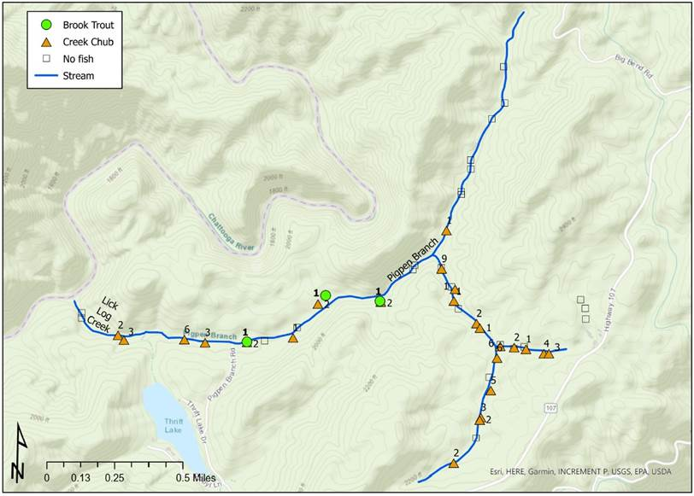

Figure 15. Eastern Brook Trout and Creek Chub distribution map based off fishing BVET surveys on Pig Pen Branch and Lick Log Creek.

USFS and SCDNR are awaiting Eastern Brook Trout establishment in Pig Pen Branch and Lick Log Creek before any habitat enhancement efforts are made. SCDNR will collaborate with the USFS moving forward to enhance habitat by adding LWD.
Significant deviations:
Deviations were made to increase Eastern Brook Trout population size for reintroduction after Antimycin treatment. During restoration efforts, Eastern Brook Trout removed from the study creek were held at Walhalla State Fish Hatchery where hatchery staff spawned the fish to increase the number of Eastern Brook Trout returned to the study creek once restoration efforts were complete. This is an improvement to the original proposed method, which stated that Eastern Brook Trout would be held offsite during Antimycin treatment and reintroduced and supplemented from other creeks, if necessary, after treatment. Hatchery staff spawned 11 unique male/female pairs, collecting 1,530 eggs for rearing in the fall of 2022. In winter of 2023 hatchery staff were able to spawn 5 unique Eastern Brook Trout male/female pairings, collecting 1,348 eggs. From the eggs produced in 2022, 50 Eastern Brook Trout were reared and were able to be used to stock Pig Pen Branch post treatment in November of 2023.
Deviations were also made for stream gradient profiles. Stream gradient was measured using USFS LIDAR data to position Antimycin drip stations no more than 75 feet of elevation apart. This is necessary because Antimycin has been shown to break down after traveling 75 feet of elevation. Prior to Antimycin treatment, SCDNR staff measured stream discharge (ft³/sec) and used these values to calculate how much Antimycin will be required to maintain 8 ppb for 8 hours during treatment at each station. This is a deviation from the proposed 25-meter gradient profiles SCDNR was to perform using clinometers. This alternate approach using LIDAR has been a major improvement to this project by saving time and effort that would have been used to collect on the ground gradients profiles.
Deviations were also made during the Antimycin treatment. Pretreatment calculations predicted two consecutive treatments were needed totaling 6.6 units of Antimycin for the entire project. This was based on a peer-reviewed toxicity test published in the literature, which indicated from 75-80 exposures would kill this species. It actually took between 184-376 exposures to kill all Creek Chubs in this project. This could be related to several variables including: 1) Antimycin-A used was older product and had lost some effectiveness; 2) Pig Pen Branch and Lick Log Creek had large amounts of fine sediment and detritus (fine particulate organic matter); and 3) Creek Chubs are likely more hardy to the chemical than that published in the literature and professional estimation from past efforts. Bioassays conducted prior to field treatment estimated between 128-256 exposures were needed to obtain 100% mortality. Our bioassays appear more accurate than published studies, but still underestimated exposures needed in the field setting.
Estimated Federal Cost:
In cooperation with other federal agencies and NGO’s, the overall costs for the dam removal by agency are as follows: USFWS- $12,500, SC Native Plant Society- $1,500, TU- $23,370 ($12,800 cash, $10,750 in-kind labor), USFS Total = $37,600 ($6,600 dam removal, Antimycin project - $21,000, BVET surveys $10,000), Virginia Tech CATT = $4,000 (Table 18).

Table 18. Total two-year project expenditures.

 | TOTAL 2-YR BUDGET EXPENDITURES
 | FEDERAL | NON-FED (Match)
Personnel TG | $73,168.20 | $40,093.73
Personnel Hourly | 1,769.19 | $18,002.85
Fringes (44%) & (28%) | $33,431.03 | $20,597.12
Indirect (17.35%) | $12,284.90 | $
Total Personal Services | $120,680.32 | $78,693.70
contractual services (inc utilities) | $4,583.79 | $228.51
supplies (inc fuel) | $25,201.64 | $12,340.36
fixed charges (ins) |  | $2,646.00
travel | $3,108.78 | $1,198.54
equipment
Total Operations | $32,894.21 | $16,413.41
Totals | $153,574.53 | $95,107.11
PROJECT TOTAL | $261,481.64

Recommendations: Monitor Eastern Brook Trout and ensure establishment in Pig Pen Branch and Lick Log Creek and proceed with habitat enhancement as needed. Work with USFS to encourage use of a deepwater siphon by Thrift’s Pond landowners to reduce stream temperatures in Lick Lock Creek. All objectives of the grant have been accomplished. We recommend to close this grant. Follow-up surveys and monitoring will be conducted under SCDNR’s Federal Aid Sportfish Restoration Project with USFWS.

Literature Cited:

Barbour, M.T., J. Gerritsen, B.D. Snyder, and J.B. Stribling. 1999. Rapid bioassessment protocols for use in streams and wadeable rivers: periphyton, benthic macroinvertebrates and fish, Second Edition. EPA 841-B-99-002. U.S. EPA; Office of Water; Washington, D.C.

Dolloff, Andrew C., David G. Hankin, and Gordon H. Reeves. 1993. Basinwide Estimation of Habitat and Fish Populations in Streams. Southeastern Forest Experiment Station. General Technical Publication SE-83. United States Forest Service.

English, William R. and Jeremy W. Pike. 2006. Short and Long-term Impacts of Antimycin (Fintrol) on Non-target Organisms Including: Benthic Macroinvertebrates, Crayfish, Salamanders, and Periphyton. A report submitted to SCDNR. 162 pp.

English, William R. and Jeremy W. Pike. 2008. Assessment of the Impacts of the Use of Antimycin on Non-target Aquatic Insects, Crayfish, and Salamanders in the Restoration of Brook Trout to Crane Creek. Study completion report submitted to SCDNR and USFS. 80 pp.
Gilderhus, P.A., B.L. Berger, and R.E. Lennon. 1969. Field trials of antimycin A as a fish toxicant. U.S. Fish and Wildlife Service, Investigations in Fish Control No. 27:1- 21.

Great Smoky Mountains National Park Fishery Management Plan. 1993. Unpublished. Gatlinburg, Tennessee. 48 pgs.

Moore, S.E, M.A. Kulp, B. Rosenlund, J. Brooks, and D. Propst. 2008. A Field Manual for the Use of Antimycin A for Restoration of Native Fish Populations. Natural Resource Report NPS/NRPC/NRR—2008/001. National Park Service, Fort Collins, Colorado. Moore, S.E., M.A. Kulp, J. Hammonds, and B. Rosenlund. 2005. Restoration of Sams Creek and an assessment of Brook Trout restoration methods, Great Smoky Mountains National Park. Technical Report NPS/NRWRD/NRTR-2005/342. Fort Collins, CO. 37 pp.

Moore, S.E., M.A. Kulp. 2005. Native Brook Trout Restoration on King Creek, Sumter National Forest. Great Smoky Mountains National Park. Summary Report.

National Park Service: Management Policies, Management of the National Park System. 1988. 115 pages.

Pregler, K.C., K. Yoichiro, D. Rankin, J.A. Coombs, A.R. Whiteley. Characterizing genetic integrity of rear-edge Trout populations in the southern Appalachians. 2018. 17 pgs.

Rankin, D and Houck, W. 2009. Fisheries Investigations in Lake and Streams- SCDNR Annual Progress Report. F-63-14-1: 184.

South Carolina Department of Natural Resources. 2015. South Carolina’s State Wildlife Action Plan and Supplemental Volume. https://www.dnr.sc.gov/swap/index.html.

South Carolina Department of Natural Resources. 2020. Unpublished data of Fisheries Investigations in Lakes and Streams. Project F-63.

USFWS. Feb. 2017. Chauga Crayfish - Conserving South Carolina’s At-Risk Species: Species facing threats to their survival. chauga crayfish fact sheet_SC_2017.pub (fws.gov)

US Geological Survey. 2000. Revised protocols for sampling algal, invertebrate, and fish communities as part of the national water quality assessment program.

Whalen, James K. 2021. Personal communication. USFS Fishery Biologist, Francis Marion and Sumter National Forest.

Prepared by: Hailey Goyette Title: Fisheries Biologist
Dan Rankin Title: Fisheries Coordinator

