I. COVER PAGE

A. General Information

Project Title:
‘Chop and Drop’ in the Sunday River, Maine:

A NFHAP project for an EBTJV intact status subwatershed

Amount of NFHAP funding requested: $39,445.00

Project Location: Riley Twp., Oxford County, Maine

Congressional District: Maine, District 2

Applicant Organization:

Androscoggin River Watershed Council
PO Box 1541
Bethel, ME 04217
Project Officer: Fergus Lea
Phone: (207) 783-9186
Email: flea@avcog.org

Date Submitted: October 12, 2006

B. Sponsoring Fish and Wildlife Service Fisheries Office

U.S. Fish and Wildlife Service
Craig Brook National Fish Hatchery
East Orland, ME 04431
Project Officer: Scott Craig
(207) 469-7300 (ext. 226)
(207) 469-6725 Fax
scott_craig@fws.gov
II. EXECUTIVE SUMMARY

A. Purpose and Content

PROJECT SUMMARY

Field priority: To be provided by FWS sponsoring office

Title of the project:

‘Chop and Drop’ in the Sunday River, Maine: A NFHAP project for an EBTJV intact status subwatershed

Proposed accomplishment:

More gradual runoff, increased pool frequency to provide adult brook trout habitat, and more productive habitat resulting from the trapping of allochthonous organic matter.

Description:

Importance of the project to the resource:
The addition of woody debris to low order streams will benefit lotic brook trout populations by maintaining adequate flows throughout drought periods, by reducing downstream destabilization resulting from high peak flows and excessive inputs of sediment, and by enhancing brook trout habitat within the treatment reach.

Problem and specific cause of the problem:
Brook trout habitat in the Sunday River drainage has been degraded by poor land use practices, including timber harvesting, log driving, farming, and commercial and recreational development. Much of the river and its tributaries are unstable, over-widened, and lacking in deep pools, thereby reducing nursery and adult brook trout habitat.

Objective of the project with reference to the problem:
Although degradation is being addressed through a comprehensive watershed survey and main-stem restoration effort, the causal problem of accelerated runoff has not been addressed. This proposal will assess the efficacy of adding woody debris to reduce peak flows, create pools, and trap organics to enrich depauperate headwater streams.

Method applied to accomplish the objective:
A half-mile-long treatment reach of each of two tributaries will receive woody debris. These tributaries and a nearby control tributary will be monitored identically for geomorphic, chemical, biological, and flow responses.

Additional information pertinent to adequately describe the importance and/or urgency of completing the project:

The riparian forest stands of the upper Sunday River, typical of western Maine watersheds, are immature and are not recruiting large woody debris to the streams or floodplains. Large woody debris counts at the proposed treatment sites are fewer than 25 per mile, compared to historic wood counts of 150-500 per mile in undisturbed stands. The lack of wood increases sediment transport, flashiness of flows, drought flows in summer, and over winter mortality of brook trout. By adding large woody debris to a more natural loading, the streams will collect sediments and organics, create pool and spawning habitat, reduce flash flooding, and stabilize and connect the channels and their associated floodplains.

Each treatment site will be one half mile long. Wood loads will be increased to a more historic amount. Actual loads will be determined based on the availability of the riparian stands. Monitoring will occur in the lower portion of the treated sites. If this project is successful, the technique will be expanded to other tributaries within the drainage to moderate runoff and enhance brook trout habitat. Moderated flows will also enhance the probability of success for stabilization projects in downstream, higher-order reaches.

Fish passage barriers to be removed by this project: None.

Funding Information:

Fund | Year |  |  |  |  | Total
Fund | 1 | 2 | 3 |  |  | Total
NFHAP | $22,769 | $8,338 | $8,338 |  |  | $39.445.00

What is the estimated duration of the project?

Three years of monitoring is planned to account for annual flow variability.

Record anticipated first year partner contributions:

Partner | Cash Matching | In Kind
Eastern Brook Trout Joint Venture | $22,769.00
Maine Dept. of Inland Fisheries & Wildlife |  | $6,000.00
Maine Dept. of Transportation | $255,000.00
Maine Dept. of Environmental Protection |  | $400.00
Total: | $277,769.00 | $6,400.00

Record anticipated new FTEs (information provided by Fish and Wildlife Service sponsoring office): none

Record Congressional District: Maine, District #2
III. PROJECT DESCRIPTION, SCOPE OF WORK, AND PARTNER INFORMATION

A. Project Description and Scope of Work
Project need:
At the request of the Sunday River Watershed Interest Group, which was concerned about high peak flows resulting in property damage, three comprehensive studies were conducted on the Sunday River:
- The Maine Department of Inland Fisheries and Wildlife conducted a biological survey of the Sunday River in 1998 to address concerns about frequent flooding and channel migration. The survey revealed, in part, that much of the river is unstable and over widened. Degradation is attributed to a variety of land uses, including timber harvest, log drives, farming, and commercial and residential development. All of the six sites evaluated in the lower 9.2 miles of the river received a ‘poor’ rating for channel stability.

- In 2002, the Oxford County Soil & Water Conservation District, the Sunday River Watershed Interest Group, and the Maine Department of Environmental Protection conducted a watershed survey of the upper (western) portion of the drainage. Surveyors documented a total of 178 erosion sites and began cooperative efforts to reduce erosion from these sites.

- In 2003, Parish Geomorphic and Kleinschmidt Energy & Water Resource Consultants conducted a geomorphic assessment of the Sunday River, confirming the earlier assessment and including results of the watershed survey. This study found, in part, that “(h)igh flows develop very quickly and move very rapidly through the watershed in response to significant rainfall.” They concluded that land use changes exacerbated the flashy nature of the drainage, and that “(f)or a basin with sharply peaked hydrographs, any wetland feature that provides flow attenuation or storage is probably significant [emphasis added].” They also noted that “(a)s the impacts to the lower reaches are an accumulation of upstream impacts, numerous small scale projects may lead to greater stability downstream [emphasis added]. Based on the results of this work, any restoration work should be aimed at controlling sediment input at the upper end of the watershed and maintain[ing] tributaries and controlling runoff from the headwaters through better conveyance systems or storage Best Management Practices.”

Purpose, goals, and objectives:
Based on this assessment, we are proposing to evaluate the efficacy of adding large woody debris to low order streams to attenuate flows, recognizing that, if this experiment proves successful, additional sites will need to be treated to achieve basin-wide flow moderation. We also anticipate that pool creation and nutrient-trapping will enhance brook trout habitat in the immediate treatment area as well as downstream.

Work to be performed by:
The Androscoggin River Watershed Council (ARWC) will administer the project and contract with local providers for final project design and implementation. The ‘chop and drop’ procedure will add significant quantities of large woody debris to two half-mile long sections of two Sunday River tributaries. ARWC will also administer the monitoring and evaluation of most physical responses on the treatment and control streams. The Maine Department of Inland Fisheries and Wildlife (MDIFW) will procure all necessary environmental permits and monitor fish and flow responses in conjunction with the project. The Maine Department of Environmental Protection (MDEP) will monitor macroinvertebrate responses to the project. The Maine Department of Transportation (MDOT) is implementing the restoration plan for another Sunday River tributary at Barker Brook. The overall work scope of these projects will restore and enhance brook trout habitat of a ~33,000 acre subwatershed, the Sunday River.

Landowner:
The Maine Department of Conservation, Bureau of Public Lands is the landowner and is granting access to all sites for the duration of the project.

Duration of benefits:

The project area is publicly owned by Maine and protected from development in perpetuity.

Expected results:
We expect the woody debris enhancements to reduce peak flows, create pools, and trap organics that will enrich depauperate headwater streams. Monitoring will be conducted annually on both treatment and reference reaches for a period of three years. Geomorphic monitoring will consist of longitudinal profiles; flow monitoring will consist of water level loggers and instantaneous staff gages; biological monitoring will consist of invertebrate and fish sampling to compare species relative abundance and brook trout condition.

Timetable for accomplishment of major activities:
Final project design, implementation and the initiation of monitoring protocols will be completed by October 2007. Annual reports for all project aspects will be completed by December of each year. Final project evaluation and monitoring reports will be completed by May 2010.

B. Partner Information
Letters of support or commitment from partners can be provided upon request.
Organization | Affiliation | Category | Role(s) | Contribution
Maine Department Of Transportation | Partner | State Agency | Restoration Design and Implementation of other tributary – Barker Brook | Financial
Maine Department of Inland Fisheries and Wildlife | Partner | State Agency | Fishery Monitoring for 3 years | Services in-kind,  Project administration
Maine Department of Conservation, Bureau of Public Lands | Public Landowner | State Agency | Access and Site Oversight | Site access and oversight (in-kind)
Maine Department of Environmental Protection | Partner | State Agency | Macroinvertebrate Monitoring | Contracted and services in-kind
Androscoggin River Watershed Council | Partner | Local Conservation Group | Project Administration  Contract services | Grant, project and contract administration
Trout Unlimited | Supporter | Conservation Group (National) | Monitoring assistance | Volunteer Services (in-kind)
Sunday River Ski Area | Supporter | Corporation | none | support
Town of Newry | Supporter | Local Government | none | support

- Partners contributing more than NFHAP request: 1 – Maine Department of Transportation contributing $255,000 for restoration of Sunday River watershed at Barker Brook.
- Ratio of partner contribution of total project cost to grant request: ~7:1 ($273,400:$39,445)
- Spatial benefit of the grant request: This project will enhance 1 mile of stream within a ~33,000 acre subwatershed.
- Number of partner categories: 5

IV. MAP OF PROJECT AREA

Treatment Sites Control Sites
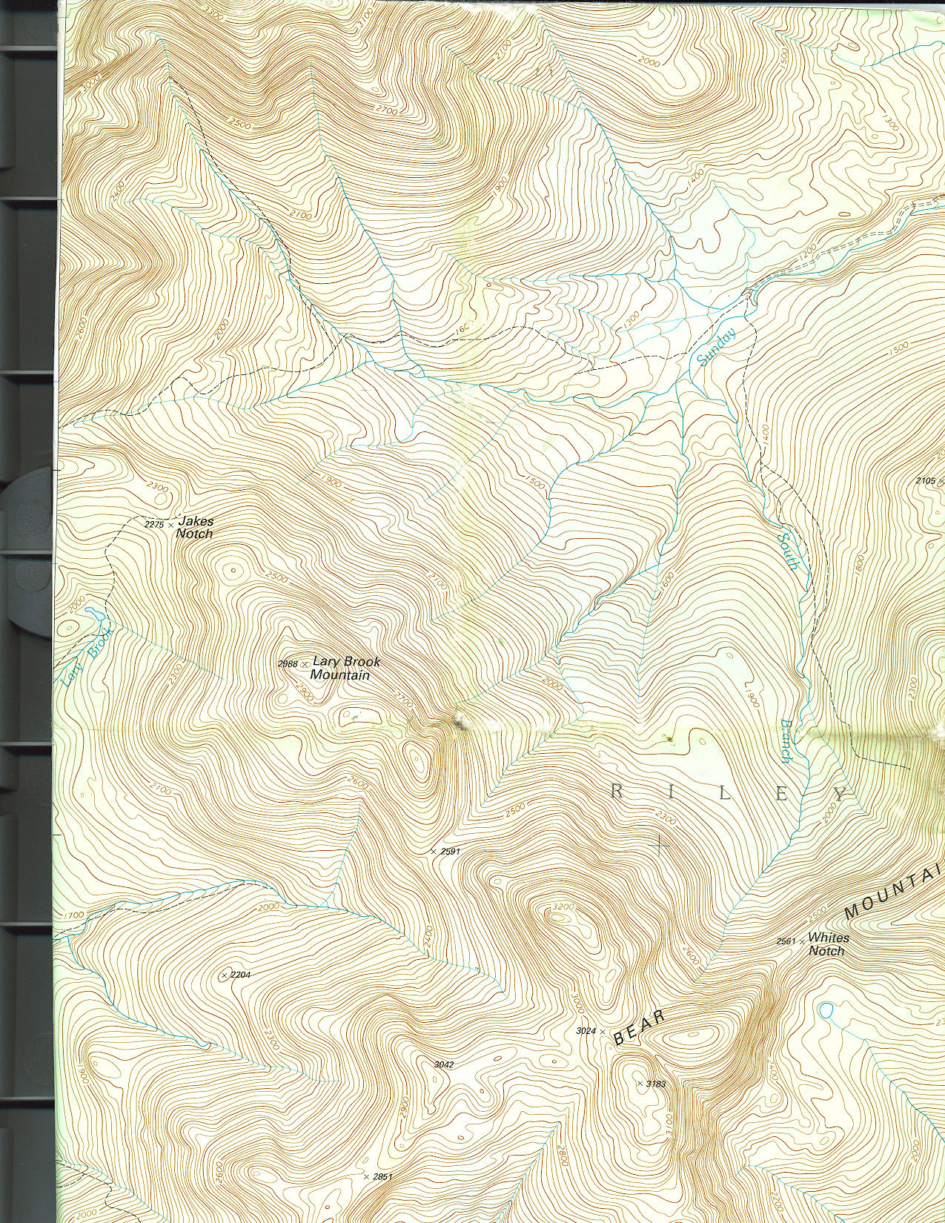

Control
Site # 2

Site # 1

Note: Center point of project is at 44.4822° Lat / -70.9692° Long (WGS84 decimal degrees)
UTM NAD 83: Zone 19 343408E / 927313N

HUC8 watershed is 01040002 HUC10 Name: Androscoggin River (2) at Rumford Point BKT lotic status is ‘Present: Intact Large’

V. PHOTOGRAPHS OF THE PROJECT AREA

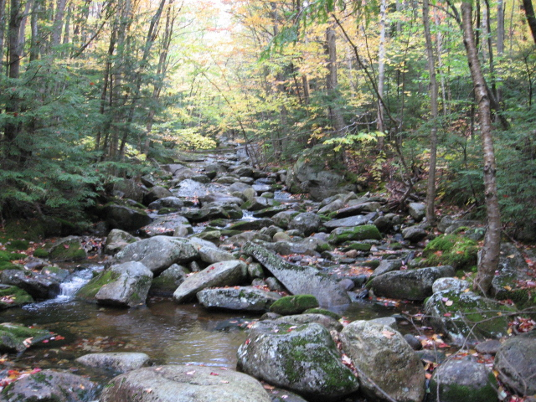

#1

Treatment site # 1, unnamed tributary to Sunday River
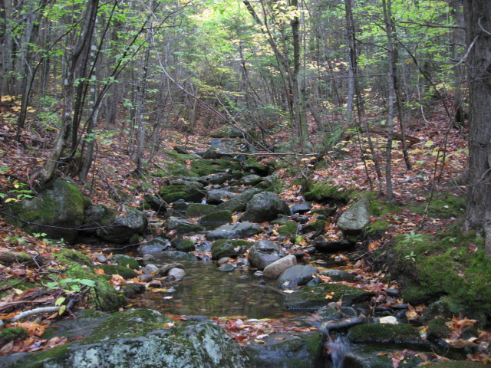

Control

Control site, unnamed tributary to the Sunday River
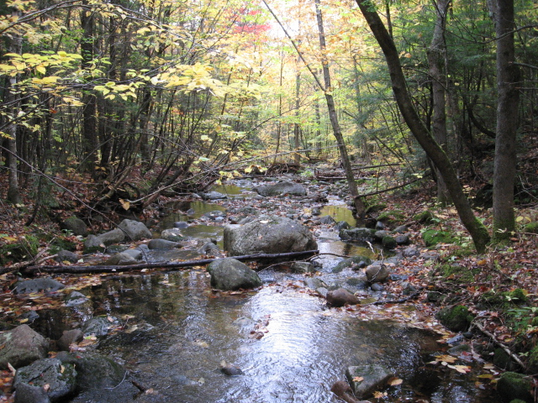

2

Treatment site No. 2, unnamed tributary to the Sunday River.

VI. PROJECT BUDGET

Values in BOLD are NFHAP/EBTJV requests
Budget Item | Partner | Year 1 | Year 2 | Year 3 | Total | Description/Activity
Overall project coordination | ARWC | 3,029 | 1,738 | 1,738 | $6,505 | Oversee project implementation, monitoring, fees, equip rental, and reporting.
Site selection | ARWC | 1,080 |  |  | $1,080.00 | Choose and mark treatment and control sites.
Addition of large woody debris | ARWC | 9040 |  |  | $9,040.00 | “Chop and drop” trees across two ½ mile reaches of stream.
Topographic surveying | ARWC | 2040 | 2040 | 2040 | $6,120.00 | Cross sections and longitudinal profiles at project and control reach; data analysis
Substrate particle size analysis | ARWC | 1900 | 1900 | 1900 | $5,700.00 | 6 pebble counts at each study site; data analysis
Oriented ground photography | ARWC | 660 | 660 | 660 | $1,980.00 | GPS photo sites, location map with linked ground photos, data analysis
Surficial mapping | ARWC | 1020 |  |  | $1,020.00 | Mapping of physical features, GIS entry, data analysis
Macroinvertebrate sampling and analysis | MDEP | 1600  400 | 2000 | 2000 | $5,600.00  $400.00 | 3 colonizing “rockbags” per station (control and 2 treatment reaches), taxonomic identification and report
Flow loggers and gages | MDIFW | 2400 |  |  | $2,400.00 | 1 flow logger per station (control and 2 treatment reaches)
Fish Monitoring | MDIFW | 6000 | 6000 | 6000 | $18,000 | Annual electrofishing of 2 sites per treatment and control sites for 3 years
Restoration of Barker Brook | MDOT | 255,000 |  |  | $255,000 | Implementation of restoration plan for Barker Brook, Sunday River watershed
Total: Requested  Contributed |  | $22,769  $261,400 | $8,338  $6,000 | $8,338  $6,000 | $39,445  $273,400
ARWC = Androscoggin River Watershed Council
MDEP = Maine Department of Environmental Protection
MDIFW = Maine Department of Inland Fisheries and Wildlife
MDOT = Maine Department of Transportation

VII. EVALUATION

A. Conservation of Sustainable Brook Trout Populations:

By virtue of their inclusion within Maine Public Reserve Land, managed by Bureau of Parks and Lands, Maine Department of Conservation, the proposed study stream reaches belong to the citizens of Maine, are accessible to the public, and are protected from development. The project addresses the following Problem identified in Maine’s Brook Trout Species Plan: “Environmental degradation from stream-side cutting, development, and pesticide/herbicide application threaten some stream fisheries.” (Bonney 2001) The associated Strategy calls for “Continue[d] cooperation with other state and federal agencies charged with evaluating and enforcing these areas of degradation… [and to] Inform the public and encourage interest and participation in addressing these issues.” (ibid.)

B. Endangered Species: N/A

D [sic]. Economically important species not also listed as threatened and endangered species: N/A

E. Special Considerations: The Maine Department of Transportation has scheduled a restoration project for another Sunday River tributary, Barker Brook, for 2007. It is advantageous to complete the ‘chop and drop’ woody debris enhancements to the upper tributaries in conjunction with the Barker Brook restoration. By coupling these projects we can greatly enhance our watershed monitoring and project evaluation aspects of these projects. In addition, implementing both projects in the same year will reduce the overall timeframe of watershed disturbance.

F. EBTJV Habitat Restoration Priority: unknown

G. Habitat Connectivity and Enhancing Population Mobility: There are no currently known barriers to fish passage in the Sunday River subwatershed. This system is somewhat unique in that resident wild brook trout have free access to all parts of the watershed. Previous obstructions due to logging practices have been breeched or removed. However, overall habitat quality for adult trout is still compromised because of past degradative land-use practices. This project proposes to enhance existing habitat for trout by restoring natural hydrologic processes to the system.

H. MANAGEMENT ASSETS:

Monitoring will be conducted annually on both treatment and reference reaches for a period of three years. Geomorphic monitoring will consist of longitudinal profiles; flow monitoring will consist of water level loggers and instantaneous staff gages; biological monitoring will consist of invertebrate and fish sampling following MDIFW and MDEP standard protocols. The area will be accessible to public fishing without extraneous fee, but sterile, high elevation, streams seldom produce brook trout of legal size (6 inches). Instead, they are believed to serve as “feeder streams” from which brook trout migrate into more productive habitat where growth rates increase and they may attain legal size.

This study will also be used as a demonstration project that documents the success of the addition of large woody debris to enhance brook trout habitat. Findings will be shared with the EBTJV, other state and federal agencies, anglers, and with attendees of local, state, and regional water-related conferences. These findings will contribute to the knowledge of watershed management, and will be shared with those interested in streams and brook trout fisheries through personal interactions with the public, newspapers articles, and relevant newsletters.

An ad hoc subgroup of the Androscoggin River Watershed Council.

