Culvert replacement and instream habitat restoration on Indian Stream, NH in conjunction with the NFHAP and NH’s EBTJV Strategy

Project Location: New Hampshire, Coos County, Pittsburg
- Congressional District: 2
EBTJV / NFHAP Funding Requested: $50,000
- Total Project Cost: $175,000
- Total Federal Matching: $50,000
- Total Non-Federal Matching: $125,000
- Type of Project: In-stream habitat, Fish passage

APPLICANT
Organization: Trout Unlimited
Project Officer: Joe Norton
Street: 97 Main, Suite 106
City, State, Zip: Lancaster, NH 03584
Telephone Number: 603-788-3147
Fax Number: 603-788-3147
EMail Address: JNorton@tu.org

Sponsoring Fish and Wildlife Service Fisheries Office
Fish and Wildlife Service Office: Central New England Fishery Resources Office
- Project Officer: Joe McKeon
Street: 151 Broad Street
City, State, Zip: Nashua, NH 03063
- Telephone Number: (603) 595-3586
Fax Number: (603) 595-3586
EMail Address: Joe_McKeon@fws.gov

Date Submitted: 10.01.2009
I. PROJECT DESCRIPTION, SCOPE OF WORK, AND PARTNER INFORMATION

- Project Description and Scope of Work (not to exceed 500 words)

Culvert Replacement and Woody Habitat Restoration:
In 2006, an initial watershed-based assessment of coldwater habitat conditions was completed by Trout Unlimited (TU) in the Upper Connecticut (UC) in New Hampshire and Vermont. In 2008, TU designated the UC as one of its Home Rivers Initiatives (HRI), the only one in New England. TU’s HRI covers over 700 sq. mi from Murphy Dam at Lake Francis to the mouth of the Upper Ammonoosuc, including 19 tributaries. TU’s assessment identified fish habitat problems throughout the watershed, including lack of riparian habitat, poor instream habitat diversity and complexity, and inadequate stream crossings. All these impacts greatly limit available fish habitat for all life stages of Eastern brook trout.

Indian Stream, the northern most tributary in TU’s project area, is the second largest (70.8 sq. mi.) with the largest baseflow. The watershed still suffers from logging damage inflicted from the late 1800’s through the 1980’s. As a result, the river runs too wide and shallow with few pools, scours during runoff, becomes turbid with rainfall, contains little habitat complexity, and has temperature concerns. The watershed is now well-forested, but trees are set back from the stream, with mature trees not yet contributing woody material to the channels. Little riparian buffer exists in the lower agricultural reaches, with livestock free to move within the channels. Based on fish, habitat, and culvert surveys conducted by TU and NH Department of Fish and Game (NHFG) in 2009, the tributary nursery streams have cold water with very good fish productivity and overall good to excellent fish habitat conditions, but culverts greatly limit access to them, and necessary spawning migrations are curtailed. The stream’s geology is metamorphic and unique to NH, with better buffering conditions than many other UC tributaries. Indian Stream is also unique in that a large landowner, The Forestland Group, owns a majority of the watershed. The stream has strong state conservation easements already in place. For these reasons, TU has identified Indian Stream as a high priority tributary where restoration will provide strong ecological benefits to Eastern brook trout and the UC watershed.

Based on the above mentioned surveys, TU will initiate the first phase of a long-term culvert removal and instream habitat program by replacing four high priority culverts and initiating instream woody habitat restorations in Indian Stream, starting on the East Branch. The culverts are on four important nursery streams, Dry Creek, Johns Brook, Hidden Brook and Alder Brook, and each culvert greatly impacts instream habitat. Additionally, the culverts on Dry and Johns are also fish passage barriers. TU expects culvert design and engineering to take place in 2010 and construction in 2011. Instream habitat restoration will be conducted using the “Chop & Drop” method on three miles of Indian Stream’s largest tributary, the East Branch. Chop and Drop will be implemented during the 2010 field season with follow up in 2011. Chop and Drop assessments and procedures will be conducted by skilled consultants and NHFG fisheries biologists.

- Partner Information (not to exceed 100 words)
Project Partners
Partner Name | Contribution  In-Kind | Contribution  Cash | Federal or Non- Federal | Partner  Category | Role of Partner
NH Fish & Game Dept.* | 7,000  11,000 |  | N  F | State | Major Partner- in all projects and decisions
NH TU Chapters | 2,000 |  | N | Non-Profit | Volunteer Assistance
NH Dept. of Resources & Economic Development | 5,000 |  | N | State | Road system owner & Conservation easement holder
Eckerd School | 5,000 |  | N | Youth | Riparian plantings
Elm Research Institute | 10,000 |  | N | Non-Profit | Provides trees for plantings
The Forestland Group | 20,000 |  |  | Corporation | Provides trees for chop and drop
Total In-Kind | 61,000
*In-kind work supported by both federal and non-federal funds.

5 Year Indian Stream Project Timeline
Field Season | 2009 | 2010 | 2011 | 2012 | 2013
Task
Watershed sampling-Annual | Initiated Yearly→
Riparian habitat plantings-Annual | Initiated Yearly→
Culvert assessment & prioritization | 95% Complete | Complete  Yearly visual assessments→
Geomorphic habitat assessment | Mainstem -E.Branch to mouth-Start | Complete
Aerial survey | Fall 2009
Culvert design and engineering |  | Alder, Hidden, Johns Brooks; Dry Creek | 2-4 Culverts-TBD | 2-4 Culverts-TBD | 3-5 Culverts-TBD
Culvert construction |  |  | Alder, Hidden, Johns, Dry | 2-4 Culverts-TBD | 2-4 Culverts-TBD
Tributary habitat  projects |  | E.Branch.  Start chop & drop | E.Branch.  Finish chop & drop | M.Branch. Start chop & drop | M.Branch  Continue chop &drop
Mainstem habitat  projects |  |  | Apply for grants | Project design | Project construction
Annual Watershed Sampling-Temperature loggers were installed in 14 locations throughout the Indian Stream Watershed. Water chemistry samples were taken. Tributaries were electrofished in select areas and above/below culverts. Data was collected on all species present. Tributaries where recent washouts occurred were walked to assess and document the changes. Yearly watershed sampling will be conducted throughout the life of the HRI.
2 Culvert Assessment & Prioritization-Culverts were assessed according to NHFG protocol. Culverts were ranked according to need. Data will be entered in the NH database.

II. MAP OF PROJECT AREA (attached)

III. PHOTOGRAPH(S) OF PROJECT AREA (no more than 2, please provide credits and attach photo release forms) Joe Norton-Photos
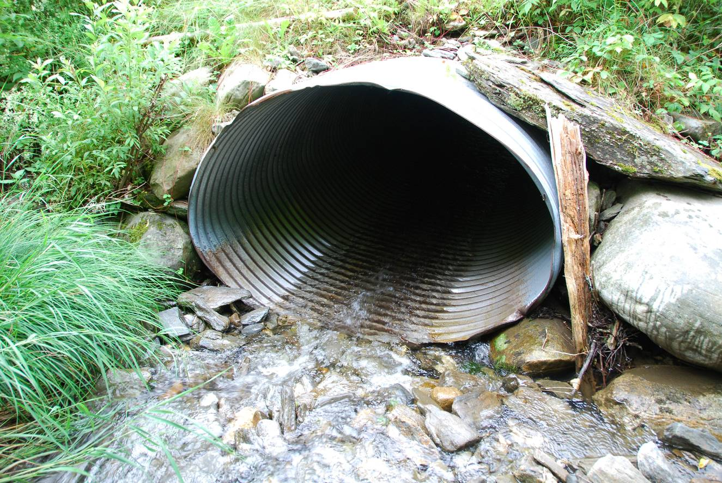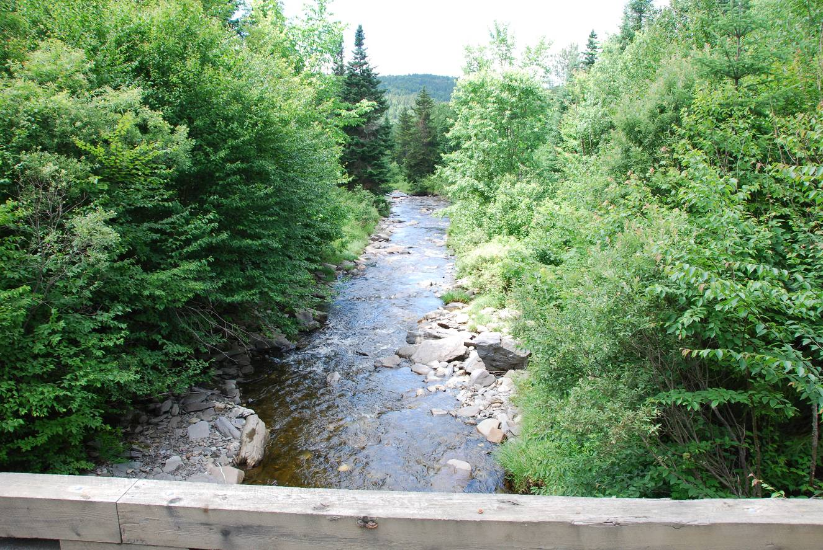

IV. PROJECT BUDGET

Indian Stream 2 Year Project Budget
Revenue | 2010 | 2011 | Totals
EBTJV | 50,000 |  | 50,000
UCMEF | 125,000 |  | 125,000
Other Contributors
Total Revenue | 175,000 |  | 175,000
Expenses | 2010 | 2011
Chop & Drop  (consultant contractor) | 36,000 |  | 36,000
Culvert Design & Engineering  (consultant) | 50,000 |  | 50,000
Culvert Construction  (contractor) |  | 50,000* | 50,000
Salaries & Related Expenses 26%B,10 %O | 13,600 | 13,600 | 27,200
Equipment | 4,000 | 2,000 | 6,000
Travel & Monitoring | 3,000 | 3,000 | 6,000
Total Expenses: | 106,600 | 68,600 | 175,280
*Other funding required for construction. These funds can replace two culverts,
or will be leveraged with additional funds to replace all four culverts listed.

B. Budget Table

Partner | Activity | NFHAP Request | Non-Fed. Contribution | Federal Contribution | Total | Acres/ miles  Affected
EBTJV | Woody habitat E.Branch | 18,000 (50%)
UCMEF | Woody habitat-E.Branch |  | 18,000 (50%) |  | 36,000 | 3
EBTJV | Culvert Design | 4,000 (9%)
UCMEF | Culvert Design |  | 46,000 (91%) |  | 50,000
EBTJV | Culvert Construction | 18,000 (36%)
UCMEF |  |  | 27,000 (54%) |  | 50,000 | 5

V. EVALUATION QUESTIONS (4 pages maximum)

- Conservation of Sustainable Brook Trout Populations:
- Explain how the project sufficiently protects brook trout habitat. Does the project include fee simple land purchase or easements?
  - Indian Stream (70.8 sq. mi.) is the second largest watershed in the Upper Connecticut. Most of the culverts on Indian Stream culverts create fish habitat issues for Eastern brook trout. The culverts selected for work rate as high priorities due to their potential for failure or because they are a migration barrier, or both. Failed culverts will cause the direct loss of habitat for all aquatic species from sedimentation. By replacing the culverts with severe “problem potential”, TU’s project will proactively protect nursery habitat.
  - The East Branch of Indian Stream was straightened in sections and has poor stream complexity from logging. The riparian areas are growing back, but are not yet contributing to the stream. Low amounts of organic matter are retained in the system. From a construction viewpoint the stream is largely inaccessible to construction equipment while boulders are not readily available for instream projects. East Branch feeder tributaries have been found to be some of the more productive reaches in the watershed. By restoring habitat to the main East Branch we will increase the carrying capacity of those adjacent stream reaches to offer greater habitat and protection to all life stages of Eastern brook trout and other important species in Indian Stream watershed.
  - The majority of Indian Stream is part of NH’s 160,000+ acre Connecticut Lakes Headwaters Working Forest. The forest is a mix of publicly and privately owned land, under conservation easement administered by the NH Department of Resources and Economic Development.

- List the specific regional or range wide EBTJV habitat objectives addressed by the project and describe how the project will contribute towards them.
  - By selecting Indian Stream for restoration work the project meets the specific range wide objectives listed in: Eastern Brook Trout: Roadmap to Restoration to maintain the current number of intact watersheds, strengthen those populations, and improve those watersheds.
- List the specific state-level EBTJV habitat objectives addressed by the project and describe how the project will contribute towards them.
  - This project meets the specific challenges in the North Region from sediment, water temperatures from land use changes, and fragmented populations from dams and culverts.
- List the State Wildlife Action Plan habitat conservation goals that are addressed by the project.
  - 507 Objective: Restore or maintain natural flow regimes
  - 508 Objective: Restore and maintain watershed continuity
  - 701 Objective: Protect riparian/shoreland habitat and other wildlife corridors
  - 702 Objective: Protect unfragmented blocks and other key wildlife habitats

- Threatened and Endangered Species and Species of Conservation or Management Concern:
- Will the completed project benefit any federally listed threatened or endangered species?
  - According the NH Natural Heritage Bureau, in the IS watershed there are no known records.
- Will the completed project benefit any state listed threatened or endangered species?
  - American Marten are present. Culvert replacement and instream habitat restorations will have minimal benefit.
- Will the completed project benefit any state or federal species of conservation or management concern?
  - Wood Turtle, Northern Red Bellied Dace and Finescale will benefit from this project.
- Will the project benefit other species of economic importance not included above?
  - Recreational economies are a critical component to northern NH. Moose, Whitetail Deer, Ruffed Grouse, and Woodcock will all benefit from our holistic approach to restoring the Indian Stream watershed.
- How does the project contribute to the conservation of genetically distinct populations or species?
  - Based on genetic research conducted by NHFG, the contribution will be minimal.

- Project Benefits:
- What is the status of the brook trout population (intact, reduced, and extirpated) in the watershed (see www.easternbrooktrout.net)?
  - Intact. According to the EBTJV, approximately 7% of New Hampshire’s subwatersheds are known to contain a high percentage (>90%) of historic habitat occupied by self-sustaining (wild) brook trout populations, which are primarily concentrated in northern New Hampshire, including the Upper Connecticut
- What is the EBTJV priority ranking for the proposed project watershed (see www.easternbrooktrout.net)?
  - #33084-1.66
- Does the project connect to a watershed that is identified as intact or reduced?
  - Indian Stream is connected to the Upper Connecticut between Lake Francis and Canaan Dam. The UC is listed as intact.
- Will the project provide expansion of existing habitat?
  - Yes, two of the four culverts identified and listed in this grant are migration barriers with a high potential for failure. Three miles of instream habitat restoration will expand the carrying capacity in those reaches.
- Will the project restore tributary stream or mainstem habitats?
  - Chop and Drop procedures will restore 3 miles of habitat on the east branch, the largest Indian Stream tributary. Indian Stream is the second largest tributary of the UC in the HRI watershed. Culvert remediation will restore those nursery tributaries selected.
- What is the probability of long-term success in supporting a sustainable fishable brook trout population in the project area?
  - High probability-Initial surveys indicate that tributary nursery streams are cold, have strong populations of young EBT, and have good rearing conditions.

- Endurance of Benefits:
- What percentage of the watershed above the proposed project is protected in perpetuity?
  - 90%+- of the watershed is in the protected Connecticut Lakes Headwaters Working Forest. In addition, the lower Amey Dairy Farm in the lower Indian Stream delta is certified organic and protected by conservation easements.
- What are the root causes of the watershed degradation and which of these are addressed by the project?
  - The root cause of the watershed degradation stems from over 140 years of historic logging practices.
- Are there competitive non-native or invasive fish in the watershed with access (no barrier) to the proposed project?
  - The mainstem of the Upper Connecticut has naturally reproducing brown trout and rainbow trout. Fish surveys to date, conducted on Indian Stream tributaries, found no life stages of either species. It appears that spawning brown and rainbow trout are not using the watershed significantly.
- What species of trout or other aquatic species are currently stocked within the proposed project watershed?
  - EBT are the only species stocked in the Indian Stream watershed. Brown and Rainbow Trout are stocked in the mainstem UC.

- Management Assets:
- Describe the plans for monitoring and evaluation.
  - Throughout the life of the HRI, the entire watershed of the Upper Connecticut will be monitored. Data collection will be conducted for fisheries habitat and climate change data. TU will annually monitor the Indian Stream watershed in conjunction with NHFG. Other Grants are pending for a seasonal TU employee with time split between NH and VT projects and focusing our NH work on Indian Stream.
During the 2009 field season the following tasks were implemented. Water temperature data loggers were installed in 14 sites in the watershed, water chemistry and pH samples were taken, and fisheries data was collected on Indian Stream tributaries. Tributaries were electrofished in select areas and above/below culverts. Data was collected on all species present. All data collected is entered into NHFG data bases for future use and evaluation. Tributaries where recent washouts occurred were walked to assess and document the changes. Yearly watershed sampling will be conducted throughout the life of the HRI.
- Describe the plans for public fishing access at the project site.
  - As part of the Connecticut Lakes Headwaters Working Forest, the entire watershed is open for many recreational activities including fishing. There are two fly fishing only ponds in the Indian Stream watershed.
- Describe any outreach or educational components of the project.
  - During the 2009 field season the project coordinator hosted TU’s Youth Trout Camp. Students learned fish sampling techniques from NHFG and participated in a buffer revegetation project on lower Indian Stream at the Amey Dairy Farm. The project also hosted the Eckerd Youth Camp for similar riparian revegetations and attended conservation events including the Nulhegan Wildlife Festival at the Nulhegan Refuge. Similar outreach days are expected in 2010. As part of the Home Rivers Initiative, outreach through attendance at events and engaging youth in service learning education events are integral components of the HRI.
- How will the project improve the recreational fishery?
  - Fish surveys show productive nursery streams with poor habitat in the mainstem, branches, and larger tributaries. Instream habitat in these larger reaches is a limiting factor for adult fish, making restorations in these larger reaches highly important to the recreational fishery.
- Describe the long-term maintenance plan for the project.
  - TU works with NHFG on annual monitoring in the Indian Stream Watershed. Annual watershed sampling began during the 2009 field season. Water temperature data loggers were installed in 14 sites in the watershed, pH and water chemistry samples were taken, and fisheries data was collected on Indian Stream tributaries. In addition, culverts were assessed and prioritized for removal.

- Other Special Considerations:

- Supporting Documentation and Management Plans:
- Literature Cited
- References to published interagency fishery or aquatic resource management plans.
  - Eastern Brook Trout: Status and Threats-NH
  - Eastern Brook Trout: Roadmap to Restoration
  - www.easternbrooktrout.net)
  - Upper Connecticut River Strategic Fisheries Management Plan-NH

- Please attach a letter of support from the state fishery management agency responsible for the project area. The letter must show state support for the project, identify how the project meets the state’s goals and objectives and address how the recreational value of the population will be affected.

