September 29, 2009

Mr. Joe Norton
Trout Unlimited
97 Main Street, Suite 106
Lancaster, NH 03584

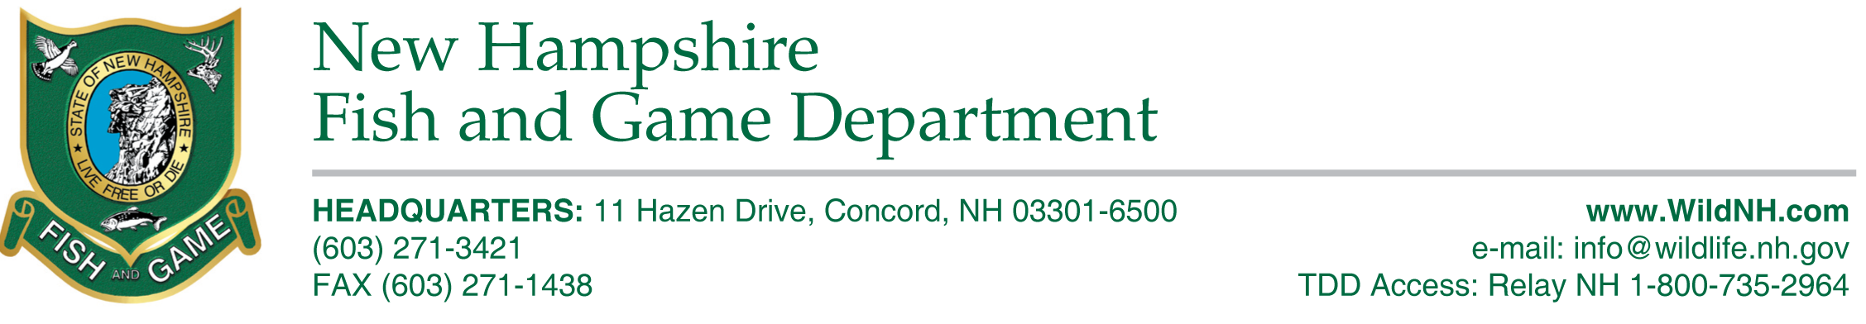
Mr. Norton:

As a Project Partner for the Indian Stream Restoration Project, the New Hampshire Fish and Game Department is strongly supportive of your efforts at Indian Stream. The Department is committed to contributing technical expertise and in-kind dollars to this Project for at least several years as large-scale project like this require much time, patience and excellent planning.

From our research in the Dead Diamond and Nash Stream Watersheds, it is clear that wild brook trout require access to high quality spawning habitat, and that culverts very often preclude the necessary migration of adult brook trout into tributaries that are important for spawning and rearing. We have also determined empirically that healthy brook trout populations require instream wood and pools. The Indian Stream Restoration Project, like the Nash Stream Restoration Project, aims to restore pools, instream wood, and connectivity at the Watershed Level.

The Department is strongly supportive of your proposal entitled, "Culvert replacement and instream habitat restoration on Indian Stream, NH ". Please feel free to contact me at 603-271-2744 or john.a.magee@wildlife.nh.gov, or our Coldwater Project Leader, Dianne Timmins at 603-788-3164 or dianne.timmins@wildllife.nh.gov. Thank you for allowing the Department to be a partner in this very important project.

Sincerely,
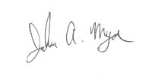

John Magee
Fish Habitat Program Coordinator

