Expanding Brook Trout within Willow Creek as per the NFHAP and PA EBTJV State Conservation Strategy

Project Location: (Pennsylvania, Berks County, Maidencreek Township)
- Congressional District: District 17, Rep. Tim Holden
EBTJV / NFHAP Funding Requested: $50,000
- Total Project Cost: $121,800
- Total Federal Matching: $0
- Total Non-Federal Matching: $71,800
Type of Project: In-stream habitat, Riparian planting and Assessment

APPLICANT
Organization: Maidencreek Township
Project Officer: Diane Hollenbach
Street: 1 Quarry Road, PO Box 319
City, State, Zip: Blandon, PA 19510
Telephone Number: (610)-926-4920
Fax Number: (610)-926-6314
E-Mail Address: maidentwp@aol.com

Sponsoring Fish and Wildlife Service Fisheries Office
Fish and Wildlife Service Office: Northeast Fisheries Center
- Project Officer: Meredith Bartron
Street: PO Box 75
- City, State, Zip: Lamar, PA 16848-4247
- Telephone Number: (570)-726-4995
Fax Number: (570)-726-3255
E-Mail Address: Meredith_Bartron@fws.gov

Date Submitted: October 2, 2009
I. PROJECT DESCRIPTION, SCOPE OF WORK, AND PARTNER INFORMATION

A. Project Description and Scope of Work
The goal of the project on Willow Creek located within Blandon, Berks County, PA is to expand suitable brook trout habitat within a residential greenway owned by Maidencreek Township (MCT). Secondly, partners feel there is a chance for educational and recreational opportunities for the surrounding communities.

Willow Creek begins in Ruscombmanor Township just south of Fleetwood, PA. It flows in a westerly direction into MCT for a total of 9.7 miles before entering Maiden Creek just west of Berkley. The creek, characterized as a limestone stream, drains an area of 21.7 square miles. Willow Creek is deemed a cold water fishery by the PA DEP and supports a wild brook trout population of 58 kg/ha approximately 2.2 miles downstream of the project area, one of the most productive in the state (DEP 2009). Also, another unquantified permanent wild brook trout population exists within a tributary just upstream of the project site (Kaufmann 2005). Differences in habitat characteristics and quality largely account for the differences in brook trout biomass at these locations. Within the project reach, the substrate is comprised mainly of sand and gravel, with layers of silt and clay, whereas the locations supporting permanent wild trout have coarser substrate consisting of gravel, cobble and boulders. Additionally, the riparian buffer is much denser above and below the project site. The creek is also on the Department of Environmental Protection’s (DEP’s) 303 (d) Integrated Impairment List due to storm water runoff and flow variability resulting from the recent development around the watershed.

- Fish habitat and stream bank stabilization will be addressed by the use of in-stream habitat enhancement devices within 5000+ feet of the creek. This aspect will be constructed by township employees, Pennsylvania Fish & Boat Commission PFBC staff and volunteers.
- Re-vegetate 6+ acres of floodplain with native trees and shrubs immediately following construction of habitat devices using volunteer labor.
- Shift local stocking efforts over to other nearby streams based on project success.
- Make pamphlets for distribution to interested citizens.
- Construct kiosks upon project completion to commemorate the effort and educate future generations of the work done.

This project will lead to increased brook trout population within the project stretch because:

- The construction of habitat devices will stabilize the banks and greatly reduce erosion within the project area.
- The devices will also help to narrow and deepen the channel, facilitating sediment transport, which should encourage reproduction and macroinvertebrate habitation.
- Once the riparian plantings mature, temperatures within the reach will likely stay suitable for trout year long.

The PFBC has completed pre-monitoring of the project site, which included assessment of the habitat, electro-shocking and water chemistries. They believe the combination of the lack of a woody canopy to shade the stream and bank erosion are the limiting factors inhibiting wild brook trout within the proposed project site. The PFBC has agreed to monitor at one, three and five years after completion to determine project success.

B. Partner Information (not to exceed 100 words)

Partner Name | Contribution  In-Kind | Contribution  Cash | Federal or Non- Federal | Partner  Category | Role of Partner
Pennsylvania Fish & Boat Commission | $17,000 |  | Non-Federal | State Agency | Project design, oversight, monitoring
Maidencreek Township | $34,000 |  | Non-Federal | Local Government | Donated materials, labor & equipment
Berks County Conservation District | $3,200 |  | Non-Federal | Local Conservation Group | Assisting in riparian buffer design and completion
Maiden Creek Watershed Association | $4,000 |  | Non-Federal | Local Conservation Group | Volunteers, publicity
TU – Tulpehocken Chapter | $4,000 |  | Non-Federal | National Conservation Group | Volunteers, publicity
Fleetwood High School | $4,800 |  | Non-Federal | Local High School | Volunteers
Schuylkill Valley High School | $4,800 |  | Non-Federal | Local High School | Volunteers

- Project Timeline

2009 – Water quality/fish monitoring (pre-implementation)
2010 – Grants awarded, construct project and seek additional funding, NFHAP funds used
2011 – Water quality/fish monitoring, funds secured and remainder of NFHAP funds used and project completed
2013 – Water quality/fish monitoring
2015 – Water quality/fish monitoring
II. MAP OF PROJECT AREA (HUC 420921)
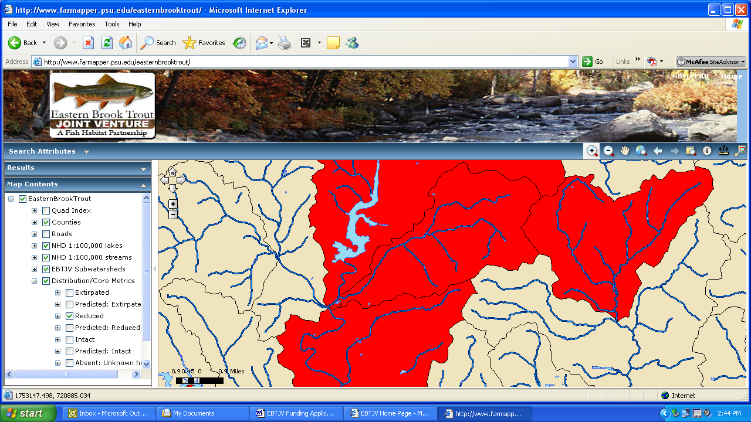

III. PHOTOGRAPH(S) OF PROJECT AREA
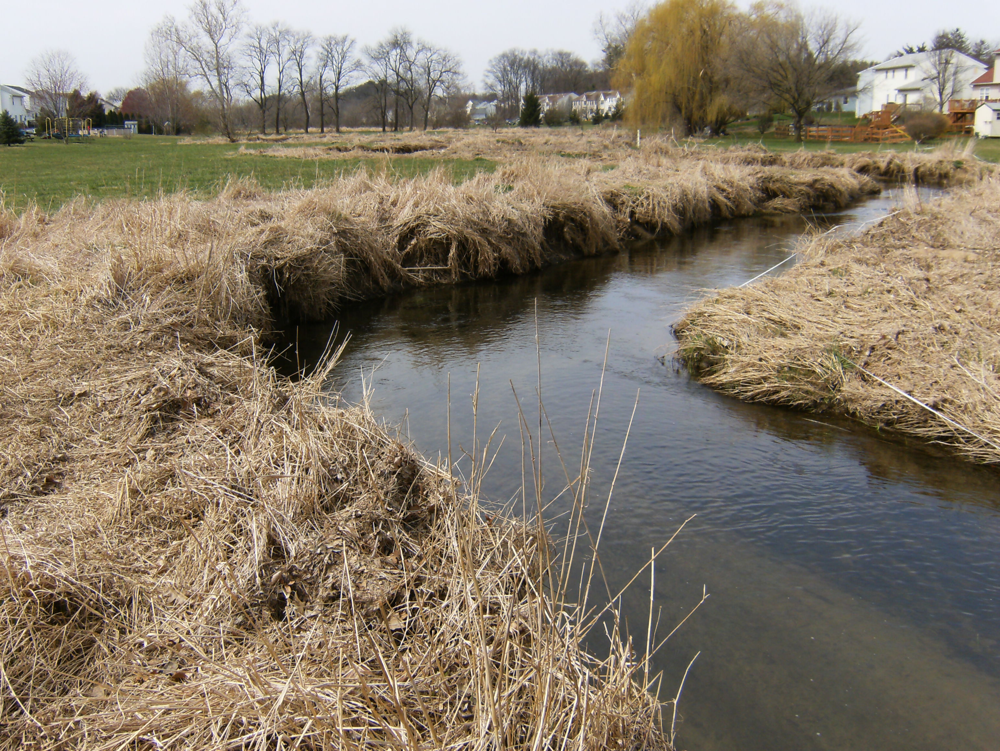
General habitat conditions in Willow Creek; John Buzzar/PA Fish & Boat Commission
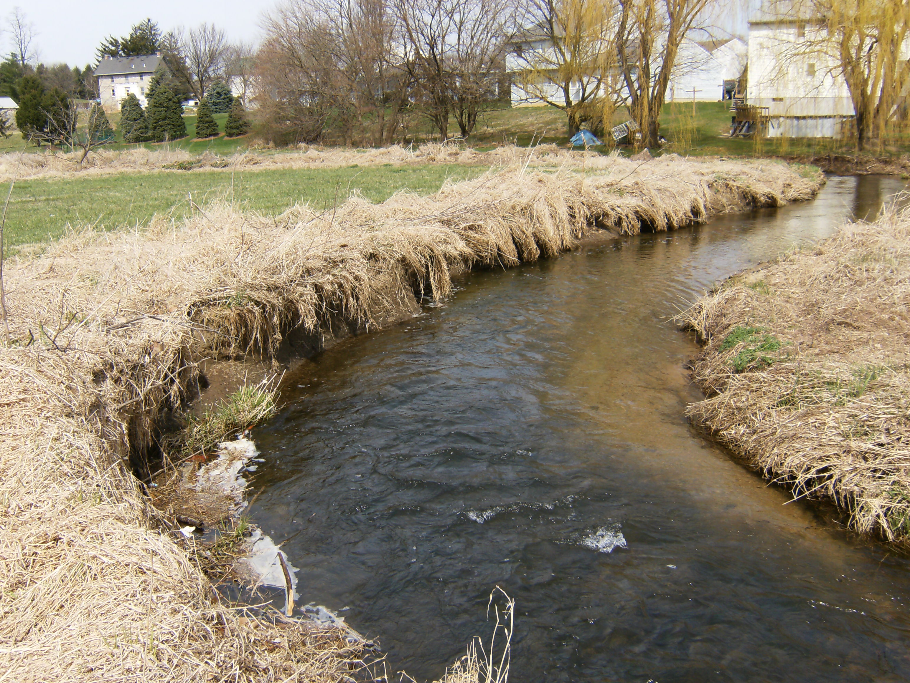
Evidence of erosion in Willow Creek; John Buzzar/PA Fish & Boat Commission

IV. PROJECT BUDGET

B. Budget Table

Partner | Activity | NFHAP Request | Non-Fed Contribution | Federal Contribution | Total | Acres/ miles
MCT | Donated logs |  | $20,000 (In-kind) |  | $20,000 | 1 miles
MCT | Administration |  | $4,000 (In-kind) |  | $4,000 | 1 miles
MCT | Labor |  | $10,000 (In-kind) |  | $10,000 | 1 miles
MCT | R5/R6 stone | $8,000 |  |  | $8,000 | 1 mile
MCT | Equipment rental | $13,000 |  |  | $13,000 | 1 mile
MCT | Riparian planting | $25,000 |  |  | $25,000 | 6 acres
MCT | Purchase/ Install kiosks | $3,000 |  |  | $3,000
PFBC | Monitoring |  | $7,000 (In-kind) |  | $7,000 | 1 miles
PFBC | Project design & over sight |  | $7,000 (In-kind) |  | $7,000 | 1 miles
PFBC | Donated materials |  | $3,000 (In-kind) |  | $3,000 | 1 miles
PFBC | Print pamphlets | $1,000 |  |  | $1,000
Berks Co. Cons. Dist. | Riparian buffer design |  | $3,200 (In-kind) |  | $3,200 | 6 acres/ 1 mile
Maidencreek Watershed Association | Volunteer labor |  | $4,000 (In-kind) |  | $4,000 | 6 acres/ 1 mile
Tulpehocken TU | Volunteer labor |  | $4,000 (In-kind) |  | $4,000 | 6 acres/ 1 mile
Fleetwood H.S. | Volunteer labor |  | $4,800 (In-kind) |  | $4,800 | 6 acres/ 1 mile
Schuylkill Valley H.S. | Volunteer labor |  | $4,800 (In-kind) |  | $4,800 | 6 acres / 1 mile
Totals |  | $50,000 | $71,800 |  | $121,800 | 6 acres/ 1 mile

V. EVALUATION QUESTIONS

- Conservation of Sustainable Brook Trout Populations:

The plan will deal with several impacts to the brook trout population (degraded habitat, eroded banks and lack of riparian buffer) in the middle portions of Willow Creek. Only a couple miles downstream of the project site exists a Class “A” wild brook trout population, which exceeds the kilograms of trout biomass per hectare requirement for Class “A” waters by nearly two-fold. Though, waters within the project site support few wild trout, due to unsuitable habitat conditions many are only transient inhabitants. Despite the Cold Water Fishery (CWF) designation by DEP, water temperatures can become too warm for trout and sediment deposition affects spawning success in the reach. Construction of in-stream habitat devices and planting of native plants will help to counteract these problems. Riparian forest buffers are natural sponges that have been shown to absorb and bind much of the sediments, nutrients and some of the pollutants in runoff before they reach the waterway. The shade provided by the trees and shrubs maintain lower water temperatures and their leaves and twigs are the primary source of food for the aquatic food web. They also slow the speed of storm water, reducing erosion of the small swales and gullies that feed the stream.

Several of the proposed activities in the project align with goals of the Schuylkill River Watershed Conservation Plan, the Tulpehocken Creek Watershed Conservation Plan and the Maiden Creek Watershed Conservation Plan. They include most notable public outreach and education, riparian buffer establishment and storm water management. The project does not include fee simple land purchase or easements of any kind.

The project addresses several regional and range-wide EBTJV habitat objectives:
- III. Change the classification of 30% of the watersheds. We will strengthen the populations we have, changing red watersheds to yellow and yellow watersheds to green – This project has the potential to change the watershed’s status from red to yellow.
- IV. Maintain and improve 70% of watersheds. We will curb the decline of population loss, preventing yellow watersheds from going red, and red watersheds from going gray, while maintaining or strengthening red and yellow watersheds – Sampling completed by southeastern fisheries management division of the PFBC revealed that a 0.9-mile stretch of Willow Creek to be Class “A” wild brook trout water. Population numbers may have rebounded even more significantly within the watershed to be reclassified to yellow status.

The venture also supports the management priorities outlined for the Mid-Atlantic Region:
- Improve Water Quality – Stream bank stabilization will decrease sedimentation to the creek.
- Promote and Restore Riparian Forests – Lower water temperatures during heat waves due to woody macrophytes shading the solar radiation.

Moreover the project also meets components of all five objectives outlined in Pennsylvania’s Brook Trout Conservation Strategies state plan as follows:
- Habitat Protection and Improvement – improve aquatic habitat and stabilize stream banks through the use of in-stream habitat structures and native tree and shrub plantings along one mile of Willow Creek.
- Assessment – pre and post monitoring will be conducted by PFBC staff.
- Brook Trout Protection, Restoration and Enhancement – improve water quality and habitat to enhance the brook trout population in the creek.
- Outreach – promote project benefits/results through various media such as PFBC website, local newspapers, pamphlets and kiosks. Much of which is to gain public support for the project.
- Recreational Fishing – increase the recreational fishing opportunity for brook trout in Willow Creek by bolstering the brook trout population.

Additionally, goals for stream and river habitat in the Pennsylvania State Wildlife Action Plan are being fulfilled:
- Enhance and Restore High-Priority Lotic and Riparian Habitats: The restoration actions to be undertaken will help to restore conditions within Willow Creek. The Schuylkill River Watershed is listed as high priority.
- Pursue Improved Water Quality of Priority Rivers: The work, once completed, will aid in improving water quality throughout the Schuylkill River Watershed.

- Threatened and Endangered Species and Species of Conservation or Management Concern:

There are no known benefits to any federal or state listed threatened or endangered species.

In Pennsylvania, wild brook trout are an economically important species. A statewide angler use, harvest and economic survey conducted by the PFBC indicated that wild trout angling benefits the state and local economies with $2 million annually. The creek downstream of the project site supports one of the best wild brook trout populations within the Commonwealth of Pennsylvania.

- Project Benefits

The lowest level EBTJV priority ranking was given to the watershed where the project occurs. The status of the brook trout population is listed as reduced <50% according to the EBTJV. The Willow Creek watershed is connected to the Maiden Creek and Schuylkill River watershed both of which contain reduced populations of brook trout. A goal of the project is to expand suitable brook trout habitat upstream in the main-stem of Willow Creek through channel/bank stabilization and riparian plantings. According to state fisheries biologists, the probability of maintaining a fishable wild brook trout population within the project area is high. In addition, removal from DEP’s 303 (d) Integrated Impairment List could be a reality.

- Endurance of Benefits:

Storm water runoff and flow variability are the core causes of watershed degradation listed by DEP’s) 303 (d) Integrated Impairment List. Additionally, warm summer water temperatures and the lack of spawning substrate inhibit the expansion of brook trout. Construction of habitat improvement devices will create much needed habitat for aquatic organisms, prevent erosion caused by storm water and assist sediment transport downstream. The riparian plantings will also lower water temperatures and aid in slowing and filtering flood waters.

In 2006, a 1.8 mile stretch of Willow Creek, including the project site was designated as Approved Trout Stocking Waters and receives 1000 hatchery brook trout annually (PFBC 2006). Evaluation will occur and if a sizeable brook trout population develops within the project area, stocking efforts will be directed to another waterway. No invasive fish species inhabit the creek; the only competition comes from stocked fish. Approximately ten percent of the watershed upstream is protected through public ownership.

- Management Assets:

The PFBC as in-kind match will monitor this project 1, 3 and 5 years after completion. Fish and water quality will be evaluated using standard agency protocols in wadeable streams. An initial assessment evaluating the fish population and water quality has already been completed at the project site.

Habitat improvement devices generally require little to no maintenance during the first 15 years. Maidencreek Township enrolled in the Cooperative Habitat Improvement Program (CHIP) and under this agreement partners, with the assistance of the PFBC, are required to allow public fishing and maintain habitat structures for up to 20 years. Implementation of the proposed activities will facilitate improved recreational fishing by providing habitat for fish, bank stabilization and sediment transport. Once riparian plantings take hold and begin sufficiently shading the stream the fishing opportunity for brook trout should be phenomenal. While the majority of riparian land is owned by the township; several residential properties come within a few feet of the water. Making public access limited to walking in from one of the two bridges that delineate the site, but fishing is permitted through the entire project area.

Project partners will hold a public meeting prior to any construction activities to take any public comments and shed light on any issues. The PFBC, along with the township and Berks County Conservation District will disseminate project information to local media and citizens. As part of the volunteer effort to complete re-vegetation of the riparian zone, supervising staff will give a short talk informing folks the benefits of our work. Lastly, kiosks commemorating project benefits/achievements will be erected at various points along Willow Creek.

- Other Special Considerations:

Project development has been ongoing for several years and background monitoring of water and fish in relation to the project was completed this past spring. PFBC habitat division staff designed plans in 2005 and 2007 for 6500+ feet of Willow Creek indicating proper placement and usage of approved habitat improvement structures. Furthermore, PFBC staff has acquired the necessary permits for the project from DEP. Although we believe the requested funds will complete a large portion of the effort, additional funding will be required. Ultimately, a successful grant reward will help us to easily leverage the supplementary funds needed to see this venture through.

The maintenance and boundary issue the township has had with residents is a point of contention. The creek and part of its floodplain lies in a Maidencreek Township greenway bordered by residential lawns, some of the residents feel it necessary to mow land they do not own and very close to the stream in some cases. The entire project is on land publicly owned and maintained by Maidencreek Township. Woody vegetation will be planted throughout the majority of township property and left to grow so as to alleviate a maintenance burden from the township.

- Supporting Documentation and Management Plans:

DEP, Division of Water Quality Assessment and Standards, Harrisburg, PA. Pennsylvania
Code. Title 25. Chapter 93. Water Quality Standards (www.pacode.com), Commonwealth
of Pennsylvania, 2009.

Kaufmann, M. 2005. Pennsylvania Fish and Boat Commission Area Fisheries Manager.
Personal Communication.

PFBC, Harrisburg, PA. Class A Wild Trout Waters, Pennsylvania Fish and Boat Commission,
2006.

