EBTJV Habitat Enhancement Project for Brook Trout in the Asaph Run Watershed, PA

NFHAP funding requested: $20,000
Project Location: Tioga State Forest, Shippen Township, Tioga County, Pennsylvania
- Congressional District: 5th District of Pennsylvania

Sponsoring Fish and Wildlife Service Fisheries Office
Fish and Wildlife Service Office:
Northeast Fishery Center
U.S. Fish and Wildlife Service Northeast Fishery Center
Street: P.O. Box 75
City, State, Zip: Lamar, PA 16848
- Project Officer: Meredith Bartron
- Telephone Number: (570) 726-4995
- Facsimile Number: (570) 726-3255
- Email Address: Meredith_Bartron@fws.gov

APPLICANT
Organization: Pennsylvania Fish and
Boat Commission
Project Officer: Jason Detar
Street: 450 Robinson Lane
City, State, Zip: Bellefonte, PA 16823
Telephone Number: (814) 359-5119
Facsimile Number: (814) 359-5153
Email Address: jdetar@state.pa.us

Date Submitted
August 17, 2007

II. PROJECT DESCRIPTION, SCOPE OF WORK, AND PARTNER INFORMATION

A. Project Description and Scope of Work

Need for the project: The project is needed to restore and enhance degraded brook trout habitat in the Left and Right Branches of Asaph Run. Both streams contain good water quality, but their physical habitat is limited, especially adequate pool habitat and overhead cover. Dirt and gravel forest roads parallel the Left Branch for about 2 miles and the Right Branch for 1 mile. The presence of the forest roads directly adjacent to the streams has resulted in destabilization of stream banks and heavy erosion has occurred in some areas. Both streams contain very good wild brook trout populations ranging in biomass from 27 - 45 kg/ha. However, due to the shallow nature of the streams and relatively limited habitat for adult trout, > 95% of the brook trout captured during PA Fish and Boat Commission (PFBC) surveys were less than 175 mm (7 in) in length. The entire Asaph Run watershed is designated as a High-Quality Coldwater Fishery, the second highest level of protection that can be assigned by the PA Department of Environmental Protection (PA DEP). Today, brook trout populations in only 10% of Pennsylvania’s historical subwatersheds remain >50% intact (Hudy et al. 2006). The Asaph Run watershed is one of the few subwatersheds within Pennsylvania that falls into this category, which further indicates the high priority of conserving and enhancing brook trout in this watershed.

Purpose, goals, and objectives: The purpose of the project is to improve and increase brook trout habitat, specifically habitat that is conducive to supporting adult brook trout (pools of adequate depth to provide year-round protection and overhead cover) and to reduce major bank erosion that continues to degrade habitat. The project will aim to improve adult brook trout habitat and populations in degraded areas using PFBC-designed trout habitat enhancement devices that incorporate large woody debris and boulders into the system. The devices serve the dual purpose of enhancing trout habitat by scouring pools at the tips of the logs, and increasing overhead cover while stabilizing banks and reducing erosion by diverting water away from the toe of the eroding banks and encouraging deposition in this area. As deposition occurs through time, the bank slope decreases, which allows for riparian vegetation to become established stabilizing the bank. Devices typically used include multi-log vane deflectors, log cross vanes, and log bank cribbing (see attached PFBC Habitat Improvement Manual for Trout Streams for more information). Native vegetation will be planted to enhance the current riparian zones, stabilize banks, and expedite the recovery process.

The goals and objectives of this project include: 1) enhance instream habitat for adult brook trout that will increase carrying capacity of these larger individuals, 2) stabilize banks and reduce erosion using habitat devices and riparian plantings, 3) assess the effects of habitat enhancement on the brook trout population in treatment and control reaches, 4) form long-term partnerships that will play a vital role in conserving and enhancing brook trout in PA, and 5) improve angling quality and opportunities.

The project supports the Principal Goals of the EBTJV including restoring brook trout populations, encouraging partnerships, program implementation support, increasing angling opportunities, and monitoring and evaluating brook trout populations and Pennsylvania’s Brook Trout Conservation Strategies including habitat protection, population assessment, brook trout protection, restoration, and enhancement, outreach, and recreational angling.

Work to be done and by whom: Project planning and design work will be conducted by the PFBC. The PFBC, PA Department of Conservation and Natural Resources (PA DCNR), Tiadaghton Chapter of Trout Unlimited will conduct the installation of instream habitat enhancement devices (e.g., log vane deflectors, log cross vanes, log bank cribbing, etc.) to improve habitat and reduce erosion. Riparian plantings comprised of native trees and shrubs will be conducted by all partners. Construction oversight and project management will be conducted by the PFBC. The PFBC has been designing and installing habitat enhancement structures under the Adopt-A-Stream program for nearly two decades and have successfully completed hundreds of projects throughout the Commonwealth. The PFBC will evaluate brook trout populations and physical habitat pre and post treatment; population dynamics data collected in the treatment reach will be compared to the control reach to determine if the habitat enhancement structures have improved the population. The PA DCNR will provide assistance with obtaining materials for project and transporting them to the site. The PA DEP and Tioga County Conservation District will provide assistance with obtaining encroachment permits necessary to work in the streams. The Tiadaghton Chapter of Trout Unlimited will provide assistance with various hands-on tasks to aid in the completion of the project. The PFBC will draft a final report for the project.

Who owns or will own and manage affected lands: All lands within the project area are owned by the state of Pennsylvania and are part of Tioga State Forest. State forest lands are open to free, year-round public access in perpetuity.

Duration of benefits, including length of any land or management contracts, easements or other agreements: Duration of project benefits is expected to be perpetual.

Expected results and how and when they will be monitored: Expected results are improved adult brook trout habitat, increased abundance of adult brook trout within project area, and reduced bank erosion and associated sedimentation. Instream habitat will be enhanced throughout 3 stream miles and 1,200 feet (~0.5 ac) of riparian habitat will be restored. Brook trout populations will be monitored via three-pass electrofishing and habitat will be assessed using the U.S. EPA’s Rapid Bioassessment Protocols habitat assessment. Streams will be monitored for at least 1 year pre and 4 years post treatment in treatment and control reaches.

Timetable for accomplishment of major activities during the one-year performance period:
- Project partners will meet and discuss project plans
- Site/habitat assessment, planning, and design work will be conducted, and all necessary county, state, and federal permits obtained
- Brook trout populations will be sampled and habitat parameters assessed to obtain pre treatment data in both treatment and control reaches
- Materials for project will be obtained and delivered to site
- Instream habitat enhancement structures will be constructed
- Project management and construction oversight will be conducted by PFBC

B. Partner Information

PFBC = Pennsylvania Fish and Boat Commission
PA DCNR = Pennsylvania Department of Conservation and Natural Resources
PA DEP = Pennsylvania Department of Environmental Protection
USFWS = U.S. Fish and Wildlife Service – Ecological Services, PA Field Office
TCCD = Tioga County Conservation District
TU = Tiadaghton Chapter Trout Unlimited

Partner Name | Contribution  In-Kind | Contribution  Cash | Federal or Non- Federal | Partner  Category | Role of Partner
PFBC | $13,500 |  | Non-Federal | State Agency | Project oversight, technical assistance habitat enhancement structure design, brook trout population monitoring and habitat assessment, monitoring data analysis and reporting of project
PA DCNR | $10,500 | $10,000 | Non-Federal | State Agency | Equipment and operators for habitat enhancement structure construction, funding for materials
PA DEP | $1,000 |  | Non-Federal | State Agency | Environmental Permitting
USFWS-Northeast Fishery Center | $2,000 |  | Federal | Federal Agency | Brook trout population monitoring and habitat assessment
Tioga County Conservation District | $1,000 |  | Non-Federal | State Agency | Environmental Permitting
TU | $4,000 |  | Non-Federal | Local Conservation Group | Habitat enhancement structure construction

-Local partners, including sportsmen groups, will be involved with all aspects of the project
-Four (4) partner categories are identified in the partnership – state agencies (3), federal agency (1), local
government (1), and local conservation groups (1)

C. Milestones and Timelines
• Obtain landowner consent (completed).
- Meet with all partners to establish a working timeline (Spring 2008).
- Obtain encroachment permits for project (Spring 2008).
- Conduct site assessment (completed) and engineering design of habitat enhancement structures (Spring 2008).
- Conduct pre-treatment fishery surveys to evaluate brook trout population and habitat in treatment and control reaches (Summer 2008).
- Construct fish habitat structures throughout treatment reaches (Summer or Fall 2008).
- Conduct riparian buffer plantings throughout treatment reaches (Fall 2008 or Spring 2009).
- Erection of educational signage at access areas (Fall 2008).
- Disseminate project status and information (Summer and Fall 2008; Spring 2009).
- Conduct post-treatment fishery surveys to evaluate brook trout population and habitat in treatment and control reaches (Summer 2009, 2010, and 2011).
- Throughout the aforementioned process, project partners will conduct project tracking meetings. Information on the project, including methodology, timetable, and partnerships will be provided to the public through various media.

III. MAP OF PROJECT AREA

Treatment Reach
Treatment Reach
Left and Right Branch Asaph Run Habitat Enhancement Project

Coordinates for center point of project area (NAD 83):
Left Branch Asaph Run: 41.791121 / 77.464629
Right Branch Asaph Run: 41.797834 / 77.443415
HUC6 watershed code: 420151
HUC8 watershed code: 2050205

IV. PHOTOGRAPHS OF PROJECT AREA

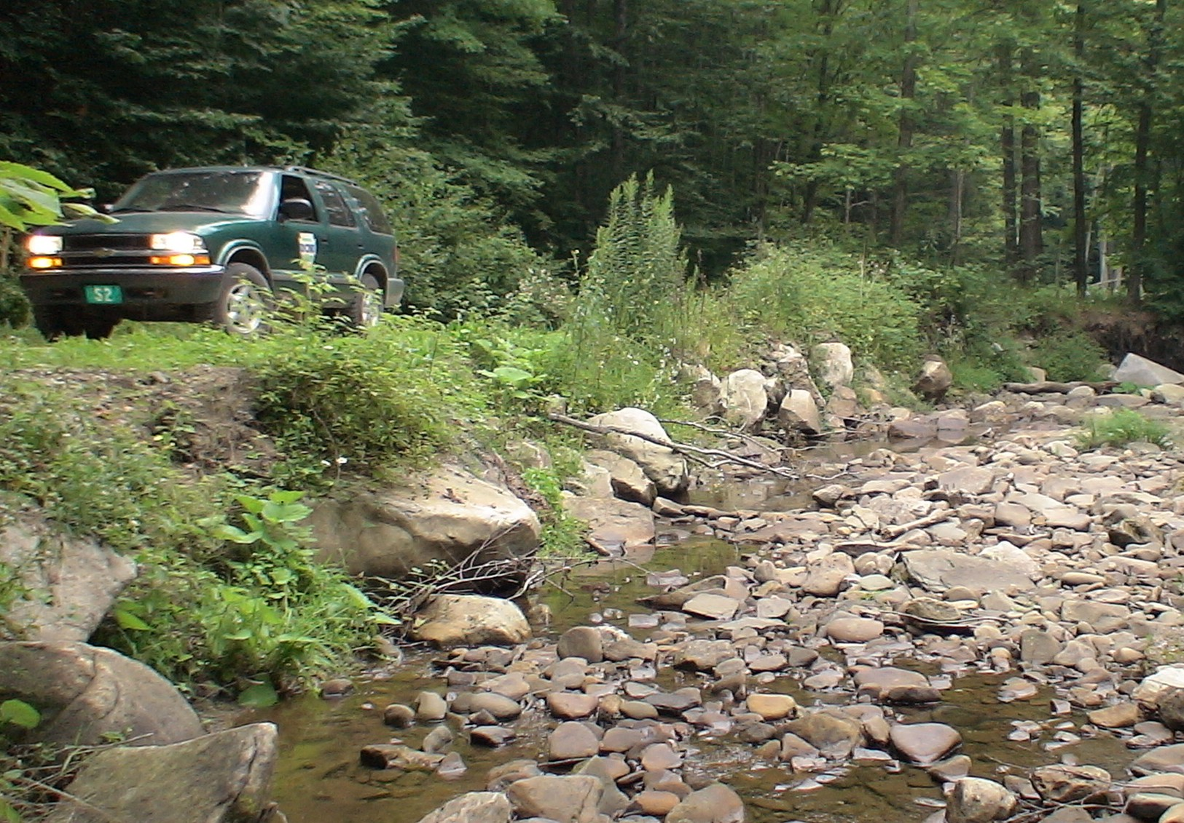
Photograph of the Left Branch Asaph Run project area showing the dirt and gravel forest road that parallels the stream, bank erosion, and overly wide and shallow instream habitat with little overhead cover. Photo by: PA Department of Conservation and Natural Resources.

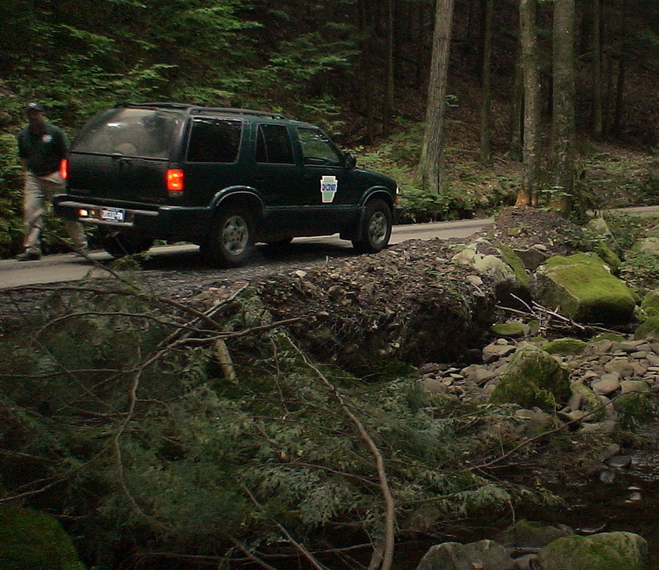
Photograph of the Right Branch Asaph Run project showing the dirt and gravel forest road that parallels the stream and bank erosion. Photo by: PA Department of Conservation and Natural Resources.

V. PROJECT BUDGET
Partner | Activity | NFHAP Request | Non-Fed. Contribution | Federal Contribution | Total | Acres/ Miles Affected
PFBC | Site Assessment and Design Work  I. Salaries |  | $3,000 (in-kind) |  | $3,000
PFBC  PA DCNR  PA DCNR  TU  EBTJV  PA DCNR  EBTJV | Instream Habitat Enhancement  Work  I. Salaries  II. Contractor Services  III.Supplies/Materials | $4,000  $14,000 | $3,000 (in-kind)  $3,000 (in-kind)  $7,000 (in-kind)  $3,000 (in-kind)  $10,000 (cash) |  | $3,000  $3,000  $5,000  $3,000  $4,000  $10,000  $14,000 | Habitat throughout 3 miles of stream restored
PFBC  PA DCNR  TU  EBTJV | Riparian Habitat Enhancement  I. Salaries  II. Supplies/Materials | $2,000 | $500 (in-kind)  $500 (in-kind)  $1,000 (in-kind) |  | $500  $500  $1,000  $2,000 | 0.5 acres of riparian habitat will be restored
PADEP  TCCD | Environmental  Permitting  I. Salaries |  | $1,000 (in-kind)  $1,000 (in-kind) |  | $1,000  $1,000
PFBC  USFWS | Brook trout  Population Monitoring and Habitat Assessments  I. Salaries |  | $6,000 (in-kind) | $2,000 (in-kind) | $6,000  $1,000
PFBC | Monitoring Data Analysis and Final Report of Project  I. Salaries |  | $1,000 (in-kind) |  | $1,000
Totals: |  | $20,000 | $40,000 | - $2,000 | Grand Total:  $62,000
-If project is funded, EBTJV grant will be managed and administered by the PFBC.
-PA DCNR is contributing more funding than grant request
VI. EVALUATION QUESTIONS

A. Conservation of Sustainable Brook Trout Populations:

The project area and watershed is located on state forest land that provides superior protection from development in perpetuity. Water quality is protected by its High-Quality listing by PA DEP. Both the Left and Right Branches of Asaph Run harbor very good, sustainable populations of wild brook trout and both streams are popular destinations for trout anglers. Recreational quality of the fishery is high. The project will aim to improve habitat and enhance the existing brook trout population.

The project supports the following goals of Pennsylvania’s Brook Trout Conservation Strategies:
1.2 Improve brook trout habitat.
2.2 Monitor status of existing brook trout populations.
3.1 Protect existing brook trout populations from future degradation.
3.2 Restore and enhance brook trout populations.
4.2 Develop relationships that foster brook trout enhancement, protection, and restorations.

The following Principal Goals of the EBTJV are supported by this project:
- Conserve, enhance, or restore brook trout populations that have been impacted by habitat modification.
- Encourage partnerships among management agencies.
- Develop support for program implementation.

The following Rangewide Biological objectives are supported:
- Stop the decline of brook trout populations.
- Restore brook trout where habitats can be feasibly restored.
- Increase recreational fishing opportunities.
- Complete quantitative status assessments.
- Maintain and restore healthy ecosystems and watersheds.
- Implement brook trout habitat enhancement projects.
- Monitor and evaluate brook trout population responses to habitat enhancement and restoration projects.

In addition, the project supports the EBTJV Rangewide Conservation Strategies by restoring habitat which has watershed scale implications; supporting research by evaluating habitat enhancement as an effective tool for improving brook trout populations and habitats; and contributing to the large-scale monitoring of brook trout populations and habitats throughout the Commonwealth.

B. Endangered Species:

The PFBC and USFWS are currently in the final stages of the amendment process to add the eastern brook trout to Pennsylvania’s State Wildlife Action Plan at Conservation Tier 5 - Maintenance Concern Level. Conservation Tier 5 contains species that are considered relatively abundant and fairly secure in Pennsylvania, but have undergone declines. More information on this amendment can be found at: http://www.fish.state.pa.us/newsreleases/2007/brook_wap.htm

By reducing erosion and sedimentation, the project will benefit the eastern hellbender salamander, a large, stream-dwelling salamander which is found throughout the larger Pine Creek watershed in which Asaph Run is located. The eastern hellbender is a species of concern in Pennsylvania.

There will be no known benefits to any federally or state listed threatened or endangered species related to the completed project.

C. Economically important species not also listed as threatened and endangered species:

Wild brook trout are an economically important species in Pennsylvania. The Asaph Run watershed is a popular destination for wild trout anglers and angling opportunities would be enhanced through this project. Recreational quality of the fishery is very high. A 2004 statewide angler use, harvest, and economic survey conducted by the PFBC indicated that wild trout angling has an economic benefit of about $2 million annually to the local and state economy.

D. Special Considerations:

Headwater areas of both the Left and Right Branch Asaph Run are well forested and protected by the Asaph Wild Area and other portions of Tioga State Forest. Much interest is present within the PFBC, DCNR, Trout Unlimited, and local sportsman groups to maintain, protect, and enhance the Asaph Run watershed and the wild brook trout population it supports. The project is located within the larger Pine Creek Valley, a highly popular area with anglers and outdoor recreationists. The Asaph Run watershed has high recreational use potential and is a popular stream with trout anglers. In addition, the project is located in the heart of the PA Wilds, a recent initiative by PA’s natural resource agencies to promote ecotourism, outdoor recreation, and conservation in northcentral PA. The project is located entirely on state forest land, open to free, year-round public use. The watershed has excellent public access via state forest roads that parallels much of the streams. Additionally, the PA DCNR’s Asaph Picnic and Camping Area is located at the confluence with Left and right Branch Asaph Run provides for increased recreational opportunities and encourages additional use of the wild brook trout fishery in the Asaph Run watershed. The main stem of Asaph Run is also expected to benefit from the habitat enhancement in the upper portion of the watershed.

The Asaph Run watershed has been identified by the Mid-Atlantic Highlands Action program as being located in a high priority forest patch for protection and restoration. The project will help restore and protect an important region of the Appalachian forest ecosystem in Pennsylvania.

E. EBTJV Targeted Watershed:

The targeted watershed information was not available on the EBTJV website.

The HUC6 subwatershed that comprises the Asaph Run watershed is listed as intact > 50%.

F. Habitat Connectivity and Enhancing Population Mobility

The project will occur within the Left and Right Branches of Asaph Run and the tributaries to these streams are relatively unaltered and support good wild brook trout populations as well. Habitat connectivity between tributaries and main stem is good. Over 80% of the Asaph Run watershed is located on Tioga State Forest, which provide for free year-round public access and protection for the watershed in perpetuity. Additionally, a large portion of the watershed within and above the project areas falls within the Asaph Wild Area, which provides even greater protection.

The project area and tributaries already contain very good, fishable populations of brook trout and the watershed is a popular destination with wild trout anglers. The probability of success for the project is high and will enhance the current brook trout population and angling opportunities. The habitat enhancement devices utilized by the PFBC generally have life expectancies of at least 20 years, with some continuing to function for very long periods after installation. The main cause of habitat degradation in the project reach is bank erosion and reduction of adult brook trout habitat, which will be addressed through the project to the fullest extent possible. Minimal development is present within the watershed. Asaph Run is also expected to benefit from the project by decreasing sedimentation.

G. MANAGEMENT ASSETS:

Monitoring of the brook trout population pre and post treatment will be conducted throughout the duration of the project by the PFBC and USFWS using standard agency protocols for monitoring and evaluating trout populations in wadeable streams. PFBC staff has already conducted brook trout population estimates in both treatment reaches of the Left and Right Branches of Asaph Run and have documented the presence of very good wild brook trout populations ranging in biomass from 27 - 45 kg/ha. Population densities and biomass are expected to increase as adult habitat is improved. The sites will be resurveyed as part of the monitoring plan and the historic data provides additional pre treatment data that can be used during analyses. Control sites will also be established upstream of the treatment reaches and/or in neighboring streams.

Monitoring of the physical habitat will be conducted pre and post treatment by the PFBC using the U.S. EPA’s Rapid Bioassessment Protocols visual-based habitat assessment.

The project area and entire watershed is located on state forest land that is accessible year-round to free public fishing. Angling in the project area will follow the catch and release regulations already established by the PFBC for the streams. Both stream sections are open for year-round angling under the regulations.

The project is being developed as a high-profile demonstration project to promote the EBTJV and the positive outcomes that can be gained through partnerships. We feel confident that the project will increase public awareness of the EBTJV and its goals and objectives and will hopefully provide an avenue to garner new partnerships and added resources to conduct additional habitat enhancement and restoration projects in northcentral Pennsylvania. The project area will be signed and will be available for public education of stream habitat enhancement work and its benefits to the watershed and the wild brook trout population.

H. Supporting Documentation

Please see attached support letter, photo release form, and FONS from.

Literature Cited

Hudy, M., T. M. Thieling, N. Gillespie, and E. P. Smith. 2006. Distribution, status, and
perturbations to brook trout within the eastern United States. Available at: www.brookie.org

