Meduxnekeag Watershed, ME in-stream habitat restoration: A NFHAP project for the EBTJV

Project Location: Houlton Band of Maliseet Trust Land, Towns of Littleton and Monticello, Aroostook County, Maine
- Congressional District of Project: ME 2
- Congressional District of Applicant: ME 2
EBTJV / NFHAP Funding Requested: $45,485.00
- Total Project Cost: $169,785.00
- Total Federal Matching: $121,550.00
- Total Non-Federal Matching: $2,750.00

APPLICANT
Project Officer: Sharri Venno, Environmental Planner
Organization: Houlton Band of Maliseet Indians
Street: 88 Bell Road
City, State, Zip: Littleton, ME. 04730
Telephone Number: (207) 532-4273 ext. 215
Fax Number: (207) 532-6883
EMail Address: envplanner@maliseets.com

U.S. Fish and Wildlife Service Sponsoring Office
- Project Officer: Scott Craig
Fish and Wildlife Service Office: Maine Fishery Resources Office
Street: 306 Hatchery Rd.
- City, State, Zip: East Orland, ME 04431
- Telephone Number: (207) 469-6701 ext 226
Fax Number:
EMail Address: Scott_Craig@fws.gov

USFWS FONS Database Project Number: Operational Need: 53371-2011-366

Coordination Completed with US Fish and Wildlife Service Fisheries Office (Check One):
X Yes, 8/06/2012 Date Coordination Began
No
I. PROJECT DESCRIPTION, SCOPE OF WORK, AND PARTNER INFORMATION

A. Project Description:
To enhance brook trout habitat quality, we propose to install 41 wood and boulder structures in the channel of two river stretches in the Meduxnekeag Watershed restoring in-stream habitat complexity and long term stability in these areas. The first stretch is along the mainstem of the Meduxnekeag River between Lowery Bridge and the Covered Bridge. The second is along a reach of the north branch adjacent to Monticello Fish and Game Club. Both of these areas suffered historical impacts from logging and dams, resulting in shallow, wide channels essentially devoid of pools and other cover. Boulder clusters, isolated logs, and boulder-supported log jams are structural design elements that can reduce flow velocities, increase flow complexity, and encourage sediment deposition that all serve to narrow and deepen the channel. All three types of structures proposed occur naturally in the watershed and are associated with excellent habitat features including deep pools for cover and clean gravels segregated from fines for spawning. These structures will also allow natural recruitment processes to sustain the created habitat (Field, 2010).

B. Proposed Methods (Max Characters: 350):
HBMI will contract John Field, fluvial geomorphologist, certified NRCS Technical Service Provider, to create final design plans, provide layout & oversee installation of fish habitat structures. Natural/existing log-jam & boulder structures seen on the Meduxnekeag will be replicated to improve habitat for wild brook trout at restoration sites.

C. Project Timeline: Obtaining environmental permits and needed adjacent landowner agreements and final design work will take place during the winter/spring of 2011/12. Project materials (boulders and logs) will be gathered over the fall/winter of 2011/2012. We propose a construction window for late summer 2012 to minimize construction impacts on water quality. MDIFW will provide pre and post-installation fishery and habitat monitoring at both sites annually through 2014.

D. Proposed Accomplishment Summary (Max Characters: 500):
This project will return targeted river stretches to a more natural, sustainable state of in-stream habitat complexity, increase brook trout habitat quality by introducing structural components in sections of these stretches adjacent to cool water tributaries, & promote interest in future restoration activities in other degraded sections of the watershed. This project supports & advances attainment of the goals of the EBTJV, NFHAP, and Maine’s Comprehensive Wildlife Conservation Strategy.

E. State the Importance of the project to the Resource (Max Characters: 350):
This project will restore 1.9 miles of degraded aquatic habitat on the Meduxnekeag River mainstem & 1/4 mile of its north branch. Resident wild brook trout will have access to greatly improved spawning habitat, thermal refugia and cover. Improving aquatic habitat is important for the long term productivity of brook trout in this Watershed.

F. Problem and Specific Cause of the Problem (Max Characters: 350):
The Meduxnekeag has wide, shallow channels lacking pools & large woody debris & is geologically constrained to a narrow, straighter channel than a typically meandering stream. Constrained flows exert even greater stress on a channel bed with no roughness elements. Wood & boulders were removed during earlier logging & dams operations (Field 2010).

G. Objective of the Project with Reference to the Problem (Max Characters: 350):
Our goal is long-term improvement of brook trout habitat by strategically placing boulder clusters, isolated logs & and boulder-supported log jams in 2 low quality stretches of the river. These elements function together to increase flow complexity, reduce the widths of severely over-widened reaches, & maximize habitat improvements (Field 2010).

H. Partner Information

Partner Name | Contribution  In-Kind | Contribution  Cash | Federal or Non- Federal | Partner  Category | Role of Partner
HBMI | $1,325 |  | Federal | Tribe | Project Coordination, Grant Administration  Permit procurement, Public Information & Outreach
USDA, NRCS |  | $119,550.00 | Federal | Federal Agency | WHIP$, Wild Brook Trout Habitat Restoration
ACOE | $1,000.00 |  | Federal | Federal Agency | Project monitoring
MDIFW | $1,250.00 |  | Non-Federal | State Agency | Project monitoring, Permitting Assistance
Monticello Fish and Game Club | $250.00 | - | Non-Federal | Local Landowner | Site Access and Control
SASWCD | 1,250.00 |  | Non-federal | State Agency | Classroom & Field activity for local school children on instream fish habitat
EBTJV |  | $45,485 | Federal | National Conservation Group | Financial Support, Wild Brook Trout Habitat Restoration

II. MAP OF PROJECT AREA (one only)
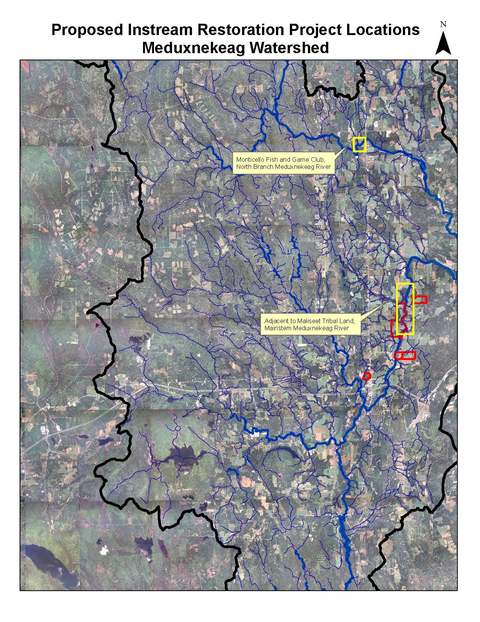
III. PHOTOGRAPH(S) OF PROJECT AREA (no more than 2, please provide credits and attach photo release forms)
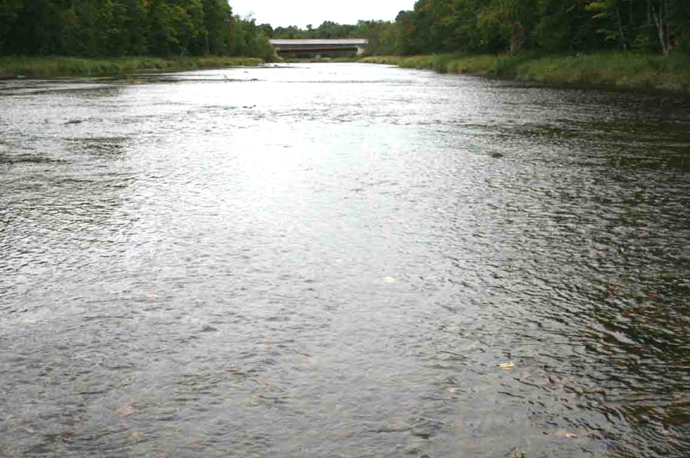
View of a portion of the mainstem site: Looking downstream at the Covered Bridge.

Note overwidened, shallow reach characteristic of degraded brook trout habitat.

Photo Credit: John Field, Field Geology Services
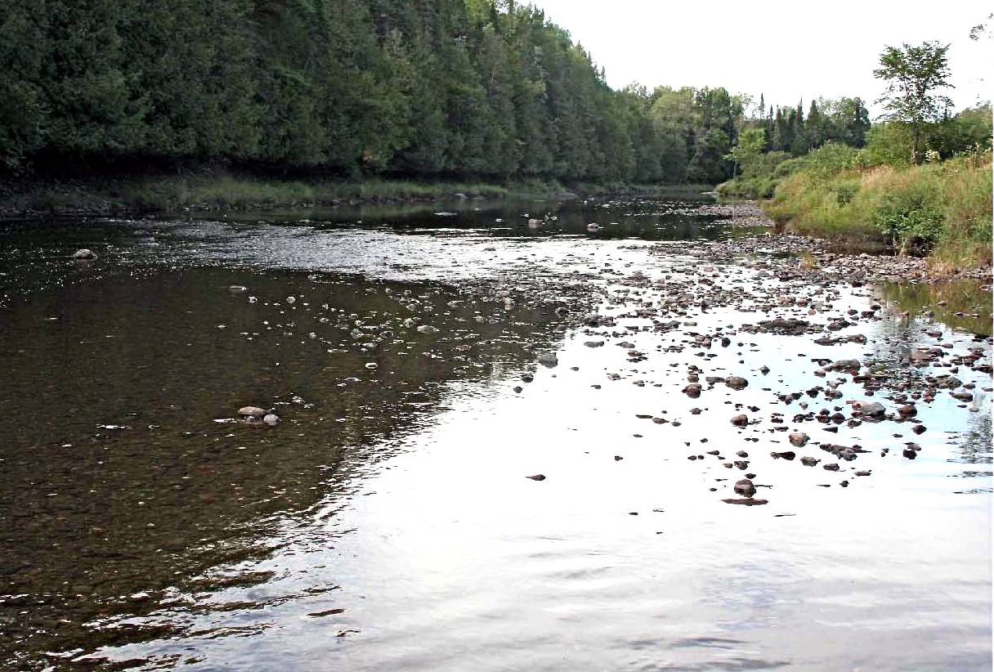
View of the north branch site:
looking upstream - Fish and Game Club property on the right side of the photo.

Note over-widened, shallow reach characteristic of poor quality brook trout habitat.

Photo Credit: John Field, Field Geology Services

IV. PROJECT BUDGET

A. General Requirements

B. Budget Table

Partner Name | Partner Category * | Activity of Partner ** | Budget Category*** | EBTJV  NFHAP Request | Non-Federal Contribution |  | Federal Contribution |  | Total Contribution | Acres/  Miles Affected
 |  |  |  |  | In-Kind | Cash | In-Kind | Cash | Total Contribution | Acres/  Miles Affected
MDIFW | State Agency | Environmental Permitting | Personnel |  | $250 |  |  |  | $250
MDIFW | State Agency | Project Monitoring | Personnel |  | $1000 |  |  |  | $1000
HBMI | Tribe | Coordination/Grant Administration | Personnel |  |  |  | $1,000 |  | $1,000
SASWCD | State Agency | Education and Outreach | Personnel |  | $1,250 |  |  |  | $1,250
Fish & Game Club | Private Landowner | Landowner Agreement | Personnel |  | $250 |  |  |  | $250 | ~0.25
USDA Natural Resource Conservation Service | Federal Agency | Restoration –WHIP $ | Construction/ Contractual |  |  |  | $103,095 |  | $103, 095
USDA Natural Resource Conservation Service | Federal Agency | Restoration –WHIP $ | Final Design, Layout, Oversight / Contractual |  |  |  | $16,455 |  | $16,455
ACOE | Federal Agency | Project Monitoring | Personnel |  |  |  | $1,000 |  | $1,000
EBTJV |  | Restoration | Construction/ Contractual | $30,235 |  |  |  |  | $30,235
EBTJV |  | Restoration | Final Design, Layout, Oversight / Contractual | $15,250 |  |  |  |  | $15,250
Total Contribution |  |  |  | $45,485 | $2,750 |  | $121,550 |  | $169,785 | ~2.25 miles

- EVALUATION QUESTIONS

- Please provide the GPS Coordinates for the project in UTM NAD 83.
Site coordinates are (in decimal degrees): (Site1) mainstem from Lowery Bridge @ 46.181106 N -67.804181 W to Covered Bridge @ 46.209678 N -67.800142 W and (Site 2) north branch at Monticello Fish and Game Club from 46.307786 N -67.846419 W to 46.309933 N -67.843678 W (NAD83, Zone 19N)

- Please list the type of project. Please limit responses to these choices: in-stream habitat, riparian planting, fencing, acid mine drainage remediation, fish passage, reintroduction, assessment, etc.
This is an in-stream habitat project.

- Are brook trout currently present at the project site or in the project stream? If not, were brook trout historically present? Is the habitat known to be suitable for restoration / reintroduction of brook trout?
Wild Brook trout are currently present at the project sites and the sites are suitable for habitat restoration actions.

- Please describe how the project will provide for the expansion or improvement of existing habitat?
The project addresses several habitat concerns within the Meduxnekeag Watershed. It restores habitat complexity at targeted project sites, these sites are located adjacent to relatively intact, cool water tributaries to improve access to thermal refugia, and it establishes long-term structural habitat elements that will support ongoing recruitment and maintenance of habitat complexity.

- Does the project include a protection component? Is the land currently protected?. Does the project include fee simple land purchase or easements?
The project includes a portion of the mainstem adjacent to tribal trust lands. These lands are held in trust by the federal government for the benefit of the Houlton Band of Maliseet Indians (HBMI) in perpetuity. Protecting and restoring fish habitat is part of the Tribe’s long term goal to sustain and manage HBMI's natural resources for the continuing benefit of Maliseet human, cultural and ecosystem health.

- What percentage of the watershed above the proposed project is protected in perpetuity?
The Gordon Manuel Wildlife Management Area – located upstream from the mainstem restoration site and encompassed by the Meduxnekeag Watershed - is owned and managed by the Maine Department of Inland Fisheries and Wildlife and protected in perpetuity. This area is 6,382 acres in size, approximately 3.5 percent of the watershed.

- List the specific regional EBTJV habitat objectives addressed by the project and describe how the project will contribute towards them.
This project addresses Regional Habitat Objectives: 1 – Maintain the status of 493 Northern subwatersheds classified as Healthy; 2 – Strengthen brook trout populations in 20 Northern subwatersheds classified as Healthy; 7 – Validate the predictive status model by contributing toward the assessment of 700 Northern predicted status subwatersheds. The Meduxnekeag subwatershed is considered Healthy by the EBTJV. This project will assure that this status is maintained, that in-stream habitat conditions are enhanced and access to coldwater refugia is expanded. In addition, surveys and monitoring contributed by MDIFW in this and adjacent subwatersheds will contribute toward validating the predictive model by Theiling 2006.

- State which, if any, EBTJV priority the project addresses:
This project address the following EBTJV priorities: 1. protect brook trout populations across the eastern United States, 3. monitor and evaluate brook trout population responses to habitat protection, enhancement and restoration projects, and 5. increase recreational fishing opportunities for wild brook trout.

- What is the EBTJV subwatershed number and associated priority ranking for the proposed project?
Watershed # = 230172
Priority Score = 1.56
Map = All Maine maps have this priority score for the subwatershed

- Will the completed project benefit any federally listed threatened or endangered species?
The completed project may benefit Atlantic salmon in the St. John River classified by the Committee on the Status of Endangered Species in Canada (COSEWIC) as endangered in 2001 and reconfirmed in 2010 (Canadian Rivers Institute, 2011).

- Will the completed project benefit any state listed threatened or endangered species?
The project does not appear to benefit any state listed threatened or endangered species but will likely increase all native fish species inhabiting the Meduxnekeag Watershed.

- Will the project provide or enhance connectivity to or within an intact subwatershed?
The project will enhance connectivity within an intact watershed by restoring habitat complexity in sections of degraded river that are adjacent to tributaries with good habitat complexity.

- What are the root causes of the watershed degradation and which of these are addressed by the project?
The root causes of overall habitat degradation in this system are historical impacts from logging and dam construction. We propose to address this concern by replacing aquatic habitat elements removed by these activities.

- Describe the plans for project monitoring and evaluation.
MDIFW will implement annual standardized fish, habitat and geomorphic survey protocols above, within and below the project sites for two years. ACOE will use these same protocols to monitor the project sites for one additional year as part of a larger Meduxnekeag Watershed Management Planning Project scheduled to begin in the Fall of 2012. MDIFW will also solicit local anglers to provide angling trip information as part of our Volunteer Angler Program for a minimum of two years after project completion to assess changes to the fishery subsequent to habitat remediation.

- Describe the expected effect on the brook trout population. To what degree will the project strengthen the brook trout population status?
We expect brook trout abundance to increase at the habitat restoration sites. By addressing habitat constraints in these areas, trout will have access to significantly more high quality habitat overall and improved access to upstream tributaries and thermal refugia over a longer period during the summer season.

- Please describe the long term benefit of the project and provide an estimate of the length of time the project is expected to be effective. If a plan for long term maintenance is necessary, please describe it.
HBMI’s long-range goal is to implement and/or promote restoration projects at all locations in the watershed identified as degraded habitat by our fluvial geomorphology assessment. This project will provide a demonstration of aquatic habitat restoration that can support and inform other such projects. Proposed boulder cluster structures will replace similar boulder structures that were likely once present in the river before logging activities removed them in the 19th and 20th centuries. Boulders once placed will sustain habitat features for many decades or centuries even if slight boulder movement occurs over time. Although log structures to be built will decay over a few decades, these structures will be naturally replaced over time as wood recruitment to the river increases along the forested riparian buffer.

- Do stockings of other strains of brook trout, Salmonids or other exotics occur, and if so, where does the stocking take place w ith respect to the project site (in HUC, in HUC but below barrier or adjacent HUCs)? Currently brook trout and brown trout are stocked in the watershed. Hatchery brook trout are stocked at Logan Lake ~ 4 miles upstream from the mainstem restoration site in the “Meduxnekeag River at the Canadian Border” subwatershed. Brook trout have also been stocked at the restoration site on the north branch since 1998. MDIFW manages Conroy and Deep Lakes (~ 1.5 mi upstream of the north branch site, and ~ 3.25 mi upstream from the mainstem site, respectively) with hatchery fish. (Frank Frost, pers. comm..) Brown trout (Salmo trutta) established themselves as a self-sustaining fishery in the watershed after the species was stocked in Nickerson Lake for three consecutive years beginning in 1942 with intermittent stocking in the watershed until 1992 (Frost, 2002).

- Please describe the current status of the project. Is it planned, permitted and ready to begin? Please identify the targeted month and year for project completion.
Sites proposed for restoration were identified as priority sites in an Aquatic Habitat/Fluvial Geomorphology assessment completed in 2010. The Houlton Band of Maliseet Indians (HBMI) signed a contract on July 27, 2011 with USDA Natural Resources Conservation Service to implement a portion of the proposed project. Additional resources are available when additional landowner permission is obtained. We have already begun identifying sources of project materials (i.e. boulders and logs) and will continue to do so in fall/winter of 2011/2012. HBMI will procure all necessary landowner permission and environmental permits over winter/spring of 2012. This project should comply as category 1 – Notification Required under Maine’s Programmatic General Permit with the ACOE as long as activities take place between July 14 and October 2. Design standards for the project will comply with the Corps’ Category 1 non-reporting exemption. USDA NRCS has completed NEPA and NHPA Section 106 review for the portion of the project currently under contract. Additional review will take place as additional WHIP Forestry Incentive funds are contracted. This stage of the project will be completed by Fall 2013.

- Will public access be allowed at the project site? If so, what kinds of recreational activities are allowed - public fishing, nature trails, etc?
Public access and recreational angling will continue to be provided at Lowery Bridge. The Covered Bridge also provides public access from the road right-of-way. The river and tributaries are open to recreational angling during open water season. Canoeists and kayakers often use Lowery and the Covered Bridges as launch and/or destination/take out points for their trips.

- What is the recreational quality of the potential fishery?
The Meduxnekeag continually supports a stellar brook trout fishery. One indication of the recreational quality of this fishery is the concern displayed by the fishing community about its health. Local anglers, worried about the impact of increased fishing pressure on trout fisheries (both brook and brown) in the mainstem of the Meduxnekeag petitioned MDIFW in the 1980s to place special restrictions on trout fishing in the area (Frost, 2002).

- Describe any outreach or educational components of the project and how many individuals / students will be served.

Southern Aroostook Soil and Water Conservation District will provide 2 days (1 classroom and 1 field) of educational activities for 5th, 6th and 7th graders – @ 120 students - in two school districts focused on fish habitat. The field portion will incorporate visits to the completed restoration site as well as to a degraded site and a high quality habitat site within the Meduxnekeag Watershed.

In addition, this project has the potential to be a great demonstration project highlighting the benefits of in-stream fish habitat restoration in areas affected by historical impacts from dams and logging. On the mainstem, both the Covered Bridge and Lowery Bridge provide exceptional opportunity to view habitat improvements. The Houlton Band of Maliseet Indians (HBMI) has established an easement that provides public fishing access at Lowery Bridge. HBMI will also provide guided tours of habitat improvements along our stretch of the restoration area in collaboration with USDA, NRCS office in Houlton and the Southern Aroostook Soil and Water Conservation District. Photos and a discussion of habitat improvements will be available on our website and we will solicit news coverage from local news media outlets. Interest engendered in members of the Monticello Fish and Game Club given the project’s direct benefit to fish habitat adjacent to their facilities will multiply by word of mouth as they share stories of the outcome with other local riverfront landowners. HBMI’s long-range goal is to implement and/or promote restoration projects at all locations in the watershed identified as degraded habitat by our fluvial geomorphology assessment.

- If applicable, please briefly describe how this project will promote adaptation to climate change.
More and more severe weather conditions (e.g., droughts) are predicted as a result of climate change. Brook trout populations may become disconnected from upstream/tributary thermal refugia in the Meduxnekeag Watershed during drought conditions thereby experiencing increased mortality rates. Improving mainstem aquatic habitat condition, especially by adding additional deep water pools near cool water sources, can increase survival rates of trout inhabiting the Meduxnekeag.

- Please explain how this project is a good investment of funds, using a quantitative approach where possible and the recreational and / or economic value of the project.
This project is a good investment given the moderate cost of in-stream habitat restoration using locally available, natural materials rather than highly engineered structures. Working on both sites simultaneously is more cost effective than if each site was remediated at different times. Contractors with the necessary experience in in-stream habitat restoration projects may need to come from a great distance from the watershed, so mobilization costs will be greatly reduced if both projects are completed simultaneously. Trucking costs will also be greatly minimized and the natural character of the projects greatly enhanced by securing trees and boulders from within the watershed. This proposal represents a passive approach to restoration that is cheaper, more consistent with natural processes, and more sustainable than more active restoration approaches such as the construction of a meandering channel pattern that may not represent a naturally sustainable planform in the Meduxnekeag Watershed.

- SUPPORTING DOCUMENTATION:

- Literature Cited

Edwards, E. A., Gebhart, G., & Maughan, O.E., 1983, Habitat suitability information: small mouth bass: U.S. Department of Interior, Fish and Wildlife Service FWS/OBS-82/10.36, 47 p.

Fluvial Geomorphology and Culvert Assessment of the Meduxnekeag River, Aroostook County, Maine; Prepared for Houlton Band of Maliseet Indians Littleton, Maine; Dr. John Field, Field Geology Services, Farmington, ME July 2010 http://www.maliseets.com/nr_reports/Meduxnekeag%20Report.pdf

Raleigh, R. F., 1982, Habitat suitability index models: brook trout: U.S. Department of Interior, Fish and Wildlife Service FWS/OBS-82/10.24, 42 p.

Southern Aroostook County Soil and Water Conservation District, 1993, Watershed protection plan / environmental assessment, main branch Meduxnekeag River watershed, Aroostook County, Maine: Houlton, Maine, 86 p.

Theiling, T. M. 2006. Assessment and predictive model for brook trout (Salvelinus fontinalis) population status in the eastern United States. MS Thesis. James Madison University. Harrisonburg, VA. 65 p.

2 References to published interagency or aquatic resource management plans

Frost, F., 2002, Meduxnekeag River salmonid fisheries management: Fishery Progress Report Series No. 2, Maine Department of Inland Fisheries and Wildlife, 27 p.

