Indian Stream Fish Habitat Restoration Project

NFHAP Funding Requested: $30,000
Project Location: New Hampshire, COOS County,
Congressional District 1.

APPLICANT | Sponsoring Fish & Wildlife Service Fisheries Office
Trout Unlimited | Connecticut River Coordinator
Joe Norton | 103 East Plumtree Road
97 Main, Suite 106 | Sunderland, MA. 01375
Lancaster, NH 03584 | Jan Rowan
603-788-3147 | 413-548-9138
jnorton@tu.org

Date Submitted: (9/30/2008

A. Project Description and Scope of Work

Background:
The Upper Connecticut River (UC) is a special New England fishery of regional importance, providing large river habitat for native eastern brook trout (EBT). It is the only NH River listed in John Ross’s book: America’s 100 Best Trout Streams. In 2005, Trout Unlimited (TU) conducted an initial watershed-based assessment of coldwater habitat conditions, providing a baseline to assist resource management decisions. From this, a project coordinator was hired and TU designated the UC as one of its 12 Home Rivers, the only one in New England. Home River Initiatives (HRI) are intensive multi-year on-the-ground restoration projects. TU’s HRI covers an area of the mainstem (465 sq.mi) from North Stratford to Lake Francis , including 15 tributaries,

Need:
Indian Stream, the most northern stream in TU’s project area, is the second largest tributary (70.8 sq. mi.) with the largest baseflow. It has suffered from historical logging practices since the mid 1800’s. For example, in 1939 researchers recorded 0% cover over the stream on the entire mainstem. Sections were straightened and it lacks habitat complexity as a result of over widening, Removed for log drives, it is almost entirely devoid of large boulders and woody habitat. There is little riparian buffer in the lower agricultural reach, with livestock free to move within the channels. Roads are generally not a problem, but in many places have little vegetated buffer. Several smaller tributaries have very perched culverts (4). In general, connectivity is very good.

Purpose, Goals, & Objectives:
Indian Stream runs wide and shallow with few pools, scours during runoff, becomes turbid with rainfall, contains little habitat complexity, has temperature concerns, and has several impassable culverts on its tributaries. All these impacts greatly limit available fish habitat for all life stages.
For these reasons, TU has identified Indian Stream as a high priority tributary that will provide strong benefits to the UC. As part of our restoration effort, TU is proposing an intensive habitat restoration project of Indian Stream.

TU is seeking funding to complete an aerial survey, conduct a detailed geomorphic and habitat assessment and conduct riparian plantings on Indian Stream.

Working Partners:
NH Fish & Game, Lyme Timber, NH Department of Forest & Lands, NH Department of Economic Development

Land Owners & Managers
Indian Stream is unique with a large landowner, Lyme Timber, owning a majority of the watershed. It has strong state conservation easements in place, controlled and managed by the State of NH,

Duration of Benefits:
Restorations efforts will result in sustainable EBT populations in Indian Stream and increased populations of EBT in the mainstem UC.

Expected Results & Monitoring
Restoration efforts will result in, reduced siltation, increased habitat complexity, greater spawning success and juvenile recruitment, and increased populations of EBT and other important native species in the Connecticut River and its tributaries. Long term monitoring will be done by state agencies NH, including NHFG, Department of Lands and Trout Unlimited.

1 Year Timetable for Accomplishments
The aerial survey will be completed after leaf off or before leaf on, the detailed habitat assessment will be conducted during the field season of 2009. Riparian plantings will be conducted in 2009.

B. Major Partner Information
Partner Name | Contribution In-Kind | Contribution Cash | Federal or Non-Federal | Partner Category | Role of partner
Upper Connecticut Mitigation and Enhancement Fund |  | $80,000 Pending Matching Grant | Non-Federal | Grantor | Major Funding and providing a match for EBJV Funds
NH Fish & Game Department | Monitoring and habitat project participation |  |  | State Agency | Partner in Restoration Efforts
Lyme Timber | Single Large Landowner with available timber. |  |  | Landowner | Cooperating Landowner, providing Wood for stream introduction
NH Department of Economic Development | Easement Holder |  |  | State Agency | Holds Conservation Easement

C. Milestones and Timeline.
TU has completed an initial habitat assessment of the 465 sq.mi. Upper Connecticut watershed and hired a project coordinator for this multi-year restoration project.

Proposed Indian Stream Work Summary

First and foremost, all restoration work that Trout Unlimited conducts is designed and carried out in cooperation with the landowner and its other project partners. Work is coordinated with all applicable state agencies, particularly with the New Hampshire Fish and Game’s (NHFG) fisheries division and other organizations. Nothing is done without the consensus of all parties involved. All projects will go through the proper state and federal permitting process.

- Initial Watershed-Based Assessment-Completed in 2005, report June 2006. A general watershed assessment of coldwater habitat conditions in the Upper Connecticut River project area from North Stratford (Nulhegan) to Lake Francis (Murphy Dam), including Indian Stream and 14 other tributaries in NH and Vermont. This assessment provides a baseline to assist resource management decisions by the partnership.

- Aerial Survey-A detailed aerial survey of Indian Stream (200-scale) will be flown to provide a photographic base map of the stream for design purposes and allowing identification of the stream reaches most needing restoration work. Grant applications for the aerial survey are in process.

- Detailed Geomorphic and Habitat Assessment-Following the aerial survey, grant applications will be written for a detailed geomorphic and habitat assessment of the watershed, providing a work plan for restoration projects and thus allowing the partnership to prioritize its efforts on critical reaches within the Indian Stream watershed.

- Restoration Projects-Based on the detailed geomorphic and habitat assessment, and in consultation with the landowner, restoration projects will be planned and conducted. Probable projects include:
  - Culvert Replacement-Overall connectivity in Indian Stream is good but several culverts have been identified in the initial assessment as fish passage barriers.
  - Riparian Habitat Restoration-In 1939, researchers recorded 0% cover over the stream on the entire mainstem. Since then conditions have improved, but many areas remain exposed and temperatures issues are a concern. Riparian plantings and streambank stabilization projects are anticipated.
  - Instream Habitat Restoration-Indian Stream lacks critical fish habitat diversity. Much of the mainstem is devoid of complex woody habitat and the stream lacks a diversity of pools and riffles and suffers from scouring. Habitat restoration projects will likely include strategic wood and boulder placements.

- Sustaining-TU anticipates long term monitoring with NHFG of the partnership’s restoration work in the Indian Stream watershed. An additional possibility includes partnering with a local college or university for restoration studies and long term monitoring.

III. Map of Project Area

GPS: 45°9.560' 71°21.179'-Moose Brook HUC6 #33080,33084, 1.66

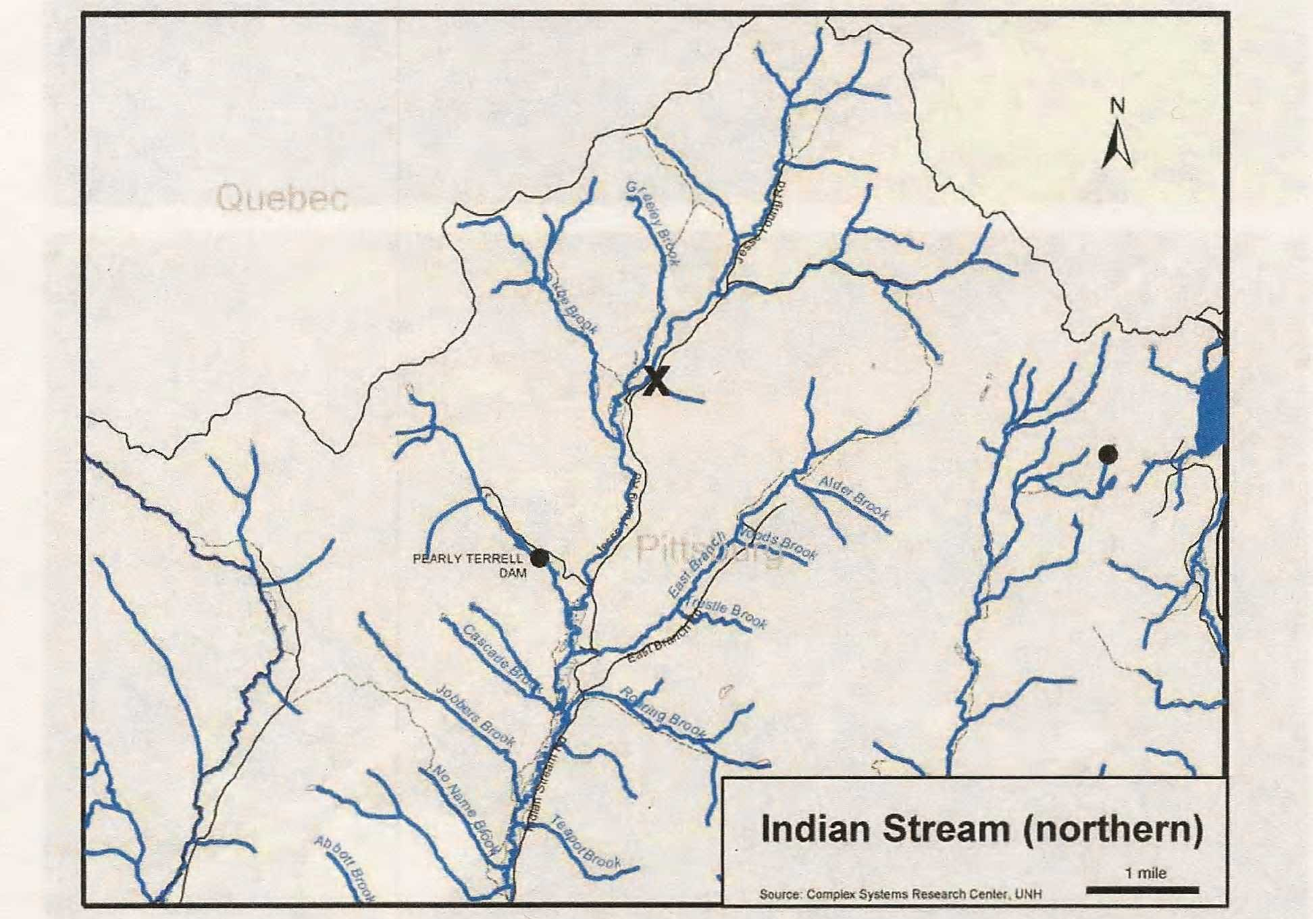

*Black Dots=Dams, Black X=Barriers (Culverts), Gray X=Possible Barriers
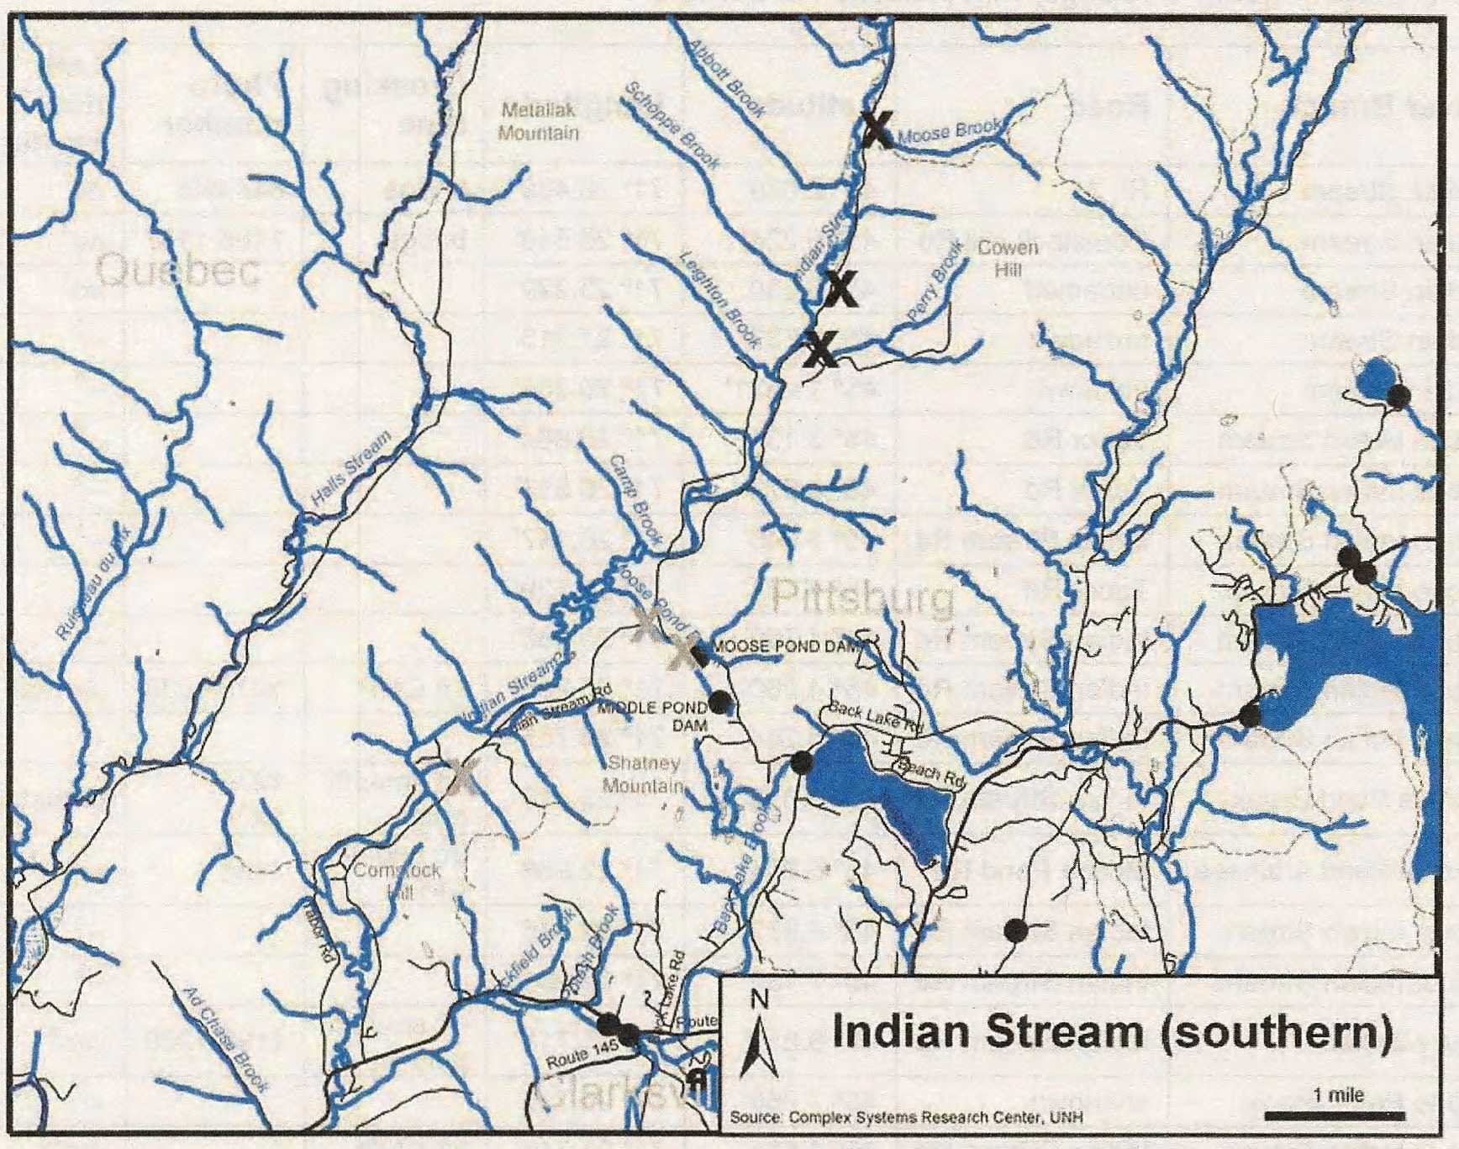

*Black Dots=Dams, Black X=Barriers (Culverts), Gray X=Possible Barriers

IV. Proposed Budget
Partner | Activity | NFHAP  Request | Non-Federal Contribution | Federal Contribution | Total | Acres/Miles  Affected
Upper Connecticut River Enhancement & Mitigation Fund | Aerial survey, Detailed Assessment & Riparian Plantings |  | $80,000 Pending |  | $80,000 | 25 Miles
EBJV | Aerial Survey, Detailed Assessment & Riparian Plantings |  | $30,000 |  | $110,000 | 25 Miles
Trout & Salmon Foundation | Aerial Survey |  | $10,000 Pending |  | $120,000 | 25 miles

Costs | Amount | Totals
Aerial Survey | $15,000 | $15,000
Detailed Geomorphic and Habitat Assessment | $70,000 | $95,000
Riparian Plantings | $30,000 | $115,000
Salaries, Benefits & Operating Expense | $6636 | $121,636

V. Evaluation Questions

- Conservation of Sustainable Brook Trout Populations:

Based on TU’s initial habitat assessment in 2005 and state NH Fish & Game data, Indian Stream contains native EBT (Emerson 2003a, Graber 2005) and was identified as a tributary of the Upper Connecticut River where major fish benefits could occur from restoration efforts. Trout Unlimited will play a major partnership role with state, federal, and local agencies, organizations and landowners, in a multi-year effort to restore Indian Stream, a native eastern brook trout tributary of the Upper Connecticut River. Indian Stream is unique in having a single large cooperating landowner (Lyme Timber) with strong state-owned and monitored conservation easements in place. Restoration efforts will improve over 25 miles of stream that have been affected by historical logging practices since the 1800’s. While the habitat is severely degraded, the common watershed-wide problem of overall mainstem connectivity is good with EBT able to migrate freely into and out of Indian Stream to the Connecticut River, allowing passage for all life stages of EBT.

- Threatened and Endangered Species and Species of Conservation of Management Concern:

Restoration of Indian Stream will also help many other native fish species, large game, and small game including Woodcock and Ruffed Grouse.

- Other Species of Economic Importance not Included Above:

Recreation, including hunting and fishing, and forest products are the only major industries in northern NH. The fish and wildlife of the north country enhance the region economically. The watershed is a popular recreation destination for all New England. Riparian restorations will enhance woodcock and ruffed grouse habitat and instream projects will help many native species, including EBT.

- Special Considerations:

Indian Stream has temperature concerns, running wide and shallow with few mature trees lining the stream. Riparian plantings will serve as a hedge against the threat of climate change and the trend towards warmer weather. With the majority of the land in conservations easements and owned by a single large landowner, Indian Stream poses a unique opportunity. The benefits of stream restoration will be seen this tributary as well as in the mainstem Upper Connecticut, aiding migratory fish and promoting cooler downstream for EBT in the mainstem Connecticut..

- EBJV Target Watershed:

The watershed is located in #33080,33084, a major tributary of the Upper Connecticut.

- Habitat Connectivity and Enhancing Population Mobility:

Indian Stream has the largest baseflow in TU’s 465 sq. mi. project area. It has been severely affected by historical logging practices, but overall connectivity is good with no barriers on the mainstem and few (4) culvert barriers on feeder tributaries. EBT can now migrate freely from the Upper Connecticut to Indian Stream. Because connectivity is not a serious problem,restoration efforts can focus on instream and riparian restorations that will greatly enhance the productivity of this major tributary.

- Management Assets

This grant will initiate restoration efforts on Indian Stream beginning with a detailed geomorphic and habitat assessment targeting EBT, conducting an aerial photographic survey, and to initiate riparian plantings. State agencies will assist in projects and monitor work including conducting long-term evaluations of populations of EBT and other native species. The watershed is protected by state easements with the Department of Economic Development, with open access to the public for recreation, including hunting, fishing and hiking.

- Letter of support:

Attached Letter of Support from NHFG.

