Marshall Brook, ME culvert replacements: A NFHAP project for the EBTJV

Project Location: Maine, Hancock County, Town of Southwest Harbor
- Congressional District of Project: ME 2
- Congressional District of Applicant: ME 2
EBTJV / NFHAP Funding Requested: $50,000
- Total Project Cost: $150,000
- Total Federal Matching: $3,750
- Total Non-Federal Matching: $96,250

APPLICANT
Organization: Maine Department of Inland Fisheries & Wildlife
Project Officer: Greg Burr, Regional Fishery Biologist
Street: 317 Whitneyville Road
City, State, Zip: Jonesboro, ME. 04648
Telephone Number: (207) 434-5925
Fax Number: (207) 434-5923
EMail Address: gregory.burr@maine.gov

U.S. Fish and Wildlife Service Sponsoring Office
Fish and Wildlife Service Office: Maine Fishery Resources Office
- Project Officer: Scott Craig
Street: 306 Hatchery Rd.
- City, State, Zip: East Orland, ME 04431
- Telephone Number: (207) 469-6701 ext 226
Fax Number:
EMail Address: Scott_Craig@fws.gov

USFWS FONS Database Project Number: 53371-2010-360

Coordination Completed with US Fish and Wildlife Service Fisheries Office (Check One):
X Yes, 8/23/2010 Date Coordination Began
No
I. PROJECT DESCRIPTION, SCOPE OF WORK, AND PARTNER INFORMATION

A. Project Description and Scope of Work (Max Characters: 500):
We propose to replace the existing undersized, improperly set round culvert inhibiting fish passage at the road/stream crossing of Marshall Brook with the Seal Cove Road in Southwest Harbor, Maine with an open bottom culvert. The Town of Southwest Harbor owns the site and will also install the replacement crossing. This action will reconnect a historic sea run brook trout stream with the estuary at Bass Harbor.

B. Proposed Methods (Max Characters: 350):
MDIFW will contract with the Town of Southwest Harbor to install an open bottom culvert on the east branch of Marshall Brook in conjunction with the town’s scheduled efforts to replace an undersized, problematic crossing on the west branch of Marshall Brook.

C. Project Timeline: Design work is underway and preliminary fishery monitoring surveys for this project have already been completed. We propose a construction window for fall of 2011 to coincide with a scheduled crossing replacement on the west branch of Marshall Brook. MDIFW will perform post-replacement fishery monitoring at both sites annually through 2013.

D. Proposed Accomplishment Summary (Max Characters: 500):
This project will reconnect a historical sea run brook trout stream with a coastal estuary. In addition, replacing the existing undersized culvert on the east branch of Marshall Brook will return the stream to a natural flow regime with less backwatering and thermal stress issues. This project greatly assists attaining goals for the EBTJV, NFHAP, and Maine’s Comprehensive Wildlife Conservation Strategy.

E. State the Importance of the project to the Resource (Max Characters: 350):
This project will reconnect about 4 miles of coastal stream with the Bass Harbor estuary. A remnant resident population of brook trout will again have free access to the marine environment. Maintaining estuarine connections is vital for the long term sustainability of brook trout in small, coastal stream networks.

F. Problem and Specific Cause of the Problem (Max Characters: 350):
An undersized, improperly set culvert has caused extensive backwatering on the upstream side of the crossing. It is a barrier to fish passage and blocks the flow of water and sediment. This results in a significant impoundment subject to elevated water temperatures. Southwest Harbor has targeted both crossings of Marshall Brook for remediation.

G. Objective of the Project with Reference to the Problem (Max Characters: 350):
The primary objective is to reconnect a remnant coastal brook trout population to the estuary by replacing a chronic fish passage barrier with an open bottom arch culvert.

H. Partner Information (not to exceed 100 words)

Partner Name | Contribution  In-Kind | Contribution  Cash | Federal or Non- Federal | Partner  Category | Role of Partner
MDIFW | $5000 |  | Both | State Agency | Project management, permitting assistance, project monitoring
Town of Southwest Harbor | $45,000 | $50,000 | Non-Federal | Local Government and Landowner | Replace East and West Branch Crossings

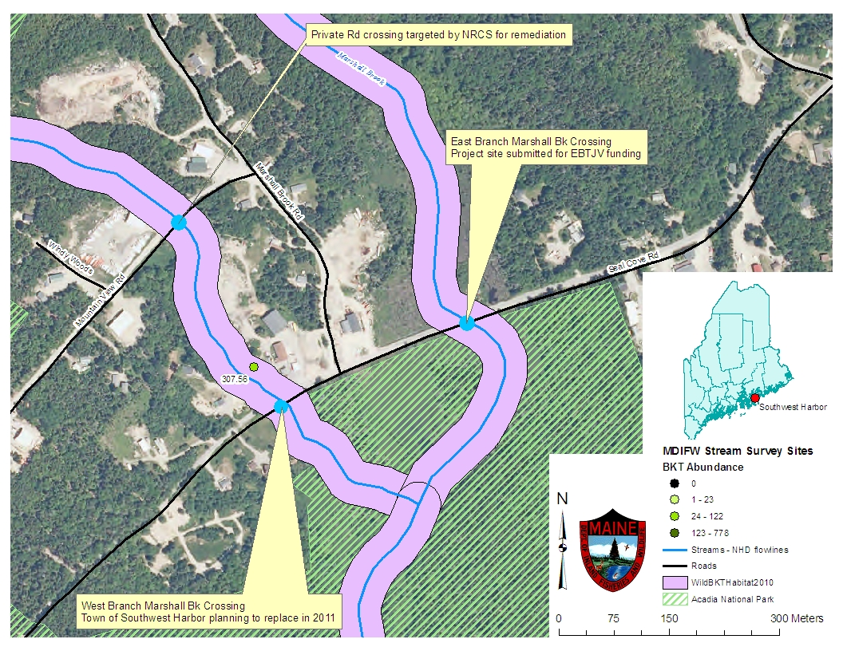
II. MAP OF PROJECT AREA (one only)
Site location of proposed culvert replacement at the crossing of the East Branch of Marshall Brook with the Seal Cove Rd, Southwest Harbor, ME.

III. PHOTOGRAPH(S) OF PROJECT AREA (no more than 2, please provide credits and attach photo release forms)

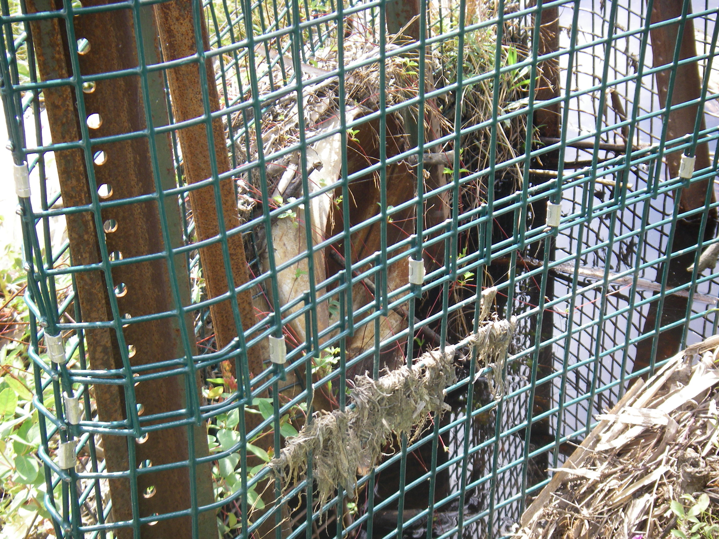
Upstream end of East Branch Marshall Brook existing culvert. Note the bottom of the culvert is above the water level signifying that the existing culvert is placed too high relative to the stream bed.
Photo credit: M. Gallagher, MDIFW

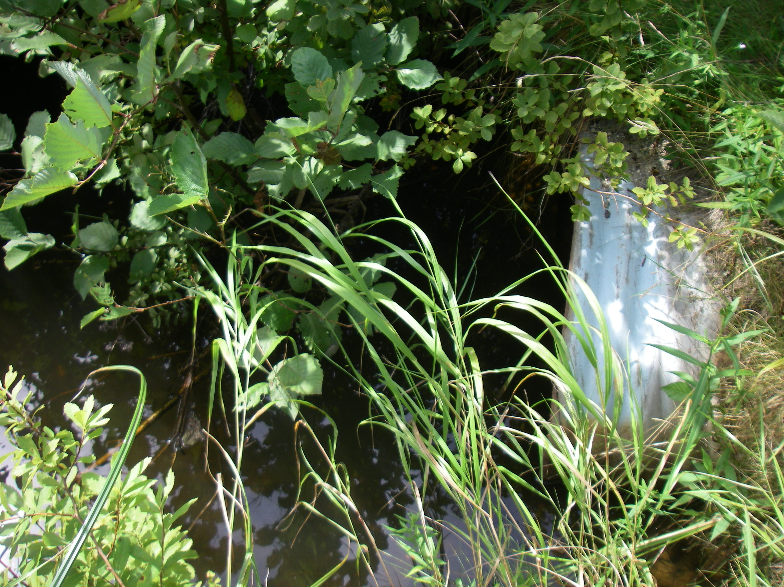
Downstream end of the East Branch Marshall Brook existing culvert. Note the width of the stream channel greatly exceeds the width of the culvert opening.
Photo credit: M. Gallagher, MDIFW

IV. PROJECT BUDGET

B. Budget Table

Partner Name | Partner Category * | Activity of Partner ** | Budget Category*** | EBTJV  NFHAP Request | Non-Federal Contribution |  | Federal Contribution |  | Total Contribution | Acres/  Miles Affected
 |  |  |  |  | In-Kind | Cash | In-Kind | Cash | Total Contribution | Acres/  Miles Affected
MDIFW | State Agency | Environmental Permitting | Other |  | $250 |  | $750 |  | $1000
MDIFW | State Agency | Project Monitoring | Monitoring |  | $1000 |  | $3000 |  | $4000
Town of Southwest Harbor | Local Government and Landowner | Replace West Branch Crossing | Construction | $10,000 | $25,000 | $50,000 |  |  | $85,000 | ~2 miles
Town of Southwest Harbor | Local Government and Landowner | Replace East Branch Crossing | Construction | $40,000 | $20,000 |  |  |  | $60,000 | ~2 miles
Total Contribution |  |  |  | $50,000 | $46,250 | $50,000 | $3,750 |  | $150,000 | ~4 miles

- EVALUATION QUESTIONS

- Please provide the GPS Coordinates for the project in UTM NAD 83.
Site coordinates are: 552140.98 W 4903741.78N (NAD83, Zone 19N)

- Please list the type of project. Examples include: in-stream habitat, riparian planting, fencing, AMD, fish passage, reintroduction, assessment, etc.
This is a fish passage project.

- Does the project include a protection component? If so, explain how the project sufficiently protects brook trout habitat. Does the project include fee simple land purchase or easements?
Much of the Marshall Brook drainage is within Acadia National Park. In addition, the upstream site on the West Branch of Marshall Brook targeted for remediation by the NRCS will include a 15 year habitat conservation agreement between the landowner and the NRCS. Maine’s programmatic permit with the Army Corps of Engineers (ACE) requires replacement crossings to comply with a minimum standard of 1.2 x bankful width with a natural substrate bottom through the crossing. In addition, the Town of Southwest Harbor is designing crossing criteria for both the East and West branches to meet or exceed 100 year flow events. Hence, this crossing, once replaced will guarantee unhindered fish passage for the lifetime of this crossing as well as replacements in the future.

- What percentage of the watershed above the proposed project is protected in perpetuity?
Approximately 75% of the drainage area above the project site is within Acadia National Park and hence, is protected in perpetuity.

- List the specific regional EBTJV habitat objectives addressed by the project and describe how the project will contribute towards them.
This project addresses Regional Habitat Objectives: 1 – Maintain the status of 477 Northern subwatersheds classified as Healthy; 2 – Strengthen brook trout populations in 20 Northern subwatersheds classified as Healthy; 7 – Validate the predictive status model by contributing toward the assessment of 700 Northern predicted status subwatersheds.

- List the specific state-level EBTJV habitat objectives addressed by the project and describe how the project will contribute towards them.
This project addresses Maine State Habitat Objectives: 2.1.2 – Identify degraded stream habitats and prioritize for restoration efforts – Identify barriers to fish passage and re-establish habitat connectivity where possible; 2.2.2 – Identify critical areas and habitats for conservation planning and land protection, identify critical spawning, nursery, thermal, and winter refuge areas. The marine environment is a vital thermal refuge for coastal brook trout populations. 2.4.1 – Restore degraded habitats, establish collaborative partnerships with State, Federal, Tribal, and private entities to implement stream restoration projects. 2.4.2 Restore degraded habitats, monitor efficacy of implemented projects for ecological responses and indicators of success.

- Please state whether the project is an enhancement, restoration or protection project.
This project is an enhancement project with the goal of improving the overall drainage connectivity from headwater to estuary. This project is located within the ‘best of the best’ coastal brook trout habitat in Maine and contributes toward reconnecting brook trout habitat to existing protected habitats in Acadia National Park.

- State which, if any, EBTJV priority the project addresses:
This project improves and reconnects habitats within an area of the ‘best of the best’ coastal brook trout habitat. The drainage supports a healthy, self sustaining population of brook trout although current access to the marine environment is limited.

- What is the EBTJV priority ranking for the proposed project watershed for the type of project (enhancement, restoration or protection) being proposed?
Watershed # = 230822
Priority Score = 1.66
Map = All Maine maps have this priority score for the subwatershed

- Will the completed project benefit any federally listed threatened or endangered species?
This project may benefit the federally listed Atlantic salmon and falls within the Distinct Population Segment (DPS).

- Will the completed project benefit any state listed threatened or endangered species?
This project will likely increase all native fish species inhabiting Marshall Brook. Overall increased fish abundance will likely benefit Least Bitterns known to forage in the Marshall Brook estuarine marshes. Least Bitterns are listed as Endangered by the State of Maine.

- Does the project demonstrate watershed scale planning?
The project subwatershed and all adjacent to it are classified as Intact or Predicted Intact. Acadia National Park is currently systematically replacing and upgrading all the road/stream crossings within the Marshall Brook drainage on their lands. The NRCS is currently working with one private landowner to address fish passage constraints at the crossing of the West Branch of Marshall Brook above the proposed project area. This proposal addresses the two crossings within the drainage owned by the Town of Southwest Harbor.

- Please describe how the project will provide for the expansion or improvement of existing habitat?
This project addresses multiple habitat concerns within the Marshall Brook system. We propose to reconnect the headwaters of Marshall Brook to the estuary at Bass Harbor. This will return the system to a natural flow regime from headwater to estuary. In addition, upgrading the crossing conditions at both the East and West Branch sites, will increase local water and sediment flow, decrease backwatering complications and assist with alleviating thermal stress for trout.

- What are the root causes of the watershed degradation and which of these are addressed by the project?
The root causes to overall habitat degradation in this system is a loss of ecological connectivity from headwater to estuary. We propose to address this concern at two road/stream crossings within the drainage.

- Describe the plans for post project monitoring and evaluation.
MDIFW will continue annual standardized fish, habitat and geomorphic survey protocols above and below the project sites for two years. MDIFW already completed comparable surveys at the West Branch site in 2007. Because of extensive backwatering at the East Branch site, similar survey efforts were not able to be completed at that time. MDIFW will also solicit local anglers to provide angling trip information as part of our Volunteer Angler Program for a minimum of two years after project completion to assess changes to the fishery subsequent to remediation of the identified connectivity issues.

- Describe the expected effect on the brook trout population. To what degree will the project strengthen the brook trout population status?
We expect the Marshall Brook brook trout population to increase in both number and size quality. By addressing the fish passage constraints on this system, trout will have access to much more habitat as well as the ability to move between freshwater and marine habitats at will. Coastal trout that forage in estuaries can attain considerable size compared to non-migrants.

- Please describe the long term benefit of the project and provide an estimate of the length of time the project is expected to be effective. If a plan for long term maintenance is necessary, please describe it.
This project will remedy identified fish passage constraints at two sites for the duration that a road remains at the site. Although the lifespan of road/stream crossings is about 15 years, recent changes in Maine Law and permitting processes will guarantee that subsequent replacements at these sites conform to fish passage requirements.

- What size stream does the project benefit - tributary stream or main-stem habitats?
This project benefits all stream types form headwater to mainstem to estuarine habitats.

- What competitive non-native or invasive fish are in the watershed with access (no barrier) to the proposed project?
None

- Are other strains of brook trout or other salmonids or other exotics stocked within the proposed project watershed? Where (e.g. upstream, downstream, and distance from project site) does the stocking take place with respect to the project site? There are no other strains of brook trout or other salmonids or other exotics stocked within the project watershed.

- Please describe the current status of the project. Is it planned, permitted and ready to begin? Please identify the targeted month and year for project completion.
The sites have been identified as problematic since 2007. The Town of Southwest Harbor is currently designing remedial replacements for both crossings and completed designs are expected by January 2011 . MDIFW will procure all necessary environmental permits over winter/spring 2011. This project should comply as category 1 – Notification Required under Maine’s Programmatic General Permit with the ACE for stream crossing activities. Design standards for both sites will comply with the Corp’s Category 1 non-reporting exemption. MDIFW will also consult with MDEP for NEPA compliance and this project will likely comply as a Categorical Exclusion under one or both of the following:
1.4 B. Resource Management.
(3) The construction of new, or the addition of, small structures or improvements, including structures and improvements for the restoration of wetland, riparian, instream, or native habitats, which result in no or only minor changes in the use of the affected local area. The following are examples of activities that may be included.
1.4 E. Financial Assistance.
(1) State, local, or private financial assistance (grants and/or cooperative agreements), including State planning grants and private land restorations, where the environmental effects are minor or negligible.
MDIFW will also consult with the Maine Historic Preservation Commission to assure that the project poses no threats to resources of historic or cultural significance.
MDIFW will also consult with USFWS Ecological Services office to remediate any potential conflicts with federally listed Atlantic salmon. Although the site is within the Gulf of Maine DPS, the site does not fall within designated critical habitat for the species.

- Will public access be allowed at the project site? If so, what kinds of recreational activities are allowed - public fishing, nature trails, etc?
Public access and recreational angling will continue to be allowed the full length of stream riparian zone.

- What is the recreational quality of the potential fishery?
The quality of the recreational fishery in the Marshall Brook system below the problematic crossing is very high with anglers catching larger sized sea-run as well as resident wild eastern brook trout. The proposed new crossing will reconnect up-stream cold-water refugia, spawning and nursery habitat to the migrating and resident wild trout populations below. Overall size quality of fish inhabiting the upper reaches should increase as larger sized individuals found below can once again access the headwaters.

- Describe any outreach or educational components of the project and how many individuals / students will be served.
This project has the potential to be a great demonstration project highlighting newer fish passage guidelines for road/stream crossings in Maine on municipal properties. Recent changes in Maine Law regulating road/stream crossing standards has caused some concern among private and municipal landowners. The Town of Southwest Harbor is working with fishery managers to show that compliance with new guidelines can be achieved cooperatively.

- If applicable, please briefly describe how this project will promote adaptation to climate change.
Coastal trout populations disconnected from estuarine access are often at grave risk of local extirpation because coastal trout often use estuaries as thermal refugia. By reconnecting coastal populations with estuarine access, we can assure thermal refuge areas are available even as interior temperature regimes change.

- Please explain how this project is a good investment of funds, using a quantitative approach where possible and the recreational and / or economic value of the project.
This project is a great investment because for a moderate cost ($50,000) two problematic fish passage constraints can be addressed simultaneously at a much reduced overall project cost than if each was replaced individually. The two crossings, one on the East Branch and one on the West Branch of Marshall Brook, are relatively near each other and the roadbed will need to be leveled and raised to accommodate the upgraded designs. Being able to modify the roadbed for both crossings simultaneously is much more cost effective than if the Town replaced each crossing at differing times. The Town has already approved the upgrade for the West Branch crossing and the necessary road work to accommodate it. With this investment of $50,000 or basically the cost of another new open bottom culvert pipe, the East Branch crossing can be remedied simultaneously. In addition, the ecological benefits of reconnecting both headwater branches to the mainstem of Marshall Brook are pronounced. The upgrades of both these crossings will reconnect both headwater branches to free-flowing, natural conditions to the Bass Harbor estuary.

- Specify the NFHAP tasks upon which you will work. A list of tasks to choose from can be found in the instruction document.
- Number: P-6. 4 | Type: Habitat
Build strong grassroots support that places fish habitat conservation high on the public agenda. Partners at all levels—federal, tribal, state and local—will help bring new and sustained attention to the need for action and will mobilize diverse stakeholder groups to advocate for fish habitat protection, restoration and enhancement.
- Number: Strategy 1 – Identify and protect intact and healthy waters | Type: Habitat
Project or action identifies healthy intact systems to protect from the threats of degradation. This may include efforts that not only identifies those areas, but actively protects them through on the ground efforts. Example of this would include (but not limited to) purchasing of lands or exclusion fencing from cattle.
- Number: Strategy 2- Restore natural variability in river and stream flows and water surface elevations in natural lakes and reservoirs. | Type: Habitat
Project or action works towards rehabilitating natural flow regimes in a system. Actions could include but are not limited to identifying those areas in need of flow regime restoration, and actively restoring natural flow and variability through such actions as water level manipulation or stream bed restoration
- Number: Strategy 3 – Reconnect fragmented river, stream, reservoir, coastal, and lake habitat to allow access to historic spawning, nursery and rearing grounds. | Type: Habitat
Project or action works towards reconnecting habitats within a system. This would include, but are not limited to, actions such as barrier removal.

- Please describe the expected Performance Metrics. A list of Service performance measures to select from can be found in the instruction document.
    - Total number of population assessments completed – MDIFW will conduct a minimum of 8 additional fish population assessments, one above and below each site for at least two years post culvert replacement.
5.1.10 Total number of in-stream/shoreline miles restored in U.S. – this project will restore about 4 miles of stream to a natural flow regime.
5.1.11 Total number of fish passage barriers removed or bypassed – 2 existing fish passage barriers will be removed.
5.1.12 Number of miles re-opened to fish passage – About 4 miles of coastal stream will be open from headwater to estuary.

- SUPPORTING DOCUMENTATION:

- Literature Cited
- References to published interagency fishery or aquatic resource management plans.

