Eastern Brook Trout Joint Venture
Completed Project Report Form

Project Title: North River VA Stream Channel Restoration for Brook Trout Under EBTJV/NFHAP

- Sponsor: Trout Unlimited

- Partners involved:
Virginia Department of Game & Inland Fisheries
George Washington National Forest
Virginia Council of Trout Unlimited
Appalachian Partnership Coordination Office

- Project costs:
Total cost: $37,000
Non federal amount: $2,000
Federal amount: $35,000

- Describe any additional species of greatest concern or the state wildlife action plan listed habitat conservation goal (s) supported by the project.
Cow Knob salamander
Neotropical migratory songbirds such as the cerulean warbler

- Description:
This project is part of a larger effort that began in 2004 with the long-term goal of re-establishing native brook trout in a six mile stretch of stream in the George Washington National Forest. This area was channelized in the 1950’s and 1960’s. Gabions were also installed in the past, but due to improper installation they served to accelerate water velocities and down-cutting. The result of these cumulative actions was a loss of the pool / riffle association. To date, more than 4,000 linear feet of stream have been restored and brook trout re-established. This project restored approximately 0.75 miles of stream using natural channel design.

- Methods used:
Natural channel design methods were used to install a series of cross-vein and J-structure in-stream devices to stabilize flows and create and maintain low-water pools that will serve as essential habitat during droughts and other seasonal low-flow periods.

- If applicable, what is the number of stream miles and or acres of brook trout habitat?:
This project restored 0.75 miles of stream for brook trout.
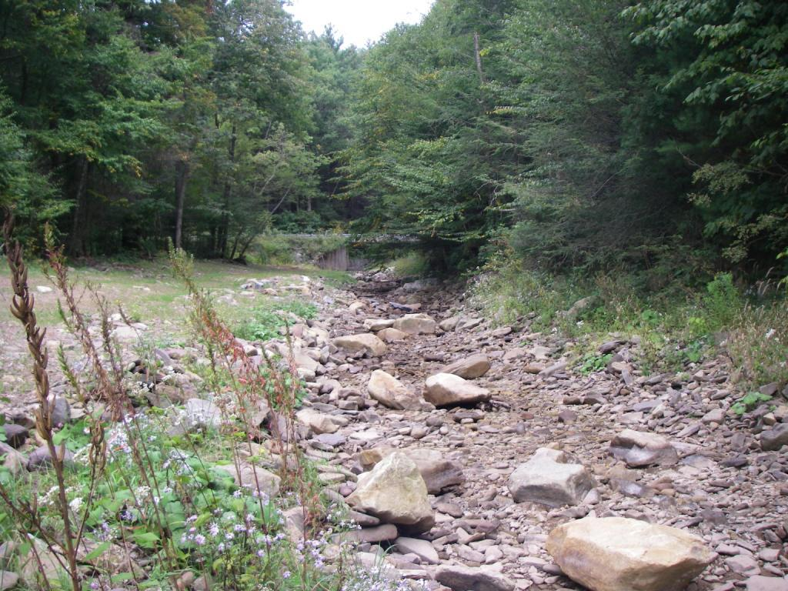

Photo 1: North River Before Construction
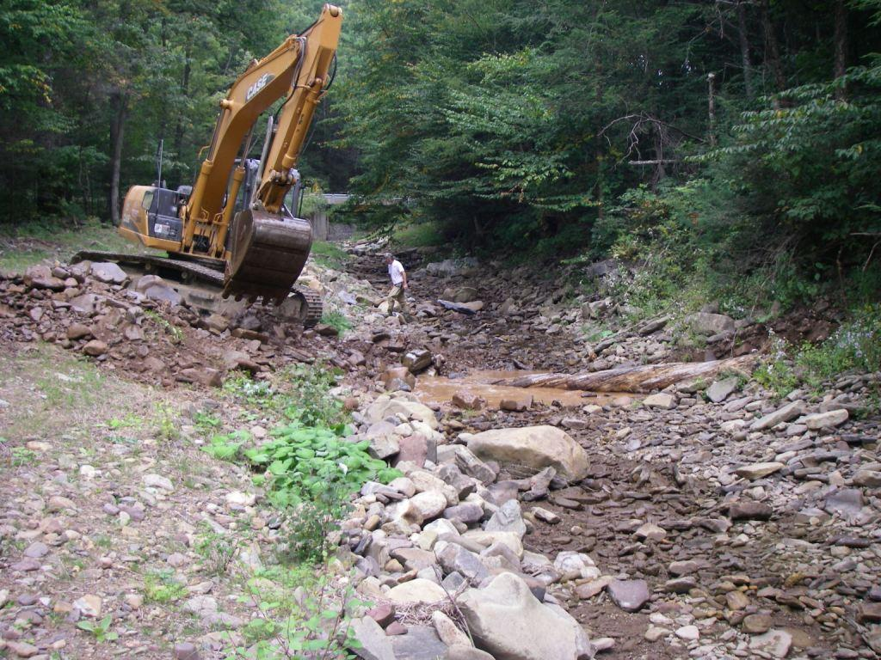

Photo 2: North River During Construction
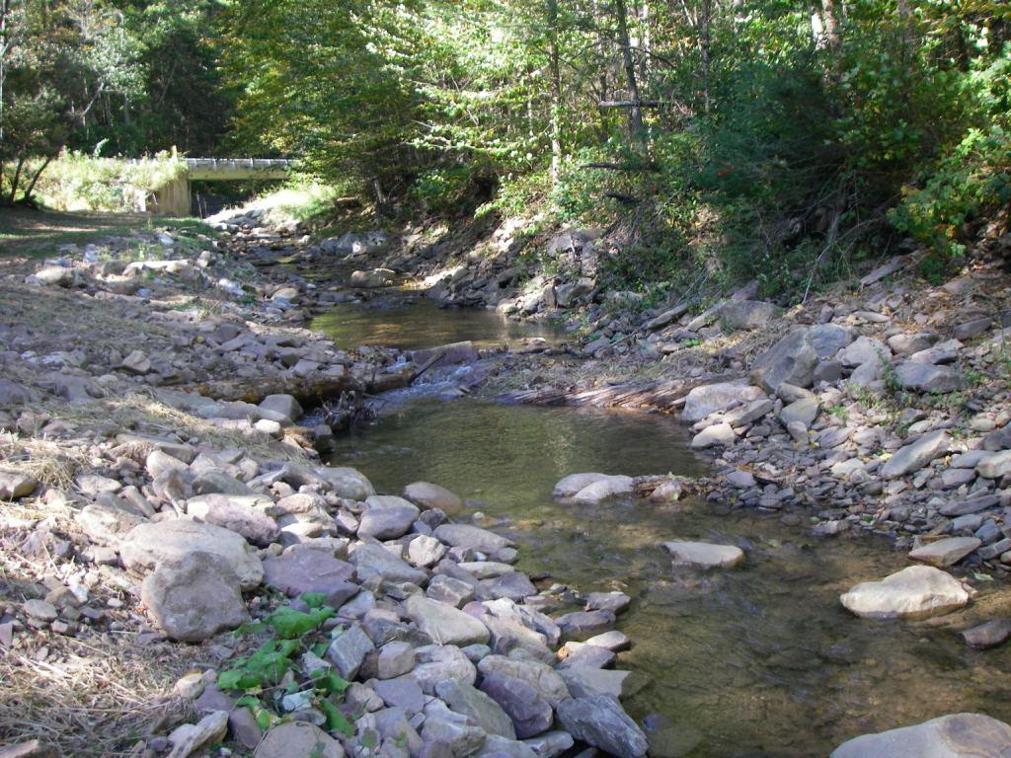

Photo 3: North River After Construction

