WVDNR Stream Restoration Program:
Upper Shaver’s Fork, WV: Aquatic Passage

Project Location: Randolph/Pocahontas Counties, WV
- Congressional District of Project: WV-02, WV03
- Congressional District of Applicant: WV-02
EBTJV / NFHAP Funding Requested: $50,000
- Total Project Cost: $545,860
- Total Federal Matching: $23,000
- Total Non-Federal Matching: $472,860

APPLICANT
Organization: West Virginia Division of Natural Resources, Wildlife Resources Section

Project Officer: Steve Brown, Program Manager, Stream Restoration Program

Street: PO Box 67, Ward Road

City, State, Zip: Elkins, WV, 26241

Telephone Number: 304-637-0245
Fax Number: 304-637-0250
EMail Address: stevebrown@wvdnr.gov

Sponsoring U.S. Fish and Wildlife Service Fisheries Office
Fish and Wildlife Service Office: Appalachian Partnership Coordinators Office
- Project Officer: Keith McGilvray
Street: 400 E. Main St.
- City, State, Zip: White Sulphur Springs, WV 24986
- Telephone Number: (304) 536-4760
Fax Number: (304) 536 4634
EMail Address: Keith_McGilvray@fws.gov

USFWS FONS Database Project Number : 53374-2010-358

Coordination Completed with US Fish and Wildlife Service Fisheries Office (Check One):
X Yes, 9/1/2010 Date Coordination Began
No
I. PROJECT DESCRIPTION, SCOPE OF WORK, AND PARTNER INFORMATION

A. Project Description and Scope of Work

The Stream Restoration Program (SRP) of the WVDNR seeks to restore habitat linkages between two spawning tributaries and the mainstem of the Upper Shaver’s Fork (USF) between Cheat Bridge and Spruce, WV. Poor tributary-mainstem connections continue to threaten the sustainability and expansion of brook trout populations in genetically isolated tributaries as well those in the USF mainstem. To address these problems, two blocking railroad culverts will be replaced with passage-friendly culverts.

B. Proposed Methods

Utilizing equipment suitable for worksites accessible only by rail, WVDNR will replace two barrier culverts with precast bottomless box structures. NSD step-pool systems will establish new “connector” channels above and below the replaced culverts. Preliminary NSD designs, landowner agreements, permit applications, and baseline data collection have already been completed.

C. Project Timeline

Design Review Phase: Sept. 1, 2010 – Oct. 30, 2010

- Design and pre-construction review
- Submittal of revisions
- Approval of revisions
- Final Design and construction review
- Finalize Permits
- Order Materials

Implementation Phase: Oct. 30, 2010 – Nov. 15, 2011

- Transport and Stage Materials, Equipment
- Construction @ Lamothe
- Construction @ Beaver
- Quality Control inspections (bi-weekly)
- Final Construction Walk-through and completion
- As-build survey

D. Proposed Accomplishment Summary (Max Characters: 500)

This project proposes to replace two impassable railroad culverts and construction of NSD step-pool systems will 1) facilitate passage to access habitat and cool water refugia during mainstem low flow conditions and 2) ensure the genetic sustainability of tributary brook trout populations. These tributary enhancements will bookend major natural streamchannel design (NSD) projects in the USF mainstem.

E. State the Importance of the project to the Resource (Max Characters: 350)

Physically and genetically isolated tributary populations are vulnerable to local catastrophic events. The habitat in these tributaries is also critical, but unavailable, to fish in the mainstem of USF. To ensure the genetic viability of tributary populations and re-establish an USF meta-population of brook trout, reconnecting these tributaries is of vital importance.

F. Problem and Specific Cause of the Problem (Max Characters: 350)

Beaver Creek and Lamothe Creek are two important tributaries of the USF. Both of these tributaries flow under railroad tracks that parallel the USF. Both culverts are barriers to brook trout attempting to move upstream to spawn or to seek thermal refugia from high summer temperatures in the USF mainstem.

G. Objective of the Project with Reference to the Problem (Max Characters: 350)

The objective of the proposed project is to restore habitat linkages between two spawning tributaries, Beaver Creek and Lamothe Creek, and the mainstem of the USF. WVDNR will replace two barrier culverts with precast bottomless box structures. NSD step-pool systems will establish new “connector” channels above and below the replaced culverts.

H. Partner Information (not to exceed 100 words)

As indicated below, the WVDNR’s SRP is rich in partnerships, notable among which are an interagency agreement with West Virginia University Natural Resource Analysis Center (Davis College of Agriculture, Natural Resources and Design) and a stream restoration design subcontract with Canaan Valley Institute.

Partner Name | Contribution  In-Kind | Contribution  Cash | Federal or Non- Federal | Partner  Category | Role of Partner
NRCS | $10,000 |  | fed | Federal Agency | Technical Assistance, Coordination,
USFS | $10,000 |  | fed | Federal Agency | Technical Assistance, Coordination
WVU | $30,000 |  | Non-fed | State Agency | Assessment, Monitoring, technical assistance
WVDNR |  | $400,000 | Non-fed | State Agency | Funding Source
WV Rail Authority  (WVRA) | $2000 |  | Non-fed | State Agency | Coordination, landowner access
Durbin & Greenbrier Valley Railroad (DGVRR) | $2000 |  | Non-fed | Corporation | Coordination, logistics
Trout Unlimited (TU) | $1000 |  | Non-fed | Corporation | Coordination, technical review
The Nature Conservancy (TNC) | $2000 |  | Non-fed | Corporation | Coordination, Assessment
Shavers Fork Coalition (SFC) | $1000 |  | Non-fed | Local Conservation Group | Coordination, Assessment
Snowshoe | $12,860 |  | Non-fed | Corporation | Coordination, access, housing
Steve Callen | $2000 |  | Non-fed | Private  Landowner | Coordination,  Landowner access
NRCS (WHIP) |  | $3000 | fed | Federal Agency | Trees
WVDNR | $20,000 |  | Non-fed | State Agency | Airborne Lidar Survey
EBTJV/NFHAP |  | $50,000 | Fed |  | Funding Source

II. MAP OF PROJECT AREA (one only)

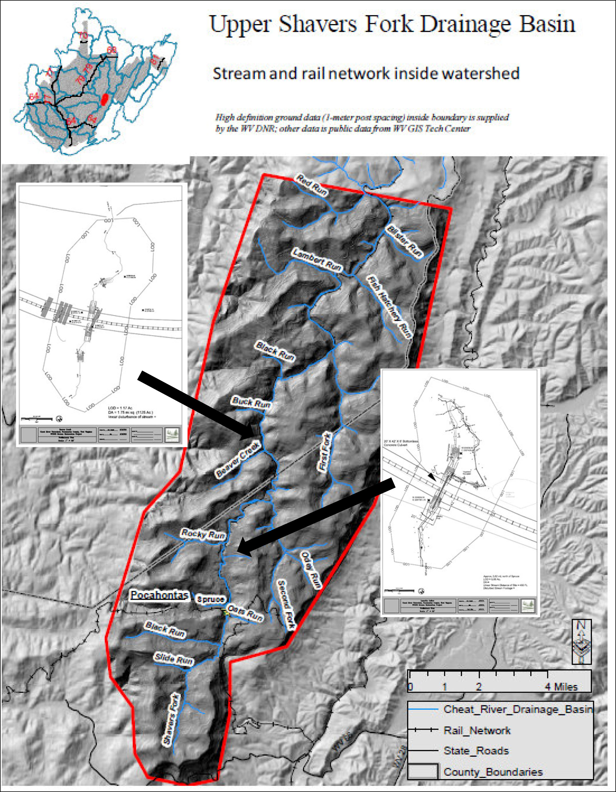

III. PHOTOGRAPH(S) OF PROJECT AREA (no more than 2, please provide credits and attach photo release forms)
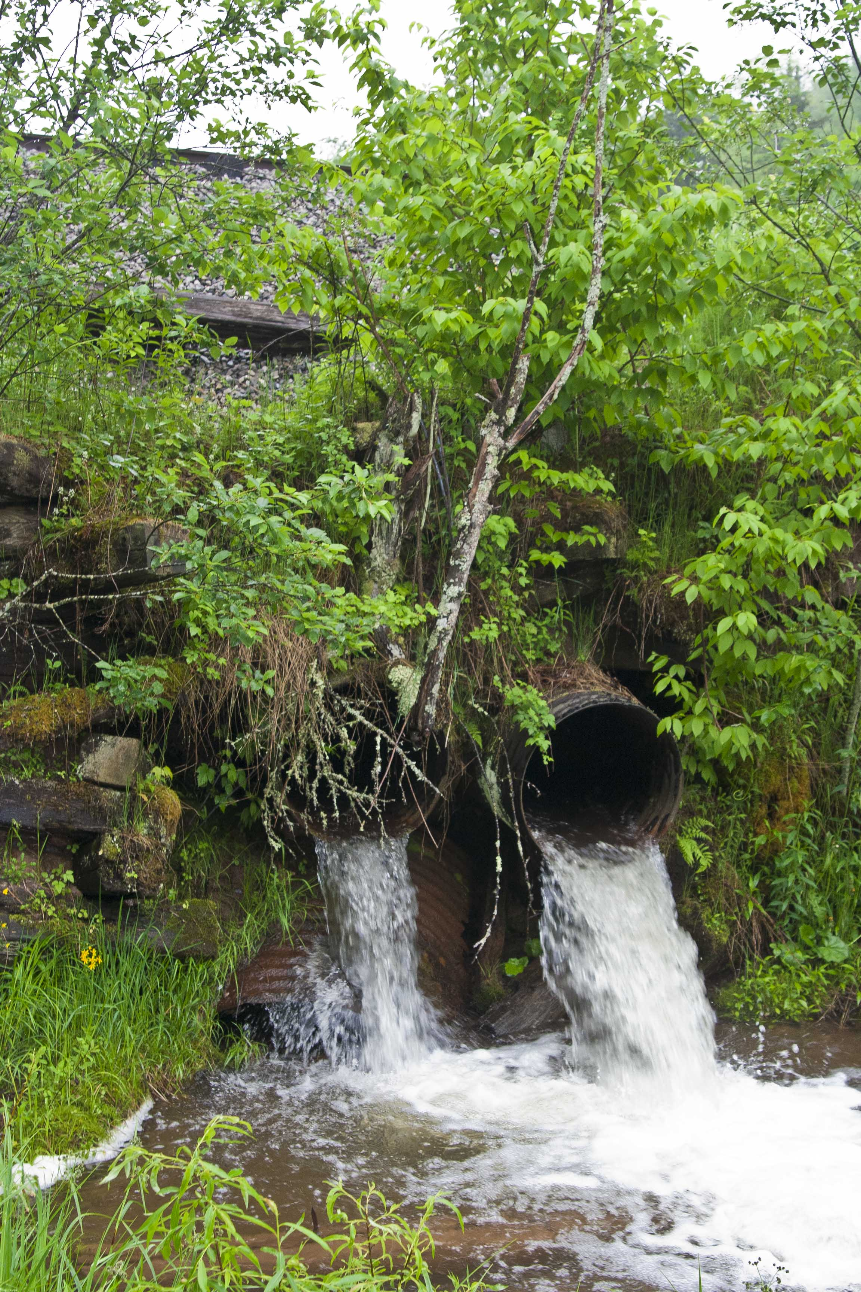

Beaver Creek Culverts

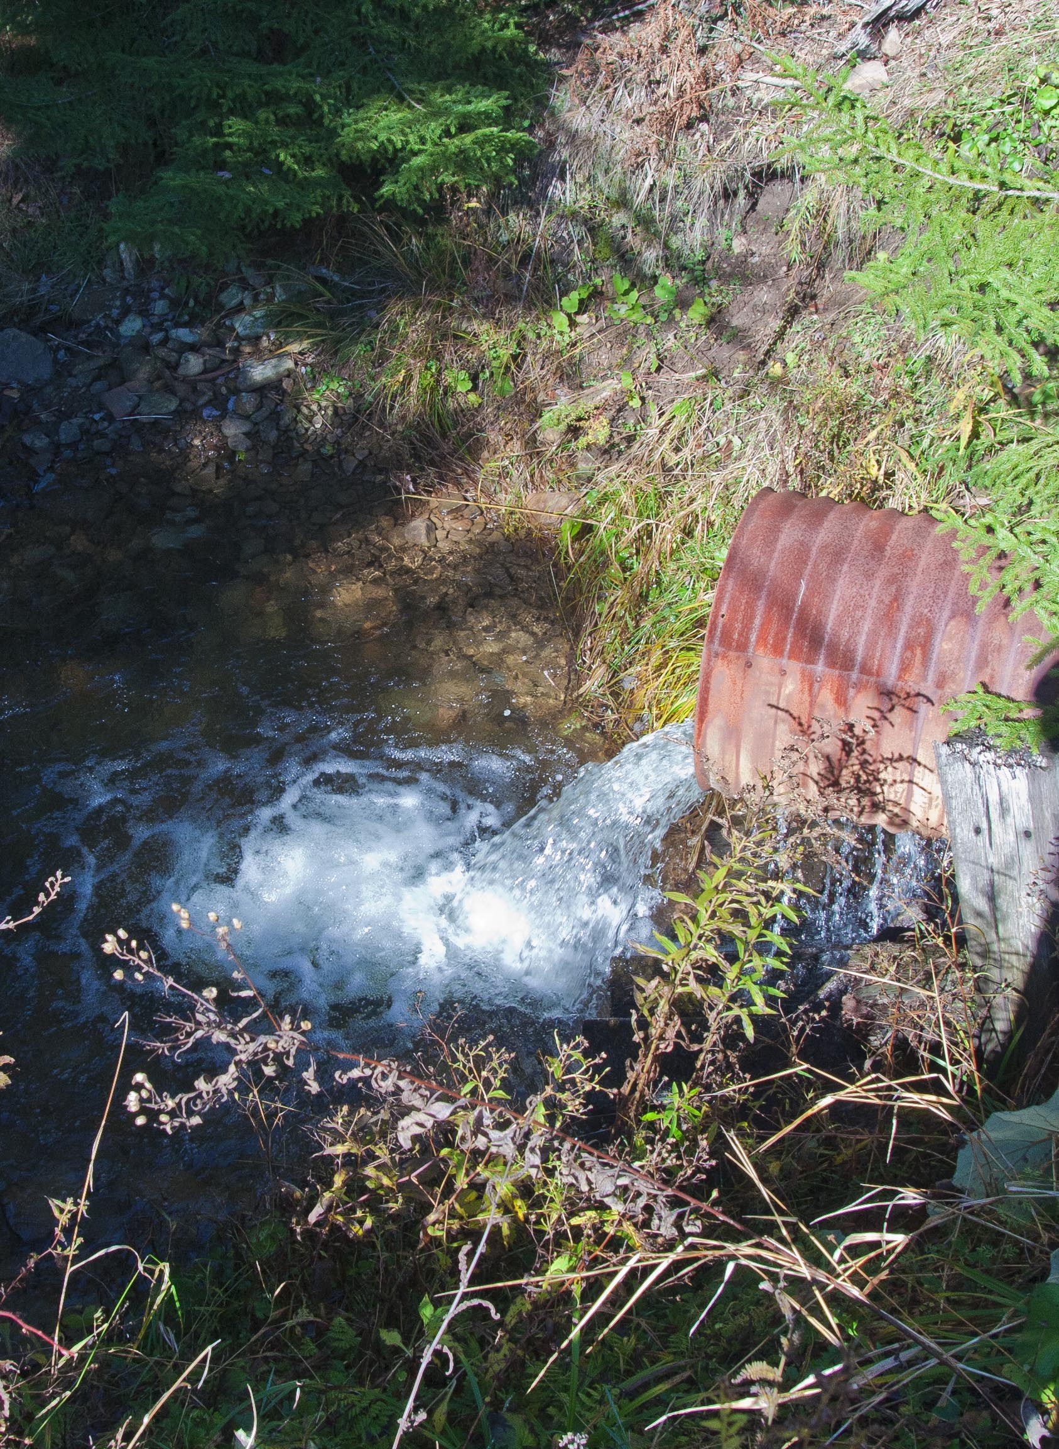

Lamothe Culverts
IV. PROJECT BUDGET

A. General Requirements

These projects will remove fish passage barriers and create habitat and linkages to 2 key brook trout spawning tributaries on the USF (Beaver Creek and Lamothe Run).

Expenses associated with these projects include the following:

WVDNR Stream Restoration Program
Upper Shavers Fork Fish Passage
Beaver Creek and Lamothe
Budget Estimate
Materials |  |  | Cost per Unit/Rate |  |  | Units/hrs. |  | Cost
Bottomless Culverts |  | $50,000 |  |  |  | 2 |  | $100,000
Boulders |  |  | $40 |  |  | 1800 | tons | $72,000
Gravel |  |  | $40 |  |  | 50 | tons | $2,000
non-woven textile |  | $0.80 |  |  |  | 1000 | sy | $800
woven textile |  | $0.80 |  |  |  | 1000 | sy | $800
hardwood mat |  | $2,000 |  |  |  | 1 |  | $2,000
piper slope drain |  | $20 |  |  |  | 800 | ft | $16,000
sod matting |  | $5 |  |  |  | 1500 | ft | $7,500
temporary seeding |  | $200 |  |  |  | 5 | ac | $1,000
permanent plantings |  | $5,000 |  |  |  | 5 | ac | $25,000
brush mattress |  | $10 |  |  |  | 800 | ft | $8,000
Live stakes |  | $5,000 |  |  |  | 2 | job | $10,000
mulch (straw) |  | $45 |  |  |  | 100 | bale | $4,500
mulch (hauling) |  | $50 |  |  |  | 2 | job | $100
Button Cap Nails |  | $15 |  |  |  | 4 | 10lbs | $60
Silt Fence |  | $2 |  |  |  | 200 | ft | $400
 |  |  |  |  |  | subtotal |  | $250,160
Equipment |  | Cost per Unit/Rate |  |  |  | Units/hrs. |  | Cost
Hytracker Excav. |  | $90 |  |  |  | 250 | hr | $22,500
25 cubic yd gond. |  | $45 |  |  |  | 160 | hr | $7,200
End Load Railcart |  | $90 |  |  |  | 160 | hr | $14,400
trackmobile |  | $90 |  |  |  | 120 | hr | $10,800
Hi-rail Dump trk |  | $75 |  |  |  | 80 | hr | $6,000
Hi-rail trk |  |  | $40 |  |  | 80 | hr | $3,200
Jd 644 end loader |  | $80 |  |  |  | 160 | hr | $12,800
Hi-rail fuel trk |  | $25 |  |  |  | 80 | hr | $2,000
Mob/demobilization |  | $3,000 |  |  |  | 2 | jobs | $6,000
 |  |  |  |  |  | subtotal |  | $84,900
Labor |  |  | Cost per Unit/Rate |  |  | Units/hrs. |  | Cost
Pre-construction
Project Coord &
Management |  | $60 |  |  |  | 320 | hr | $19,200
Watershed Assess. |  | $75 |  |  |  | 480 | hr | $36,000
Surveys & Permits |  | $75 |  |  |  | 320 | hr | $24,000
Designs |  |  | $100 |  |  | 320 | hr | $32,000
Construction
Operators |  | $60 |  |  |  | 960 | hr | $57,600
Site Supervisor
(Const. & logistics) |  | $75 |  |  |  | 240 | hr | $18,000
Designer Oversight |  | $100 |  |  |  | 240 | hr | $24,000
 |  |  |  |  |  | subtotal |  | $210,800
 |  |  |  | GRAND |  | TOTAL |  | $545,860

B. Budget Table
Partner Name | Partner Category | Activity of Partner | Budget Category | EBTJV  NFHAP Request | Non-Federal Contribution |  | Federal Contribution |  | Total Contribution | Miles Affected
 |  |  |  |  | In-Kind | Cash | In-Kind | Cash | Total Contribution | Miles Affected
WVDNR | State Agency | Culvert removal | Contractual |  |  | 50,000 |  |  | 50,000 | 8
WVDNR | State Agency | Construct | Contractual | 50,000 |  | 250,000 |  |  | 300,000 | 8
WVDNR | State Agency | Restoration | Contractual |  | 20,000 | 100,000 |  |  | 120,000 | 8
WVU | State Agency | Monitoring | Contractual |  | 30,000 |  |  |  | 30,000
NRCS | Fed Agency | Restoration | Contractual |  |  |  | 10,000 | 3,000 | 13,000 | 8
Steve Callen | Private  Land. | Restoration | Other |  | 2,000 |  |  |  | 2,000 | 8
Snowshoe | Business | Restoration | Other |  | 12,860 |  |  |  | 12,860 | 8
SFC | CG Loc. | Restoration | Other |  | 1,000 |  |  |  | 1,000 | 8
TNC | CG Nat. | Restoration | Other |  | 2,000 |  |  |  | 2,000 | 8
TU | CG Nat. | Restoration | Other |  | 1,000 |  |  |  | 1,000 | 8
DGVRR | Business | Restoration | Other |  | 2,000 |  |  |  | 2,000 | 8
WVRA | State Agency | Restoration | Other |  | 2,000 |  |  |  | 2,000 | 8
USFS | Fed Agency | Restoration | Other |  |  |  | 10,000 |  | 10,000 | 8
Total Contrib |  |  |  | 50,000 | 72,860 | 400,000 | 20,000 | 3,000 | 545,860 | 8

- EVALUATION QUESTIONS

- Please provide the GPS Coordinates for the project in UTM NAD 83.

Beaver Creek (590,940E, 4,260,182N)
Lamothe Creek (591,102E, 4,258,085N)

- Please list the type of project. Examples include: in-stream habitat, riparian planting, fencing, AMD, fish passage, reintroduction, assessment, etc.

Fish Passage, Riparian Planting, and In-stream habitat

- Does the project include a protection component? If so, explain how the project sufficiently protects brook trout habitat. Does the project include fee simple land purchase or easements?

These projects are on state-owned property and will be protected as a public resource

- What percentage of the watershed above the proposed project is protected in perpetuity?

75% of the watershed is protected in perpetuity (Monongahela National Forest and WV Rail Authority). 100% of the project area is state property and is protected in perpetuity.

- List the specific regional EBTJV habitat objectives addressed by the project and describe how the project will contribute towards them.

Strengthen brook trout populations in 105 subwatersheds classified as reduced by 2012.
Northern Region = 30
Mid-Atlantic Region = 45
Southern Region = 30

This project will increase successful spawning of larger individuals who have benefited from time spent in a larger stream system, but are currently prevented from returning to their stream of origin.

- List the specific state-level EBTJV habitat objectives addressed by the project and describe how the project will contribute towards them.

Restore habitat conditions needed to improve population productivity and expand brook trout range in reduced and greatly reduced watersheds. Barrier removal will allow trout to return to their stream of origin, improving genetic diversity and thus strengthening the population

- Please state whether the project is an enhancement, restoration or protection project.

Enhancement

- State which, if any, EBTJV priority the project addresses:

The project improves and reconnects habitats adjacent to the best of the best that have a high likelihood of supporting stable brook trout populations.

- What is the EBTJV priority ranking for the proposed project watershed for the type of project (enhancement, restoration or protection) being proposed?

Watershed # = 540417
Priority Score = 0.35
Map = WV Best for Enhancement

- Will the completed project benefit any federally listed threatened or endangered species?

No

- Will the completed project benefit any state listed threatened or endangered species?

No

- Does the project demonstrate watershed scale planning?

These projects demonstrate watershed scale planning. These sites where chosen by the USF coordination committee upon review of a decade of assessment data, field reviews, and with the goal of synergy among other restoration activities planned for the watershed by both WVDNR SRP and USDA NRCS.

- Please describe how the project will provide for the expansion or improvement of existing habitat?

Culvert replacement will allow for fish passage and hence access to and from tributary habitats and cold water refugia. Natural stream restoration above and below culvert replacements will add step-pool habitats to problematic stream confluences.

- What are the root causes of the watershed degradation and which of these are addressed by the project?

Root causes of watershed degradation include pH, temperature, inadequate microhabitats, and tributary fish passage barriers caused by historical railroad construction. This project will remove tributary barriers and will produce microhabitats. While temperatures in the mainstem may not be significantly reduced by culvert replacement, fish will be able to move upstream into tributary cool water refugia during low flows.

- Describe the plans for post project monitoring and evaluation.

Monitoring and assessment plans should be explicitly linked to measurable restoration objectives and restoration objectives should be explicitly linked to known limiting factors in the target system. The proposed plan will combine a long-term monitoring program with a shorter, radio-telemetry study.

Base Monitoring Program

The base, long-term monitoring program will be comprised of the following elements:

- Temperature
- Water Quality
- Habitat Quality
- Benthic Invertebrate diversity and productivity
- Brook trout abundance, growth, and survivorship

The study area for the base monitoring will include an upper control region (upstream of Rocky Run), a lower control region (downstream of Second Fork), and a middle treatment region (between Second Fork and Rocky Run).

Temperature will be monitored continuously from May 1 – December 1 each year with Onset continuous temperature data loggers placed strategically within the study area. At least three data loggers will be placed in the upper and lower control segments. We will place an additional 9-12 data loggers within the middle treatment segment in order to assess fine scale variation in thermal conditions (total # loggers = 3 + 3 + 12 = 18). Previous research has indicated that small scale thermal refugia are critical for brook trout survivorship in the Shavers Fork mainstem.

Water quality and benthic invertebrates will be sampled three times each year (spring (May), summer (August), and fall (November)). Water quality parameters of interest include: pH, conductivity, hardness, total dissolved solids, alkalinity, acidity, sulfates, dissolved metals, nitrate, and total phosphorus. Invertebrate metrics quantified will include: total abundance, total biomass, total genus richness, EPT richness, and WVSCI.

Habitat quality assessments will use techniques of Petty et al. (2001) and Hansbarger et al. (2008). These protocols are designed to quantify overall habitat complexity and the total area of preferred brook trout habitat availability (Hansbarger et al. 2008). Habitat will be measured under spring-time and summer-time baseflow conditions. Habitat parameters quantified will include: mean thalweg depth, CV of thalweg depth, current velocity, substrate composition, pool volume, distance to fish cover, canopy cover, and large woody debris. Brook trout prefer habitats with moderate depth and current velocity within 1 m of cover (Hansbarger et al. 2008).

Brook trout populations will be sampled in June of each year in two different ways. First, we will use three pass depletion sampling at long-term study segments throughout the study area (one in the lower control, one in the upper control, and three in the middle treatment segment). All fishes captured will be identified and weighed and measured. All trout (brook, rainbow, and brown) will be given an individual mark, which can be used to estimate growth, survivorship, and dispersal. Second, we will sample at least 25% of all preferred brook trout channel unit habitats using single pass electrofishing (Petty et al. unpublished manuscript). Brook trout have been shown to prefer intermediate gradient riffle, pool, and run habitats. They also have been shown to avoid low gradient riffles and glides (Petty et al., unpublished manuscript). These channel units have been mapped throughout the study area. We will randomly select 25% of the preferred habitats for regular sampling each year. Trout captured during channel unit sampling will be measured, weighed, and marked.

We propose a base monitoring schedule that will proceed through the proposed construction phase of 2011 and 2012, and continue for a 5-year post construction phase from 2013 – 2017. In total, monitoring will take place from May 2010 through December 2017 (8 year total).

Radio-Telemetry Study

In addition to the base monitoring study described above, we propose to conduct a radio-telemetry study designed much like the study described in Hansbarger (2004) and Hansbarger et al. (2008).

The purpose of the radio-telemetry study will be to:
- Quantify use of the habitat enhancement structures by brook trout;
- Quantify use of thermal refugia created by the restoration project; and
- Determine if the restoration project slows the rate of brook trout loss from the project area during summer-time warming.

The telemetry study will be necessary for determining if the restoration project has been successful in creating thermal refugia and preferred microhabitats for brook trout.

Field sampling for the telemetry study will begin in Spring 2013 and continue through Fall 2014. The study will be finalized Fall 2015 (total period = 2.5 years).

The study area for the telemetry study will be the same area as the base monitoring (including the lower control, upper control, and middle treatment segments).

- Describe the expected effect on the brook trout population. To what degree will the project strengthen the brook trout population status?

Re-connectivity of Beaver Creek and Lamothe Creek to the USF mainstem, along with microhabitat established above and below newly placed bottomless box culverts, will provide ingress and egress to critical spawning habitat, open new areas as cold water refugia, and promote the re-establishment of meta-populations in the USF.

- Please describe the long term benefit of the project and provide an estimate of the length of time the project is expected to be effective. If a plan for long term maintenance is necessary, please describe it.

The replacement of problematic culverts provides immediate as well as long term benefits to the USF brook trout fishery. These benefits will be monitored and measured. With proper designs, these culverts and associated natural stream restoration should last for 50 years or more. The ancillary benefit to the watershed comes through education and an awareness of the importance of fish passage to WV Rail Authority. As they maintain the rail they will be more sensitive to keeping passages open for fish as well as likely to replace other culverts in the future with the fishery in mind.

- What size stream does the project benefit - tributary stream or mainstem habitats?

Both tributary and mainstem habitats.

- What competitive non-native or invasive fish are in the watershed with access (no barrier) to the proposed project?

There are no non-native or invasive fish species in the watersheds proposed for culvert replacement.

- Are other strains of brook trout or other salmonids or other exotics stocked within the proposed project watershed? Where does the stocking take place with respect to the project site?
No

- Please describe the current status of the project. Is it planned, permitted and ready to begin? Please identify the targeted month and year for project completion.

Lamothe Creek is designed and permitted. Beaver Creek is designed and permits pending in the next few weeks. Construction on Lamothe & Beaver (materials staging) will begin in fall of 2010. Both projects will be completed by Fall, 2011.

- Will public access be allowed at the project site? If so, what kinds of recreational activities are allowed - public fishing, nature trails, etc?

Yes, unrestricted public access at Beaver Creek via Forest Service road and via rail/trail at Lamothe Creek.

- What is the recreational quality of the potential fishery?

High, both in the tributaries and in the USF mainstem

- Describe any outreach or educational components of the project and how many individuals / students will be served.

Through the interagency agreement with WVU – undergraduate and graduate students have been engaged and will continue to work on the projects. WVDNR SRP is actively developing a photo and video library to create a documentary of all enhancement, restoration, and research implemented on USF over the next 5 years. WVDNR SRP has actively been coordinating with local stakeholder groups in an effort to educate them not only on USF projects, but the importance of brook trout fishery sustainability in general. Angler access and an interpretive kiosk are planned at the Beaver Creek site.

- If applicable, please briefly describe how this project will promote adaptation to climate change.

Access to thermal refugia and riparian tree plantings are key strategies for climate change adaptation.

- Please explain how this project is a good investment of funds, using a quantitative approach where possible and the recreational and / or economic value of the project.

The USF is a unique high elevation and remote watershed with a rich natural and human history. Tourism trains frequenting the area bring thousands of visitors per year. The investment in this project will directly increase quality fishing days by virtue of better habitat and a more sustainable fishery. WVDNR estimates that each mile of quality trout stream receives 870 angler days annually and generates over $61,000 in annual economic impact from recreational expenditures.

- Specify the NFHAP tasks upon which you will work. A list of tasks to choose from can be found in the instruction document.

Number: Strategy 3 – Reconnect fragmented river, stream, reservoir, coastal, and lake habitat to allow access to historic spawning, nursery and rearing grounds. | Type: Habitat
Project or action works towards reconnecting habitats within a system. This would include, but are not limited to, actions such as barrier removal.

- Please describe the expected Performance Metrics. A list of Service performance measures to select from can be found in the instruction document.

5.1.11 Total number of fish passage barriers removed or bypassed = 2

5.1.12 Number of miles re-opened to fish passage = 8 miles

- SUPPORTING DOCUMENTATION:

- Literature Cited

Bopp, J.A. (2002). “Combined effects of water chemistry, canopy cover, and stream size on
benthic macroinvertebrates along a Central stream continuum.” (Master’s thesis), West Virginia University, Morgantown, WV.

Dunham, J.B., and B.E. Rieman. (1999). Metapopulation structure of bull trout: Influences of
physical, biotic, and geometrical landscape characteristics. Ecological Applications 9(2):642-655.

Gaujot, R.C. (2002). “Geology, Surface Hydrology, and Fish Habitat Relationships in the upper
Shavers Fork Drainage Basin, West Virginia.” (Master’s thesis), West Virginia University, Morgantown, WV.

Hansbarger, J.L. (2005). “Trout Movement and Habitat Use in the Upper Shavers Fork of the
Cheat River, West Virginia.” (Master’s thesis), West Virginia University, Morgantown, WV.

Hansbarger, J. L., J. T. Petty, and P. M. Mazik. (2008). Microhabitat use by brook trout in small
tributaries and a large river main stem: implications for stream channel restoration in the
upper Shavers Fork, WV. Proceedings of the S.E. Association of Fish and Wildlife
Agencies 62:142-148.

Jordahl, D.M., and A. Benson. (1987). Effect of low pH on survival of brook trout embryos and
yolk-sac larvae in West Virginia streams. Transactions of the American Fisheries Society 116:807-816.

Larson, G.L., and S.E. Moore. (1985). Encroachment of exotic rainbow trout into stream
populations of native brook trout in the southern Appalachian mountains. Transactions of the American Fisheries Society 114:195-203.

Marschall, E.A., and L.B. Crowder. (1996). Assessing population responses to multiple
anthropogenic effects: A case study with brook trout. Ecological Applications 6(1):152-167.

Petty, J. T., J. Freund, P. Lamothe, and P. Mazik. (2001). Quantifying instream habitat in the
upper Shavers Fork basin at multiple spatial scales. Proceedings of the Southeastern Association of Fish and Wildlife Agencies 55:81-94.
Petty, J. T., P. J. Lamothe, and P. M. Mazik. (2005). Spatial and seasonal dynamics of brook trout
Populations in a central Appalachian watershed.Transactions of the American Fisheries Society. 134:572-587.

Schlosser, I.J., and P.L. Angermeier. (1995). Spatial variation in demographic processes of lotic
fishes: Conceptual models, empirical evidence, and implications for conservation. American Fisheries SocietySymposium 17:392-401.

Rosgen, D.L., 1996, Applied river morphology, Wildland Hydrology, Pagosa
Springs Colorado.

Thorne, D. W. (2004). Spatial and seasonal variation in brook trout diet, growth, and consumption
in a complex Appalachian watershed. (M.S.thesis) West Virginia University, Morgantown, WV.

- References to published interagency fishery or aquatic resource management plans.
West Virginia Brook Trout Conservation Strategy; 2006; The West Virginia Brook Trout
Conservation Group; Todd Petty, West Virginia University, jtpetty@mail.wvu.edu.

