National Fish Habitat Action Plan
Eastern Brook Trout Project Proposal
Fiscal Year 2008

Project Title: Whitethorn Creek Restoration, WV

Amount of NFHAP funding requested: $50,000.00

Project Location: Approximately two miles south of the confluence with Thorn Creek of the South Branch of the Potomac, Pendleton County, West Virginia, Sugar Grove district.
Latitude: 38˚ 30’00.98” N
Longitude: 79˚ 22’19.64” W

Congressional District: Second District, West Virginia

Applicant Information:
Trout Unlimited
PO Box 568
Davis WV 26260
Gary Berti, Potomac Program Director
(828) 318-5052
gberti@tu.org

Date Submitted: August 15, 2007

Sponsoring Fish and Wildlife Service Fisheries Office:
White Sulphur Springs National Fish Hatchery
400 East Main St.
White Sulphur Springs, WV 24986
Catherine Gatenby
(304) 536-1361
(304) 536-4634 (Fax)
FW5FFA_WSSNFH@fws.gov

II. Project Description, Scope of Work and Partner Information:

A. Project Description and Scope of Work
Trout Unlimited (TU) requests a grant of $50,000.00 from the NFHAP/EBTJV program to support the Whitethorn Creek - Habitat Restoration Project. Whitethorn Creek, the most significant tributary in the Thorn Creek drainage of the South Branch of the Potomac, is historically recognized as supporting one of the best brook trout populations in West Virginia. This population has been significantly reduced in recent years as a result of land use impacts and two devastating flood events. The flood events altered instream habitat quality and removed a large portion of riparian cover in the watershed. Following the loss of the relatively stable vegetated riparian corridor, unrestricted streamside livestock grazing has prevented re-growth and has caused widespread bank instability. As a sediment source, bank instability impairs brook trout feeding and spawning zones.

The purpose of this project is to 1) remove threats from agricultural impacts (sediment, nutrients, thermal and pathogens) and instream habitat loss caused by flood related activities; 2) to restore a ‘greatly reduced’ watershed to ‘Intact’ as identified in the WV Brook Trout Conservation Strategy. It will demonstrate appropriate agricultural practices alongside a brook trout stream. This project provides a crucial link with other restoration work in this watershed.

Trout Unlimited will manage the project work. In phase one TU and partners will install livestock exclusion fencing and related infrastructure to control and restrict livestock access to the stream and riparian area on two project sites. Alternative livestock watering sources will be developed to offset stream watering access. Three hardened crossings will be installed for livestock movement between grazing paddocks. Phase 2 follows livestock exclusion: Four areas of stream channel instability will be addressed by shaping bank cuts, stabilization using native vegetative plantings, and installation of instream vane structures to divert stream power away from failing banks. This effort will re-establish natural channel definition and create habitat with additional fish cover and feeding zones. Phase three begins upon completion of construction activities when TU and volunteer groups will plant trees in the newly protected riparian area to revegetate the riparian corridor and provide stream shading.

The owners of the property are farmers (Bowers/Puffenberger) with an interest in protecting brook trout populations. They will enter agreements with ten year minimum maintenance agreement. TU will assist in management of the project.

There will be a strong, active volunteer and educational component associated with the project. The local middle school science classes, with the assistance of TU staff and grassroots volunteers, will participate in field activities such as stream surveys, habitat surveys, tree plantings, invasive species eradication and ongoing site monitoring. WVDNR staff will assist with fish monitoring.

This portion of the Whitethorn Creek Riparian Restoration Project will restore approximately 1.5 miles of stream habitat and reestablish 24 acres of riparian vegetation. The restoration work will result in additional habitat and population density, provide intermediate habitat zones between upstream and downstream brook trout populations.

B. Partner Information

The project reach will be restored by Trout Unlimited in partnership with private landowners, US Fish & Wildlife Service - Partners for Fish and Wildlife Program, Natural Resources Conservation Service, Farm Services Agency, WV Department of Natural Resources, WV Division of Environmental Protection, WV Conservation Agency, local schools, other non-governmental organizations and other commercial and individual partners.

Partner Name | Contribution Inkind | Contributon Cash | Federal or nonFederal | Partner  Category | Role of Partner
Trout Unlimited – National Staff | 3000 | 1400 | Non Federal | National Cons. Grp, | Survey. Management, coordination
Landowner(s) | 4000 |  | Non fed | Private Landowners | Equipment rental, labor
USFWS – Partners for Wildlife | 10325 |  | Federal | Federal Agency | Costshare Fencing
NRCS |  | 35160 | Federal | Federal Agency | Costshare water development, crossings and plant materials. Tech Assistance.
WVDNR | 1560 |  | Non federal | State Agency | Electro-shocking, population & permit evaluation, Technical expertise
WVDEP | 300 |  | Non Federal | State Agency | Equipment for benthic and habitat surveys
Farm Services Administration |  | 18460 | Federal | Federal Agency | Cost share portions of Livestock infrastructure, incentive and rental payments for easement.
Dominion |  | 1000 | Non Federal | Corporation | Education and Outreach funds
WV Conservation Agency | 600 |  | Non federal | State Agency | Teach assistance on stream and habitat design
WV Division of Forestry | 200 |  | Non Federal | State Agency | Tech Assistance for riparian plantings
The Mountain Institute | 1500 |  | Non Federal | Local Conservation Group | Volunteers for plantings, outreach and education products
Pendleton County Schools | 1500 |  | Non Federal | Local Government | Volunteers for planting, survey, and outreach
TU Volunteers | 3500 |  | Non Federal | Local Conservation Group | Plantings, surveys, Education and Outreach,
Local Individuals | 2365 |  | Non Federal | Individuals | Plantings, surveys
Totals | 28,850 | 56,020

C. Milestones and Timeline:

December 2007: Install alternative water supplies and hardened crossings
March – April 2008: Install Livestock exclusion fencing
April 2008: Baseline benthic macroinvertebrate and habitat surveys
April 2008: Tree Planting in non-construction areas
June 2008: Fish Population survey
July – August 2008: Install instream and bank stabilization measures
October 2008: Re-survey benthics and Habitat
November 2008 –
April 2009: Complete riparian plantings

Ongoing: Outreach and education through schools, local civic groups, and local media

III. Map of Project Area: 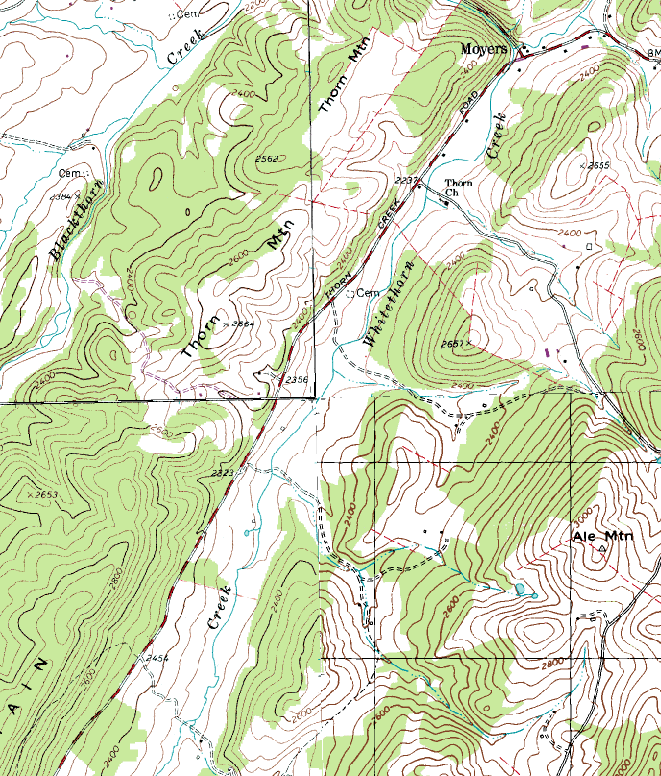

Puffenberger GPS Coordinates: Latitude: 38˚ 29’ 58.17” N
Longitude: 79˚ 21’ 58.63” W

Bowers GPS Coordinates: Latitude: 38º 30’ 30.18” N
Longitude: 79º 21’ 17.43” W

HUC8 - #02070001
IV. Photographs of Project Areas:
- Bowers Farm: 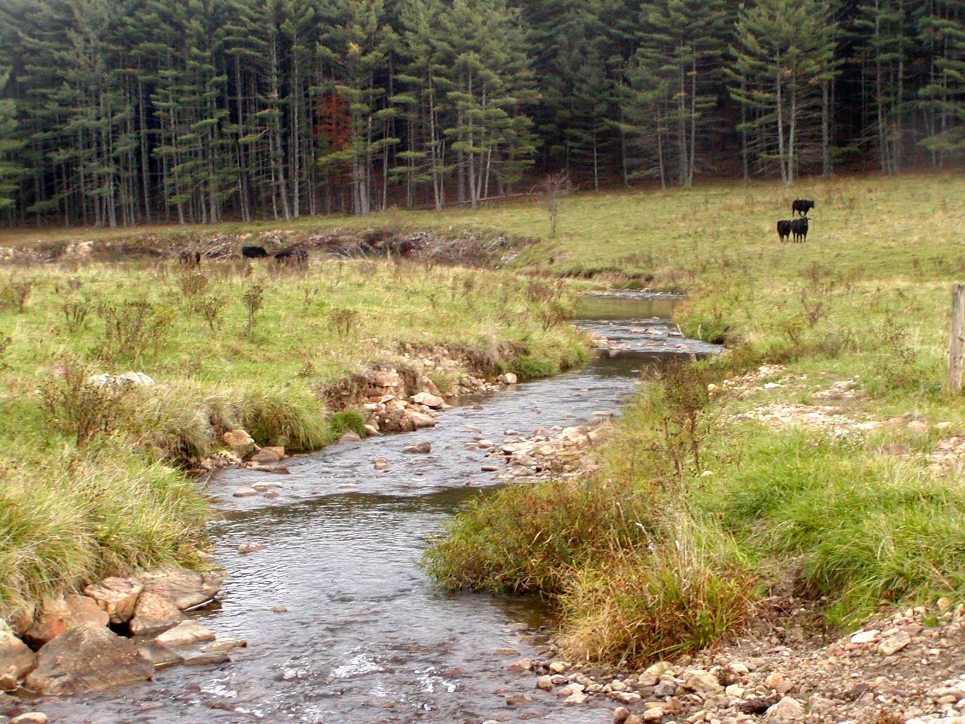
Photo by Gary Berti, Trout Unlimited

- Puffenberger Farm: 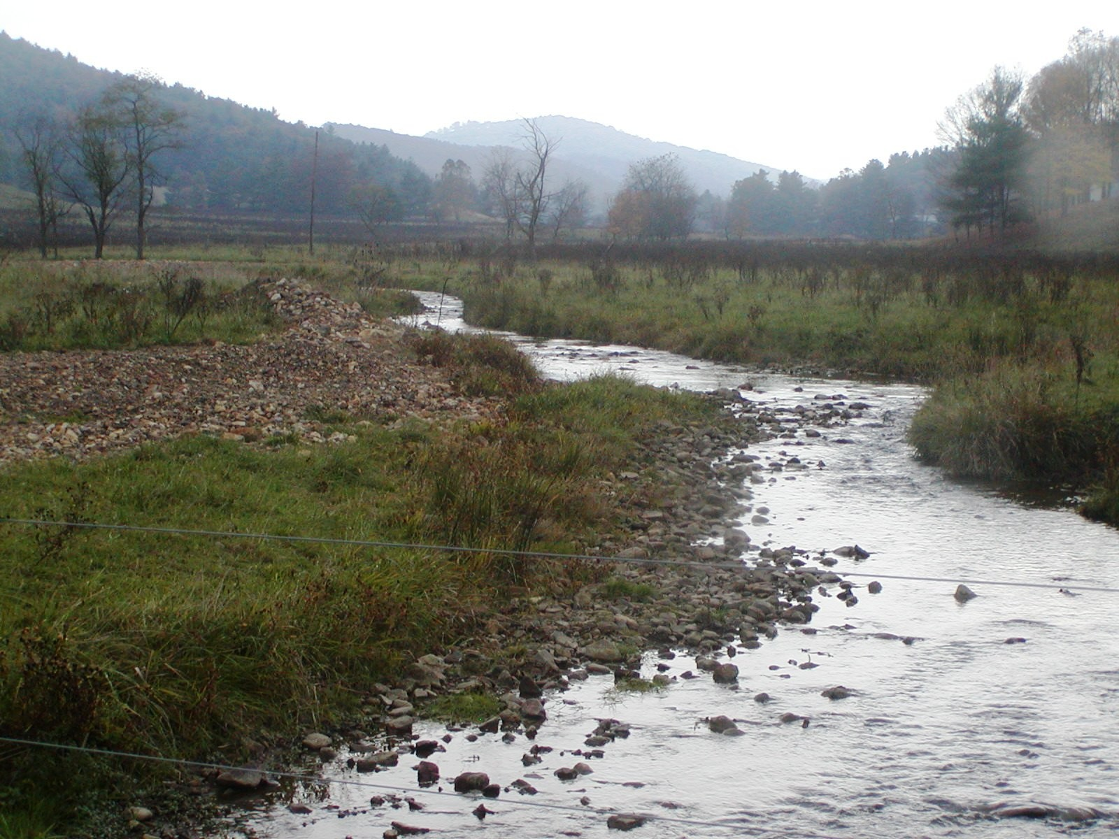
Photo by Gary Berti, Trout Unlimited

V. Project Budget:

- General Requirements:
Activity | Partners | NFHAP  Request | Non-Fed  Contribution | Federal  Contribution | Total | Acres/Miles  Affected
Construct 15840 linear feet of 3 strand high tensile fence @$3/ft | USFWS – Partners for Wildlife  NRCS  FSA  Landowners | 11,000 mat’ls  3000 labor | 2000 | 10,325  12460  8735 |  | 1.5 miles/ 24 acres
totals |  | 14,000 | 2,000 | 31,520 | 47,520
Install 3 armored water crossings and 6 water troughs with springs/wells | NRCS  FSA  Landowners | 2,000 contract  3,000 mat’ls | 2,000 | 5725  8725 | 21450 | 1.5 miles
Totals |  | 5,000 | 2,000 | 14,450 | 21,450
Plant riparian forest | TU Staff  Mountain Institute  Dominion  WVDOF  Pendleton County Schools  TU Volunteers  Local Individuals  FSA  NRCS | 15000 plant material  2500 mat’ls | 4400  1500  1000  200  1500  3500  2365 | 1000  15435 |  | 24 acres
 |  | 17500 | 14465 | 16435 | 48400
Bank stabilization and Instream Habitat | WVDNR  WVDEP  WVCA  NRCS | 4500 rock  3000 rental  6000 labor | 1560  300  600 | 1540 |  | 1.5 mi
 |  | 13500 | 2460 | 1540 | 17500
Grand Total |  | 50,000 | 20925 | 63945 | 134870

VI. Evaluation Questions

A. Conservation of Sustainable Populations:
Trout Unlimited is leading a diverse partnership between local farming, education, angling, and community interests working together with resource agencies to restore Thorne Creek watershed to the EBTJV’s ‘intact’ classification. By providing exclusion fencing for livestock, this project removes sediment, nutrient, thermal, and pathogenic threats for approximately 1.5 miles of Whitethorne Creek, a major tributary of Thorne Creek. This project also creates 24 acres of riparian habitat and provides instream habitat enhancement. Landowners are eager to implement practices and have agreed to a minimum 10 year maintenance agreement. Access will be allowed for monitoring the restoration measures and population response. This watershed is high priority for restoration and is included as such in the West Virginia Conservation Strategy. Restoration of Thorne Creek will meet the EBTJV rangewide Objective 1 – Increase the number of Healthy watersheds by 2025; Mid-Atlantic Regional Objective 4 – Improve the number of healthy watershed by 2015, and 5 – Strengthen brook trout populations in 30 reduced watersheds; it is targeted by State of West Virginia’s to be restored to ‘intact’ from ‘greatly reduced’. The accomplishment of this goal will meet objectives 1.3 and 2.2 of the West Virginia Brook Trout Conservation Objectives. This project expands the range and removes threats for an existing population of brook trout in a high priority watershed. It will contribute toward state, regional, rangewide and NFHAP objectives. It also contributes to non-game habitat creation and enhancement under the state conservation management plan.

B. Endangered Species:
This area contains intricate limestone caves known to be inhabited by two species of endangered bats, the Virginia Big-eared (Corynothinus townsendii virginianus) and the Indiana (Myotis sodalist). The project area is within two miles of two Indiana bat hibernacula and four Virginia Big-eared bat hibernacula. Both bat species forage in areas that contain patchwork of woodlands and open fields, and are known to congregate or ‘swarm’ within five miles of a hibernaculum. There is a likelihood this project’s riparian forest creation will provide a night feeding and habitat area where none existed previously.

C. Economically important species not also listed as threatened and endangered species: Brook trout is an economically important species. The WV Brook Trout Conservation Strategy dedicates a section of the economic importance of this species. From the economic perspective, cattle are an important species. Proper streamside management will provide health benefit to cattle and reduce risk of disease by removing a potential pathogen pathway between herds.

D. Special Considerations:
The landowner participation is a key component of this project. Demonstration of conservation minded agricultural management of streamside lands is critical to sustaining the continued use of these techniques. This project’s outcomes may extend beyond the habitat treated on site. If successful in attaining adequate funding to put practices on the ground, this project will continue to demonstrate the economic value of providing conservation benefits by the farm community.

E. EBTJV Targeted Watershed:
While rangewide priorities were not found on the EBTJV internet site, this watershed has been targeted as high priority by the West Virginia Conservation strategy. As West Virginia has a role in the EBTJV, its targets should qualify this watershed as an EBTJV targeted watershed.

F. Habitat Connectivity and Enhancing Population Mobility:
- Does the watershed connect to a watershed identified as intact or reduced?
Thorne Creek is identified as reduced. Whitethorne Creek is a subwatershed to Throne Creek.
- Does the project expand habitat availability of existing native brook trout populations? The project is located on a large tributary with significantly degraded habitat availability. This project expands brook trout habitat and provides connectivity to the mainstem population. Future projects will expand habitat connectivity both upstream into the tributary, and in the mainstem. There are and will be voluntary protection efforts upstream of this site on private lands.
- What is the probability of long-term success in supporting a sustainable fishable brook trout population in the area? The project will have a minimum protection period of ten years under USDA Farm Bill programs. This project should provide perpetual with minimum maintenance requirements. Ongoing partnership with the landowner will ensure the protection measures are maintained or expanded. Negative influences will be addressed in all cases. Upstream influences will continue until they are addressed and corrected, in future project work.

G. Management Assets:
- Is there an adaptive management component to the project? The project site will be monitored by TU staff and partner agencies. This will include, but not limited to, stream and habitat surveys, riparian growth monitoring, and water quality sampling. These monitoring activities will follow established protocols as established by respective agencies.
- Will the project area be accessible to public fishing? Currently fishing access is restricted by permission form the landowner only. It is possible that managed access may occur in the future, but past taking of brook trout by fishermen has paled the outlook for open, public access.
- Will the project have an educational component or is it being developed as a demonstration project for the Eastern Brook Trout Joint Venture? This project will have a strong , ongoing educational component through TU’s partnership with local schools. The program has been designed to allow multiple year opportunities for science classes to adopt stream segments and monitor them on a regular basis. This program is being targeted to include High School Environmental science classes.
All project implemented under the Potomac Headwaters program should be considered as demonstration projects for the EBTJV.

