

Our Mission: To leverage people and resources for innovative projects that promote conservation and sustainable communities.

[Piedmont Conservation Council, Inc.](http://piedmontconservation.org/)  
721 Foster St, Rm 228  
Durham, NC 27701

Phone: (919) 560-0560  
Fax:    (919) 560-0563

[Elizabeth Zander, Coordinator](mailto:Elizabeth@peidmontconservation.org)

*Barriers can also impact drinking water supplies, boating and angling opportunities, and increase the potential for flooding.*



**DID YOU KNOW?**

**ABOUT**

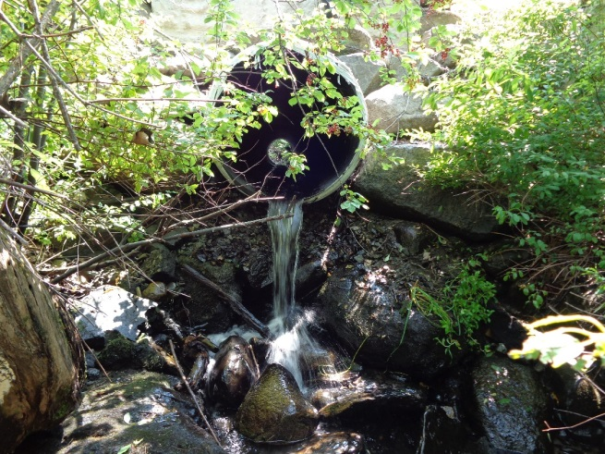

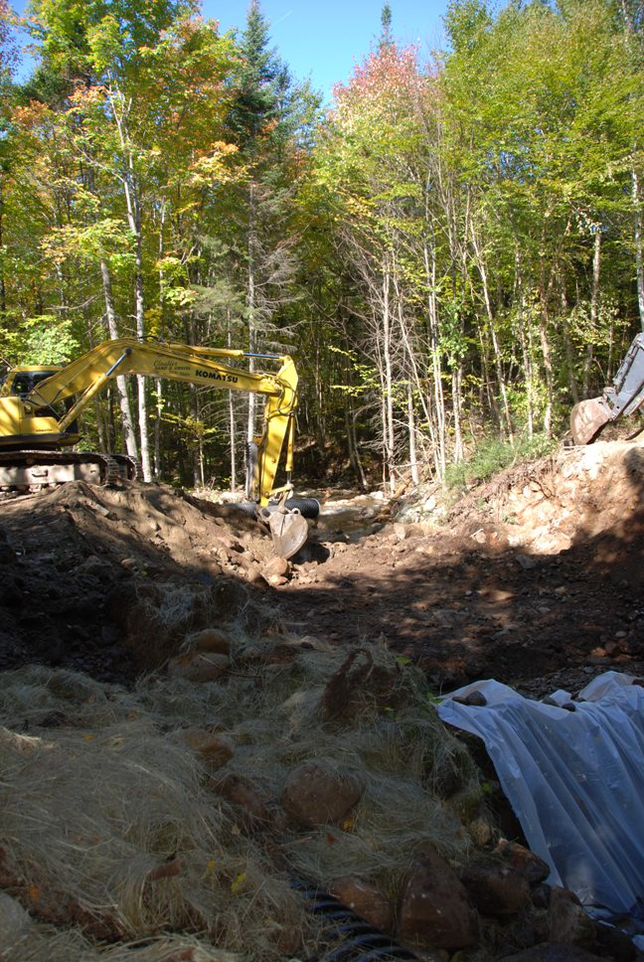

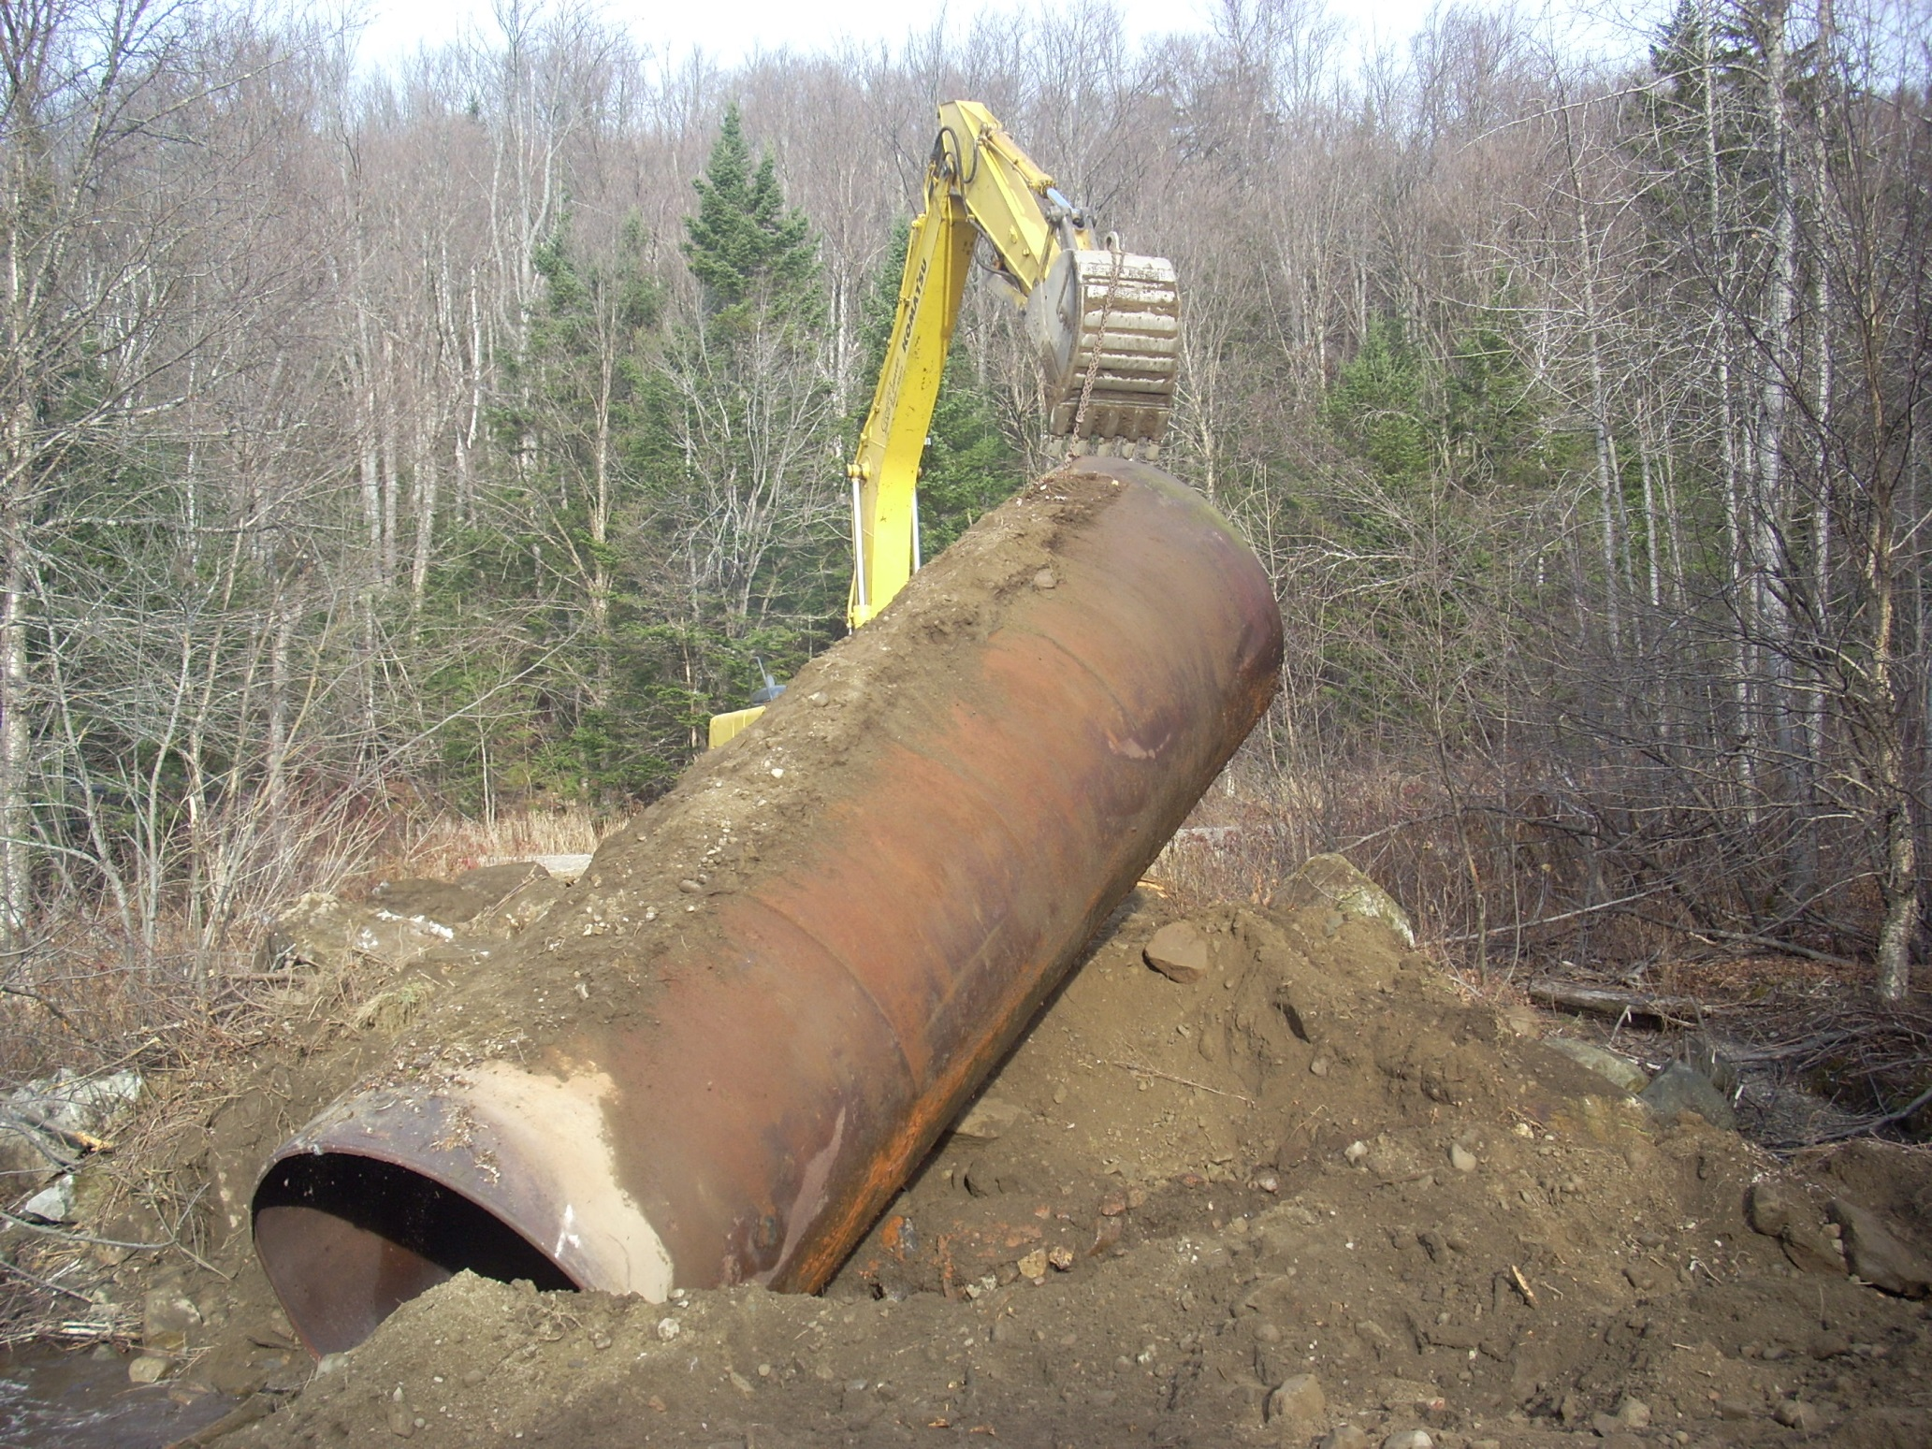

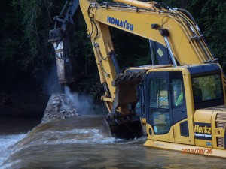

Fish passage barriers include a variety of man-made structures such as:

* Dams
* Road crossings (improperly sized or located)
* Bridges and culverts (improperly sized or located)
* Diversions (floodgates, channels, levees, etc.)

These structures are often too small in height and/or width, preventing the movement (migration) of fish and other aquatic species upstream and downstream as necessary to find food, grow, reproduce, and find water that is the appropriate temperature.

**In North Carolina, there are more than 6,000 dams, impairing over 60,000 stream miles for fish and other aquatic species and habitat.** *Sources: The NC Dam Safety Dataset, NID, aquatic obstruction inventory, field assessments, & modeling dams using the NHD Plus Stream Network.*

## **What Are Fish Passage Barriers?**

## **Why Remove Barriers To Fish Passage?**

Free the Fish

Exploring Benefits of fish passage barrier removal



Barriers that disrupt the flow and connectivity of rivers and streams can negatively impact fish, mussels, aquatic insects and other wildlife by:

* Interrupting seasonal migration
* Restricting access to quality habitat and food
* Increasing the chance of disease and encountering predators
* Promoting inbreeding, thereby reducing genetically healthy populations
* Degrading water quality

Fish passage barriers threaten the survival of many species of fish and other aquatic wildlife in the Southeast. The removal of even a single barrier can provide significant ecological benefits, improving fish access for miles both upstream and downstream. By connecting rivers and streams, fish can better access the habitat they need throughout the year. This can help protect, enhance and restore fish populations, including native species and those benefiting commercial and recreational fisheries.

*Fish like American shad and others benefit from barrier removal projects.*

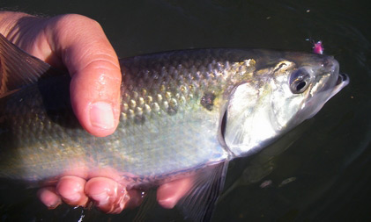

*The development of this document was funded in part by a Multi-State Conservation Grant and the Whitewater to Bluewater Partnership. For more information, visit the* [*Whitewater to Bluewater website*](http://easternbrooktrout.org/groups/whitewater-to-bluewater)*.*

*There are several agencies and organizations working to restore connectivity of aquatic habitats, fish passage improvement and dam safety in North Carolina.*

[Southeast Aquatic Resources Partnership (SARP)](http://www.southeastaquatics.net)

* Southeast Aquatic Connectivity Assessment Program (SEACAP)
* [The Southern Instream Flow Network (SIFN)](http://www.southeastaquatics.net/sarps-programs/sifn)

[Atlantic Coastal Fish Habitat Partnership (ACFHP)](http://www.atlanticfishhabitat.org)

[American Rivers (AR)](http://www.americanrivers.org)

[Contact: Erin McCombs](mailto:emccombs@americanrivers.org)

[Eastern Brook Trout Joint Venture (EBTJV)](http://www.easternbrooktrout.org)

[The Nature Conservancy (TNC)](http://www.nature.org)

[Trout Unlimited](http://www.tu.org)

[Contact: Damon Hearne](mailto:dhearne@tu.org)

N.C. Department of Environment and Natural Resources Dam Emergency Contact 1-800-858-0368

[North Carolina Dam Inventory](http://portal.ncdenr.org/web/lr/dams)

**RESources & Con**

**What You Can Do:**

*There are several things that YOU can do to help fish and other aquatic species where you live, work, and recreate:*

1. **Join** a local watershed group or other conservation organization in your community and volunteer your time and talents.
2. **Be** active by voting at town meetings on issues affecting fish habitat.
3. **Keep** your eyes and ears open for fish passage barriers, especially small dams, when fishing, paddling, hiking, wildlife viewing, etc.
4. **Report** unsafe barriers to your local dam safety office.
5. **Contact** the [Southeast Aquatic Connectivity Assessment Program](mailto:kat@southeastaquatics.net) to submit information and photos of fish passage barriers and help identify and grow the database of fish passage barriers in your state.

The removal of this [grist mill dam](http://ui.uncc.edu/story/dam-removal-and-american-shad), dating back to 1805, will have an incredible benefit to the river system. The Uwharrie is one of two major tributaries above Tillery Dam, which is a hydropower dam operated by Duke Energy Progress on the Pee Dee River. In the next few years, Duke Energy-Progress plans to trap and transport over 20,000 American shad and release the fish into the Pee Dee River above Lake Tillery, where the Uwharrie River joins. Removing the small, outdated Lassiter Mill dam will open up an additional 15 miles of the Uwharrie River’s main stem and 189 miles of perennial streams. This project was funded jointly by the USFWS’ Partners for Fish and Wildlife Program, the National Oceanic and Atmospheric Administration’s (NOAA) Community-based Restoration Program and Fish America Foundation, with additional support for staff time coming from the Z Smith Foundation. *Source: American Rivers.*

- See more at: http://www.americanrivers.org/blog/7000-reason-remove-outdated-dam/#sthash.3lnYijs8.dpuf

***[Grab your reader’s attention with a great quote from the document or use this space to emphasize a key point. To place this text box anywhere on the page, just drag it.]***



This project, which American Rivers has actively supported for more than four years from the design phase through deconstruction, is the continuation of a great partnership between American Rivers, The U.S. Fish and Wildlife Service and Piedmont Conservation Council.

**Featured Barrier Removal Project:**

**Lassiter Mill Dam on the Uwharrie River**