
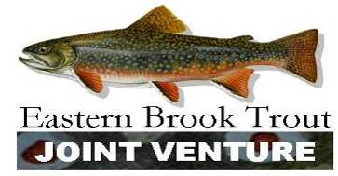
Restoring Habitat for Eastern Brook Trout-
Big Run, West Virginia


PROJECT DESCRIPTION
The Big Run project is part of Trout Unlimited’s Home Rivers Initiative Potomac Headwaters Restoration Project. The stream has suffered habitat degradation in the riparian zone, stream banks and instream due to long-term livestock grazing. There currently exists a lifetime grazing allotment on that portion of the Monongahela National Forest that supports Big Run. The Forest Service, Trout Unlimited and others have teamed up to work with the allotment holder to fence the riparian zone, create crossings and alternative water sources to completely remove the cattle from the stream. Over time, riparian reforestation will stabilize banks and provide vital shade during warm summer months. This is the initial project on Big Run. Resources have already been secured to move down stream on the Forest and on to private property. The project will include informational and educational kiosks and trails that will improve access for anglers and hikers.
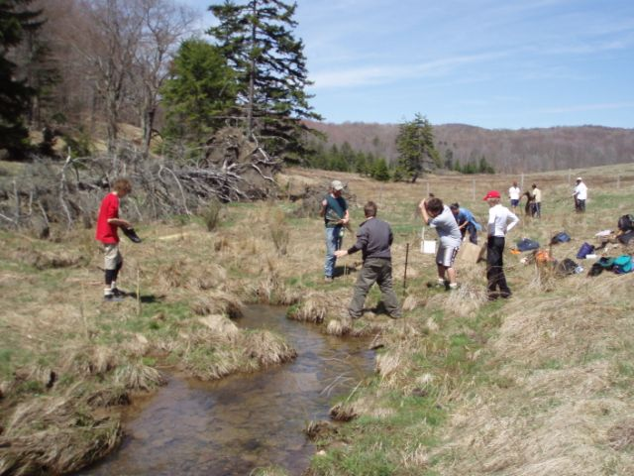

Volunteers from local schools plant thousands of trees to reforest the riparian zone. (Courtesy Bryan Moore, Trout Unlimited)

PROJECT STATISTICS
Location: Pendelton County, WV
Initiated: 2005
Estimated Year of Completion: 2015
Congressional District: WV02
Watershed Status: Reduced
Landownership Status: Public

ACCOMPLISHMENTS
- Restored 45ac. riparian forest
- 1.5 mi. stream restored through cattle exclusion
- 4 stream crossings (bridge) for cattle
- 2 alternate watering sources for cattle
- Public access to stream provided
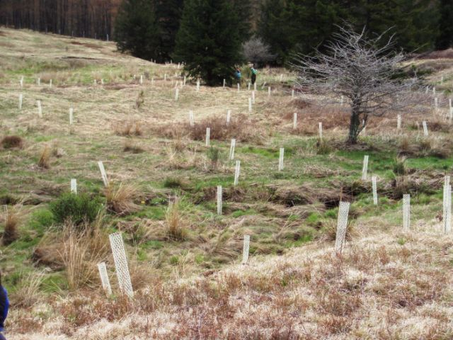

Tree plantings at Big Run, Summer 2006.
(Courtesy Bryan Moore, Trout Unlimited)

PARTNERS
- Trout Unlimited-Home Rivers Initiative
- Monongahela National Forest
- U.S. Fish and Wildlife Service
- West Virginia Department of Natural Resources
- West Virginia Department of Environmental Protection
- West Virginia Conservation Association
- National Fish and Wildlife Federation
- Fish America Foundation
- Dominion Power
- The Mountain Institute
- Boy Scouts of America
- Local and Chesapeake Bay Area school children

For more information contact:
U.S. Fish and Wildlife Service
Appalachian Partnership Coordination Office
UVA-Wise Science Center 213B
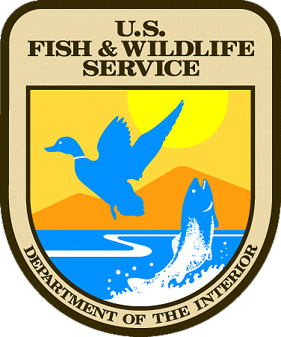
1 College Ave
Wise, VA 24293
276-376-4597, fax 276-376-4603
Maureen_gallagher@fws.gov

