PROJECT TITLE:
Restoring habitat connectivity in Machias and Saint Croix River tributary streams, ME: EBTJV&NFHAP

Project Location: (Washington County, Maine)
- Congressional District of Project: Maine 2nd District
- Congressional District of Applicant: Maine 2nd District
EBTJV / NFHAP Funding Requested: $33,000
- Total Project Cost: $142,400
- Total Federal Matching: $96,000
- Total Non-Federal Matching: $13,400

APPLICANT
Organization: Downeast Lakes Land Trust
Project Officer: Mark Berry, Executive Director
Street: P.O. Box 75
City, State, Zip: Grand Lake Stream, ME 04637
Telephone Number: 207-796-2100
Fax Number: 207-796-2100
EMail Address: mberry@downeastlakes.org

U.S. Fish and Wildlife Service Sponsoring Office
Scott Craig
Maine Fishery Resources Office
306 Hatchery Road
East Orland, ME 04431
(207) 469-6701, x226
Scott_Craig@fws.gov

USFWS FONS Database Project Number: 53371-2010-362

Coordination Completed with US Fish and Wildlife Service Fisheries Office (Check One):
X Yes, August 25, 2010 Date Coordination Began
No
I. PROJECT DESCRIPTION, SCOPE OF WORK, AND PARTNER INFORMATION

A. Project Description and Scope of Work (Max Characters: 500)

Downeast Lakes Land Trust (DLLT) will continue its work with partners to restore brook trout habitat on priority streams within its 33,708-acre Farm Cove Community Forest by removing passage barriers. Three project sites are located on tributaries to West Grand Lake, and one on a tributary to Fourth Machias Lake. DLLT will hire a local contractor and coordinate a partnership between the Natural Resources Conservation Service and U.S Fish and Wildlife Service Maine Fisheries Resource Office.

B. Proposed Methods (Max Characters: 350)
We will remove four culverts that currently are acting as fish passage barriers and replace them with fish-friendly bottomless arch culverts that allow a natural stream channel. NRCS will provide match funding, engineering design and oversight, and the Maine Fisheries Resource Office will survey for fish and install block nets during construction.

C. Project Timeline
Engineering and design work will begin in spring 2011, and construction will take place between August 1 and September 30. Two sites will be completed in 2011 and the final 2 will be completed in 2012. Post construction monitoring will be conducted by DLLT and USFWS, Maine Fisheries Resource Office.

D. Proposed Accomplishment Summary (Max Characters: 500)
This project will accomplish NFHAP priorities by restoring habitat connectivity on three brook trout habitat streams and eliminate ongoing risks of sedimentation during culvert failure, in watersheds identified as brook trout habitat protection priorities by the WBTJV on lands managed by DLLT for wildlife habitat, public recreation, and a sustainable supply of forest products.

E. State the Importance of the project to the Resource (Max Characters: 350)
This project will result in restoration of upstream passage to approximately 3 miles of habitat and eliminate sources of sedimentation, improving brook trout habitat on 3 streams.

F. Problem and Specific Cause of the Problem (Max Characters: 350)
Logging and recreational access roads were constructed with under-sized and poorly placed culverts, creating barriers to fish passage and causing periodic culvert failure and erosion of roads, leading to sedimentation of downstream habitat.

G. Objective of the Project with Reference to the Problem (Max characters: 350)
The primary objective is to restore habitat connectivity and reduce the risk of catastrophic road failure and excessive sedimentation.

H. Partner Information (not to exceed 100 words)

Partner Name | Contribution  In-Kind | Contribution  Cash | Federal or Non- Federal | Partner  Category | Role of Partner
Downeast Lakes Land Trust | $9,900 |  | Non-Federal | Local Conservation Group (also Private Landowner) | Oversight,  Materials,  On-site coordination, Post-project monitoring
Natural Resources Conservation Service | $10,000 | $77,000 | Federal | Federal Agency | Match funding, Survey, Engineering, On-site coordination
USFWS, Maine Fisheries Resource Office | $9,000 |  | Federal | Federal Agency | Fishery survey, Block-nets, On-site coordination, Post-project monitoring
Project SHARE | $3,500 |  | Non-Federal | Local Conservation Group | On-site coordination, Post-project monitoring

II. MAP OF PROJECT AREA (one only)
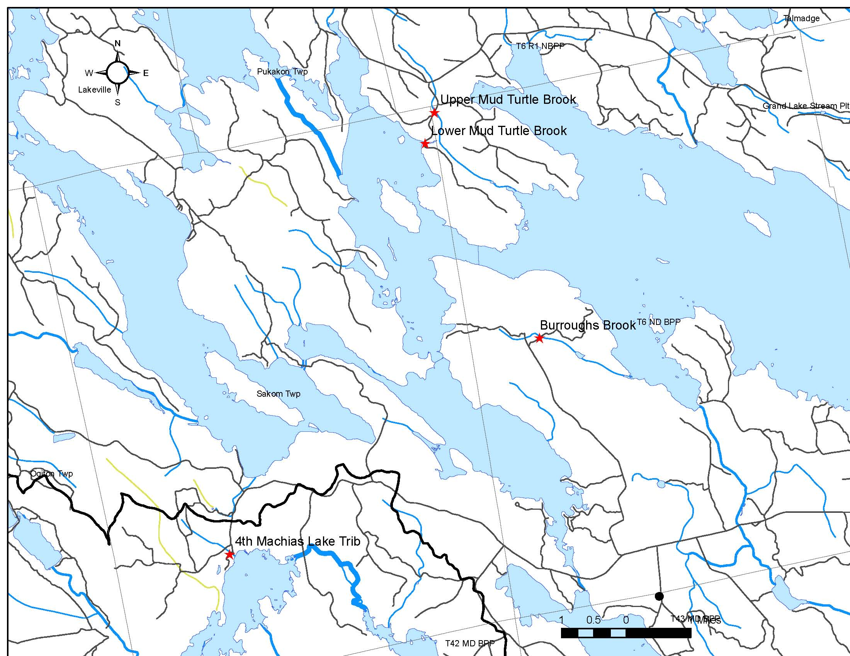

III. PHOTOGRAPH(S) OF PROJECT AREA (no more than 2, please provide credits and attach photo release forms)

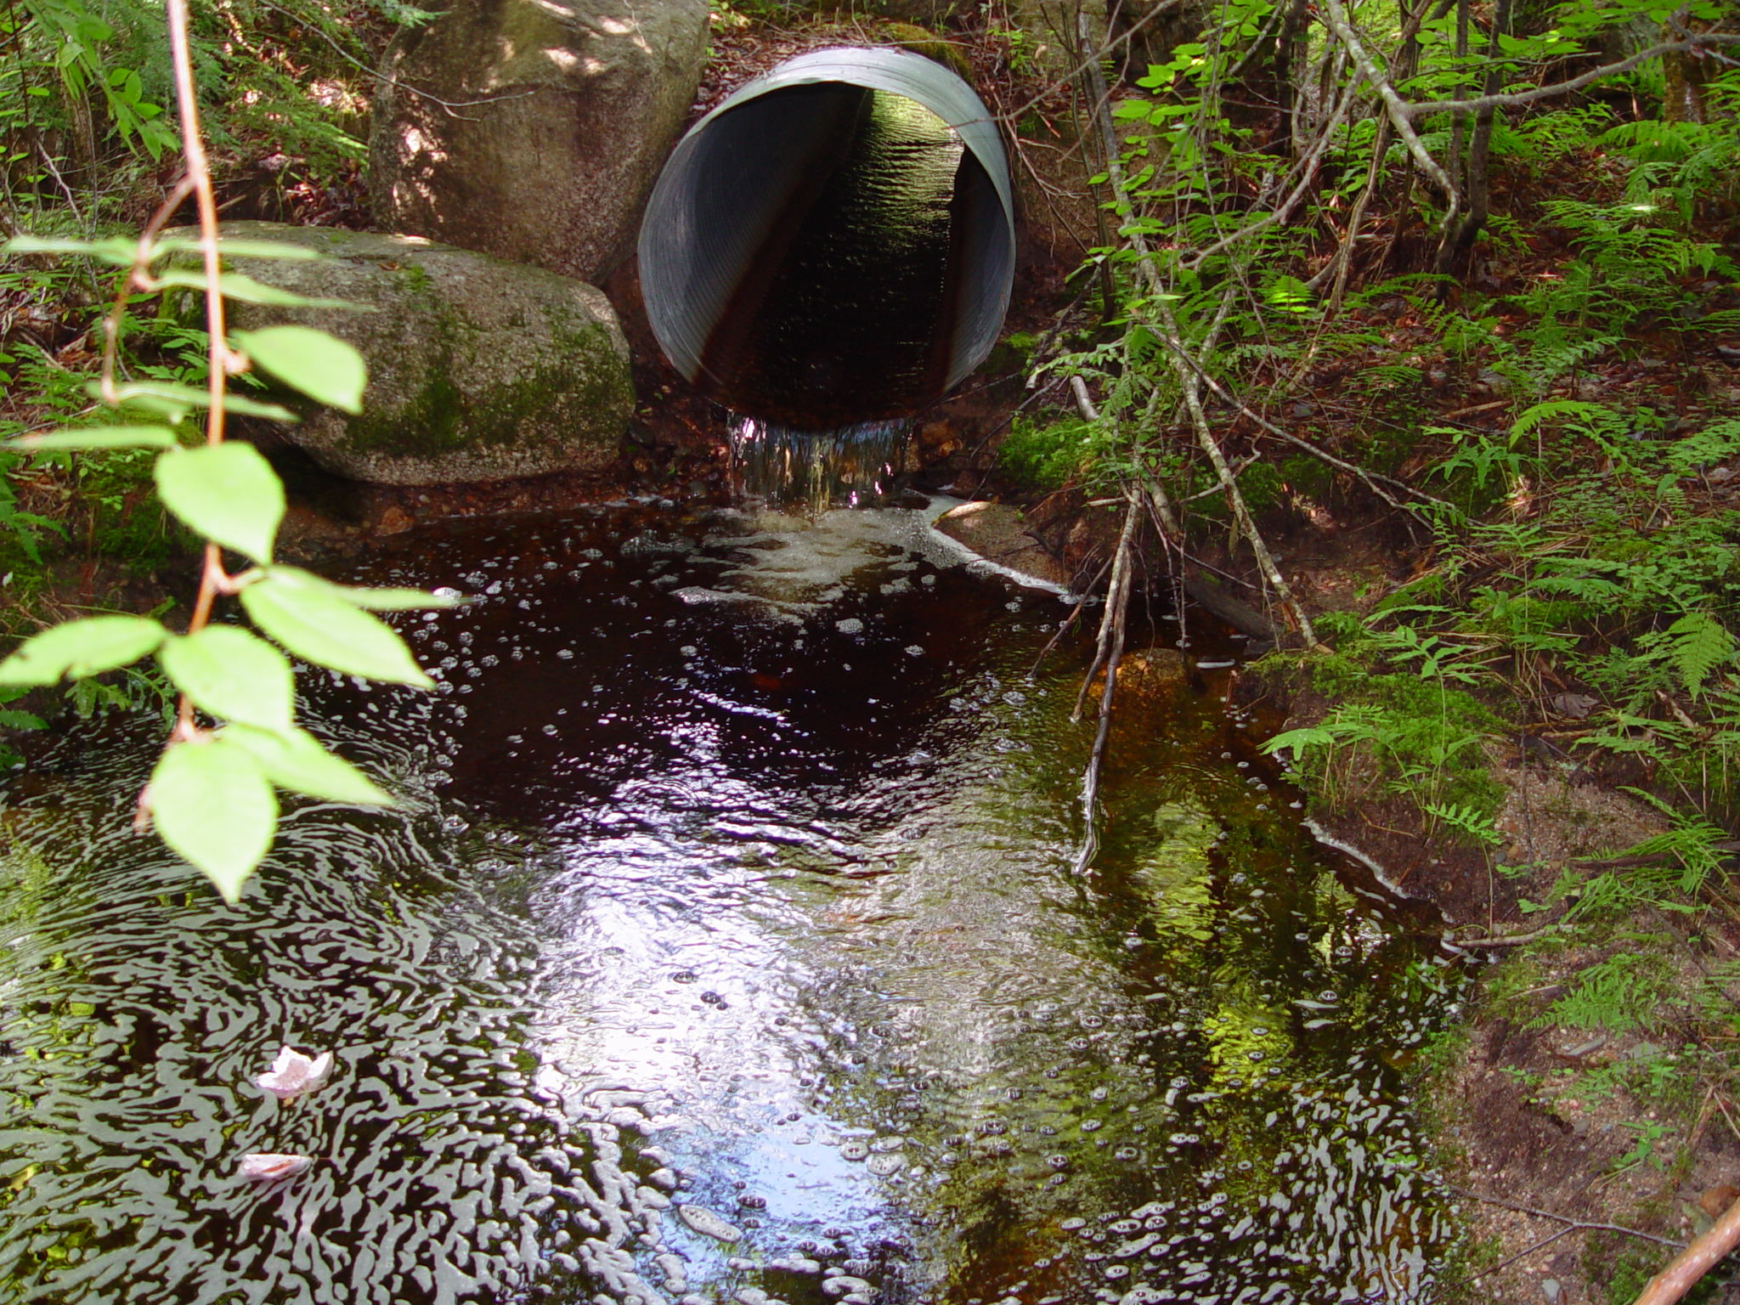
Outlet of Burroughs Brook culvert to be replaced with bottomless arch, DLLT Photo

IV. PROJECT BUDGET

A. General Requirements

B. Budget Table

Partner Name | Partner Category * | Activity of Partner ** | Budget Category*** | EBTJV  NFHAP Request | Non-Federal Contribution |  | Federal Contribution |  | Total Contr. | Acres/Miles Affected
 |  |  |  |  | In-Kind | Cash | In-Kind | Cash | Total Contr. | Acres/Miles Affected
Downeast Lakes Land Trust | Local Conservation Group | 6 days Onsite Coordination | Personnel |  | $2,400 |  |  |  | $2,400 | Restore access to approximately 3 miles of upstream habitat
Downeast Lakes Land Trust | Local Conservation Group | Gravel | Supplies |  | $5,000 |  |  |  | $5,000 | Restore access to approximately 3 miles of upstream habitat
Downeast Lakes Land Trust | Local Conservation Group | Purchase open bottom arches | Supplies | $13,200 |  |  |  | $30,800¹ | $44,000 | Restore access to approximately 3 miles of upstream habitat
Downeast Lakes Land Trust | Local Conservation Group | 6 days Contractor crew & equip. | Construction | $19,800 |  |  |  | $46,200¹ | $66,000 | Restore access to approximately 3 miles of upstream habitat
Downeast Lakes Land Trust | Local Conservation Group | Monitor: 1 day/yr for 5 yrs | Personnel |  | $2,500 |  |  |  | $2,500 | Restore access to approximately 3 miles of upstream habitat
Natural Resources Conservation Service | Federal Agency | Engineering and Design | Personnel |  |  |  | $4,000 |  | $4,000 | Restore access to approximately 3 miles of upstream habitat
Natural Resources Conservation Service | Federal Agency | 6 days Onsite Coordination | Personnel |  |  |  | $6,000 |  | $6,000 | Restore access to approximately 3 miles of upstream habitat
USFWS, Maine Fisheries Resource Office | Federal Agency | 2 days survey and block nets | Personnel |  |  |  | $2,000 |  | $2,000 | Restore access to approximately 3 miles of upstream habitat
USFWS, Maine Fisheries Resource Office | Federal Agency | 2 days Onsite Coordination | Personnel |  |  |  | $2,000 |  | $2,000 | Restore access to approximately 3 miles of upstream habitat
USFWS, Maine Fisheries Resource Office | Federal Agency | Monitor: 1 day/yr for 5 yrs | Personnel |  |  |  | $5,000 |  | $5,000 | Restore access to approximately 3 miles of upstream habitat
Project SHARE | Local Conservation Group | 1.5 days Onsite Coordination | Personnel |  | $1,500 |  |  |  | $1,500 | Restore access to approximately 3 miles of upstream habitat
Project SHARE | Local Conservation Group | Monitor: 0.5 day/yr for 5 years | Personnel |  | $2,000 |  |  |  | $2,000 | Restore access to approximately 3 miles of upstream habitat
Total Contribution |  |  |  | $33,000 | $13,400 | 0 | $19,000 | $77,000 | $142,400
1: NRCS Match funding through Wildlife Habitat Incentive Program
- EVALUATION QUESTIONS

- Please provide the GPS Coordinates for the project in UTM NAD 83.
Lat | Long | Name | Comments
45.261111 | -67.930833 | Lower Mud Turtle Brook | Off Amazon Road
45.268056 | -67.927778 | Upper Mud Turtle Brook | Off Amazon Road
45.217222 | -67.895556 | Burroughs Brook | Farm Cove road
45.169722 | -67.994444 | 4th Machias Lake Trib | Unnamed

- Please list the type of project. Examples include: in-stream habitat, riparian planting, fencing, AMD, fish passage, reintroduction, assessment, etc.
Fish passage

- Does the project include a protection component? If so, explain how the project sufficiently protects brook trout habitat. Does the project include fee simple land purchase or easements?
The project is to be conducted on lands owned in fee simple by DLLT and protected by a conservation easement. The entire watersheds of each of the three streams in this project are on protected conservation lands. This project will help DLLT fulfill the habitat potential of these conserved lands.

- What percentage of the watershed above the proposed project is protected in perpetuity?
100% of each of the three streams watersheds are protected in perpetuity by conservation easement or easement and fee ownership.

- List the specific regional EBTJV habitat objectives addressed by the project and describe how the project will contribute towards them.

This project will contribute toward the following four Regional EBTJV habitat objectives:
1. Maintain the status, or no net less, of 746 subwatersheds classified as healthy by 2012.
2. Strengthen brook trout populations in 44 subwatersheds classified as healthy by 2012.
4. Improve 10 reduced subwatersheds to healthy classification by 2012.
5. Strengthen brook trout populations in 105 subwatersheds classified as reduced by 2012.
Three sites are within HUC 230425, with a protection priority score of 1.36. Although this is well-above range-wide average and therefore a priority for protection, it indicates reduced health and habitat restoration on these streams will contribute to regional goals #4 and #5. The fourth site is in HUC 230477, with a protection priority score of 1.63, near the maximum possible, and a priority watershed for regional goals #1 and #2.

- List the specific state-level EBTJV habitat objectives addressed by the project and describe how the project will contribute towards them.

Priority 2: Habitat Protection
2.1 Identify degraded stream habitats and prioritize sites for restoration efforts
Strategy 2: Identify barriers to fish passage and re-establish habitat connectivity where possible.
2.3 Permanently protect critical habitats.
Strategy 1: Establish collaborative partnerships with State, Federal, Tribal and private entities for the permanent conservation of critical wild brook trout habitats and refuges.
2.4 Restore degraded brook trout habitats.
Strategy 1: Increase collaborative partnerships with State, Federal, Tribal and private entities to implement stream restoration projects at a rate of at least ten projects annually.
Strategy 2: Monitor efficacy of implemented projects for ecological responses and indicators of success
Priority 4: Recreational Fishing
4.1 Optimize brook trout angling opportunities.
Strategy 1: Continue to gain appropriate public access rights over private ways by purchase, negotiation and agreement, easement, gift, cooperation with landowners, and by encouragement of private groups and enterprises.

The project will remove barriers to fish passage (2, 2.1, Strategy 2). It is a collaborative partnership between State, Federal, and private entities (2, 2.3, Strategy 1) to implement stream restoration projects (2, 2.4, Strategy 1) and monitor implemented projects (2, 2.4, Strategy 2).

- Please state whether the project is an enhancement, restoration or protection project.
Protection

- State which, if any, EBTJV priority the project addresses:
1. Project protects the “best of the best” habitats that already support healthy, stable brook trout populations.
2. The project improves and reconnects habitats adjacent to the best of the best that also have a high likelihood of supporting stable brook trout populations.

The project improves habitat connectivity and watershed health in watersheds that already support healthy, stable brook trout populations and restores connectivity to portions of these watersheds with potential to support stable brook trout populations.

- What is the EBTJV priority ranking for the proposed project watershed for the type of project (enhancement, restoration or protection) being proposed?

Watershed # = 230425 HUC12= West Grand Lake
Priority Score = 1.36
Map = Maine – Subwatersheds Best for Protection

Watershed # = 230477 HUC12 4th Machias Lake
Priority Score = 1.63
Map = Maine – Subwatersheds Best for Protection . Watershed within Designated Critical Habitat for Atlantic salmon (NOAA 2009).

- Will the completed project benefit any federally listed threatened or endangered species?
Yes. The Fourth Machias Lake tributary project site is located within critical habitat of Atlantic Salmon (Gulf of Maine) DPS area (National Oceanic and Atmospheric Administration 2009). Critical habitat is defined as all perennial streams for this species. This proposal will restore ecological stream habitat and function of Atlantic salmon critical habitat.

- Will the completed project benefit any state listed threatened or endangered species?
No

- Does the project demonstrate watershed scale planning?
The direct activities of this project occur within two subwatersheds. The conservation of the surrounding landscape has been accomplished through the landscape and watershed scale Downeast Lakes Conservation Proposal. To date, 350,000 acres have been permanently conserved through this initiative since 2001, and project lands are within a 1.3 million acre international landscape of conserved lands. DLLT is currently raising funds for the permanent conservation of 21,700 acres on the east shore of West Grand Lake, including portions of four subwatersheds.

- Please describe how the project will provide for the expansion or improvement of existing habitat?

The project will provide for the expansion and improvement of existing habitat by removing passage barriers. We will remove four culverts that currently are acting as fish passage barriers and replace them with fish-friendly bottomless arch culverts that allow a natural stream channel. This project will restore habitat connectivity on three brook trout habitat streams and eliminate ongoing risks of sedimentation during culvert failure, resulting in restoration of upstream passage to approximately 3 miles of habitat.

- What are the root causes of the watershed degradation and which of these are addressed by the project?

Logging and recreational access roads were constructed with under-sized and poorly placed culverts, creating barriers to fish passage and causing periodic culvert failure and erosion of roads, leading to sedimentation of downstream habitat. The project addresses these root causes.

- Describe the plans for post project monitoring and evaluation.

Post project monitoring will be conducted by DLLT, SHARE and MEFRO. The site will be monitored for debris accumulation and/or beaver related activity. Note: The new structures should provide adequate height such that a beaver dam would not completely block the culvert inlet. If any of these debris problems arise, we will take corrective action.

MEFRO will conducted electro-fishing to determine brook trout size, condition and fish species relative abundance, and a follow-up comparison will be performed 3-5 years after the project has been completed.

- Describe the expected effect on the brook trout population. To what degree will the project strengthen the brook trout population status?

The project is expected to improve brook trout populations within the project streams, the downstream lakes, and nearby tributaries. The existing passage barriers are the primary factor reducing habitat quality in otherwise healthy streams.

- Please describe the long term benefit of the project and provide an estimate of the length of time the project is expected to be effective. If a plan for long term maintenance is necessary, please describe it.

The stream crossings are expected to last up to 75 years. DLLT will maintain the roads and structures as needed, and will own and manage the surrounding lands in perpetuity, including maintenance of riparian buffers.

- What size stream does the project benefit - tributary stream or mainstem habitats?

It will benefit habitat in three tributary streams.

- What competitive non-native or invasive fish are in the watershed with access (no barrier) to the proposed project?

Small-mouth bass and chain pickerel are present in the lakes the streams flow into; pickerel may occur in the streams.

- Are other strains of brook trout or other salmonids or other exotics stocked within the proposed project watershed? Where (e.g. upstream, downstream, and distance from project site) does the stocking take place with respect to the project site?

No salmonids are stocked in project streams or in Fourth Machias Lake (downstream from one of the project streams). River specific endangered Atlantic salmon are stocked in the Machias River Watershed downstream of Fourth Machias Lake. Native landlocked salmon and brook trout are stocked in West Grand Lake, and Grand Lake Stream, downstream from three of the sites.

- Please describe the current status of the project. Is it planned, permitted and ready to begin? Please identify the targeted month and year for project completion.

Engineering and design work will begin in spring 2011, and construction will take place between August 1 and September 30. Two sites will be completed in 2011 and the final 2 will be completed in 2012. Post construction monitoring will be conducted by DLLT and USFWS, Maine Fisheries Resource Office.

- Will public access be allowed at the project site? If so, what kinds of recreational activities are allowed - public fishing, nature trails, etc?

Yes, DLLT allows public access for traditional outdoor recreation throughout the Farm Cove Community Forest, including fishing, hunting, and wildlife observation. Snowmobile, ATV, and hiking trails exist on the property.

- What is the recreational quality of the potential fishery?

The fisheries of the Downeast Lakes region are widely-renowned, primarily for the native landlocked salmon in Grand Lake Stream and the smallmouth bass in the lakes of the region. Brook trout in area streams are fished avidly by local residents and a smaller portion of visiting anglers; but brook trout traditionally have represented an important part of the local recreational fishery.

- Describe any outreach or educational components of the project and how many individuals / students will be served.

DLLT will feature the project in its blog, email newsletter, and print newsletter, and will include the project in educational programs offered in the local community. Newsletter and web materials are expected to reach 1000 to 1500 people, while local programs are likely to reach 20-30 people.

- If applicable, please briefly describe how this project will promote adaptation to climate change.

This project will provide adaptation to climate change by improving habitat connectivity and access to cold-water refugia within a 1.4 million acre international landscape of conserved forests and wetlands.

- Please explain how this project is a good investment of funds, using a quantitative approach where possible and the recreational and / or economic value of the project.

This project is a great investment of funds for the EBTJC because for a modest cost of $33,000 to the EBTJV, four fish passage barriers will be removed at a total project cost of $142,400, enhancing recreational and economic values of the fisheries in an area renowned for the quality of its recreational fisheries.

- Specify the NFHAP tasks upon which you will work. A list of tasks to choose from can be found in the instruction document.
- Number: P-6. 2 | Type: Habitat
Support Fish Habitat Partnerships in identifying priority habitat areas within focus areas, developing action plans and conservation strategies, and implementing projects. The plan will help local and regional efforts garner the necessary resources and provide decision analysis and other evaluation tools necessary to succeed. Working with partnerships to demonstrate successful on-the-ground habitat improvement projects is recognized as critical to the success of the national effort.
- Number: P-7. 2 | Type: Habitat
Focus existing resources to increase effectiveness in achieving results. Act as a catalyst for increased cooperation among federal, state, tribal and local agencies and increased collaboration with conservation organizations, landowners and other stakeholders.
- Number: P-7. 7 | Type: Habitat
Communicate project results and lessons learned. Enable and facilitate learning among all partners about aquatic ecosystems and how to be good stewards of aquatic resources.
- Number: Strategy 3 – Reconnect fragmented river, stream, reservoir, coastal, and lake habitat to allow access to historic spawning, nursery and rearing grounds. | Type: Habitat Project or action works towards reconnecting habitats within a system. This would include, but are not limited to, actions such as barrier removal.
- Number: Strategy 4 – Reduce and maintain sedimentation, phosphorus and nitrogen runoff to river, stream, reservoir, coastal, and lake habitats to a level within 25% of the expected natural variance in these factors or above numeric State Water Quality Criteria | Type: Habitat

- Please describe the expected Performance Metrics. A list of Service performance measures to select from can be found in the instruction document.
- 5.1.11 Total number of fish passage barriers removed or bypassed: Four
- 5.1.12 Number of miles re-opened to fish passage: Approx. 3

- SUPPORTING DOCUMENTATION:

- Literature Cited
National Oceanic and Atmospheric Administration (2009). "Endangered and Threatened Species; Designation of Critical Habitat for Atlantic Salmon (Salmo salar) Gulf of Maine Distinct Population Segment; Final Rule." Federal Regester 74(117): 29300-29341.

