Culvert replacement and instream habitat restoration in the Nulhegan River, VT in conjunction with the NFHAP and VT’s EBTJV Strategy

Project Location: (Vermont, Essex County, Bloomfield/Lewis/Averill)
- Congressional District of Project: Vermont 1
- Congressional District of Applicant: New Hampshire 2
EBTJV / NFHAP Funding Requested: $50,000
- Total Project Cost: $429,800
- Total Federal Matching: $117,100
- Total Non-Federal Matching: $312,700

APPLICANT
Organization: Trout Unlimited
Project Officer: Joe Norton
Street: 97 Main Street; Suite 106
City, State, Zip: Lancaster; NH 03584
Telephone Number: 603-748-1986
Fax Number:
EMail Address: jnorton@tu.org

U.S. Fish and Wildlife Service Sponsoring Office
Fish and Wildlife Service Office: Lake Champlain Fish & Wildlife Resources Office
Project Officer: Chris Smith
Street: 11 Lincoln Street
City, State, Zip: Essex Junction, VT 05452
- Telephone Number: (802) 872-0629 x 20
Fax Number:
EMail Address: Chris_E_Smith@fws.gov

U.S. Fish and Wildlife Service FONS Database Project Number: 53330-2010-053

Coordination Completed with US Fish and Wildlife Service Fisheries Office (Check One):
x Yes 9/01/10 Date Coordination Began
No
I. PROJECT DESCRIPTION, SCOPE OF WORK, AND PARTNER INFORMATION

A. Project Description and Scope of Work

Culvert Replacement and Woody Habitat Restoration:
In 2006, an initial watershed-based assessment of coldwater habitat conditions was completed by Trout Unlimited (TU) in the Upper Connecticut River in New Hampshire and Vermont. In 2008, TU designated the Upper Connecticut watershed as one of its Home Rivers Initiatives, the only one in New England. TU’s Home Rivers Initiative covers over 700 sq. mi from Murphy Dam at Lake Francis to the mouth of the Upper Ammonoosuc, NH/Cutler Mill Brook, VT, including 19 tributaries. TU’s assessment identified fish habitat problems throughout the watershed, including lack of riparian habitat, poor instream habitat diversity and complexity, and inadequate stream crossings. All of these impacts greatly limit available fish habitat for all life stages of brook trout.

The Nulhegan River (142 sq. mi. drainage area), with four major branches; the East Branch; Black Branch, Yellow Branch; and North Branch, is the largest Upper Connecticut tributary in TU’s Vermont project area. The entire watershed still suffers from logging damage inflicted from the late 1800s through the 1980s. As a result, the branches run too wide and shallow with few pools, scour during runoff, contain little habitat complexity, and have habitual temperature concerns in their lower reaches. The watershed is now well-forested and riparian buffers exist, but many trees are set back from the stream, with mature trees not yet contributing woody material to the channels. The Nulhegan River is also unique in that a few large landowners, the USFWS Silvio O. Conte Nulhegan Wildlife Refuge (USFWS), Vermont Fish and Wildlife Department (VTFW), and Plum Creek Corporation (Plum Creek) own an overwhelming majority of the watershed. These major landowners are project partners with TU and the entire watershed has strong state conservation easements already in place managed by The Vermont Land Trust (VLT) and the Vermont Agency of Natural Resources (ANR).

The East Branch of the Nulhegan River, which has a 44 sq. mi. watershed, enters the mainstem Nulhegan River closest to the Upper Connecticut River and is the first major branch that mainstem Upper Connecticut trout will encounter during upstream migrations. It is one of the more degraded branches in the watershed. To this day, it shows the classic signs of a stream impaired from logging practices for nearly 150 years. It is over-widened; scours regularly, lacks habitat complexity, and has thermal issues during warmer summer periods. However, based on fish, habitat, and culvert surveys conducted by TU and VTFW from 2008 to 2011, the tributary nursery streams have cold water with good fish productivity and overall good to excellent fish habitat conditions, but impassible culverts greatly limit access to them, and necessary spawning and thermal migrations are curtailed. For these reasons, TU has identified the Nulhegan River as a high priority tributary where restoration, beginning with its East Branch and then moving to its other major branches, will provide strong ecological benefits to brook trout and the Upper Connecticut watershed.

Based on the above mentioned surveys and mirroring TU’s Upper Connecticut River efforts in nearby Nash and Indian Streams, TU will initiate the first phase of a long-term connectivity and instream habitat restoration program in the entire Nulhegan River watershed, starting with its East Branch, by addressing three high priority culverts and initiating large-scale instream woody habitat restorations.

The culverts are on three important nursery streams, Murphy Brook, Fisher Brook, and Brouillard Brook. Each culvert greatly impacts instream habitat and all are located near their confluences with the East Branch. Additionally, these culverts are also fish passage barriers. Murphy Brook’s culvert has the largest drop at nearly four feet and is severely undersized with a high potential for catastrophic failure due to its size and location. It is so concerning to the partnership, that Plum Creek will pay in-kind road work to move the road upstream in conjunction with the crossing work. Addressing the Fisher Brook culvert crossing will reconnect its entire watershed to the East Branch. The Brouillard Brook crossing, in addition to being a barrier, is the site of several recent road washouts. Another major East Branch tributary, nearby Mink Brook, highlights the importance of connectivity between the East Branch and its tributaries. During fish summertime community surveys over the last few years, VTFW has found larger adult brook trout in Mink Brook than in the other brooks, and has hypothesized that these fish may be growing to larger sizes by utilizing habitat in the East Branch during parts of the year while seeking thermal refuge in the much cooler Mink Brook during the summer.

Large reaches, if not nearly all of the East Branch mainstem and some areas of its larger tributaries, still suffer from the effects of historical dam building and log drives. They lack stream complexity and are devoid of wood. Wood additions, primarily through chop & drop methods have been conducted with favorable results throughout New England, including recent remediations on TU’s Indian and Nash Stream NH projects. It is a low cost, high volume restoration method in which large stretches of a stream can be effectively rehabilitated. Woody habitat additions trap sediments and organic materials, create pools and riffles, provide cover and habitat for fish and insects, and will interrupt the scouring cycle. This project launches the initial phase of large scale wood additions in the Nulhegan River watershed by conducting three miles of chop & drop in its East Branch. From this, additional follow-up prescriptions are expected as well as other instream restoration projects.

The partnership expects culvert design and engineering to take place in 2012 and construction in 2013. Instream habitat restoration will be conducted using the “chop & drop” method on three miles of stream in the East Branch watershed. “Chop & drop” will be implemented during the 2012 to 2013 field seasons by TU, VTFW, and Plum Creek fish & wildlife biologists, with any additional follow up procedures to be conducted in 2013 and 2014. Following implementation, annual restoration assessments will be conducted by TU and VTFW fisheries biologists to monitor the expected benefits to trout populations.

B. Proposed Methods (Max Characters: 350)

A licensed consultant will design and engineer crossings in 2012 for replacement in 2013. Fish, water temperature, water chemistry, and habitat data collected from 2009 to 2011will be used to prioritize reaches for “chop & drop” instream restorations to be conducted by TU, VTFW and Plum Creek biologists during the 2012 and 2013 field seasons.

C. Project Timeline
5 Year Nulhegan River East Branch Project Timeline
Field Season | 2011 | 2012 | 2013 | 2014 | 2015
Task
Watershed sampling-Annual | Initiated Yearly→
Nursery Stream Surveys | East Branch | Southern Nulhegan Basin-Complete | Move to adjacent watershed-Paul’s Stream | Paul’s Stream | TBD
Culvert assessment & prioritization | 50% Complete | Complete  Yearly visual assessments→
Stream reach assessments | Initiated Yearly→
Culvert design and engineering |  | Murphy, Brouillard, Fisher | 2-4 Culverts-TBD | 2-4 Culverts-TBD | 3-5 Culverts-TBD
Culvert construction |  |  | Murphy, Brouillard, Fisher | 2-4 Culverts-TBD | 2-4 Culverts-TBD
Tributary & upper EB mainstem habitat projects |  | Start chop & drop | Finish chop & drop | Start chop & drop follow-up procedures  Annual Monitoring | Annual Monitoring
EB mainstem habitat projects |  | Apply for grants | Apply for grants & Project design | Project construction | Project construction
Annual Watershed Sampling-Temperature loggers were installed in 5 locations throughout the East Branch Watershed. Water chemistry samples were taken in 2008 and 2011. Two stations on the East Branch, and select areas above/below culverts were electrofished. Data was collected on all salmonid species present. All East Branch tributaries were entirely walked in 2011 to assess stream habitat. Yearly watershed sampling will be conducted throughout the life of the HRI in partnership with VTFW.
2 Surveys have been completed in the North, Yellow, and Black Branches.
3 Culvert Assessment & Prioritization-Culverts were assessed according to VTFW protocol. Culverts were ranked according to need. Data will be entered in the VT database.

D. Proposed Accomplishment Summary (Max Characters: 500)
TU, VTFW, the USFWS, and Plum Creek will restore brook trout habitat by replacing three stream crossings and conducting approximately three miles of chop and drop instream restorations on the East Branch of the Nulhegan River and its tributaries.

E. State the Importance of the project to the Resource (Max Characters: 350)
This project will initiate the Nulhegan River partnership’s efforts to restore, reconnect, protect, and sustain the watershed’s native brook trout population.

F. Problem and Specific Cause of the Problem (Max Characters: 350)
Endemic to the Upper Connecticut watershed and its major tributaries, the East Branch suffers from nearly 150 years of poor logging practices, largely from the intensive logging, dams, and drives of the late 1800’s to more recent road building activity. As a result it runs wide, shallow, scours habitually, lacks stream complexity and connectivity.

G. Objective of the Project with Reference to the Problem (Max Characters: 350)
The partnership’s objective is four-fold. Reconnect the mainstem to its tributaries. Restore the watersheds instream habitat, largely but not exclusively with wood additions. Interrupt the habitual scouring cycle that plagues and delays the stream’s natural recovery. Increase headwater pools and depth to decrease overall water temperature spikes.

H. Partner Information

Partner Name | Contribution  In-Kind | Contribution  Cash | Federal or Non- Federal | Partner  Category | Role of Partner
Upper Connecticut Mitigation & Enhancement Fund (MEF) |  | $100,000 | Non-Federal | Mitigation Grant Fund | Cash for crossing and instream work.
American Rivers |  | $50,000 | ? | Conservation Group (National) | Cash for crossing design and construction
National Fish & Wildlife Foundation |  | $30,000 | Federal | Conservation Group (National) | Cash for project design, construction, implementation and monitoring provided through the Bring Back the Natives Program
Canaday Family Foundation |  | $30,000 | Non-Federal | Private Grant Foundation | TU support for Nulhegan project
Vermont Fish & Wildlife | $18,000 |  | 25% Non-Federal, 75% Federal (DJ) | State Agency | Major Partner-all aspects
Plum Creek Co. | $100,000 |  | Non-Federal | Private Landowner/Corporation | Equipment & fill for crossing work, trees for chop & drop, technical field assistance
Nulhegan Wildlife Refuge (USFWS) | $23,600 |  | Federal | Federal Agency | Housing for TU assistants, Lyndon Interns & labor for restoration work.
Lyndon State College | $19,200 |  | Non-Federal | State Agency | Labor & mileage for stream assessments, surveys & annual monitoring
Orvis Corporation | $2,000 |  | Non-Federal | Corporation | Provide waders and gear for TU crew
VT TU Chapters | $2,000 | $5,000 | Non-Federal | Local Conservation Group | Volunteer Help & Direct support

II. MAP OF PROJECT AREA (one only)
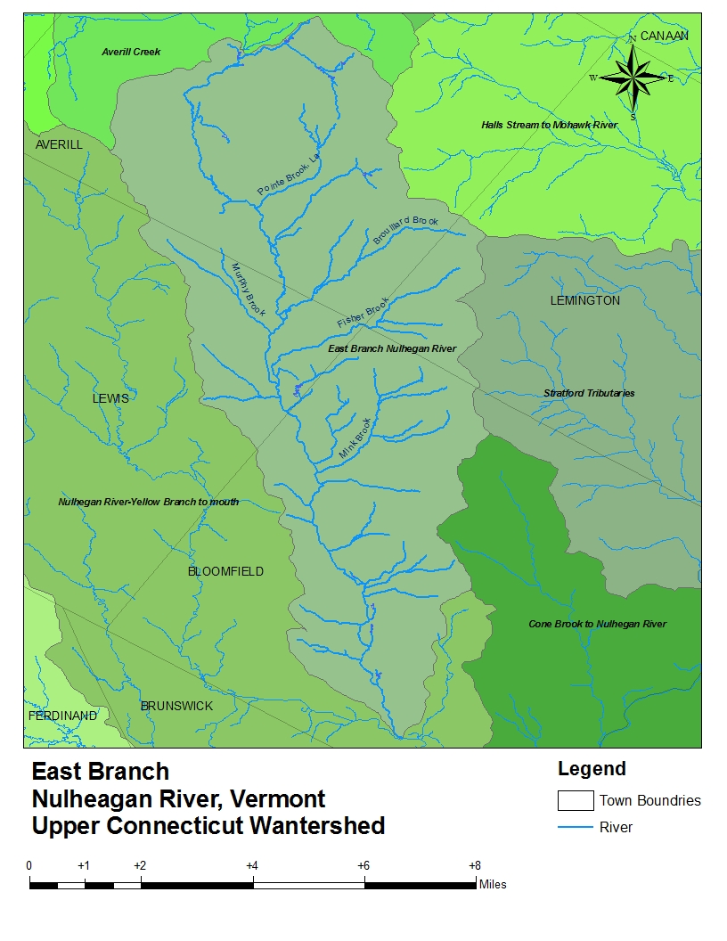
III. PHOTOGRAPH(S) OF PROJECT AREA (no more than 2, please provide credits and attach photo release forms)
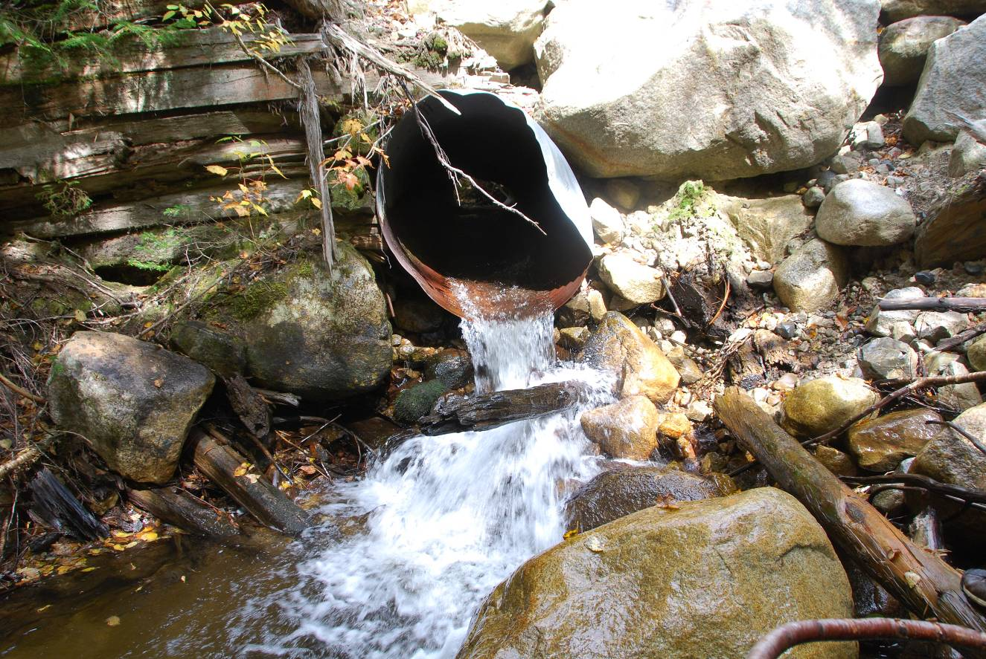
Murphy Brook Culvert
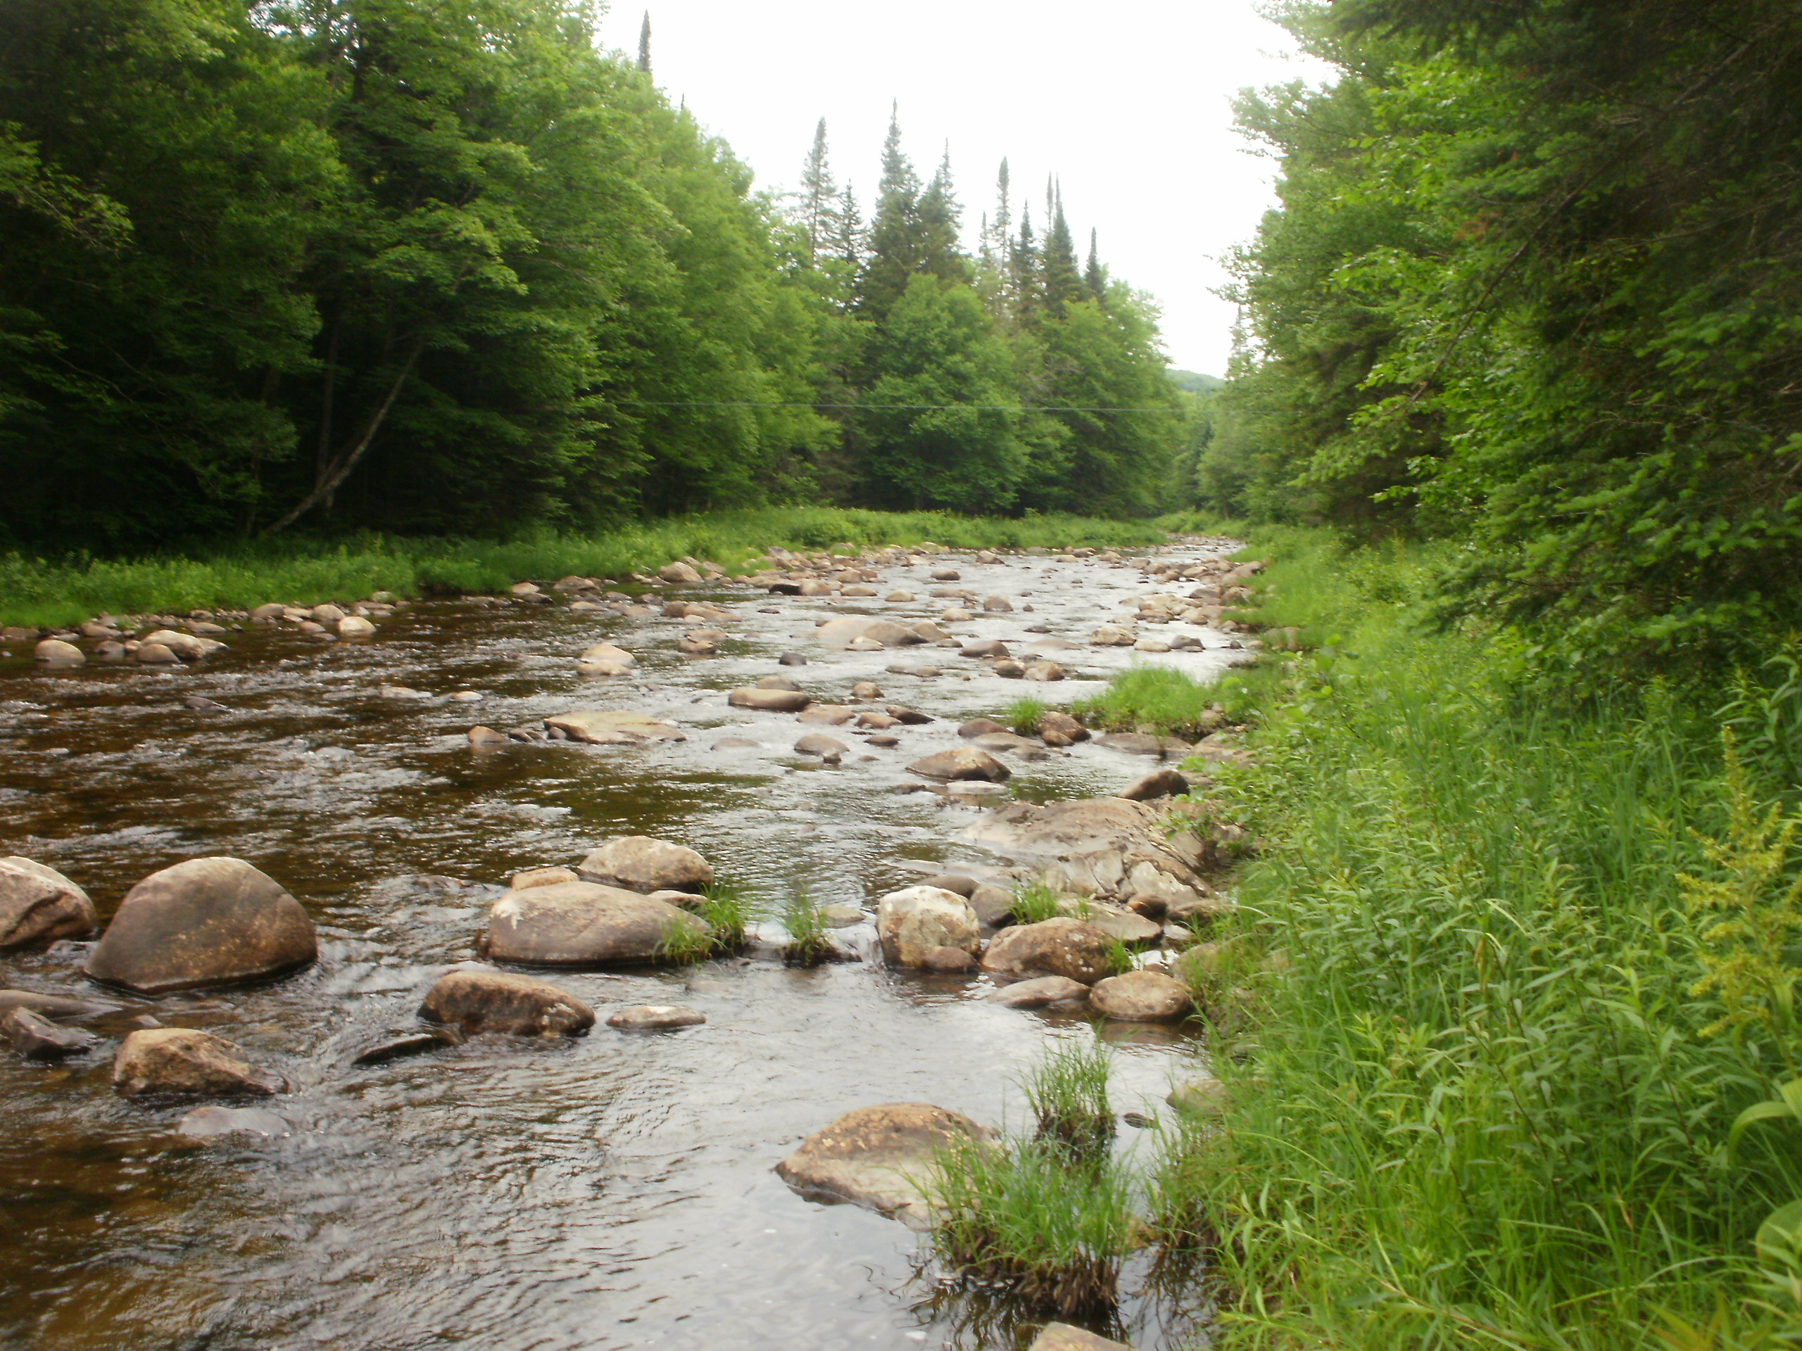
East Branch Mainstem

IV. PROJECT BUDGET

A. General Requirements

B. Budget Table
Partner Name | Partner Category * | Activity of Partner ** | Budget Category*** | EBTJV  NFHAP Request | Non-Federal Contribution |  | Federal Contribution |  | Total Contribution | Acres/Miles Affected
 |  |  |  |  | In-Kind | Cash | In-Kind | Cash | Total Contribution | Acres/Miles Affected
MEF | Mitigation Grant Fund | Culvert Replacement | Construction |  |  | $100,000 |  |  | $100,000 | 8
American Rivers | Conservation Group (National) | Culvert Replacement | Design |  |  | $20,000 |  |  | $50,000
American Rivers | Conservation Group (National) |  | Construction |  |  | $30,000 |  |  |  | 8
National Fish & Wildlife Foundation (BBN) | Conservation Group (National) | Culvert replacement | Design |  |  |  |  | $10,000 | $30,000 | 8
National Fish & Wildlife Foundation (BBN) | Conservation Group (National) | Restoration c&d | Personnel |  |  |  |  | $10,000 |  | 3
National Fish & Wildlife Foundation (BBN) | Conservation Group (National) | Monitoring | Personnel & Travel |  |  |  |  | $10,000 |  | 18
Canaday  Family Trust | Private Foundation | Culvert Replacement | Personnel |  |  | $10,000 |  |  | $30,000 | 8
Canaday  Family Trust | Private Foundation | Restoration c&d |  |  |  | $15,000 |  |  |  | 3
Canaday  Family Trust | Private Foundation | Monitoring |  |  |  | $5,000 |  |  |  | 18
EBTJV | Conservation Group  (National) | Culvert replacement | Construction | $45,000 |  |  |  |  | $50,000 | 8
EBTJV | Conservation Group  (National) | Restoration c&d | Personnel | $5,000 |  |  |  |  |  | 3
Vermont Fish & Wildlife | State Agency | Restoration | Personnel |  | $3,500 |  | $10,000 |  | $18,000 | 3
Vermont Fish & Wildlife | State Agency | Culvert Construction | Personnel |  | $1,000 |  | $3,500 |  |  | 8
Nulhegan Refuge | Federal Agency | Restoration | Housing |  |  |  | $20,000 |  | $23,600 | 3
Nulhegan Refuge | Federal Agency | Monitoring | Personnel |  |  |  | $3,600 |  |  | 18
Plum Creek |  | Culvert Removal | Equipment/  Construction |  | $75,000 |  |  |  | $100,000 | 8
Plum Creek |  | Restoration | Supplies |  |  | $25,000 |  |  |  | 3
Lyndon State College | State  Agency | Restoration | Personnel |  | $2,200 |  |  |  | $19,200 | 3
Lyndon State College | State  Agency | Monitoring | Personnel |  | $2,000 |  |  |  |  | 18
Lyndon State College | State  Agency | Assessments | Personnel |  | $15,000 |  |  |  |  | 50
Orvis Corporation | Corporation | Restoration | Supplies |  | $2,000 |  |  |  | $2,000 | 3
VT TU Chapters | Local Conservation Organization | Restoration | Personnel |  | $2,000 |  |  |  | $7,000 | 3
VT TU Chapters | Local Conservation Organization | Culvert Replacement | Construction |  |  | $5,000 |  |  |  | 8
Total Contribution |  |  |  | $50,000 | $102,700 | $210,000 | $37,100 | $30,000 | $429,800

*Partner Categories - Federal Agency, State Agency, Local Government, Conservation Group (Local), Conservation Group (National), Native American Tribe, Private Landowners, Corporations/Businesses

**Activity - Acquisition, Fish Ladder, Dam Removal, Culvert Removal, Restoration, Monitoring

***Budget Categories - Equipment, Construction, Contractual, Personnel, Travel, Supplies, Other.

NOTE: This is not a Federal Grant program and therefore does not exclude non-federal match used here from being matched to other Federal Grant sources to leverage funds for the project. Indicate if partnering contributions are in-kind or new cash. NFHAP requests should illustrate how the dollars will be spent and by what organization. Overhead such as utilities, office space, and salary to prepare applications and develop partnerships will not be funded with NFHAP funds and should not be a line item or built into the project. Activities that directly relate to completion of the project such as travel and salary to do design work let and/or monitor contracts are allowable expenses with NFHAP funds but should not constitute more than 10% of the funding request. For more information on the use of NFHAP funds, please see http://www.fws.gov/policy/717fw1.html.
- EVALUATION QUESTIONS
Please refer to the website (www.easternbrooktrout.org) for application instructions.

- Please provide the GPS Coordinates for the project in UTM NAD 83.
EB Southern Tip: -71.653329 44.771848 DD
EB Northern Tip: -71.675116 44.958985 DD
EB Eastern Tip:-71.631259 44.902528 DD
EB Western Tip: -71.729020 44.923747 DD
Watershed center: -71.670840 44.877273 DD

- Please list the type of project. Examples include: in-stream habitat, riparian planting, fencing, acid mine drainage restoration, fish passage, reintroduction, assessment, etc.
This project includes in-stream habitat restoration, fish passage connectivity, annual monitoring and yearly assessments.

- Are brook trout currently present at the project site or in the project stream? If not, were brook trout historically present? Is the habitat known to be suitable for restoration / reintroduction of brook trout?
Brook trout are present and were historically present in the Nulhegan watershed. The habitat is very suitable for restoration with a high likelihood of success due to its abundant fragmentation from culvert crossings and lack of instream complexity in its major branches.

- Please describe how the project will provide for the expansion or improvement of existing habitat?
Culvert replacements will open and expand eight miles of spawning habitat and thermal refugia for East Branch mainstem brook trout. Chop & drop in-stream restoration prescriptions will not only improve existing habitat in those reaches, it should also result in slightly cooler downstream water temperatures from an increase in cover over the streams and deepening of the stream. Likewise, an additional benefit should be seen in any tributaries that enter the East Branch in the restored reaches.

- Does the project include a protection component? If so, explain how the project sufficiently protects brook trout habitat. Does the project include fee simple land purchase or easements?
These lands are already under strict conservation easements managed by VLT in cooperation with VTANR.

- What percentage of the watershed above the proposed project is protected in perpetuity?
100 percent

- List the specific regional EBTJV habitat objectives addressed by the project and describe how the project will contribute towards them.
As stated in the EBTJV’s “Roadmap to Restoration” fact sheet, the Northern Region management priorities are to protect intact populations, determine status, reduce fragmentation, improve water quality and build partnerships. TU’s Home Rivers Initiative has worked diligently in the entire Upper Connecticut watershed to determine the status of brook trout populations and has developed strong partnerships, not only on Nulhegan River projects, but on Indian Stream, NH as well, where EBTJV is a contributing funder. Both partnerships efforts to reduce fragmentation by replacing stream crossings and conducting instream restorations go hand-in-hand with the Northern Region’s priorities.

This project addresses Vermont goals as well on Habitat Protection, Brook Trout Protection, Restoration and Enhancement, and Assessments. Specifically this project helps to develop instate expertise on crossing and instream work; it uses biological data, habitat evaluations and stream crossing inventories extensively to prioritize work; and a key Home Rivers Initiative has been quantitative fisheries assessments and yearly monitoring.

- Please state whether the project is an enhancement, restoration or protection project.
The primary objective of this project is to restore, reconnect, and sustain native brook trout and their habitats and protecting future brook trout populations from climate change by providing thermal refuge and reconnecting fragmented populations. A secondary benefit of this project will be the enhancement of the stream habitat for all fish and wildlife species.

- State which, if any, EBTJV priority the project addresses:
This project addresses EBTJV’s four major conservation goals to conserve, enhance or restore brook trout populations, to encourage partnerships among management agencies, to develop and implement outreach and educational programs to ensure public awareness, and to develop support for program implementation to perpetuate and restore brook trout populations throughout their historical range. It also addresses several primary objectives including: maintaining currently intact watersheds, strengthening watersheds, and determining brook trout population status.

- What is the EBTJV subwatershed number and priority ranking for the proposed project watershed for the type of project (enhancement, restoration or protection) being proposed?
Watershed # = 500293
Priority Score = 1.61
Map = Vermont Protection
Note: Proposed projects in watersheds that are classified as “other subwatersheds” and shown in grey on the state priority maps are not eligible for funding for that type of project.

- Will the completed project benefit any federally listed threatened or endangered species?
Atlantic salmon sac-fry are stocked in the East Branch as part of the Connecticut River recovery program but are not listed. However, the partnership’s efforts in the watershed should benefit this species and the recovery program through a higher percentage of fish achieving the smolt stage.

- Will the completed project benefit any state listed threatened or endangered species?
According the Vermont Fish & Wildlife website, no listed fish species are present. Canadian Lynx are present and listed as endangered in Vermont. The Wood Turtle is known to inhabit this region, and is a Vermont species of concern. While our efforts may or may not benefit these species, they will not harm them.

- Will the project provide or enhance connectivity to or within an intact subwatershed?
Yes, the three culvert replacements will reconnect eight miles of stream within the subwatershed.

- What are the root causes of the watershed degradation and which of these are addressed by the project?
The root cause of the Nulhegan River watershed’s degradation is from poor logging practices, beginning with the intensive cutting, dam building, and log drives of the late 1800’s through the clearcutting of the 1970’s and early 1980’s.

- Describe the plans for project monitoring and evaluation.
In partnership with VTFW and the USFWS Nulhegan Wildlife Refuge, TU’s project already has two to three years of pre-treatment temperature and fish sampling data at five stations in the East branch watershed. Following treatment, temperatures will be monitored annually throughout the Nulhegan watershed, designated stream reaches will be surveyed yearly for trout population trends, culverts will be monitored watershed-wide, and culvert replacements and in-stream restoration projects will be assessed and surveyed for brook trout population trends on an annual basis. In addition, VTFW will evaluate all current and future projects on the Vermont side of TU’s Upper Connecticut Home Rivers Initiative.

- Describe the expected effect on the brook trout population. To what degree will the project strengthen the brook trout population status?
While this project will not change the brook trout status in the Nulhegan watershed, restoring connectivity by initiating a culvert replacement program and increasing stream complexity in degraded stream reaches should contribute to increased brook trout population densities.

- Please describe the long term benefit of the project and provide an estimate of the length of time the project is expected to be effective. If a plan for long term maintenance is necessary, please describe it.
Culvert replacements are expected to last at least 50 years. In-stream chop & drop restorations should result in a narrower stream with increased pools and will likely eliminate the perpetual scouring cycle that plagues the major branches of the Nulhegan River watershed. Once this scouring cycle is interrupted, the stream should maintain a relative stasis.

- What size stream does the project benefit? Is this stream a tributary or mainstem habitat?
The East Branch at 44 sq. mi. is one of four major branches of the larger 142 sq. mi. Nulhegan River. Culvert replacements will be conducted in smaller streams that are tributaries of the major branches of the Nulhegan River, starting with its East Branch. Culvert replacements will primarily benefit these smaller “nursery” streams. However, opening up these streams to trout migration should allow larger trout to access these upper reaches during periods of warm temperatures, thus benefiting the larger branches as well. Chop & drop prescriptions will be conducted in the upper reaches of the main branches, which are in essence, small tributaries. Similarly, restoring these upper reaches should provide a benefit not only to those areas, but to adjacent downstream areas as well.

- What competitive non-native or invasive fish are in the watershed with access (no barrier) to the proposed project?
Brown trout are found in the watershed spawning naturally in small numbers. Wild rainbow trout have also been found in the East Branch watershed, but in very low numbers.

- Are other strains of brook trout, salmonids, or exotics present in the proposed watershed? Where (e.g. upstream, downstream, and distance from project site) does the stocking take place with respect to the project site?
Catchable-sized brook trout are stocked in the East Branch to support put-and-take fishing. Atlantic salmon are stocked as sac fry in the watershed as part of the Connecticut River restoration program. Brown trout are found in the East Branch and are stocked in the lower Nulhegan River. In addition to brook trout, Atlantic salmon fry, rainbow trout, and brown trout, are stocked in the Upper Connecticut River.

- Please describe the current status of the project. Is it planned, permitted and ready to begin? Please identify the targeted month and year for project completion.
The partnership expects that most of its restoration work in the East Branch of the Nulhegan will take up to five years to complete. This includes projects not listed in this grant including, mobile wood additions and some larger instream projects that will be implemented following our initial prescriptions. Simultaneously, we expect to begin similar work in an adjacent branch to begin as early as 2013.

- Will public access be allowed at the project site? If so, what kinds of recreational activities are allowed - public fishing, nature trails, etc?
The entire Nulhegan River watershed is under conservation easements. Hunting, fishing, hiking, is already allowed and snowmobiling during the winter on designated trails is a popular activity.

- What is the recreational quality of the potential fishery?
The East Branch, as well as the other Nulhegan branches, contains good populations of age 0, 1, and 2 brook trout in some select reaches and in its smaller nursery tributaries and it is highly unlikely that brook trout will ever be extirpated from the Nulhegan River watershed. However, the East Branch watershed does not have good adult trout habitat or contain many of the larger catchable fish that are prized by anglers. The goal of the partnership is to create more than museum pieces; the ultimate goal is to increase the population of larger fish in the system. The partnership is highly confidant that its work in the East Branch will increase adult brook trout habitat and populations.

- Describe any outreach or educational components of the project and how many individuals / students will be served.
Education is a prime component of TU’s work on a local and national level. This season, VTFW and TU’s Home Rivers Initiative project coordinator visited the nearby TU Youth Trout Camp and gave conservation talks, conducted streamside and instream classes and planted trees on Leech Creek, an Upper Connecticut tributary that experienced a microburst in the spring of 2011. In addition, for the last two seasons, four Lyndon State Vermont students have walked the Nulhegan River watershed and Indian Stream in NH for the Home Rivers Initiative, conducting stream habitat surveys. Their work has been instrumental in guiding the partnership’s work on reconnecting nursery streams to their main water bodies and prioritizing instream habitat improvement work.

- If applicable, please briefly describe how this project will promote adaptation to climate change.
Brook trout, requiring cold water, are an indicator species and a species that will be adversely affected if climate change predictions are realized. By improving the overall health of the stream and increasing adult trout populations, current and future culvert replacements will be a key component in allowing brook trout to adapt to the increase in water temperatures by providing them thermal refuge. Additionally, chop & drop, which increases the number and depth of pool habitat, and will increase cover in the restored reaches, should buffer temperature spikes in those reaches and decrease overall upper temperatures in adjacent downstream reaches.

- Please explain how this project is a good investment of funds, using a quantitative approach where possible and the recreational and / or economic value of the project.
In the East Branch of the Nulhegan River watershed, the partnership will reconnect eight stream tributary miles and restore three stream miles with an additional expected benefit to approximately ten to fifteen tributary stream miles from rehabilitation of their East Branch mainstem reaches. More intangible is the recreational/economic benefit that our restoration efforts will provide to the resource. However, the Upper Connecticut River is a special place. It is one of only 14 American Heritage Rivers, is listed in the book “100 Best Trout Streams”, has a hypolymnetic flow release from Murphy Dam at Lake Francis in Pittsburg that provides ideal mainstem trout habitat year-round down to the Nulhegan River confluence, and the Nulhegan River is the largest and most protected tributary in TU’s Home Rivers Initiative project area. In addition, the strength of our partnership, with VTFW fish biologists as major partners in all aspects; the USFWS Nulhegan Refuge providing labor and housing for seasonal employees; Lyndon State College providing yearly interns for surveys, assessments, and labor; and the majority landowner, Plum Creek as an instrumental partner by providing all trees for instream restorations, plus some equipment and labor for crossing and restoration work; combines our individual roles with our technical expertise, making this restoration project a winning investment.

- SUPPORTING DOCUMENTATION:

- Literature Cited
- References to published interagency fishery or aquatic resource management plans.

http://www.easternbrooktrout.org/docs/EBTJV_Roadmap_Fact_Sheet.pdf
http://www.easternbrooktrout.org/docs/EBTJV_Vermont_CS.pdf
http://www.easternbrooktrout.org/docs/EBTJV_Roadmap_Fact_Sheet.pdf
http://www.vtfishandwildlife.com/wildlife_nongame.cfm

