Eastern Brook Trout Joint Venture
Completed Project Report Form

Project Title: Camp Wihakowi Dam Removal

- Location: Northfield, Vermont

- Lat / Long Coordinates: 1166295.80, 4917502.06 UTM17N NAD83
(44.10642 , -72.67537 LL WGS84)

- Sponsor: Friends of the Winooski River

- Completion Date: October 31, 2021

- Partners involved:

Partners who provided major funding and/or technical support:
Vermont Department of Environmental Conservation
US Fish & Wildlife Service
Vermont Fish & Wildlife Department
Vermont Natural Resources Council
The Nature Conservancy Vermont
Vermont Dam Task Force

Other funders:
Vermont Community Foundation
Lake Champlain Basin Program
Watersheds United Vermont
Pur Projet

Other parties:
Landowners of the dam
Landowners of the disposal site
Town of Northfield
Regulators: SHPO, Dam Safety, Act 250, Wetlands, VFWD, Stormwater

Contractors:
SLR
106 Associates and Tico Wolff
Hilltop Construction
FluidState Consulting

Volunteers:
Cabot Creamery
Agency of Natural Resources
National Life Group

- Project costs:
- Total cost: $ 444,236
- Non federal amount: $ 304,520
- Federal amount: $ 139,716

- Final Funding:
NFHAP Funding Through EBTJV: $ 50,000
Total Federal Contributions: $ 120,621
Total Non-Federal Contributions: $ 345,000

Partner | Type of Match  (In-Kind or Cash) | Amount
The Nature Conservancy | Cash | $ 30,000
Vermont Natural Resources Council | Cash | $ 50,000
State of Vermont | Cash | $ 224,520

- Action strategy implemented in the project (according to EBTJV range wide, regional, or state level habitat strategies).
Restoration: conservation action that returns natural/historic attribute and functions to aquatic habitat.

- Priority score of the sub-watershed where the project took place.
EBTJV Classified Catchment Score = 1.4
Subwatershed Priority Score = 1.13

- Describe any additional species of greatest concern or the state wildlife action plan listed habitat conservation goal (s) supported by the project.
The project benefitted Brook Trout, a USFWS priority species in Region 5.

- Description: project objective(s):

Remove the Camp Wihakowi dam from Bull Run in Northfield, Vermont, to open 6.3 miles of stream for aquatic organism passage. Remove more than 20,000 cubic yards of sediment to restore floodplain and reduce sediment and nutrient transport to improve water quality and flood resilience. Plant almost 1,000 trees and seed floodplain with native herbaceous vegetation to restore forest cover and enhance terrestrial and aquatic habitats in the project area.

- Methods used:
Excavation of impounded sediment, including some mature woody vegetation and invasive Japanese knotweed, and destruction and removal of concrete dam.

- Project outcomes: Describe outcomes and whether or not the objectives were met. If not why? What lessons were learned?

The dam and sediment were removed according to the design, and the floodplain was revegetated. The objectives of the project were met. One lesson learned is that the biggest logistical challenge and expense were the hauling and disposal of the material removed from the site. Finding convenient and affordable disposal locations was difficult, as was sourcing enough trucks.

- What is the Brook trout population response to the project outcome?

Immediately upon removing the dam, Brook trout were able to access more than 25 miles of cold water habitat upstream, and geneflow among the sub-populations upstream and downstream of the dam was restored. Four acres of floodplain habitat along 1,100 feet of stream have been restored in the former impoundment. The population has also become more resilient to extreme events, which proved essential immediately after the dam was removed. September 2020 saw one of the most extreme droughts in recent Vermont history. Access to cold headwater tributaries was important for the survival and post drought recovery of Brook Trout in Bull Run.

- If applicable, what is the number of stream miles and or acres of brook trout habitat?

A. Protected: N/A

B. Restored/Enhanced: 6.3 miles of third order or larger streams

- If applicable what is the number of stream miles and or lake/pond acres of brook trout habitat gained access to as a result of removing a fish barrier. Include the # of fish barriers removed?

One barrier was removed, which opened access to 6.3 miles of brook trout habitat upstream from the project site.

- If applicable, what is the number of stream miles and or lake or pond acres of brook trout habitat with sediment, phosphorous, or nitrogen inputs that were rehabilitated to within 25% of natural or other desired levels such as numeric state water quality criteria?

BEFORE: credit Friends of the Winooski River
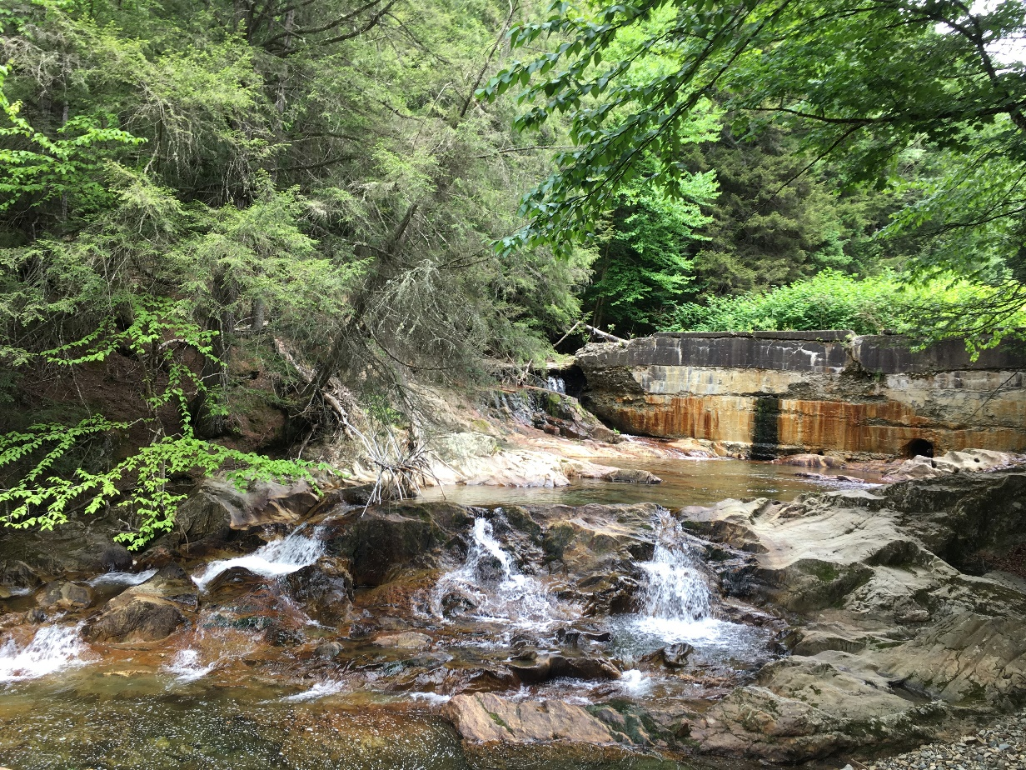

AFTER: credit Friends of the Winooski River
