EBTJV Eastern Salmonid Range Assessment: data sources, methods, and 2024 dataset summary
Table of contents
Introduction 1
Use 2
Availability 2
Assessment scope 2
Data sources 4
Results 11
2024 catchment layer – data summaries 12
2024 BKT patch layer – data summaries 15
References 19

Introduction
This document summarizes the data sources for the 2024 Eastern Brook Trout Joint Venture (EBTJV) Eastern Salmonid range assessment dataset for a technical audience. The assessment is a partnership-driven dataset integrating occurrence information for Brook Trout Salvelinus fontinalis, Brown Trout Salmo trutta, and Rainbow Trout Oncorhynchus mykiss across 17 states, developed through coordinated input from state, federal, and Tribal agencies. This version uses field data collected through 2023 and an algorithm to predict occupancy at connected upstream reaches. This document provides methods for the 2016 assessment as an integral component, as well as methods and attribution for data in the 2024 assessment. This document contains no change classification or change analysis between the 2024 and prior versions; it describes the 2024 dataset as a standalone snapshot of the current state of knowledge about salmonid occupancy across the eastern United States.

Use
The EBTJV Eastern Salmonid Assessment was developed as a compilation of what is understood about wild Brook, Brown, and Rainbow Trout presence or absence using a single method across 17 eastern states. This dataset, now in its third iteration, was designed to assist federal and state agencies, local decision-makers, regional planners, conservation organizations, and natural resource managers visualize Brook Trout occupancy for a variety of uses.
The data are available at two spatial scales – NHD medium resolution catchments, and patches, which are group of contiguous catchments occupied by wild trout.
The dataset represents the most accurate knowledge available to agency biologists at the time of development, but should be used as a screening tool. Users should exercise caution in using occupancy determinations at the catchment scale; it is not intended as definitive evidence of Brook Trout occupancy at a reach or site-specific scale. The dataset contains no information on abundance. Users are directed towards abundance.ebtjv.de.
Either scale may be used to describe broad patterns in salmonid occupancy or as a first step in a multi-step process for watershed prioritization. The EBTJV recommends using the patch scale for most applications: not only is it easier to work with and visualize (fewer polygons), it is also more intuitive. Patches aggregate catchments and thus are based on more data. Patch size can serve as a proxy of of salmonid population status (e.g., Trout Unlimited defines a Brook Trout ‘stronghold’ when a patch is >25 sq km).

Availability
The Assessment is available as a geodatabase containing three primary layers: a 2024 catchment layer containing all catchments of either allopatric Brook Trout, sympatric Brook Trout, or other salmonid species without Brook trout; a 2024 patch layer containing wild trout patches (Rainbow and Brown Trout with or without Brook Trout); and a 2024 patch layer for Brook Trout patches (allopatric or sympatric). The EBTJV Range-Wide Layers geodatabase is downloadable by request to the EBTJV at https://easternbrooktrout.org/science-data/update-to-the-ebtjv-assessment
The 2024 Brook Trout patch layer is also available as an ESRI Feature Service via https://www.arcgis.com/home/item.html?id=a49f58e0958145e09363bf077e94f7f7

Suggested Citation
If you use this dataset in your research, publication, or application, please cite it using the following format: Eastern Brook Trout Joint Venture, 2026. EBTJV Eastern Salmonid Range Assessment: Data Sources and 2024 Dataset Summary. Available at https://easternbrooktrout.org/science-data/update-to-the-ebtjv-assessment.

Assessment scope
The EBTJV Eastern Salmonid Assessment covers the native range of Brook Trout in the eastern United States across 17 states, from Maine south through the Appalachians to Georgia and Tennessee (Table 1). These 17 states also include numerous lands under federal or Tribal management, whose data are reported through state agency biologists. The Great Smoky Mountains National Park reports its salmonid occupancy data directly to the EBTJV.
The historic and contemporary boundaries for Brook Trout include areas of Canada and the upper Midwest US, however the EBTJV operates in the Eastern 17 states.
Table 1. States included in the Eastern Brook Trout Joint Venture’s Eastern Salmonid Assessment.
States included in assessment.
Connecticut
Georgia
Maine
Maryland
Massachusetts
New Hampshire
New Jersey
New York
North Carolina
Ohio
Pennsylvania
Rhode Island
South Carolina
Tennessee
Vermont
Virginia
West Virginia

Data sources

EBTJV 2016 Dataset - Catchments
The assessment uses the National Hydrography Dataset (NHD) catchment layer (1:100,000 scale; McKay et al., 2012) as its fundamental spatial unit, providing a consistent, watershed-based framework for recording occupancy status. Each record represents one NHD catchment.
The 2016 EBTJV dataset represents the first comprehensive, range-wide assessment of brook trout occupancy (presence/absence) using a standardized NHD catchment-based framework. It included 272,057 catchments within the EBTJV footprint (Hudy et al. 2008), covering approximately 629,000 km². Occupancy determinations were compiled by state EBTJV partner agencies based on available field survey data and expert biological knowledge. Each catchment was assigned an EBTJV code reflecting presence of Brook Trout, Rainbow Trout and/or Brown trout. Codes included a P if data older than 10 years were used. The earliest year noted was 1953.

EBTJV 2024 dataset - Catchments
There are 576,928 catchments covering the 17-state EBTJV range, covering 628,722 sq km. The 2024 assessment includes all catchments of these 17 states and thus includes the same 272,057 catchments as the 2016 assessment and an additional 304,871 catchments; these additional catchments are assigned a catchment code of -1 (not sampled) for North Carolina and 0P for all other states. Although it is termed the 2024 dataset due to the date when it was compiled, the data reflect field samples through 2023. The earliest year noted was 1914.

NHD catchment layer
The spatial framework for both assessments is the National Hydrography Dataset Plus Version 2 (NHDPlusV2) medium resolution catchment layer. Each NHD catchment represents the contributing drainage area to a single stream reach and is identified by a unique FEATUREID. Catchments in the EBTJV assessment have a size range of 0.0009 to 1174.45 km² and median area of 1.2 km². Catchments are the fundamental unit of occupancy recording: each record represents one NHD catchment.

EBTJV occupancy codes
EBTJV occupancy codes (EBTJV_CODE; Table 2) record wild Brook Trout presence or absence and, where present, the co-occurrence of wild, naturally reproducing non-native species. The code 0.5 was created for stocked Brook Trout. There are no codes for stocked Brown or Rainbow Trout.
Table 2. EBTJV classification codes denoting combinations of species occupying a catchment. A trailing P next to the code denotes that the data used in the classification were older than 10 years at the time of assessment.

EBTJV_CODE | Occupancy status | Notes
0 | Brook trout absent | Confirmed absence based on field survey or expert knowledge (some states use this to mean unsampled)
0.2 | Brown trout | Wild brown trout present
0.3 | Rainbow trout | Wild rainbow trout present
0.4 | Brown and rainbow trout | Wild brown and rainbow trout present
0.5 | Stocked brook trout | Brook trout stocked (note: not comprehensive)
1.1 | BKT present — allopatric | Brook trout present; no non-native salmonids detected
1.2 | BKT present — sympatric with brown trout | Brook trout co-occurring with brown trout
1.3 | BKT present — sympatric with rainbow trout | Brook trout co-occurring with rainbow trout
1.4 | BKT present — sympatric with brown and rainbow trout | Brook trout co-occurring with brown and rainbow trout
1.5 | BKT present – present with stocked brook trout | Wild and stocked brook trout co-occurring
-1 | Unsampled | No occupancy determination recorded
xP | P-flagged (any code above) | Determination based on data older than 10 years at time of assessment (this field was not automatically updated in the new release, therefore some P flags might be missing).

Algorithm to populate catchment species catchment codes – 2016 assessment as the foundation
Both the salmonid catchment assessment and habitat patch layers are created using algorithms written in Python and implemented through ArcGIS toolboxes. It operates using several spatial layers. The first is a point layer of sample locations containing sample date, salmonid species captured (count or presence), and location coordinates. Additional layers include the catchment polygon layer, flowline vector layer, catchment raster layer, flow direction raster layer, flow direction null raster layer, plus flowline VAA table, and plus flow table. Finally, a barrier layer is required. The baseline barrier dataset is derived from the National Anthropogenic Barrier Dataset (NABD) 2012. This dataset was further supplemented with the Nature Conservancy's dam layer, and state dam and impassable waterfall locations if provided (Coombs, 2024).
Catchment classification begins by determining which species were present in a field sample in a given catchment. and how long ago the sample was conducted. All samples occurring greater than 10 years from the analysis year were given a 'P' after the code representing 'predicted'. The number of NHD catchments in the EBTJV footprint far exceeds the field sampling spatial coverage, with the exception of a few jurisdictions. To classify non-sampled catchments the EBTJV created an algorithm to assign species codes to catchments based on network connectivity. Catchments upstream of a sample point were inferred from the downstream catchment, and given the classification code of that catchment until a barrier, different sample, or stream end was encountered. Culverts were not included because data on passibility were not sufficient to apply uniformly across the range. The algorithm was first used in the 2016 assessment and was an option for the 2024 assessment.
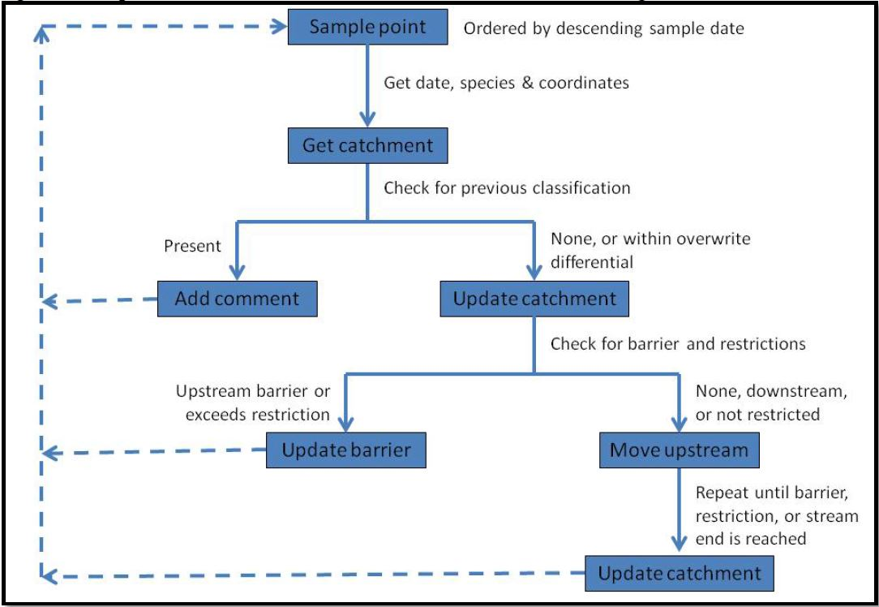
Figure 1. Assessment catchment classification data fields, from Coombs, 2024.
For Pennsylvania and states north occupancy determinations propagated upstream from directly-sampled catchments to upstream neighbors using the NHD network topology, with the number of catchments between a directly-sampled source and a given catchment recorded in a field called CATCH_CNT. MD south, these were hand coded (all CATCH_CNT = 1).
Certain restrictions ended up being necessary due to the occasional absence of smaller streams in the flowline layer, the occurrence of multiple stream reaches in a single catchment, and unrealistic biological outcomes. There are four available restriction conditions:
1) Maximum sample point distance
2) Maximum dam point distance
3) Maximum stream order to infer upstream catchment classification
4) Maximum upstream distance to infer catchment classification from the sample point
Restrictions 1 and 2 rectify sample and barrier locations occurring on streams not present in the flowline layer. Restriction 1 was not used. Restriction 2 was set to 250 m (e.g. a barrier could be a maximum of 250 m from a flowline to be considered, otherwise it would be too far from a stream line to assume it is associated with that stream).
Restriction 3 deals with assigning upstream catchments the same code as a connected downstream catchment. If a sample location occurs on a stream not present in the flowline layer that then flows into a large river, or if a catchment contains multiple flowlines and the catchment is associated with the larger stream or river, the algorithm will allow the connection upstream to travel via the larger stream or river, with limits to Strahler stream order. The connection to classify upstream is limited to stream order 4 for brook trout, and 5 for rainbow and brown trout. The exception is in Maine, where the restriction for brook trout is set to stream order 5, based on knowledge of brook trout occupancy of these larger order streams in Maine.
Restriction 4 enables the user to limit upstream catchment classification inferred from a downstream sample location based on total stream distance upstream of the sample. The default distance is 50 km for brook trout, rainbow trout, and brown trout, except in Maine, where brook trout upstream distance is limited to 80 km and rainbow and brown trout distance is limited to 10 km.

Web tool development and use, and differences between 2024 and 2016 catchment coding methods
Data updates were performed by credentialed agency biologists for each state or federal agency (“data stewards”) using a web tool developed by Jason Coombs (US Fish and Wildlife Service) for the EBTJV. The tool utilizes a suite of open-source software packages including relational database, user access management, data visualization, interactive mapping, and backend algorithm support.
The updater tool was designed to allow flexibility in making updates: the partners submit composition, location, and date information via csv or Excel file upload or direct editing within the web tool. Beginning in 2023, partners updated salmonid catchment codes based on field surveys conducted since 2016, expert knowledge review, and application of the EBTJV 10-year data currency standard (P-flagged).
By default, the upstream catchment codes and attributes are retained from the prior full dataset (2016). The tool then assigns occupancy based on most recent sample. Biologists are presented several options. First, a biologist may choose to update catchment codes for connected upstream catchments, using the “connect upstream” algorithm. Data stewards were cautioned to use the “connect upstream” feature carefully due to possibility of data overwriting, therefore its use was not universal in 2024 and was done most often in North Carolina and Pennsylvania. CATCH_CNT values did not change for the 2024 assessment, regardless of any additional sampling even in previously unassessed catchments.
Also, the biologist may opt to override the algorithm (ie bypass the most recent field sample) and provide a reason. The dataset contains fields “VAL_CHANGE” and “VAL_REASON” to guide understanding of where and why catchment codes were manually entered or changed from the algorithm-selected code.
Examples of scenarios in which data stewards needed to manually edit a catchment's classification are listed below, along with a supplied reason to standardize data across the range.
- If a catchment includes a portion of the mainstem and tributary and two data points occur in the same catchment in the same year with conflicting results (e.g., Brown Trout in mainstem and Brook Trout in tributary), manually update to the catchment code that best describes the trout community and select "Conflicting data". In some cases, this may result in a sympatric patch code.
- If a biologist knows that a barrier is present which changes trout community upstream of the barrier but it is not reflected in the data, manually update catchment code to reflect their knowledge of the stream and in comments for manual edit, select "Known barrier".
- The most recent survey results (e.g., allopatric Brook Trout) conflicts with knowledge from prior surveys (e.g., sympatric Brook Trout and Rainbow Trout) and biologist knows Rainbow Trout are still in the stream but the sampling did not pick them up this year because they occur in low density, manually update to the code that best describes the trout community and select "Biologist knowledge".
- If data is outdated and includes an inaccurate entry for a trout species present, (e.g., only data available was from 1981 and includes a hatchery rainbow trout that was recorded as a wild Rainbow Trout and is changing the catchment to sympatric Brook Trout and Rainbow Trout), manually update to the code that best describes the trout community and select "Outdated data".
- If a situation occurs in which a manual edit is needed and does not fall within the categories outlined above, manually update to the code that best describes the trout community and select "Other" and provide brief rationale for why update was made.

EBTJV Catchment layer – estimation of new or updated catchment codes
The 2024 data set builds on the 2016 data set. Biologists upload new data and the tool returns the option to review a list of catchments that would change from the prior version. The degree to which any catchment code is reviewed will vary from state to state. State data submissions and catchment code changes may reflect true changes to the state of salmonid occupancy (gains, losses), an improvement to the knowledge of salmonid presence (unassessed waters), or both. Comparing versions of the assessment to track progress or changes is of great interest to the conservation community. Several caveats cloud our ability to ascertain a true status change at any location (see Rummel et al., 2024 for a full analysis).
Additionally, it is difficult to determine which catchments contain updated data, because there is no single field in the dataset that flags a new sample. Updated records may be identified through a combination of ‘SAMP_YEAR’ (the sample year used in the most recent determination, which may be different from the most recent sample recorded), ‘CATCH_CNT’ (catchment count, where 1 indicates the catchment containing a sample or knowledge that drives the determination). For states PA and north, the combination of “CATCH_CNT” == 1 and “SAMP_YEAR” not equal to 1900 or 0 will identify catchments that contain a field sample or for which the data steward applied a manual edit. A CATCH_CNT >1 for northern states indicates a code was algorithm-derived from the 2016 assessment. Lat/Lon locations of salmonid field sampling were not retained in the data set.
We consider catchments to have an updated assessment classification if the record 1) includes new field sampling data or biologist judgement based on data, 2)is connected upstream of a newly field-sampled site (algorithm-driven), or 3) if a biologist applied judgement that changed or confirmed a catchment classification without a sample date. The three conditions are as follows, and are considered additively:
- Most conservative — direct field samples only: CATCH_CNT = 1 and sample year after 2015. The catchment was visited, the sample post-dates 2016, and the code rests on that visit alone.
- Moderate — adds algorithm-propagated: Source sample is post-2016 but the individual catchment may not have been visited directly.
- Broadest — adds biologist-knowledge assignments without a recorded date: Includes catchments where a biologist set or confirmed a code without logging a sample year. (Some of these may reflect pre-2016 knowledge carried forward).
The combination of biologist-knowledge assignment and connecting upstream algorithm integrates multiple forms of evidence beyond a single field sample and allows the EBTJV to capture the best-known information on the presence of salmonid species. However, the application of flexible assignment carries tradeoffs. The rule set for biologist judgement were applied with variability from state to state; the ability of biologists to manually review catchments is hindered by the sheer number of catchments available; and legacy differences in the use of CATCH_CNT in southern states makes it impossible to ascertain unassessed waters sampling in states Maryland and south.

EBTJV Catchment Layer – Field Attributes
Table 3. Field attributes for the 2024 catchment layer
Field | Type | Description
`GRIDCODE` | numeric | Internal NHD grid identifier. Used for spatial indexing; not an analysis field.
`FEATUREID` | numeric | **Primary identifier.** Unique NHD catchment ID. Join key across years and datasets. Values can exceed 10 digits for newer NHD features.
`SOURCEFC` | character | NHD feature class of the stream reach within the catchment. Values: `"NHDFlowline"` (flowing stream) or `"Sink"` (closed depression / no outflow).
`AREASQKM` | numeric | Catchment area in square kilometers. Range: ~0.001 to 1,174 km². Four duplicate FEATUREIDs exist in the 2024 layer; deduplicate before aggregating area.
`EBTJV_CODE` | character | **Primary occupancy classification.** See code reference table above. Includes trailing P where applicable.
`CATCH_CNT` | numeric | **Catchment count from the upstream propagation algorithm.** `0` = catchment not assessed or not reached by the algorithm; `1` = the directly field-sampled source catchment; `>1` = upstream catchment assigned the same code by the algorithm (increments by 1 per step upstream until a barrier, stream end, or restriction is encountered). Range: 0–62. Vales >1 Only occur for Pennsylvania north due to legacy of hand-coding catchments Maryland and south in prior versions.
`CUM_LENGTH` | numeric | Cumulative stream length (meters) from the catchment containing the sample point used for classification.
`SAMP_YEAR` | numeric | Year of the field sample that determined (or most recently confirmed) the occupancy code. `0` = not field-sampled. In some records, date was estimated based on best knowledge. **Known anomalies:** a small number of records have implausible values (e.g., 4, 275,760); treat non-zero values outside 1900–2024 as data entry errors. The value `1900` is used as a placeholder for unknown sample year in some records.
`SAMP_DIST` | numeric | Distance in meters from the source sample point to this catchment along the stream network. `0` for the source catchment or unassessed catchments. Range: 30–8,851 m for non-zero values.
`SAMP_OID` | character | Object ID of the source sample record in the underlying sample database. `"-1"` indicates no linked sample.
`DAM` | character | Indicates whether a dam is present in or immediately downstream of the catchment. Values: `"Yes"`, `"No"`, or blank (unknown).
`SAMP_LOC` | character | Location of the field sample relative to a barrier. Values: `"Above"`, `"Below"`, or blank. Only determined for catchments containing the sample point used for classification and a barrier.
`STR_ORDER` | numeric | Strahler stream order of the reach within the catchment. `0` = unknown or not assigned. Range: 0–8.
`COMMENT` | character | Adds the classification code and sample year for additional samples in the catchment.
`STATE` | character | State name (full name, e.g., `"Pennsylvania"`). One of 17 EBTJV range states.
`VAL_CHANGE` | character | The original catchment classification if the code was changed. Auto-populated by the Catchment Updater Tool when a biologist changes the code from its algorithm-derived or prior value. Format: `"Changed from [prior code]"` (e.g., `"Changed from 1.1"`). Blank if code was not manually changed.
`VAL_REASON` | character | **Biologist-entered free-text justification** for a manual code change. This is the primary field for understanding why a code differs from what the algorithm would assign. Often blank even when a change was made; non-empty values indicate an override with documented rationale. Often blank. Examples of manual updates to the code that best describes the trout community; "Conflicting data” – catchment includes a portion of the mainstem and tributary and two data points occur in the same catchment in the same year with conflicting results ;"Known barrier” –barrier is present which changes trout community upstream of the barrier but it is not reflected in the data; "Biologist knowledge”–The most recent survey results (e.g., allopatric Brook Trout) conflicts with knowledge from prior surveys.; "Outdated data”–If data is outdated and includes an inaccurate entry for a trout species present .;"Other" situation occurs in which a manual edit is needed and does not fall within the categories outlined above ; should provide brief rationale for why update was made.
`PRIOR_CODE` | character | The `EBTJV_CODE` value from the **previous** assessment cycle (2016), retained for traceability. May include P suffix. Blank if no prior code exists.
`PRIOR_YEAR` | numeric | Year associated with the prior assessment. `0` = no prior record. Note: value `1900` may appear as a placeholder.
`REASON` | character | Brief standardized reason for a code change (e.g., `"New Sample"`, `"New data"`). Distinct from `VAL_REASON`, which is the biologist's narrative.
`EDITOR` | character | Name of the biologist or data manager who made the most recent edit. Blank if no edit recorded.
`EDIT_DATE` | datetime | Date and time of the most recent edit. `NA` if no edit recorded.
`PRIOR_EDIT` | character | Information about a previous edit, retained for traceability. Rarely populated.
`LATEST_SAM` | datetime | Date of the most recent field sample associated with this catchment. `NA` if not sampled.
`Shape_Length` | numeric | Perimeter of the catchment polygon in decimal degrees (artifact of geographic CRS storage). Not suitable for area/length analysis; use `AREASQKM` instead.
`Shape_Area` | numeric | Area of the catchment polygon in square decimal degrees. Not suitable for area analysis; use `AREASQKM` instead.

Brook Trout patch layers
Brook Trout patches are spatial aggregations of contiguous NHD catchments sharing the same species, produced by a similar algorithm to the catchment algorithm. Patches are not connected physically (i.e., they are separated by a dam, unoccupied warm water habitat, downstream invasive species, etc.) and are generally assumed to be genetically isolated.
Patches are generated using the same data inputs and restrictions (dam layer) as the catchment algorithm and represent the continuous extent of brook trout habitat at the stream-network scale. There is no biologist or other override on patch generation or classification. Both the salmonid catchment assessment and habitat patch layers are created using algorithms written in Python and implemented through ArcGIS toolboxes.
Because patches are derived directly from catchment codes, patch geometry is specific to each assessment year and cannot be compared directly between the 2016 and 2024 datasets — a change in any constituent catchment’s code may fragment or merge patches between assessments. The EBTJV recommends using patch-level data as a broad-scale filter rather than drawing inferences about individual catchments, especially in situations where reach scale occupancy is important.
Table 4. Field attributes for the 2024 Wild Brook Trout Patch layer
Field | Type | Description
`OBJECTID` | numeric | Internal identifier. Used for spatial indexing; not an analysis field.
`FEAT_ID` | numeric | **Primary identifier.** Cannot be used to join across years and datasets, though, because geometry differs between years if catchment composition changes.
`AREA_HA` | numeric | Catchment area in hectares.
`EBTJV_CODE` | character | **Primary occupancy classification.** See code reference table above. Includes trailing P where applicable.
`NUM_CATCH` | numeric | Number of catchments, by code (e.g. 1.1 = 10, 1.2 = 2) that constitute a single patch.
`PROP_BKT` | numeric | Proportion of patch area that contains brook trout – occupied catchment. Decimal, range 0-1. Is == 1 for all patches in the brook trout patch layer.
`STATE` | character | State name (full name, e.g., `"Pennsylvania"`). One of 17 EBTJV range states.
`Shape_Length` | numeric | Perimeter of the catchment polygon in decimal degrees (artifact of geographic CRS storage). Not suitable for area/length analysis; use `AREASQKM` instead.
`Shape_Area` | numeric | Area of the catchment polygon in square decimal degrees. Not suitable for area analysis; use `AREASQKM` instead.
Table 5. Field attributes for the 2024 Wild Trout Patch layer

Field | Type | Description
`OBJECTID` | numeric | Internal identifier. Used for spatial indexing; not an analysis field.
`FEAT_ID` | numeric | **Primary identifier.** Cannot be used to join across years and datasets, though, because geometry differs between years if catchment composition changes.
`AREA_HA` | numeric | Catchment area in hectares.
`EBTJV_CODE` | character | **Primary occupancy classification.** See code reference table above. Includes trailing P where applicable.
`NUM_CATCH` | numeric | Number of catchments, by code (e.g. 0.2 = 5, 0.3 = 6, 1.1 = 1, 1.2=3, 1.3 = 2) that constitute a single patch. Patches can contain both brook trout and non-brook trout occupied catchments.
`PROP_BKT` | numeric | Proportion of patch area that contains brook trout – occupied catchment. Decimal, range 0-1.
`STATE` | character | State name (full name, e.g., `"Pennsylvania"`). One of 17 EBTJV range states.
`Shape_Length` | numeric | Perimeter of the catchment polygon in decimal degrees (artifact of geographic CRS storage). Not suitable for area/length analysis; use `AREASQKM` instead.
`Shape_Area` | numeric | Area of the catchment polygon in square decimal degrees. Not suitable for area analysis; use `AREASQKM` instead.

Optimal Performance Requirements

The tool is currently supported on the latest versions of all major web browsers, however, Google Chrome is highly recommended for the best user experience. The tool is not intended for use on mobile devices, and is a memory-intensive application. Older computers may have difficulty rendering the interface resulting in sluggish performance. If you run into issues, we recommend closing all other programs and browser tabs to increase available memory.

Design and Implementation

The following open-source software libraries were used to create the EBTJV Catchment Updater:
- PostgreSQL: Relational database
- PostGIS: Spatial database extension for PostgreSQL
- Node.js: Web server runtime environment
- Express: Web server framework and API
- Leaflet: Interactive map framework
- D3.js: Data visualization, mapping and interaction
- Bootstrap: Front-end framework and styling
- jQuery.js: JavaScript library
- Intro.js: Guide and feature introduction

Future Work and Contact Info
Development of this tool is currently ongoing. If you have any questions or encounter any errors, please contact Jason Coombs at jason_coombs@fws.gov.

Results

2024 catchment layer

Overview of Brook Trout catchments
The 2024 assessment includes576,928 catchments across 17 states, 272,057 of which were included in the 2016 assessment because they had potential Brook Trout habitat. For the purposes of this summary, we present numbers and percentages based on the subset of 272,057 catchments.
The number of Brook Trout occupied catchments vary considerably between states (range 2,752 in South Carolina to 125,182 in New York) and as a percentage (0.2 in Ohio to 60.1 in Maine, Table 6). Pennsylvania has the highest number of catchments total, reflecting that it ranks second highest in the U.S. for river and stream miles, behind Alaska. Maine has the highest number (17,640) and highest percent (60.1) of catchments containing Brook Trout.
Range-wide, Brook Trout are currently recorded as present (codes 1.1–1.4) in 41,197 catchments (15.1% of the total). An additional 20,156 catchments (7.4%) carry a BKT-present determination that is P-flagged, indicating the underlying survey data predates the 10-year data currency threshold. In total, 65.1% of all catchments in the EBTJV boundary area carry a P-flagged determination of any type, reflecting the considerable proportion of the range where the most recent survey data are older than 10 years (Table 7).

Table 6. Distribution of Brook Trout catchments in historic/potential Brook Trout catchments, by state. This table uses the subset of 272,057 potential Brook Trout catchments, not full state totals. Totals given by number, area, number that are Brook Trout occupied, and the percent that are Brook Trout occupied in the 2024 assessment. Brook Trout present includes codes 1.1, 1.2, 1.3, and 1.4. Brook Trout absent includes any catchment that either contains no salmonid species, or only non-native trout or stocked brook trout.

State | Catchments (n) | Area (km²) | BKT catchments (n) | % BKT
Pennsylvania | 53,924 | 117,330 | 12,041 | 22.3
New York | 49,330 | 125,182 | 13,871 | 28.1
Maine | 29,347 | 96,548 | 17,640 | 60.1
West Virginia | 25,391 | 52,953 | 1,928 | 7.6
Virginia | 23,722 | 52,101 | 2,546 | 10.7
North Carolina | 15,493 | 30,975 | 2,252 | 14.5
New Hampshire | 11,461 | 24,003 | 2,582 | 22.5
Massachusetts | 11,002 | 20,808 | 2,165 | 19.7
Tennessee | 8,834 | 15,367 | 474 | 5.4
Connecticut | 7,916 | 12,886 | 2,014 | 25.4
Maryland | 7,329 | 15,995 | 356 | 4.9
Georgia | 6,725 | 11,588 | 151 | 2.2
New Jersey | 6,584 | 12,092 | 249 | 3.8
Vermont | 5,715 | 24,816 | 2,740 | 47.9
Ohio | 4,153 | 6,981 | 7 | 0.2
South Carolina | 3,370 | 6,345 | 39 | 1.2
Rhode Island | 1,761 | 2,752 | 298 | 16.9

Table 7. Distribution of catchments across the EBTJV Footprint by code group. Brook Trout present includes codes 1.1, 1.2, 1.3, and 1.4. Brook Trout absent includes any catchment that either contains no salmonid species, or only non-native trout or stocked brook trout.
Code group | Catchments (n) | Area (km²) | % of catchments in EBTJV Boundary
BKT present — current | 41,197 | 135,045 | 15.1
BKT present — P-flagged | 20,156 | 53,292 | 7.4
BKT absent — current | 53,885 | 123,699 | 19.8
BKT absent — P-flagged | 156,819 | 316,686 | 57.6
Range-wide, between 12,000 and 28,000 catchments carry evidence of new assessment work since the 2016 dataset (Table 8).
Considering an update most conservatively, 12,034 catchments range-wide contain direct field samples collected after 2015. The catchment was visited, the sample post-dates 2016, and the code rests on that visit alone.
Adding algorithm-propagated catchments to the field sampled catchments, 20,719 catchments range-wide were updated. This includes the first group and adds occupancy assumed by upstream location.
Most broadly, 28,219 catchments range-wide reflect new data. This adds biologist-knowledge assignments without a recorded date. Some of these may reflect pre-2016 knowledge carried forward.
Table 8. Number of catchments by state that carry evidence of new assessment work between the 2016 and 2024 assessment. This includes new field sampling data, upstream connection to a downstream field-sample site, and biologist judgement that changed a catchment classification. This table shows cumulative number of catchments by change type from left to right.
State | New, in-catchment sample | New, In-catchment sample + algorithm-derived | New, in-catchmt +algo derived + Biologist-assigned direct code, no sample year
Connecticut | 673 | 786 | 800
Georgia | 71 | 71 | 71
Maine | 126 | 176 | 176
Maryland | 888 | 890 | 890
Massachusetts | 541 | 611 | 681
New Hampshire | 0 | 1 | 1,113
New Jersey | 149 | 201 | 207
New York | 621 | 1,566 | 7,278
North Carolina | 1,176 | 1,544 | 1,544
Ohio | 5 | 5 | 5
Pennsylvania | 4,795 | 11,593 | 11,593
Rhode Island | 74 | 82 | 82
South Carolina | 209 | 209 | 209
Tennessee | 524 | 524 | 524
Vermont | 717 | 993 | 1,579
Virginia | 308 | 310 | 310
West Virginia | 1,157 | 1,157 | 1,157
Range-Wide Total | 12,034 | 20,719 | 28,219

2024 Brook Trout patch layer – data summaries
The 2024 Brook Trout patch layer contains 11,611 patches totaling 192,889 km² of brook trout occupancy across 17 states. The majority of patches carry an allopatric code (1.1; brook trout present without non-native salmonids), which accounts for 61.6% of all Brook Trout patches and 53.5% of total BKT patch area. Sympatric patches (1.2–1.4) tend to be larger on average than allopatric patches (Table 9).
Patch sizes span several orders of magnitude. The median allopatric patch (1.1) covers 5.24 km²;the largest single patch reaches 3,922.7 km² (Table 10).
Maine is the most allopatric state (89.7% 1.1, Table 11, Figure 2), reflecting its large blocks of headwater habitat largely free of non-native salmonids. Pennsylvania and Connecticut have high proportions of 1.2 (Brook Trout co-occurring with Brown Trout).Tennessee and North Carolina have notable proportions of 1.3 (Rainbow Trout sympatry). New York and Vermont have high proportions of 1.4 (all three species), consistent with their diverse stocking and naturalization history across larger river systems.
Range-wide, the distribution of Brook Trout patches shows a strong pattern of large sympatric patches in Maine and northern New England through interior sections of the Allegheny Plateau of Pennsylvania and West Virginia, and across National Park and National Forest units from West Virginia through Southern Appalachian states. Large areas of sympatric patches occur from northern Vermont, New York, western Massachusetts, and Pennsylvania. Patches are smaller and more fragmented at the edges of the range and in the Southern Appalachians where they predominantly exist in higher elevations.
Table 9. 2024 patch metrics by Brook Trout catchment code. Median and mean values are in km² (area per patch). Max = largest single patch in that code class.

EBTJV Code | Patches (n) | Total area (km²) | Median (km²) | Mean (km²) | Max (km²)
1.1 — Allopatric | 7,153 | 103,282 | 5.5 | 14.4 | 4,082
1.2 — Sympatric (BKT & BNT) | 2,683 | 53,498 | 9.6 | 19.9 | 673
1.3 — Sympatric (BKT & RBT) | 474 | 6,330 | 6.7 | 13.4 | 275
1.4 — Sympatric (BKT, BNT & RBT) | 1,301 | 29,779 | 7.1 | 22.9 | 933
Total | 11,611 | 192,889 | — | — | —

Table 10. Brook Trout patch number and area (combined 1.1, 1.2, 1.3, 1.4) by state in the 2024 dataset.

State | Patches (n) | Total area (km²)
Maine | 1,314 | 56,367
New York | 2,731 | 40,716
Pennsylvania | 2,435 | 36,952
Vermont | 586 | 15,313
New Hampshire | 783 | 9,502
Virginia | 416 | 8,867
West Virginia | 511 | 6,698
Massachusetts | 819 | 5,584
Connecticut | 727 | 4,878
North Carolina | 673 | 3,759
Maryland | 163 | 1,416
New Jersey | 115 | 950
Rhode Island | 120 | 768
Tennessee | 113 | 694
Georgia | 76 | 312
South Carolina | 23 | 100
Ohio | 6 | 14

Table 11. Code Composition by State (% of patch area by EBTJV code) Percentages reflect the share of total BKT patch area within each state occupied by each code class. Rows sum to 100% within each state.
State | 1.1 (%) | 1.2 (%) | 1.3 (%) | 1.4 (%)
Connecticut | 49.0 | 48.9 | 0.0 | 2.1
Georgia | 74.5 | 2.0 | 11.1 | 12.4
Maine | 89.7 | 7.7 | 0.7 | 2.0
Maryland | 56.2 | 22.1 | 3.3 | 18.4
Massachusetts | 69.0 | 24.5 | 2.4 | 4.1
New Hampshire | 69.7 | 10.1 | 13.4 | 6.8
New Jersey | 42.6 | 45.3 | 0.0 | 12.1
New York | 27.2 | 32.8 | 2.2 | 37.8
North Carolina | 42.6 | 17.5 | 21.9 | 18.0
Ohio | 100.0 | 0.0 | 0.0 | 0.0
Pennsylvania | 28.9 | 60.3 | 0.8 | 10.0
Rhode Island | 100.0 | 0.0 | 0.0 | 0.0
South Carolina | 75.5 | 1.8 | 12.5 | 10.2
Tennessee | 37.1 | 4.4 | 52.2 | 6.3
Vermont | 27.1 | 35.6 | 4.6 | 32.7
Virginia | 60.7 | 11.1 | 12.1 | 16.1
West Virginia | 65.8 | 14.4 | 4.3 | 15.5

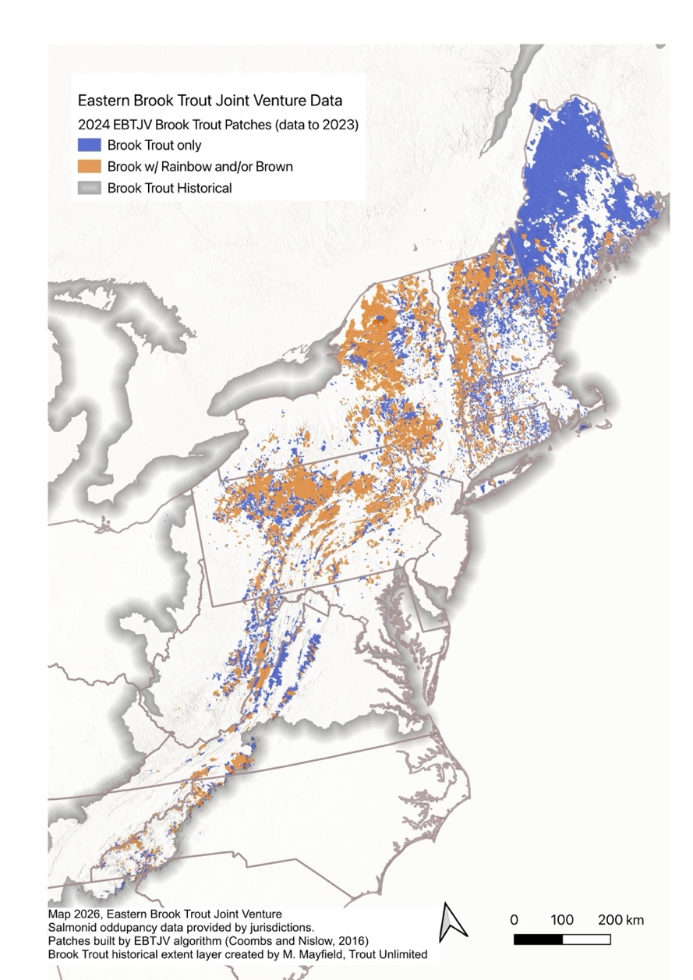
Figure 2. Range-wide patch map showing the 2024 EBTJV Assessment Brook Trout patches. Blue denotes Brook Trout only (allopatric patches, 1.1); orange denotes sympatric patches (1.2, 1.3, 1.4 combined). The historic overlay (gray border) is provided for reference and was created by Trout Unlimited.

References
Coombs, J.A. 2024. Background on EBTJV Catchment Updater Tool, and EBTJV Salmonid Catchment Assessment and Habitat Patch Layers. Report to the Eastern Brook Trout Joint Venture. Report to the Eastern Brook Trout Joint Venture. Available at https://easternbrooktrout.org/science-data/reports/ebtjv-salmonid-catchment-assessment-and-habitat-patch-layers/view

Hudy, M., T. M. Thieling, N. Gillespie, and E. P. Smith. 2008. Distribution, status, and land use characteristics of subwatersheds within the native range of brook trout in the eastern United States. North American Journal of Fisheries Management 28:1069-1085.
McKay, L., Bondelid, T., Dewald, T., Johnston, J., Moore, R., & Rea, A. (2012). NHDPlus version 2: User guide. U.S. Environmental Protection Agency.
Rummel, S.M., M. Mayfield, L.A. Maloney, H.C. Smith, and O.H. Devereux. 2024. Final Report to the Chesapeake Bay Trust. Trout Unlimited, Arlington, Virginia.
 Note
Portions of this report were generated using AI-assisted R coding (Posit AI).

Wild refers to self-reproducing; typically assumed from year-0 presence in surveys
In some places, a NHD medium resolution catchment captures more than a single stream reach, such as the reach and part of a downstream higher order stream or two small contributing reaches and the mainstem between them.

